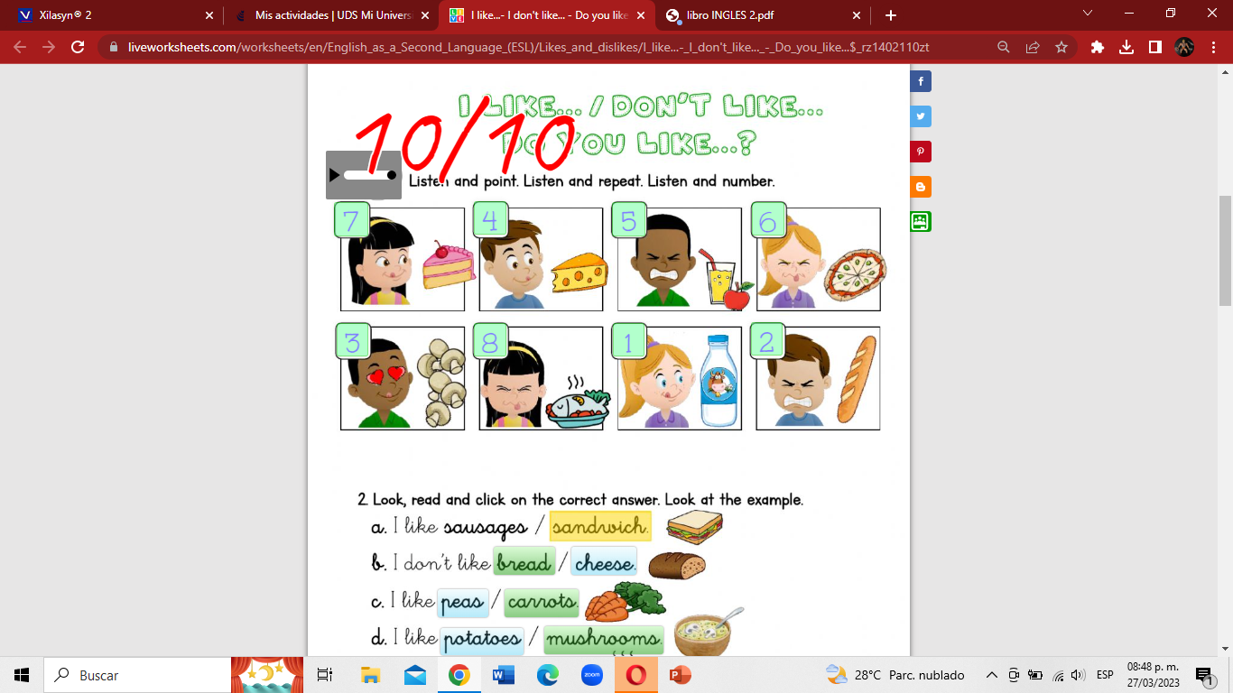

Jared Abdiel Santos Osorio 27/03/2023