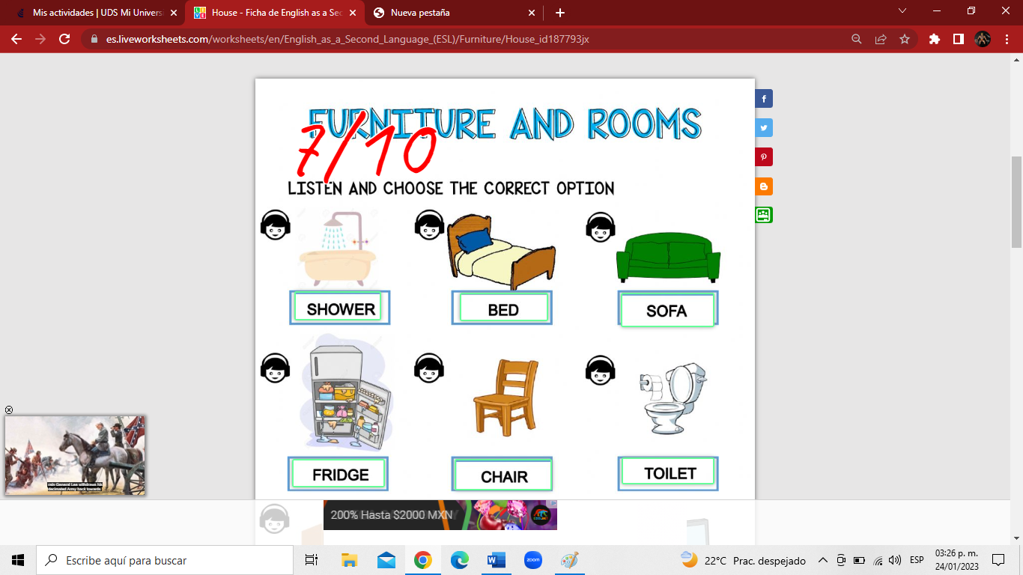

24/01/2023

Jared Abdiel Santos Osorio