

Nombre del alumno: Belén Karen Altamirano Bonifacio

Materia: Inglés ll

Tema: House descripción

Licenciatura: Psicología

**My home**

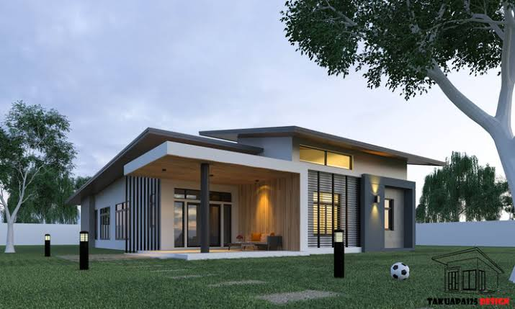

I would like my house to be a comfortable space, to have a large garden so I can have lots of plants, to have a garage, I would like it to be 2-story and for the top floor of my house to be large with 4 spacious rooms and that each room has the same thing: its beds, a sofa, lamps, some cedar furniture, closet, paintings, mirrors, and that each room has its own bathroom

At the bottom would be the room in which I would like it to be the most comfortable space for my guests with a large sofa and a large television, and that has some decorations, in the dining room would be the large table with its respective chairs, a cupboard and a window with the view towards the garden and in the kitchen you would have a full kitchen with a 3-door refrigerator with its microwave, stove, and a bar with chairs for breakfast or coffee

In the back I would like it to be the laundry room where I would have my washer, dryer, and my cleaning supplies

That would be the house of my dreams