

**Nombre de alumno:Morales Aguilar Yuleni Antonia**

**Nombre del profesor:**



**Nombre del trabajo: Unit Activity #1-U1 2LMV**

**Materia: inglés**

**Grado: 2**

**Grupo: B**

Comitán de Domínguez Chiapas a 15 de enero de 2023.

**DOES IT HAVE A VIEW?**

**Exercise 1.** Write the parts of the house (Escribe las partes de la casa)

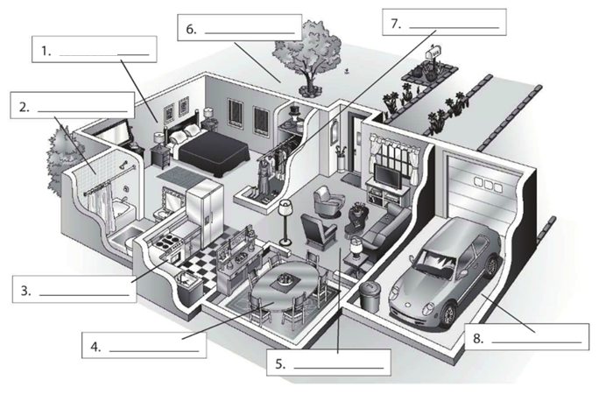

**bathroom**

**Dinner room**

**kitchen**

**Living room**

**Garage**

**closet**

**garnden**

**bedroom**

**Exercise 2.** Complete the conversation. Use the sentences in the box (Completa la conversación usa las oraciones de la caja)

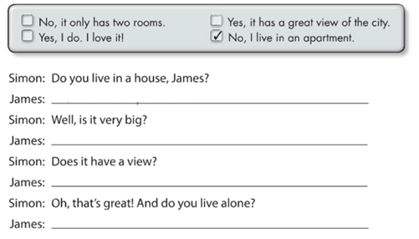

**Yes, i do. I love it**

**Yes, it has a great view of the city**

**No, it only has two rooms**

**No, I live in an apartment**

**Exercise 3.** Complete the conversation with the correct words in parenthese (Completa la conversación con las palabras correctas en parentesis)

**ans**

**Do**

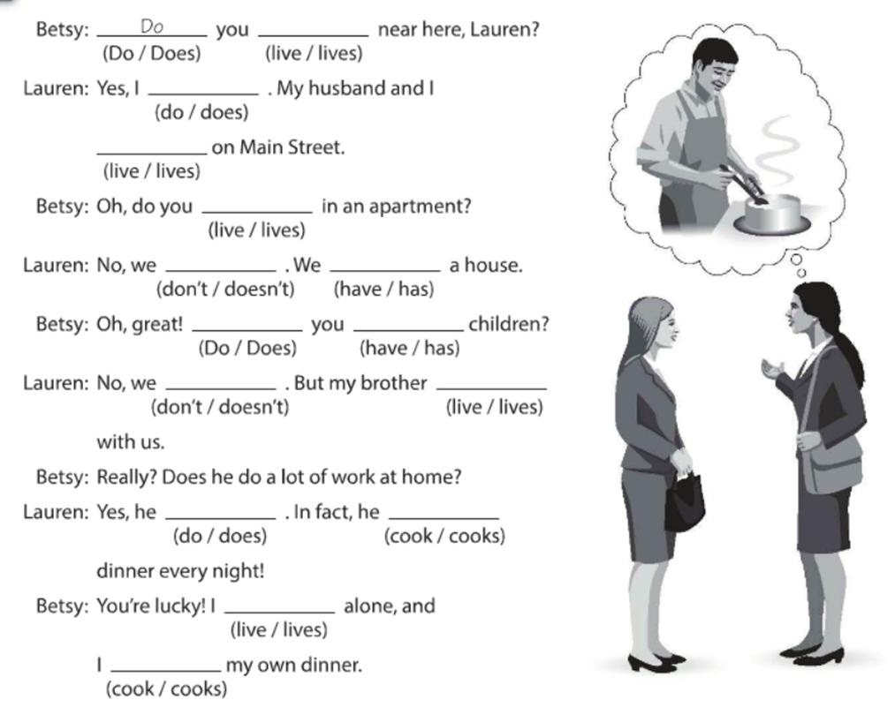

**cooks**

**live**

**cooks**

**does**

**live**

**Don´t**

**have**

**do**

**Don´t**

**have**

**live**

**lives**

**do**

**Exercise 4.** Answer these questions with your personal information Use short answers (Completa estas preguntas con tu información personal, usa respuestas cortas)

**Yes, I do or No, I don´t**

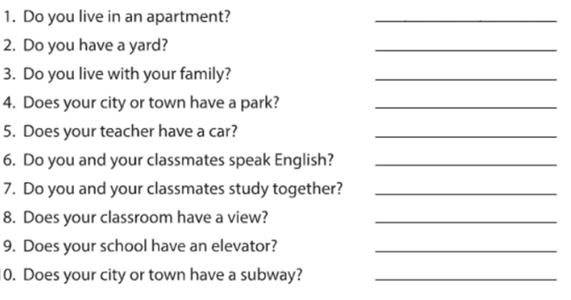

**Yes I do**

**Yes I do**

**Yes I do**

**Yes I do**

**Yes I do**

**Yes I do**

**Yes I do**

**Yes I do**

**Yes I do**

**Exercise 5.** Answer these questions about the pictures. (Responde las preguntas de acuerdo a la imagen)

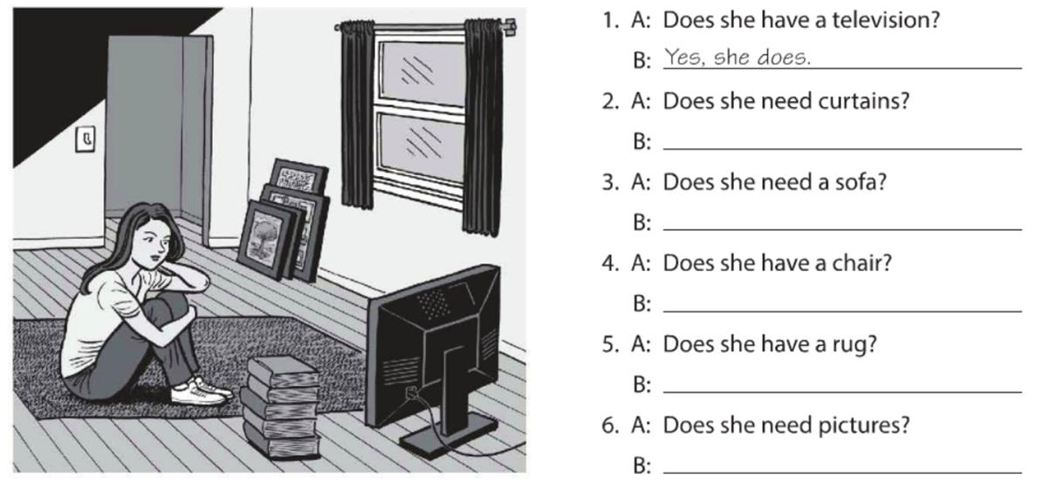

**No, she doesn´t**

**No, she doesn´t**

**Yes, she does**

**Yes, she does**

**Yes, she does**

**Yes, she does**

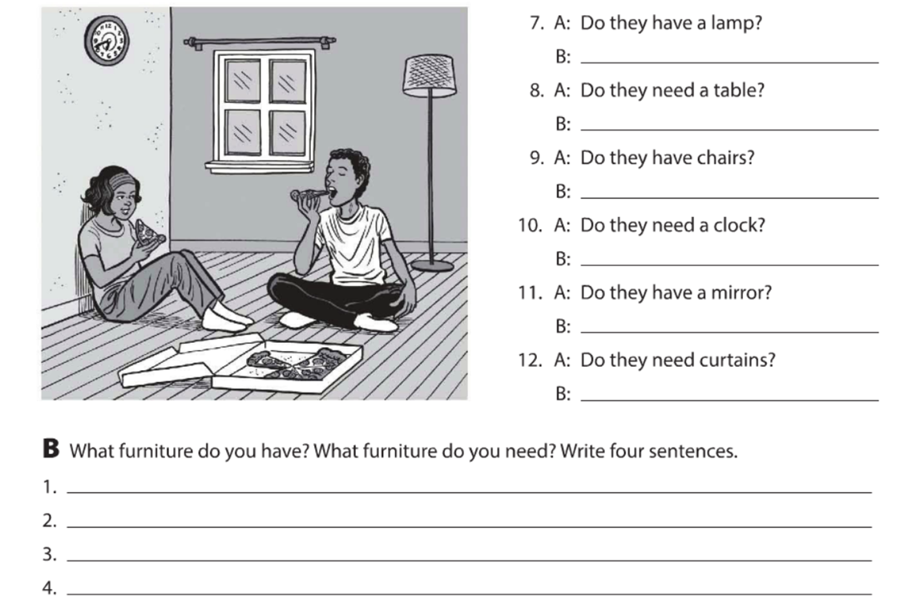

**They need a puff**

**They need a frigo**

**They need a bed**

**They need a sofa**

**Yes, they does**

**Yes, they does**

**Yes, they does**

**Yes, they does**

**No, they doesn´t**

**No, they doesn´t**

**Exercise 6.** Complete the description with “ ´s, are or aren´t ”. (Completa la descripción con “ ´s, are or aren´t ”)

**‘s**

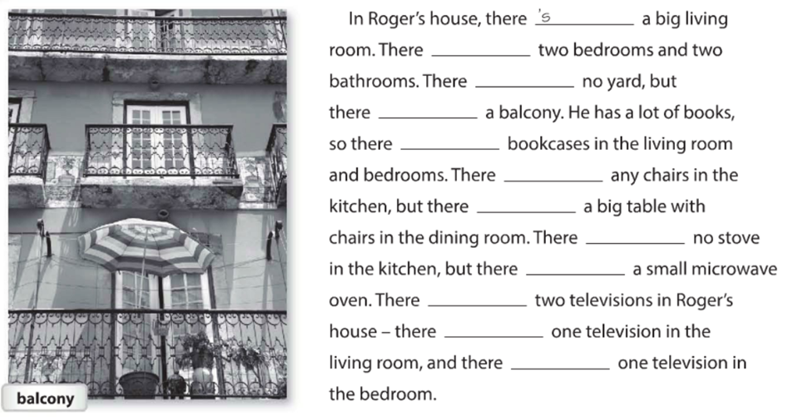

**Aren´t**

**are**

**´s**

**are**

**are**

**´s**

**´s**

**are**

**are**

**Aren´t**

**are**

**Exercise 7.** Answer these questions with information about your home. Use the phases in the box. (Responde las preguntas con información acerca de tu casa, usa la información de la caja).

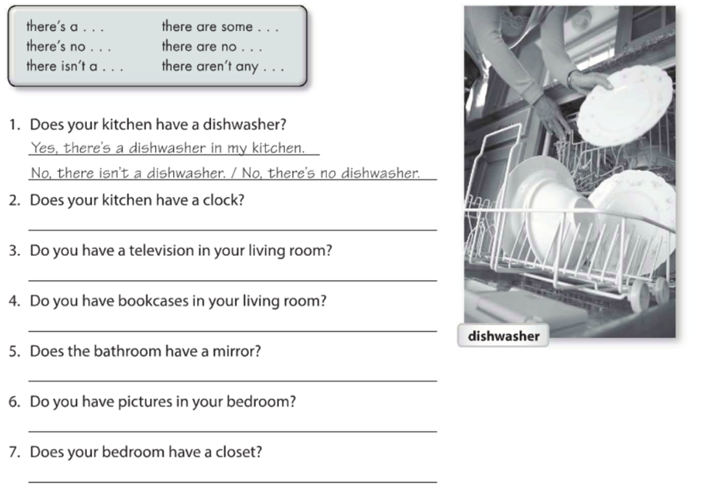

**No, there´s**

**No, there´s**

**No, there´s**

**No, there´s**

**No, there´s**

**No, there´s**

**Exercise 8.** Write sentences about the house. Use “**there”** and the words in parentheses. (Escribe acerca de la casa, usa **“there”** y las palabras en parentesis).

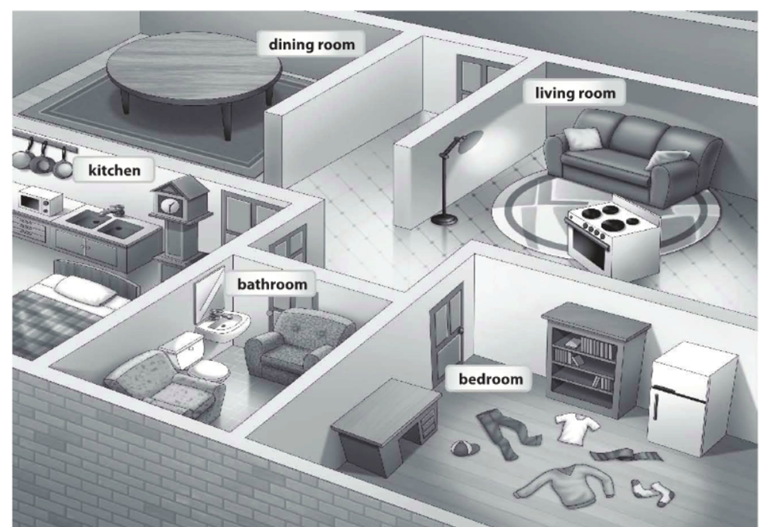

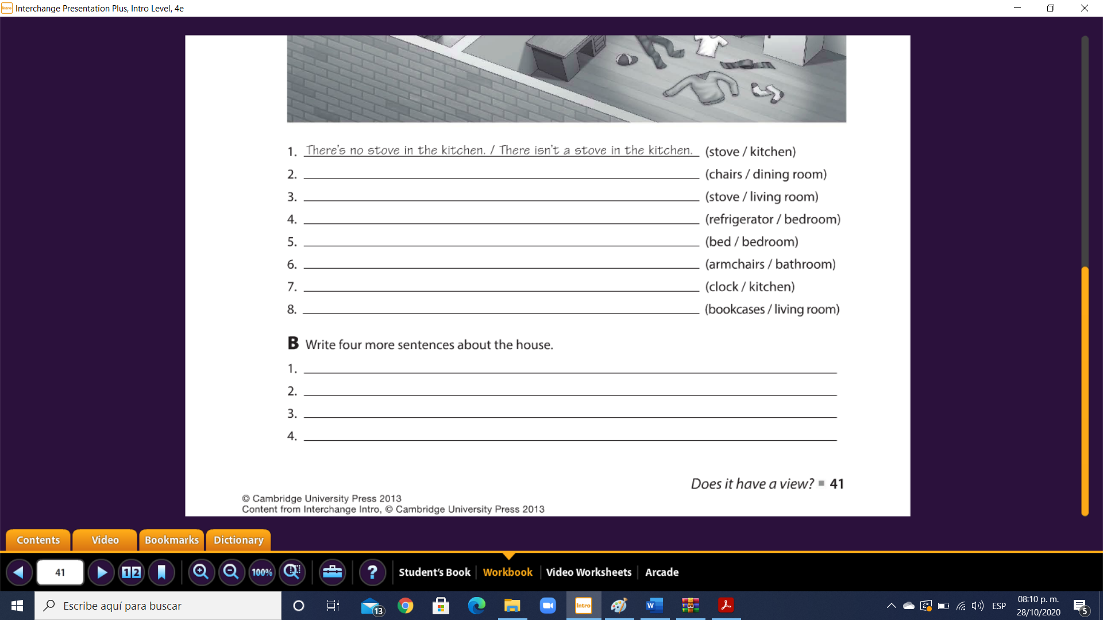

**there**

**there**

**}}}}wer**

**there**

**there**

**there**

**there**

**there**

**there**

**wer**

**there**

**there**

**there**

**there**

**Exercise 9.** Chose the correct responses. (Escoge las respuestas correctas).

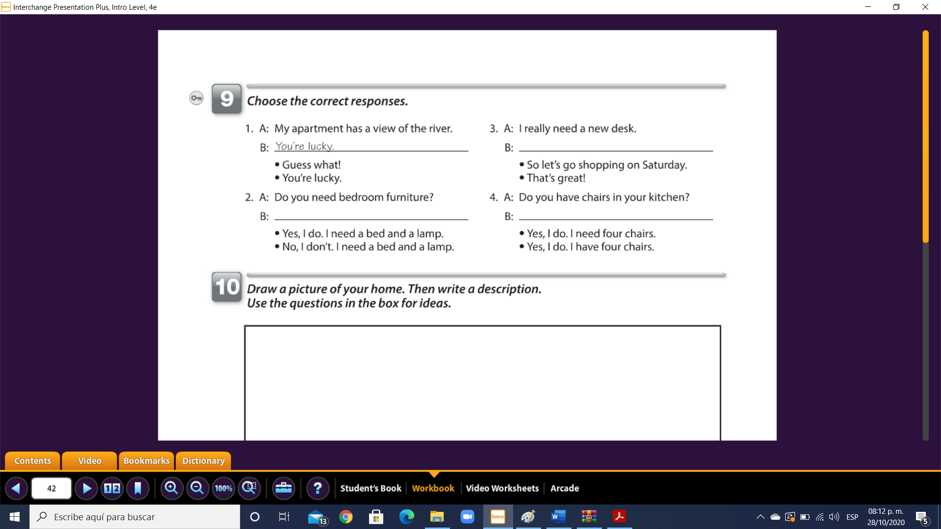

**No, I don’t. I need a bed and a lamp**

**Yes, I do. I need four chairs**

**So let´s go shopping on saturday**

**Exercise 10.** Reading comprehension (Lectura de comprensión).

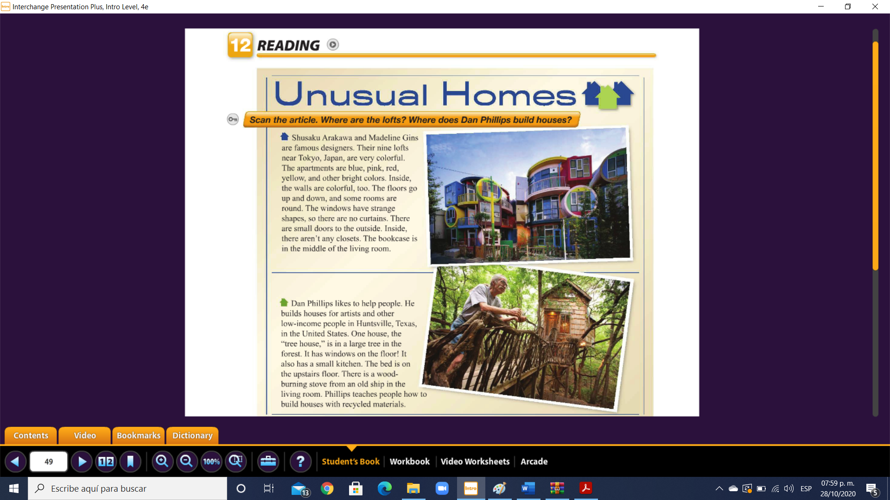

Complete the chart. (Completa la tabla).

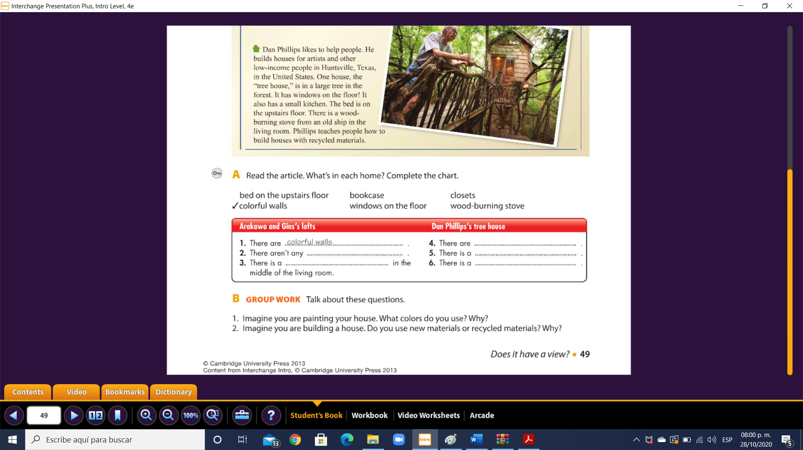

**Windows on the floor**

**Wood brining stove**

**Bed on the upstairs**

**bookcasa**

**closets**