

**Nombre de alumno: Paola Elizabeth Maldonado Cancino**

**Nombre del profesor: Juan Manuel Jaime**





**Nombre del trabajo:**

**Unit**

**Activity**

**#1**

**-**

**U**

**1**

**2**

**L**

**MV**

**Materia:**

**Ingles**

**Grado: 2**

**Grupo: “B”**

Comitán de Domínguez Chiapas a 22 de enero de 2023.

**DOES IT HAVE A VIEW?**

**Exercise 1.** Write the parts of the house (Escribe las partes de la casa)

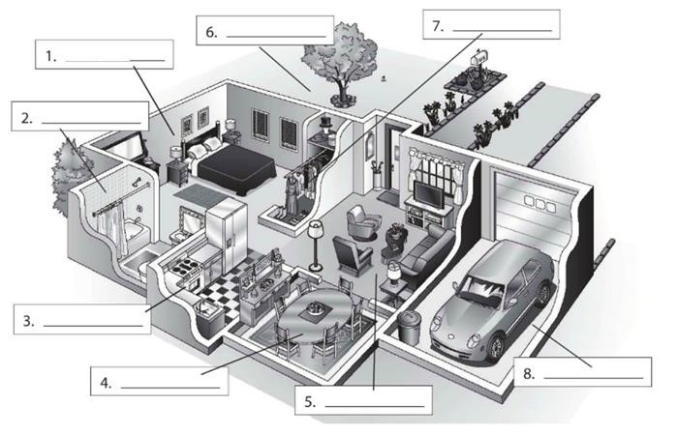

**bedroom**

**yard**

**closet**

**bathroom**

**Kitchen**

**Dining room**

**Living room**

**Garaje**

**Exercise 2.** Complete the conversation. Use the sentences in the box (Completa la conversación usa las oraciones de la caja)

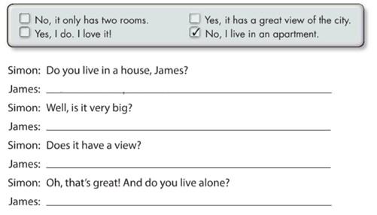

**No, I**

**live in an apar**

**t**

**me**

**No,it only has two rooms**

**Yes,it has a great view of the city**

**Yes l do. I love it!**

**Exercise 3.** Complete the conversation with the correct words in parenthese (Completa la conversación con las palabras correctas en parentesis)

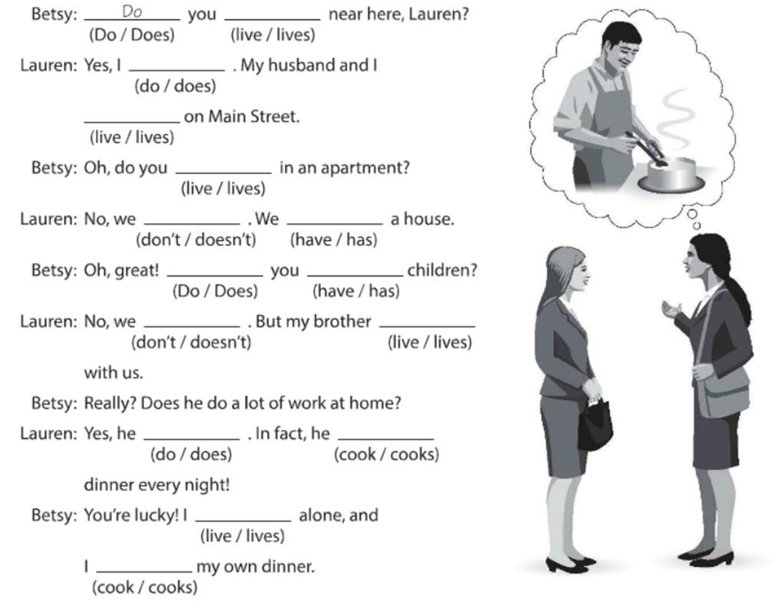

**Do**

**live**

**Do**

**live**

**live**

**Don´t**

**have**

**Do**

**Have**

**Don’t**

**lives**

**Does**

**cooks**

**live**

**cook**

**Exercise 4.** Answer these questions with your personal information Use short answers (Completa estas preguntas con tu información personal, usa respuestas cortas)

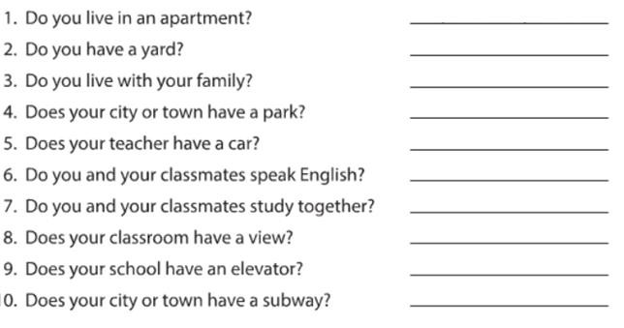

**Yes, I do**

**or**

**No, I don´t**

**Yes, l do**

**No, l**

**don’t**

**Yes, it does**

**Yes, he does**

**Yes, we do**

**Yes we do**

**No it doesn’t**

**No , it doesn’t**

**No, it doesn’t**

**Exercise 5.** Answer these questions about the pictures. (Responde las preguntas de acuerdo a la imagen)

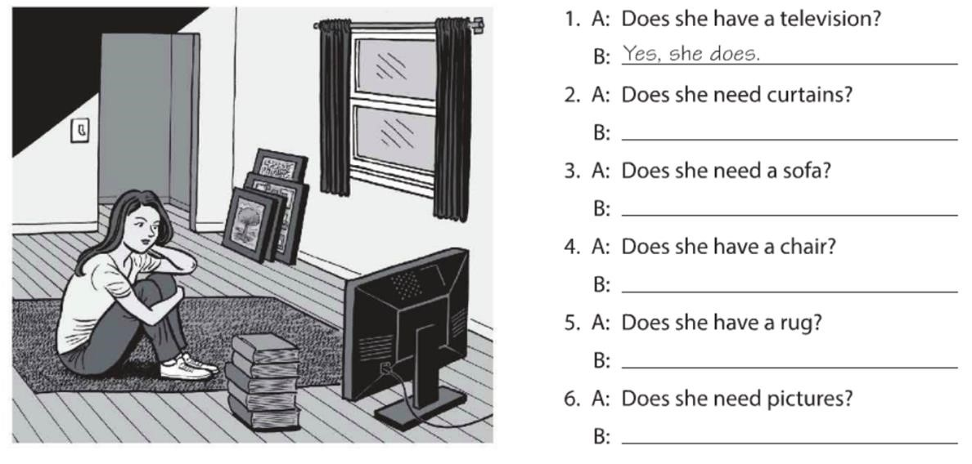

**Yes,**

**she does**

**No, she doesn´t**

**Yes,**

**she does**

**No**

**,**

**she doesn’t**

**Yes,**

**she does**

**No**

**,**

**she doesn’t**

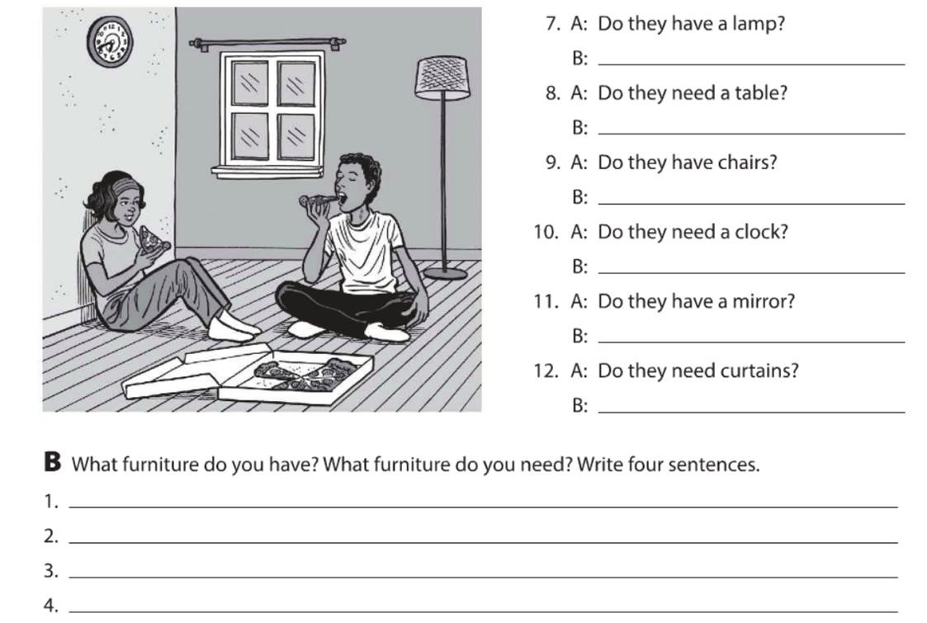

**Yes, they have**

**I have a lame**

**Yes, they do**

**Yes, they do**

**No, they don’t**

**No, they don’t**

**No, they don’t**

**I**

**have a sofa**

**I need a refrigerator**

**I need a rug**

**Exercise 6.** Complete the description with “ ´s, are or aren´t ”. (Completa la descripción con “ ´s, are or aren´t ”)

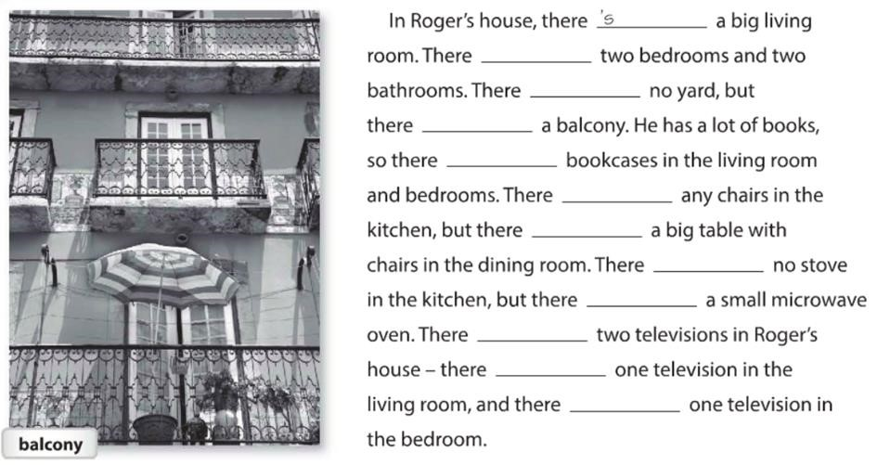

**‘s**

**‘s**

**‘s**

**‘s**

**‘s**

**‘s**

**‘s**

**‘s**

**‘s**

**‘s**

**‘t**

**‘t**

**Exercise 7.** Answer these questions with information about your home. Use the phases in the box. (Responde las preguntas con información acerca de tu casa, usa la información de la caja).

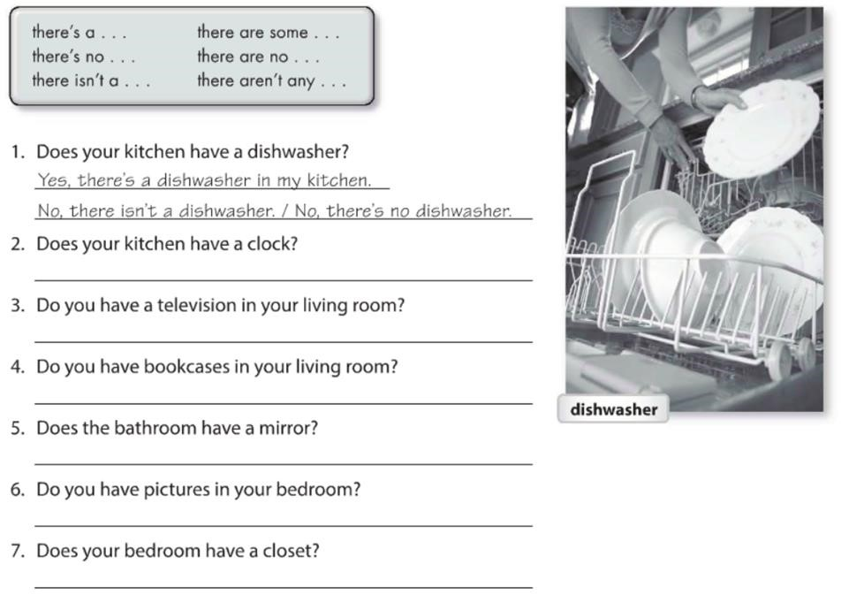

**Y**

**es**

**, there´s a**

**clock**

**Yes, there´s a television**

**Yes there’s a bookcases**

**Yes, there’s a mirror**

**Yes, there are some pictures**

**Yes, there’s a closet**

**Exercise 8.** Write sentences about the house. Use “**there”** and the words in parentheses. (Escribe ace rca de la casa, usa **“there”** y las palabras en parentesis).

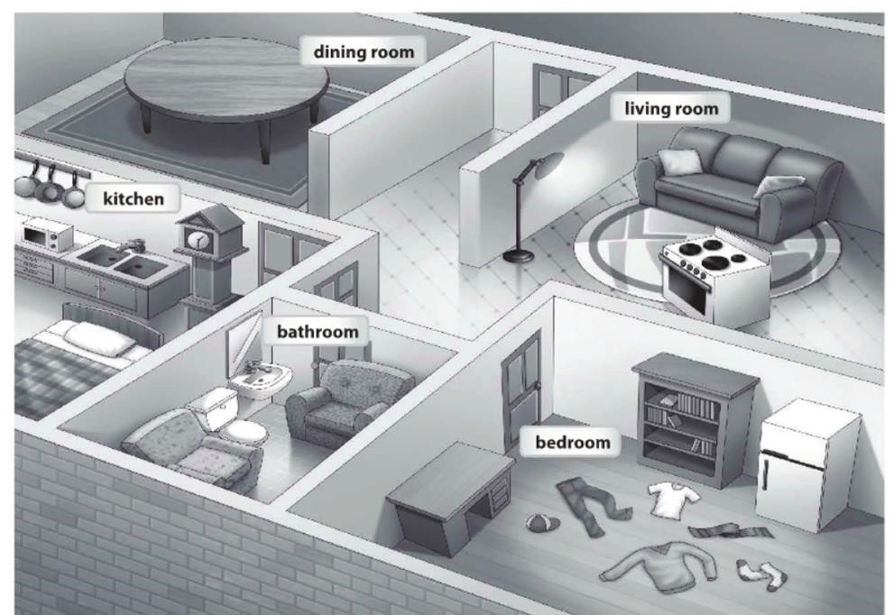

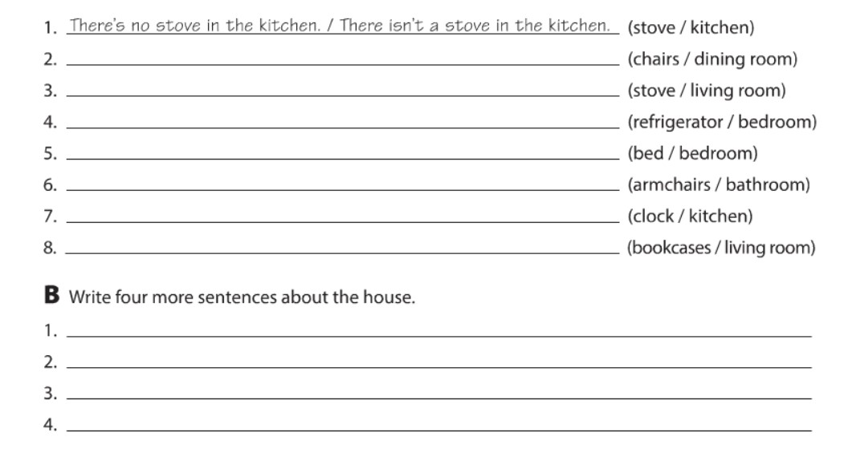

**There**

**’s no chairs**

**in the dining room**

**Theres’s a stove in the living room**

**There’s a refrigerator in the bedroom**

**There isn’t a bed in the bedroom**

**There**

**are arm**

**chairs in the bathroom**

**Theres’s a clock in the kitchen**

**There’s no bookcases in the living room**

**There’s a dresser in the bredroom**

**There’s a television in the living room**

**T**

**here**

**’**

**s a bed in the kitchen**

**There’s a closet in the bedroom**

**Exercise 9.** Chose the correct responses. (Escoge las respuestas correctas).

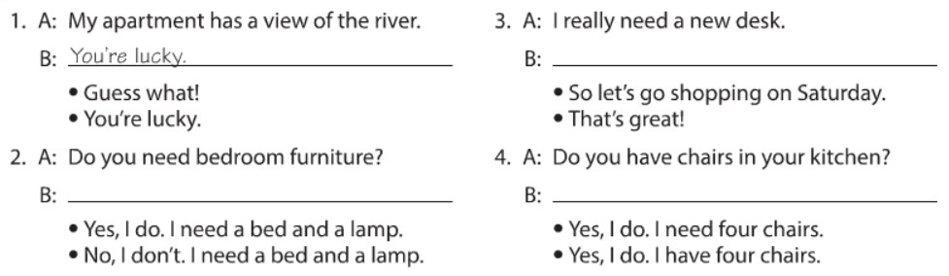

**So let’s go shopping on Saturday**

**Yes, I do. I need a bed and a lamp**

**Yes, I do. I**

**have four chairs**

**Exercise 10.** Reading comprehension (Lectura de comprensión).

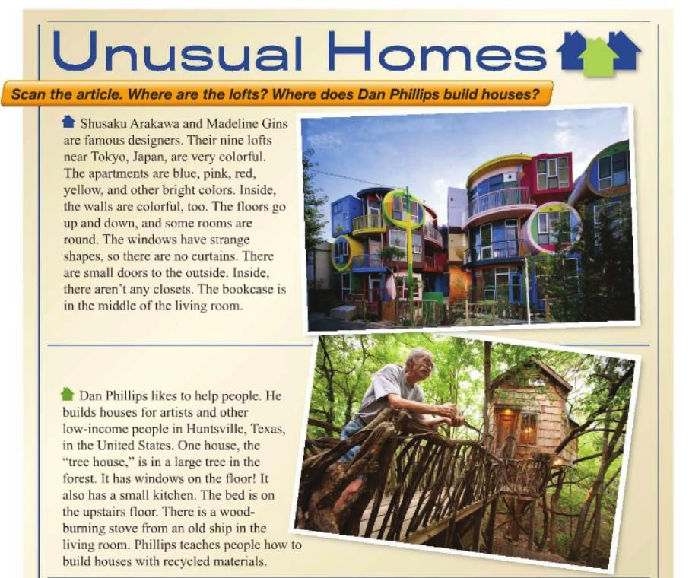

Complete the chart. (Completa la tabla).

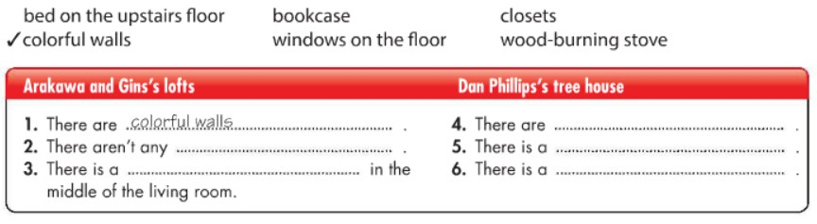

**closets**

**Bookcase**



**Windows on the floor**

**Wood**

**-**

**burning stove**

**Bed on the upstairs foor**