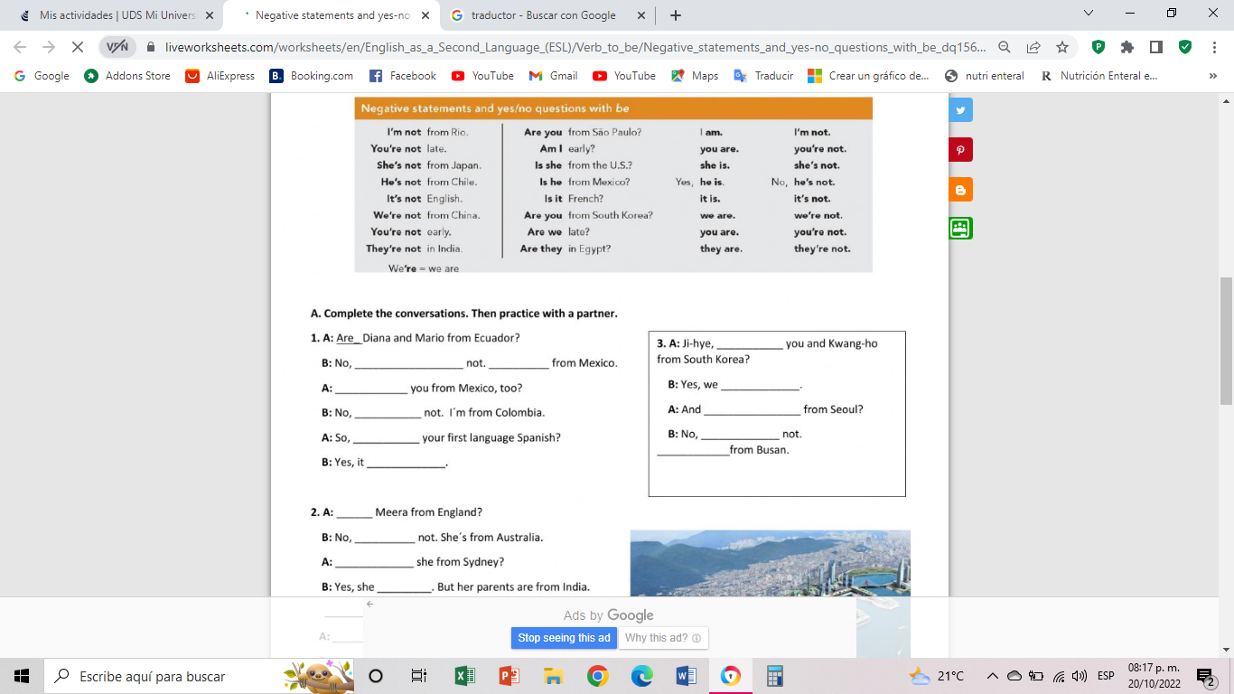

They ´ re

Is

is

She´s

is

are

We ¨ re

you

are

are

is

I´m

are

The are

Ithey¨no

is

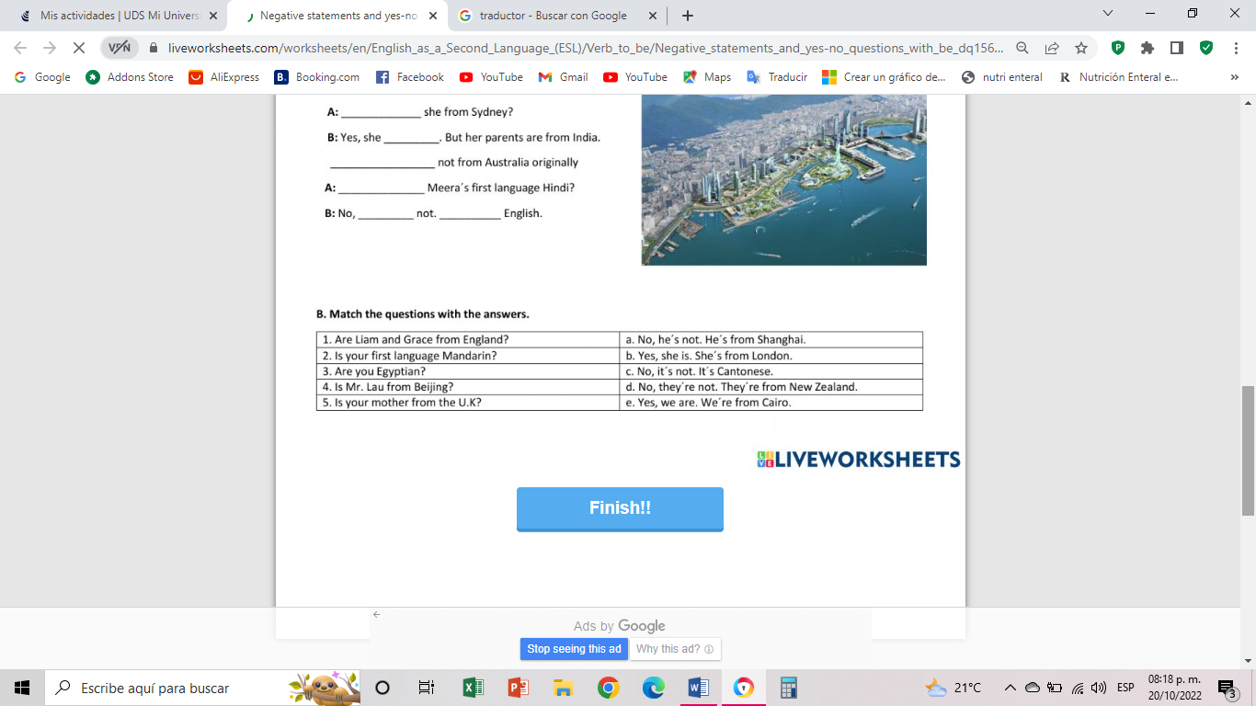

E

D

C

B

A

is

It¨ s

is

**Alumno: Jared Abdiel Santos Osorio**