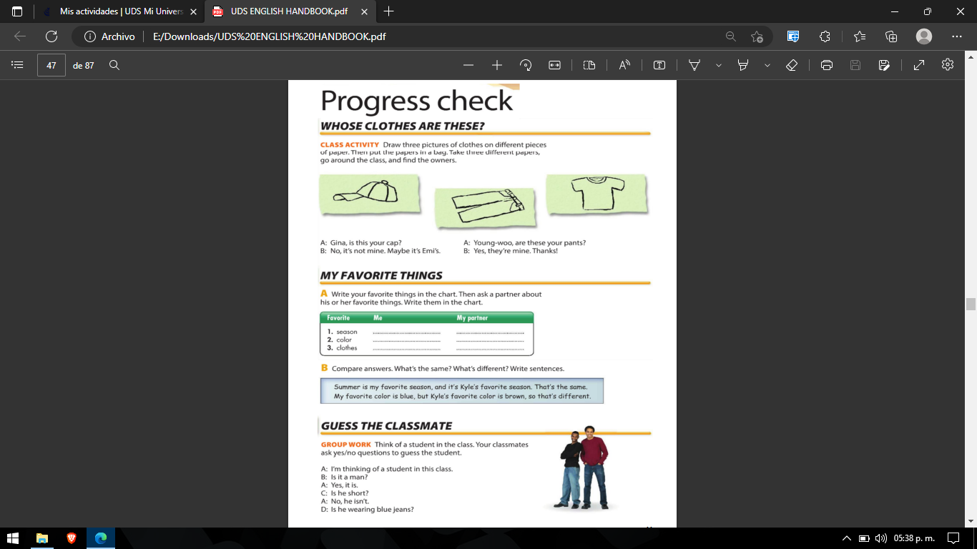

winter

Summerr

Red

Blue

Casual clothes

Casual clothes

Swimsuit

Tshirt

Socks

Sneakers

Skirt

Short’s

Jacket

High heels

Blouse

Belt

Cap

