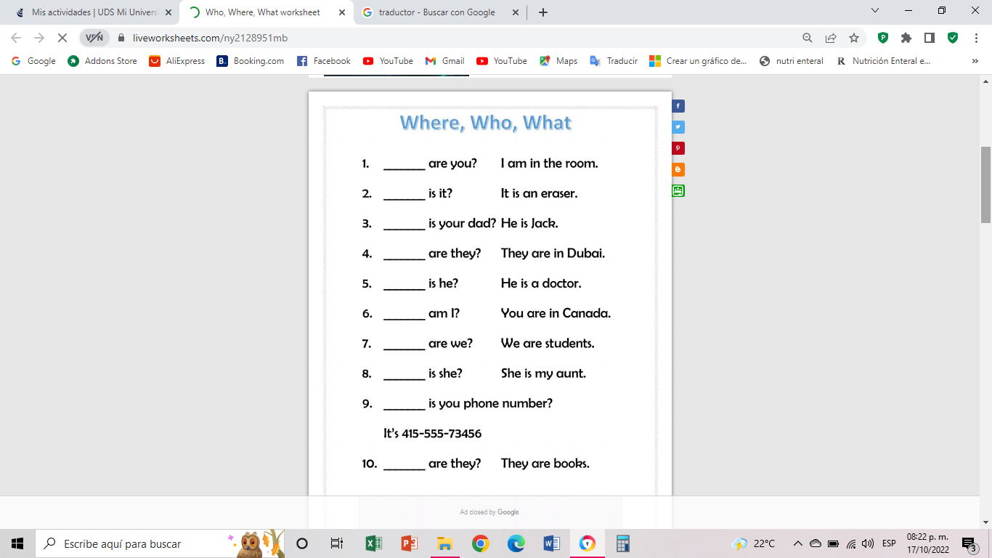

What

What

Who

Who

Where

What

Where

What

What

Where

**Jared Abdiel Santos Osorio**