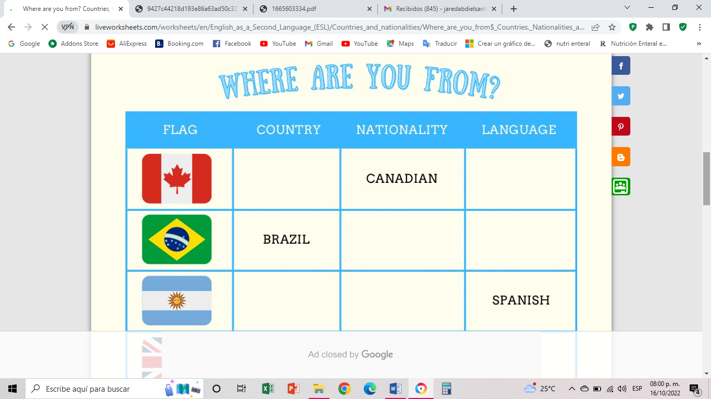

ARGENTINA

ARGENTINA

PORTUGUESE

BRAZILIAN

ENGLESH

CANADA

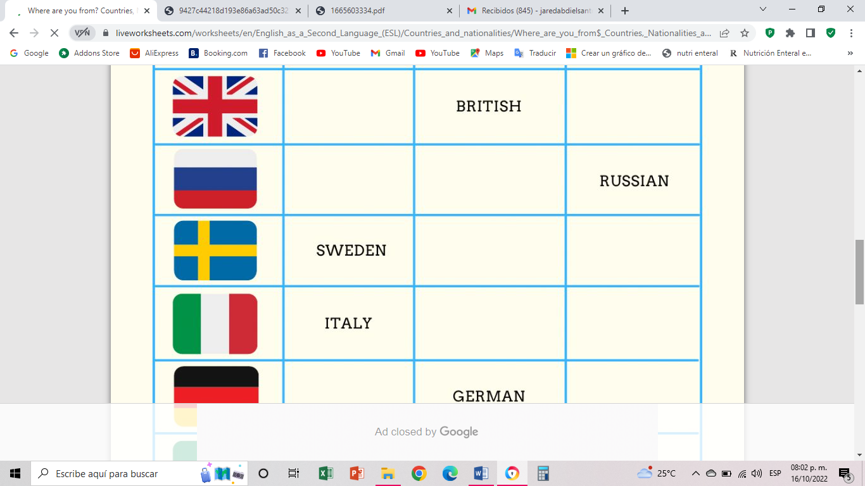

Swedish

Swedish

Italian

Italian

Russian

Russia

England

ENGLESH

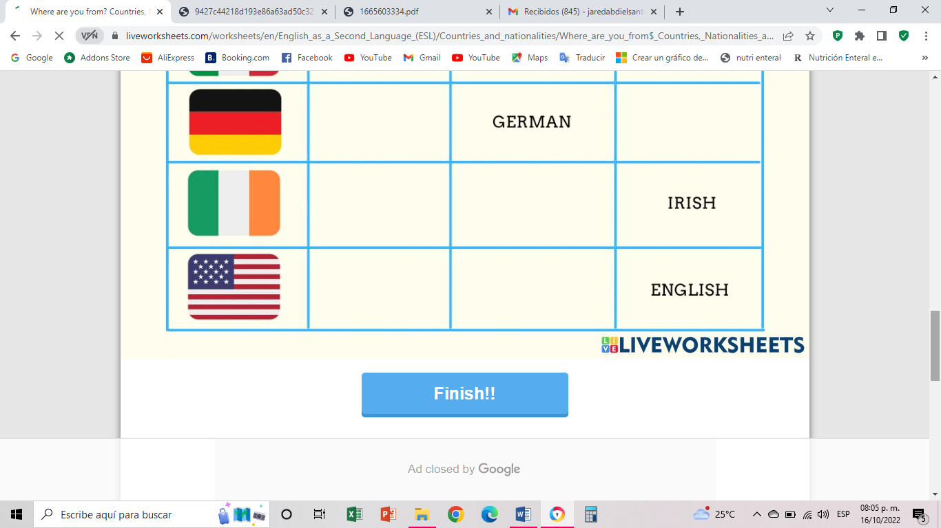

Irish

German

American

United States

Ireland

Germany

**Jared Abdiel Santos Osorio**