

**Nombre de alumno:**

**Nombre del profesor:**



**Nombre del trabajo: Unit Activity #1 Unit 4**

**Materia:**

**Grado:**

**Grupo:**

Comitán de Domínguez Chiapas a 05 de Diciembre de 2022.

**VOCABULARY - Types of clothing and shoes**

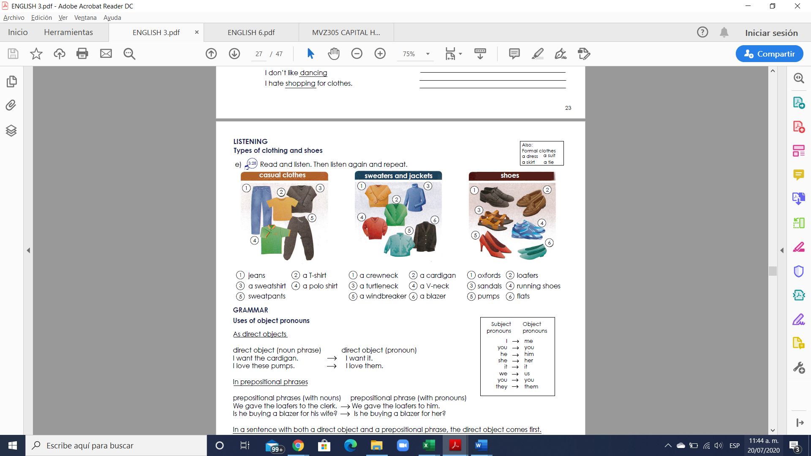

**Exercise 1.** Translate the vocabulary. (Traduce el vocabulario de la parte de arriba)

Casual clothes

1. pantalon

2. una camiseta

3.una sudadera

4.una camiseta tipo polo

5.pantalones deportivos

Sweaters and jackets Shoes

1.sueter de cuello redondo 1. zapatos formales

2.una chaqueta de botones 2.mocasines

3.un suéter de cuello de tortuga 3.sandalias

4.un suéter de cuello en v 4.zapatos para correr

5.un cortaviento 5. zapatillas

6.una chaqueta 6. Zapatos de piso

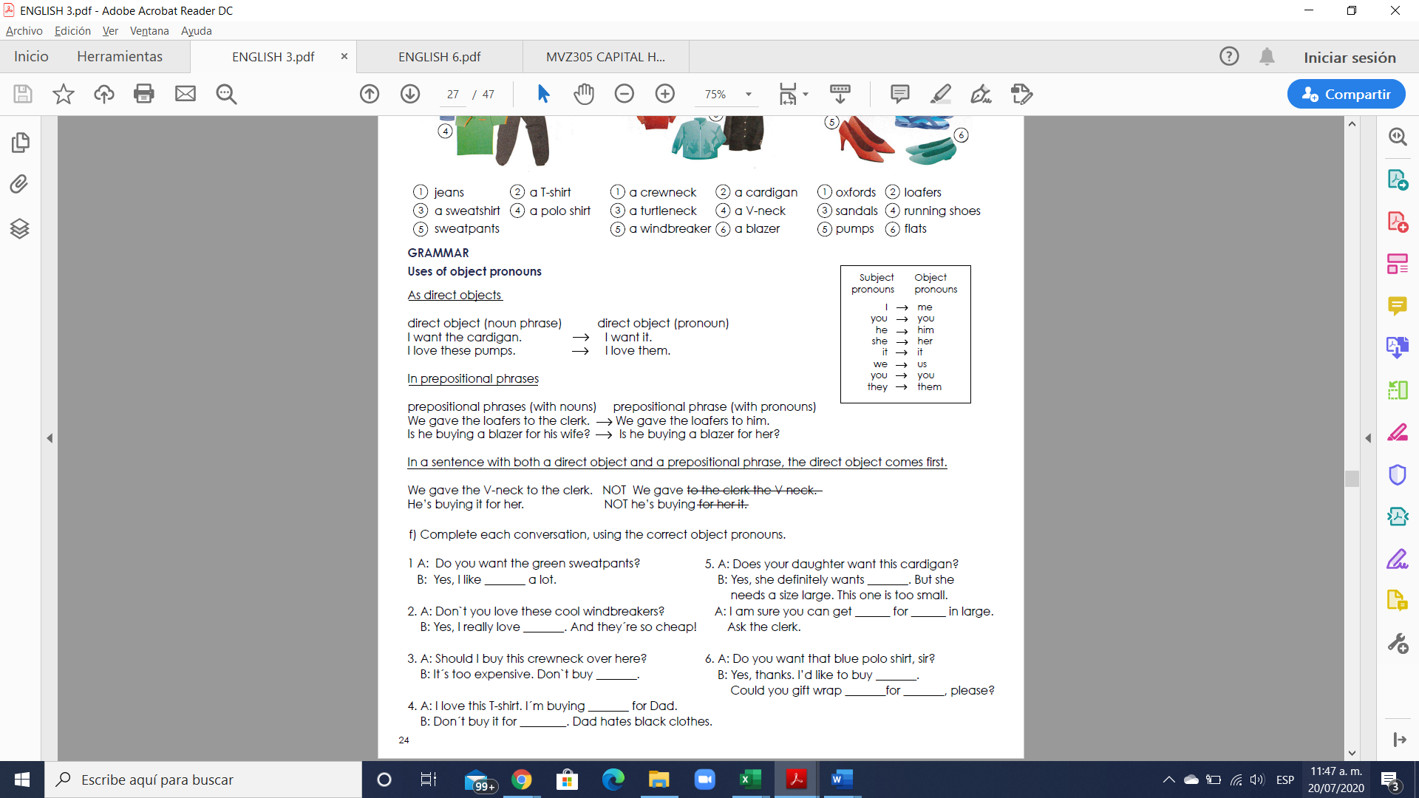

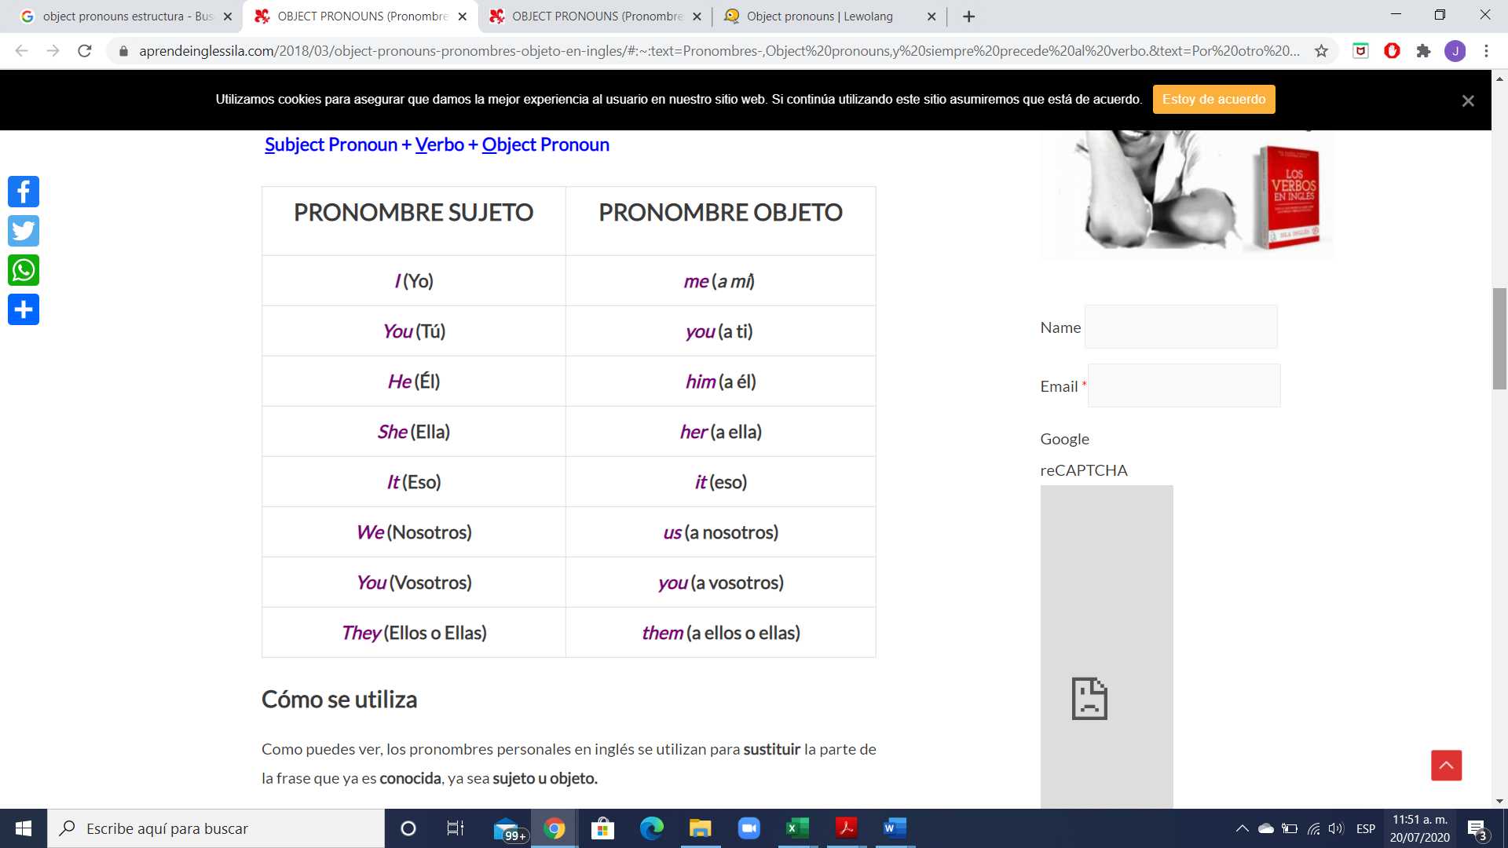

Los personal object pronouns son palabras que se utilizan para sustituir a un nombre y así evitar repeticiones. La principal diferencia entre los personal pronouns y los personal object prononuns es que mientras que los primeros reemplazan a un nombre que hace la función de sujeto, los segundos sustituyen a un nombre que no hace función de sujeto.

Una de las principales características de los personal object pronouns es que se sitúan detrás del verbo o bien detrás de una preposición (at, for, with, etc.)

Los personal object pronouns sustituyen a los nombres que hacen función de objeto, es decir, a la persona, animal o cosa que recibe directa o indirectamente la acción expresada por el verbo. Siempre se colocan detrás de un verbo o una preposición.

**Exercise 2.** Complete each conversation, using the correct object pronouns

1 A: Do you want the green sweatpants?

B: Yes, I like __them___ a lot.

2. A: Don`t you love these cool windbreakers?

B: Yes, I really love _them__. And they´re so cheap!

3. A: Should I buy this crewneck over here?

B: It´s too expensive. Don`t buy _it_.

4. A: I love this T-shirt. I´m buying _it_ for Dad.

B: Don´t buy it for _him__. Dad hates black clothes.

5. A: Does your daughter want this cardigan?

B: Yes, she definitely wants _it_. But she needs a size large. This one is too small.

A: I am sure you can get __it__ for _her_ in large. Ask the clerk.

6. A: Do you want that blue polo shirt, sir?

B: Yes, thanks. I’d like to buy __it__. Could you gift wrap __it__for __me__, please?

**Exercise 3.** Fill in the gaps with object pronouns.

1. A: Do you like studying English?

B: Yes, I love __it___ .

2. A: Do you like Lady Gaga?

B: Yes, I like ___her___ a lot.

3. A: Do you like getting up early?

B: No, I hate ___it___.

4. A: Do you like Johnny Depp?

B: Yes, I love ___him__ !

5. A: Do you like soap operas?

B: No, I hate __them__.

6. A: Do you like dogs?

B: Yes, but they don´t like ___them__!

**Exercise 4.** Select the correct answer**.**

1. The teacher wants to talk to ________ about your homework.

a) him

b) her

c) you

2. Be careful; he lied to _______ before and he may do it again.

a) us

b) they

c) we

3. Where are Andres and Maria? Didn´t invite _______.

a) us

b) them

c) we

4. The spider bit ______ on my ankle.

a) us

b) they

c) me

5.The movie was great!! We really liked ______.

a) him

b) them

c) it

**Exercise 5.** Write 5 sentences using the object pronouns.

1. zair always tells the truth to you

2. carlos teach English to her

3.he had played soccer with them

4.miceli hs been watching the game with us for hours

5.they want to give a present to you

**VOCABULARY - Food**

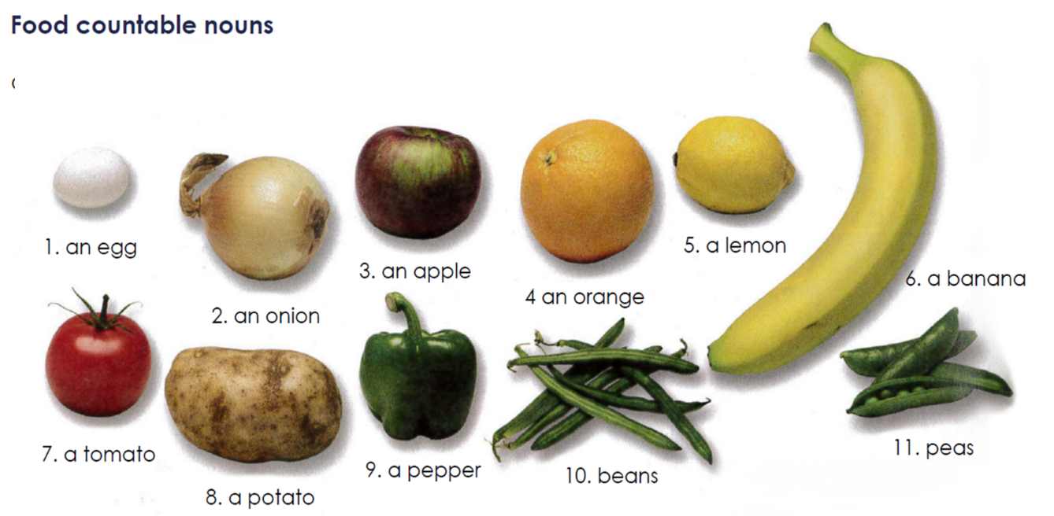

**Exercise #6.** Translate the vocabulary above. (Traduce el vocabulario de la parte de arriba)

1. un huevo

2.una cebolla

3. una manzana

4. una naranja

5. un limón

6. una banana

7. un tomate

8. una patata

9.un pimiento

10. frijoles

11.guisantes

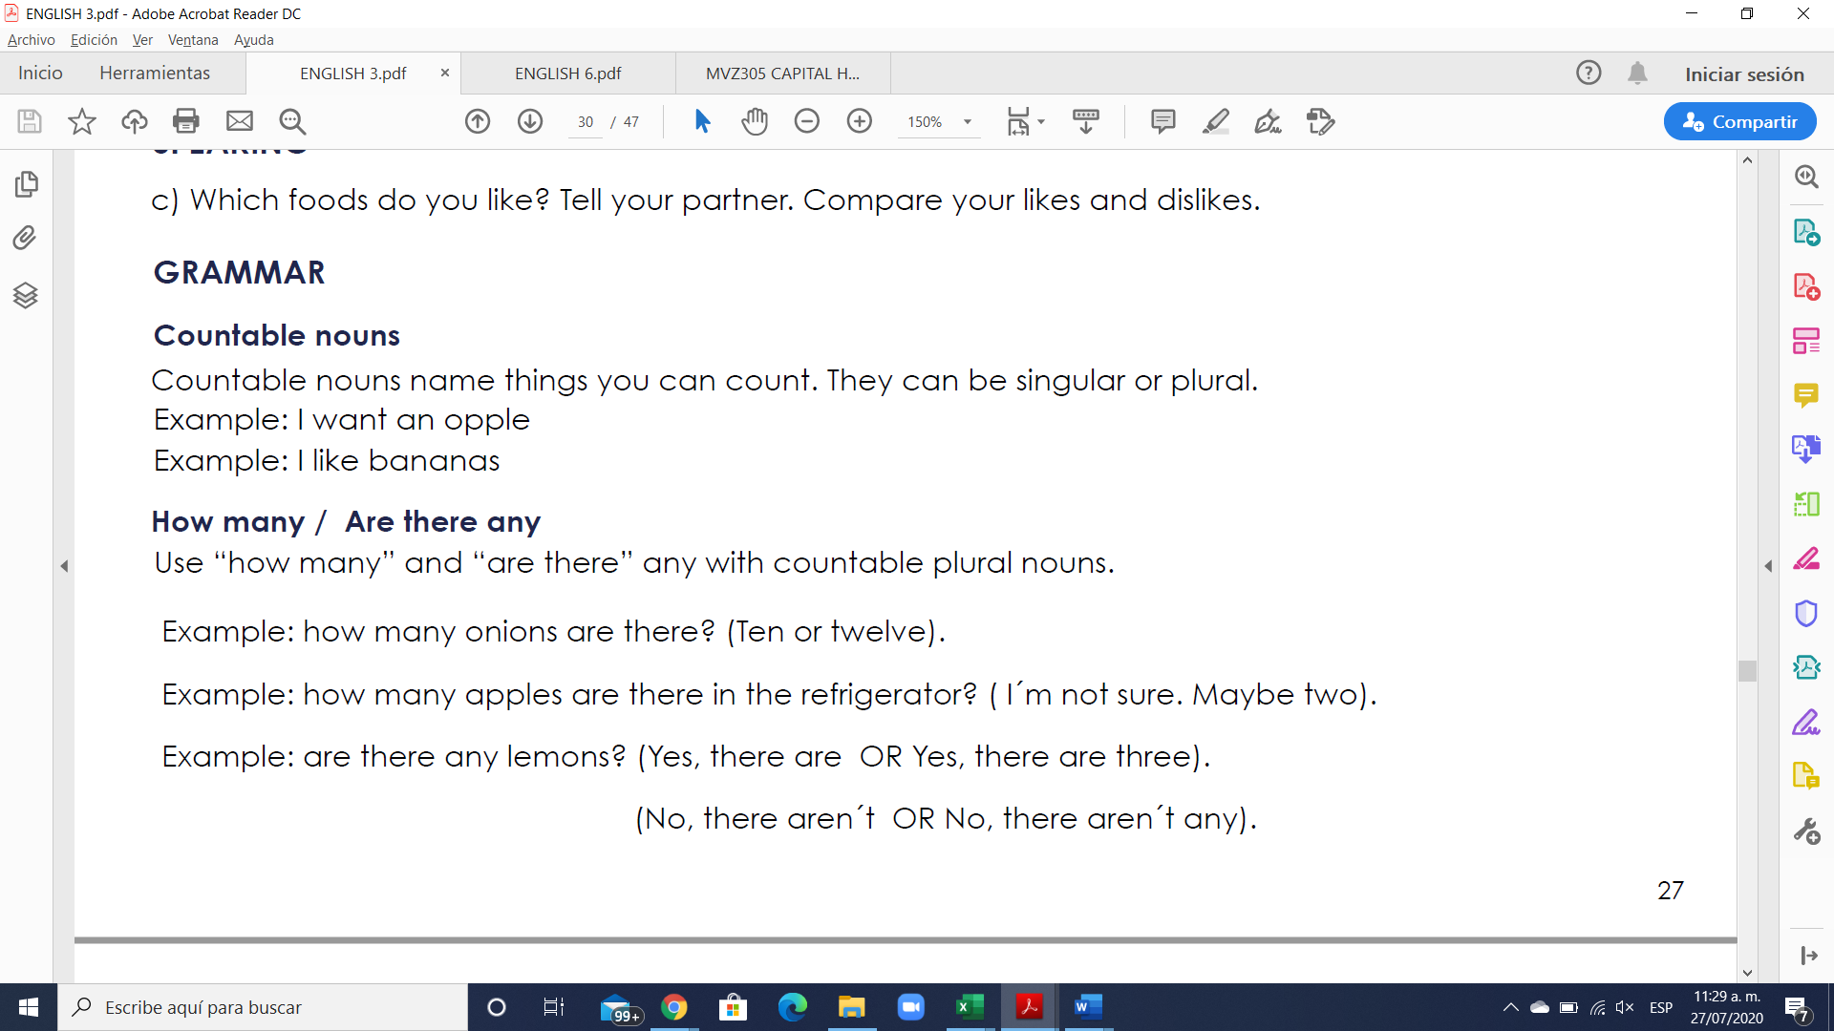

**Los countable nouns** son aquellos elementos que pueden ser contados de uno en uno utilizando los números.

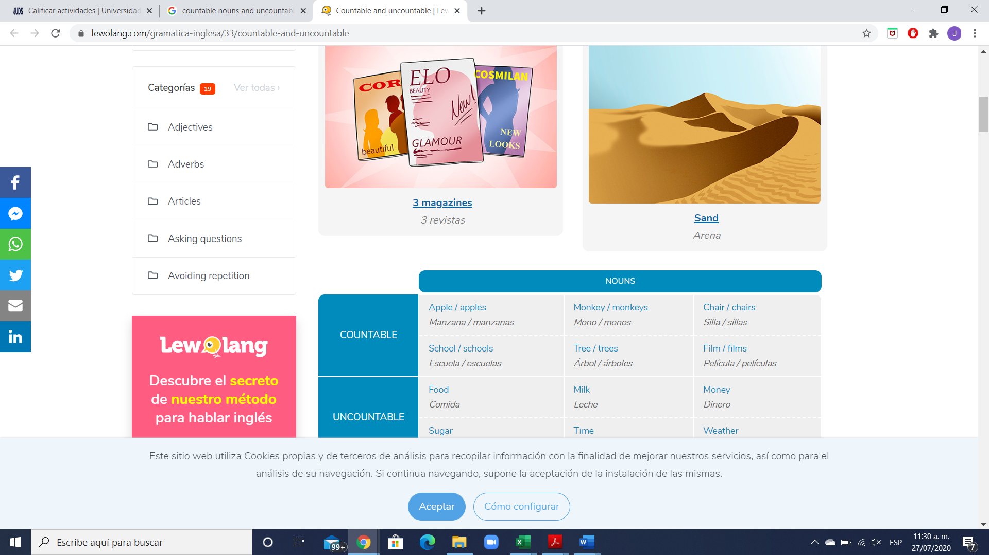

**Los nombres contables** tienen forma de singular y plural. Cuando nos referimos a los nombres contables en singular, estos pueden ir precedidos por el artículo indeterminado **a/an.**

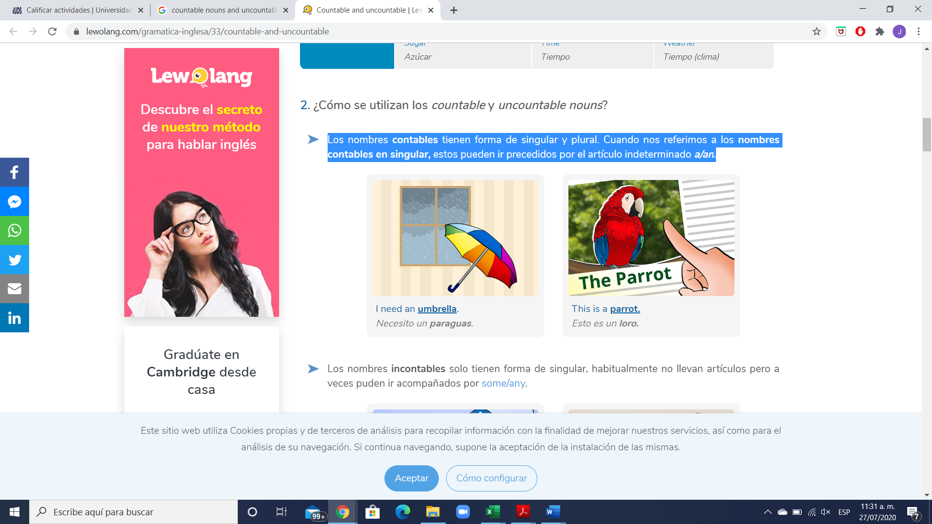

**Exercise #7.** Write 5 sentences using countable nouns. Escribe 5 oraciones usando nombres contables.

1.how much bottles of water does she have?

2.how many apples did Jorge buy?

3.that house has seven window

4.in our classroom there are only eight chairs

5.theybounght five takis

**GRAMMAR**



**How many** = Cuantos… ? (se usa solo para nombres contables)

**Are there any** = Hay algunos…? (se usa solo para nombres contables)

There are any + plural noun = Are there any + plural noun?

Example: “Are there any trains to London this morning?”

**Exercise #8.** Write 6 sentences using How many / Are there any. Escribe 5 oraciones.

1. how many apples There in the refrigerator?

2.how many watermelons are There in the table?

3.how many oranges are There in the básquet?

4.are there any fruit on the table?

5.are there any toys in the store

6. are There any dogs in the street

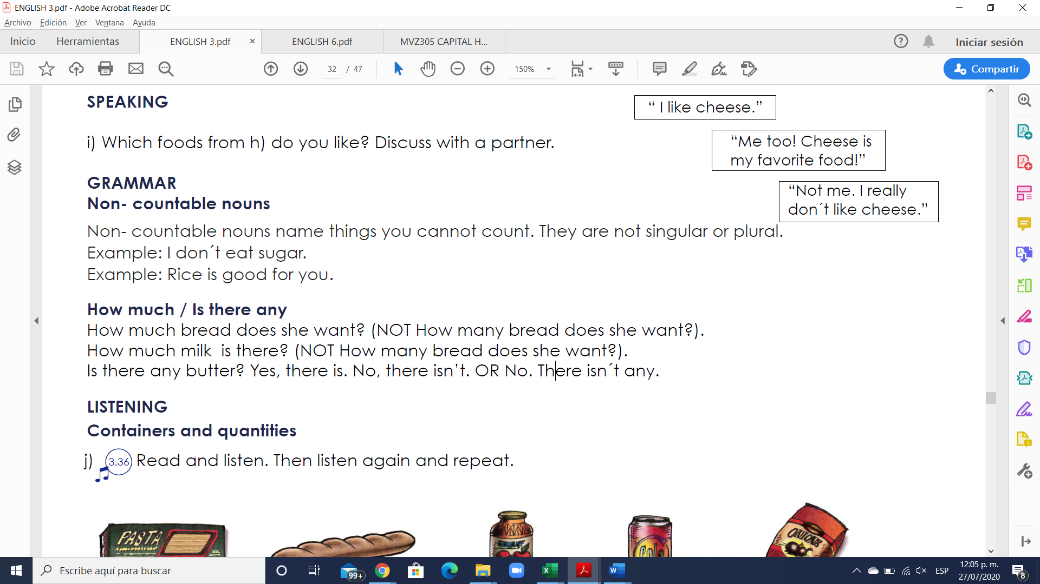

Los **uncountable nouns** son aquellos elementos que no podemos contar usando números, pero sí utilizando cuantificadores o partitivos.

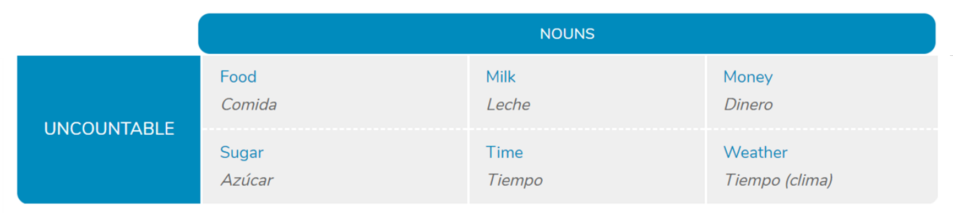

**Los nombres incontables** solo tienen forma de singular, habitualmente no llevan artículos, pero a veces pueden ir acompañados por **some/any**.

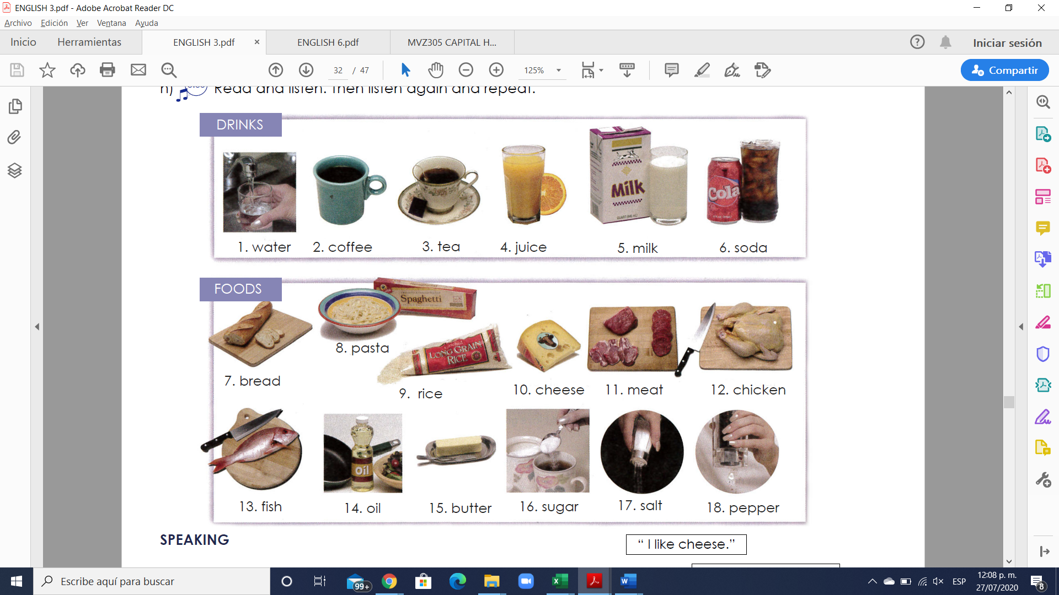

**Exercise #9.** Write 5 sentences using uncountable nouns. Escribe 5 oraciones usando nombres incontables.

1.how many butter did Maria get?

2.how many soda does he have?

3. how many liters of water did Fernanda buy?

4. there is milk in the fridge

5. how many jam in my bread

**GRAMMAR**

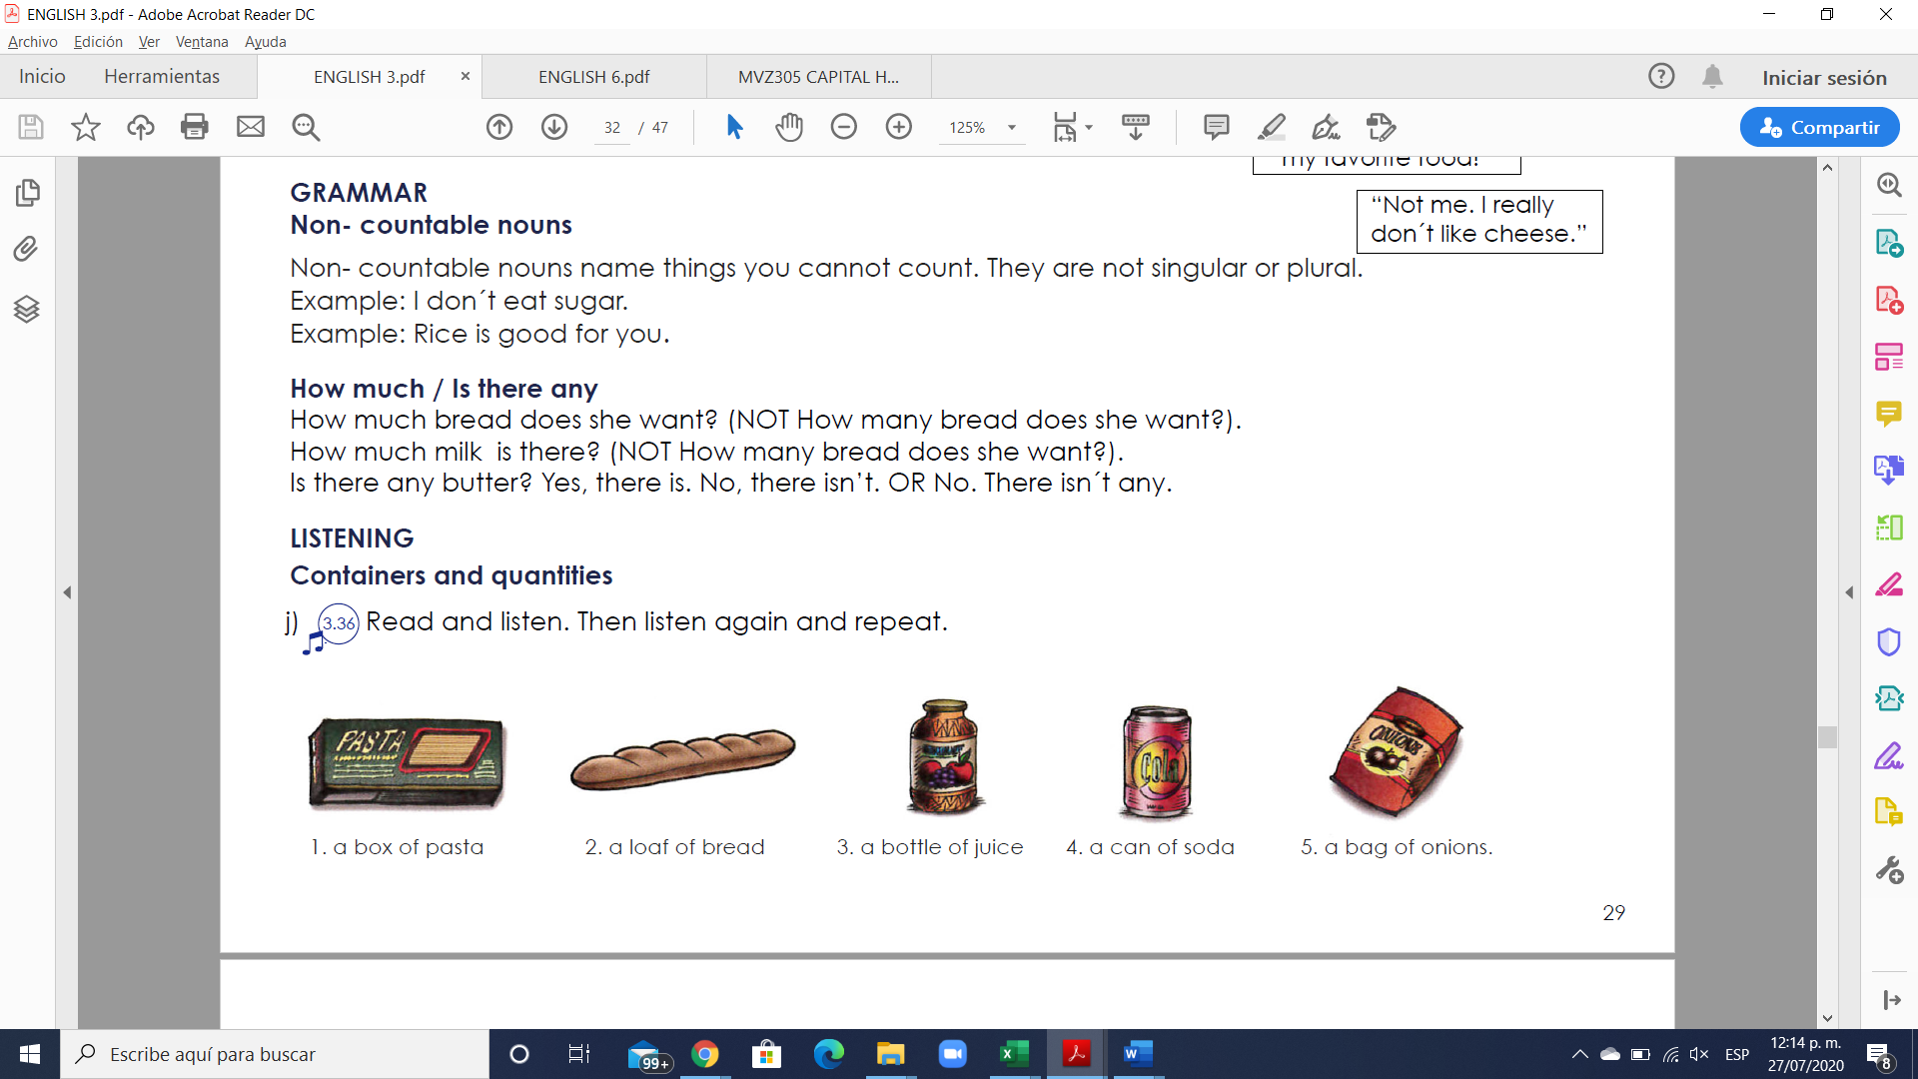

**How much** = Cuantos… ? (se usa solo para nombres incontables)

**Are there any** = Hay algunos…? (se usa solo para nombres incontables)

There is any + uncountable noun = Is there any + uncountable noun?

Example: “Is there any time to go shopping?”

**Exercise #10.** Write 6 sentences using How much / Is there any. Escribe 5 oraciones.

1.is there any letter in the mailbox?

2.how much soda there in the refrigerator?

3.is there any rat in the box’

4.how much caffe is there in the cup?

5. is there any homework missing?

6.how much butter is there in the refrigerator?

**Exercise #11.** Complete the questions with “how much” or “how many”.

1. __how much__ loaves of bread do you need?

2. __how many__ bags of potatoes do we have?

3. __how much__ cheese is there in the fridge?

4. __how much__ sugar do you want in your tea?

5. __how many__ eggs are there for the potato pancakes?

6. __how many__ cans of tomatoes are there on the shelf?

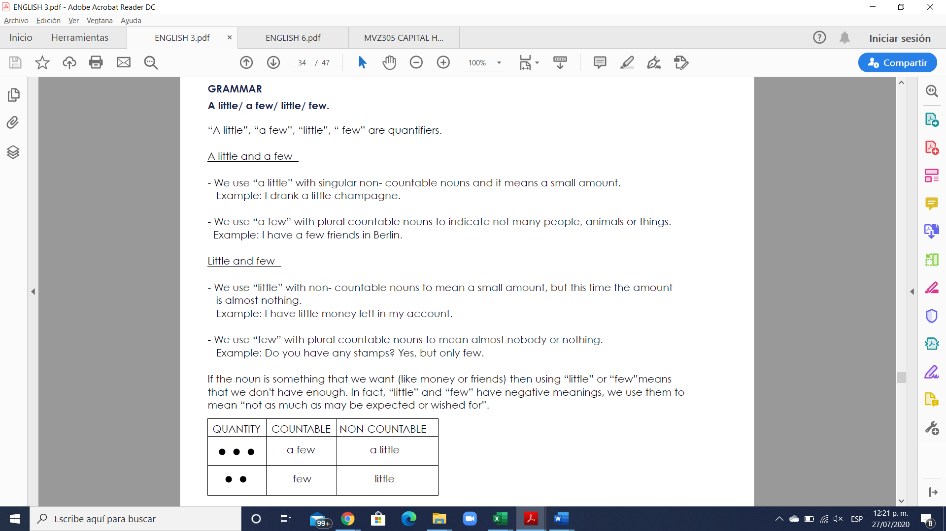

**Exercise #12.** Rewrite the sentences using few/ little.

1. We don`t have much bread left. ______We have a few bread__________________

2. The twins don’t eat many vegetables. ___littles ones don’t eat a lot of vegetables____

3. These students don’t ask many questions. ___these students ask few questions_____

4. They don’t have much opportunity to talk with him. have very few opportunities to drink he with

5. The guests aren’t drinking much wine with their meal. our guests drink very little wine their food____

6. Not many people come here. ___very few people come here_____

**Exercise #13.** Answer the questions using “a few”/ “a little.

1. Have you visited many churches? Only a few.

2. Does she make many mistakes in English? ___yes a few ________

3. Do you have many friends in your building? __very a few friends_

4. Do you have any money left? ___very little money______

5. Would you like something to eat? ___if I want to eat a little ___

6. Do you speak German? ___i speak very little____