

**Nombre de alumno:**

**Litzy Fernanda Domínguez León**

**Nombre del profesor:**

**Juan Manuel Jaime Díaz**



**Nombre del trabajo:**

**Unit Activity #1 - U2 3BEN**

**Materia: Ingles ll**

**Grado: 3er semestre**

**Grupo: BEN**

Comitán de Domínguez Chiapas a 04 de octubre de 2022.

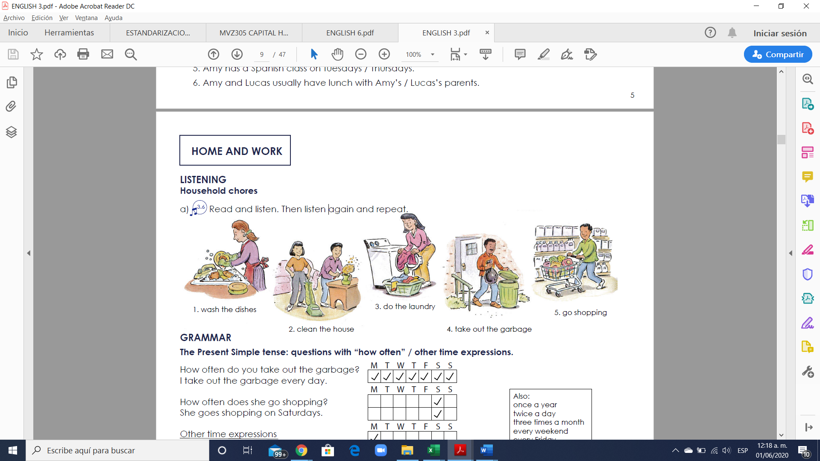

**VOCABULARY**



**Exercise 1.** Translate the vocabulary. (Traduce el vocabulario de la parte de arriba)

1. **Lavar los trastes**

2. **Limpiar la casa**

3. **Lavar la ropa**

4. **Sacar la basura**

5. **Ir de compras**

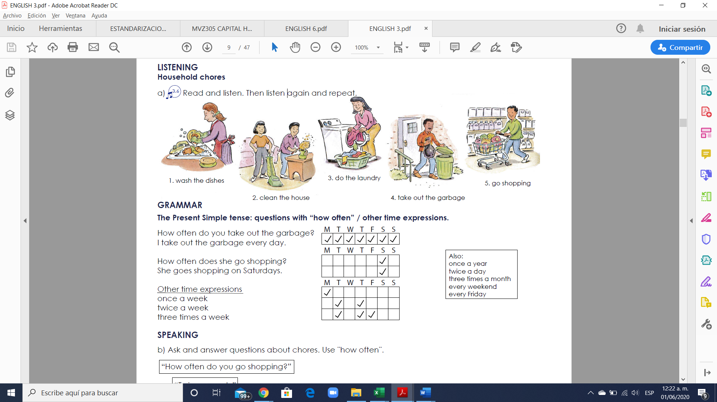

**Exercise 2.** Write 5 questions using questions with “how often” in present simple (Escribir 5 oraciones usando las preguntas “how often” en presente simple usando el vocabulario debajo)



Example: How often do you travel to Tuxtla?

**1. How often do you wash the dishes?**

**2.** **How often do you clean the house?**

**3.** **How often do you the laundry?**

**4.How often do you take out the garbage?**

**5.** **How often do you go shopping?**

**Exercise 3.** Answer your questions using the time expressions (once a year, twice a day, three times a month, every weekend, every Friday, once a week, twice a week, three times a week). Contesta las preguntas que tu elaboraste usando las expresiones de tiempo.

**Answers**

**1. I wash the dishes twice a day**

**2. I clean the house twice a week**

**3. I do the laundry once a week**

**4. I go shopping twice a week**

**5. I take out the garbage once a week**

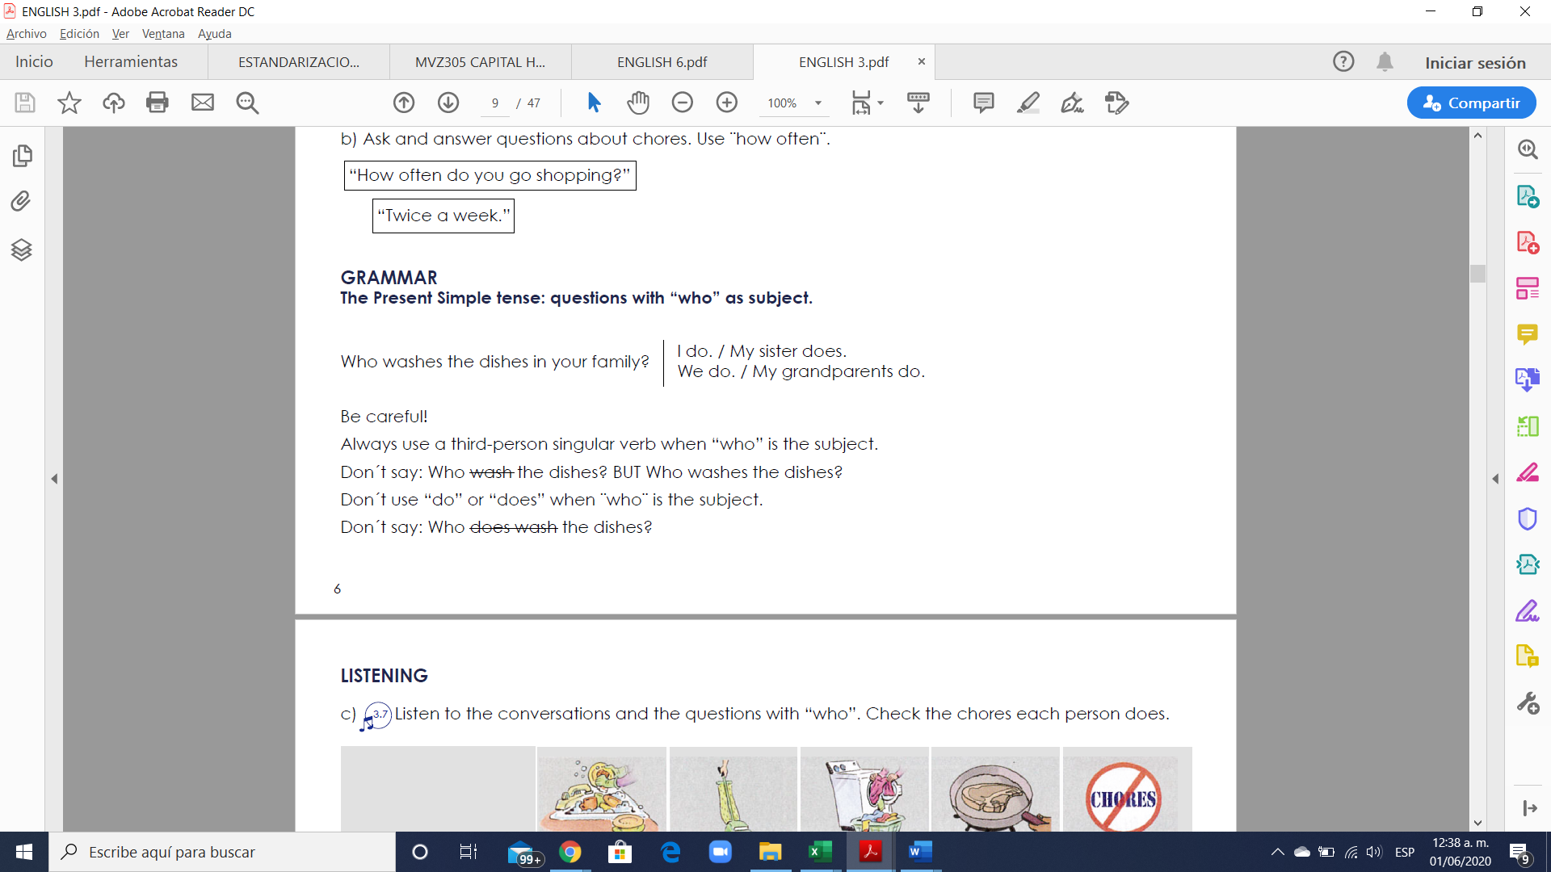

**Exercise 4.** Write 5 questions using questions with “who” in present simple (Escribir 5 oraciones usando las preguntas “who” en presente simple usando el vocabulario anterior)

**Example:** Who travels to Tuxtla every weekend?

**1. Who wash the dishes in your house?**

**2. Who goes shopping in your house?**

**3. Who does do the laundry in your house?**

**4. Who does wash the dishes in your house?**

**5. Who does take out the garbage in your house?**

**HOME AND NEIGHBORHOOD**

**VOCABULARY - Buildings**

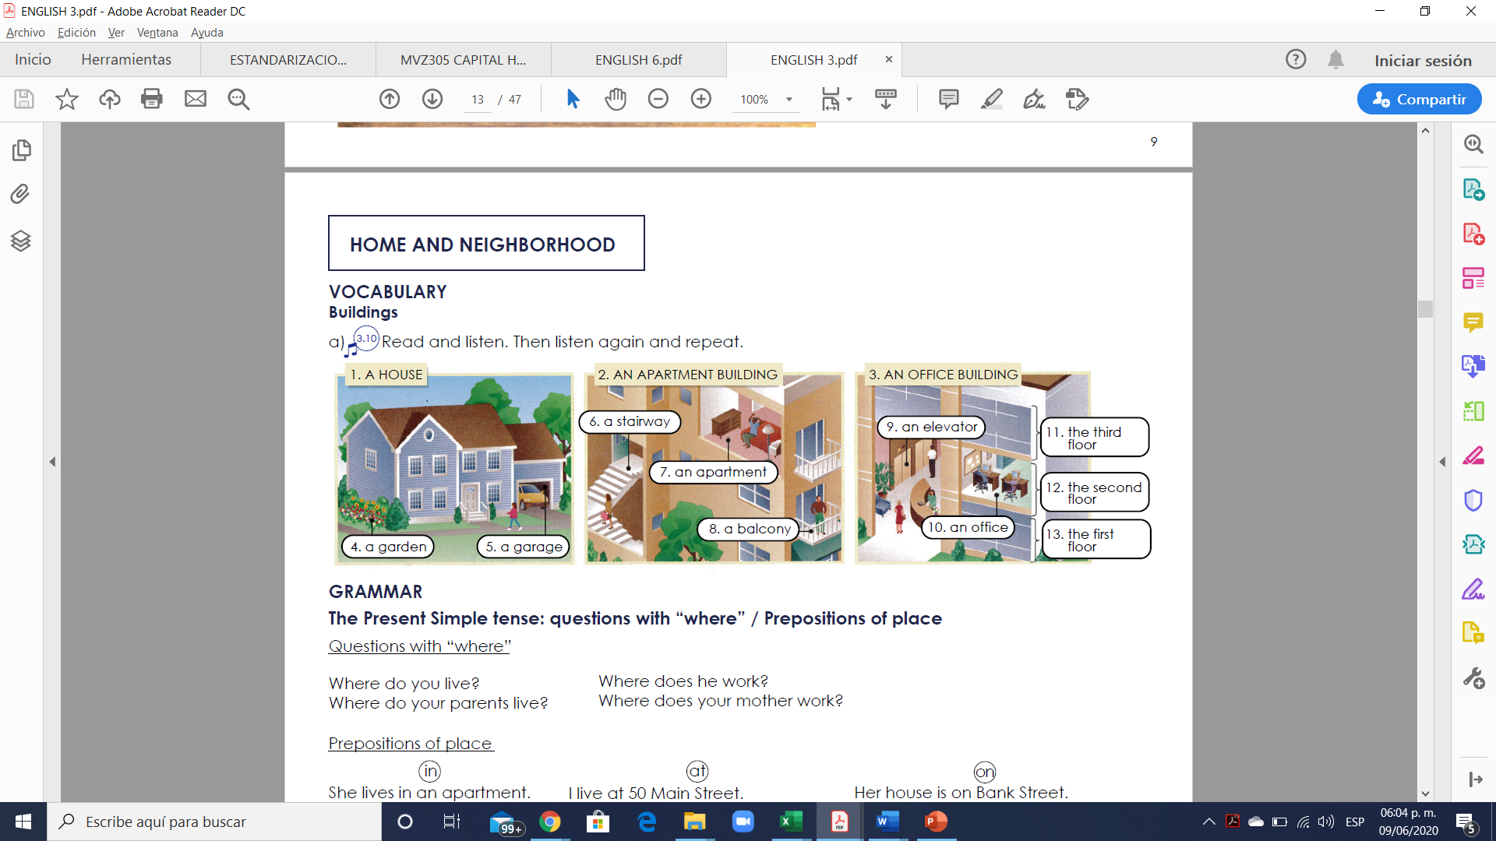

**Exercise 1.** Translate the vocabulary. (Traduce el vocabulario de la parte de arriba)

**8. Un balcón**

**9. Un elevador**

**10. Una oficina**

**11. El tercer piso**

**12. El segundo piso**

**13. El primer piso**

**1. Una casa**

**2. Un edificio de apartamentos**

**3. Un edificio de oficinas**

**4. Un jardín**

**5. Un garaje**

**6. Una escalera**

**7. Un apartamento**

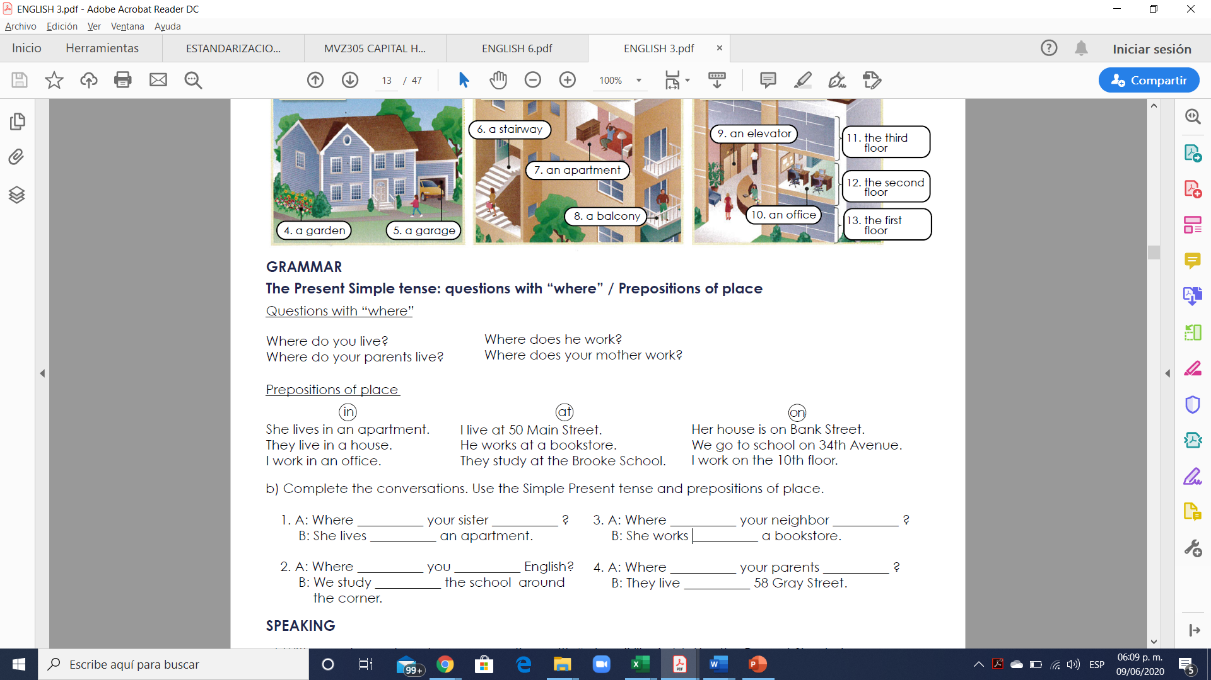

**A preposition of place** is a word which helps to describe where something or somebody is. A preposition of place describes the location of something.

There are many prepositions of place in the English language and each of them has several uses.

In this lesson, we will study 3 prepositions of place:

at

in

on

**at**

**Specific point or place**

We can use “at” to describe a very specific point or place.

Examples:

“There is a dog at the top of the steps.”

"She's waiting at the entrance."

"He's sitting on his chair at his desk."

"I work at a bank."

**in**

**Enclosed space / a large place with boundaries**

We use the preposition “in” for an enclosed space (surround or closed off on all sides). Basically, when something is inside something.

Examples:

“The dog is in the garden.”

“The apple is in a box.”

“The students are in a classroom”.

“That people live in China”.

**on**

**For a surface**

The preposition “on” is often used to describe a surface.

Examples:

“There’s a clock on the wall.”

“The apple is on the table.”

“That cat is on the floor.”

“My book is on the chair.”

**Exercise 2.** Complete the conversations. Use the Simple Present tense and prepositions of place

1. A: Where **does** your sister **on**?

B: She lives **in** an apartment.

2. A: Where **do** you **in** English?

B: We study **at** the school around the corner.

3. A: Where **do** your neighbor **in**?

B: She works **at** a bookstore.

4. A: Where **do** your parents **on**?

B: They live **at** 58 Gray Street.

**Exercise 3.** Write 6 questions with “where” and answer the questions using the Present Simple tense and the vocabulary below.

Escribe 6 preguntas con sus repuestas usando “Where” y el vocabulario debajo.

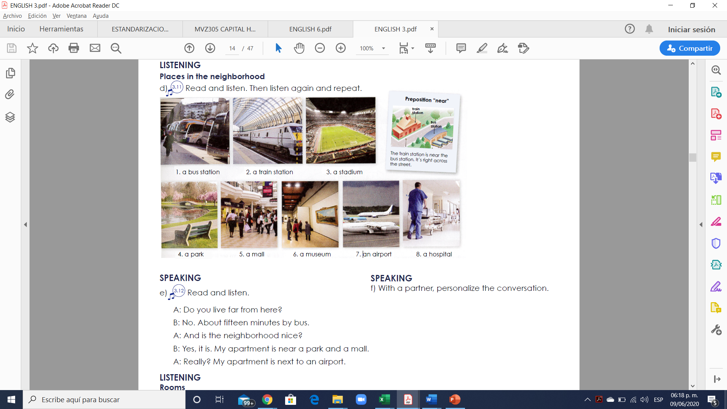

**1. It is two blocks away**

**2. It is next to the park**

**3. It is next to the train station**

**4. The taqueria is three blocks from the park**

**5. The airport is leaving the city**

**6. The hospital is across the central avenue**

**1. Where is there a bus station?**

**2. Where is there a train station?**

**3. Where is there a park?**

**4. Where is there a museum?**

**5. Where is there an airport?**

**6. Where is there a hospital?**

**Exercise 4.** Write 6 sentences using **the preposition of place** “in” “on” “at” using the present simple (Escribir 6 oraciones usando las prepositions de Lugar “in” “on” “at” en presente simple)

**1. He lives in a big apartment**

**2. They live in a house near the center**

**3. She Works at a bookstore**

**4. They study at the brooked school**

**5. We go to school on 40th avenue**

**6. I work on the 10th floor**