

**Nombre de alumno: ADRIANA GUADALUPE VAZQUEZ HERNANDEZ**

**Nombre del profesor: JUAN JAIME**



**Nombre del trabajo: Unit Activity #1 - Unit 2**

**Materia: INGLES**

**Grado: 1**

**Grupo: B**

Comitán de Domínguez Chiapas a 10 de Octubre de 2022.

**Grammar - Prepositions of Place**

**Prepositions of place are used to show where something is located and they are always found after the principal verb**, regardless of the verb tense. These prepositions are **most often used with the verb “to be”.**

**Next to (beside)**

**Meaning:** adjacent or by the side of.

**Use:** “Next to” and “beside” can be used interchangeably as the meaning is the same. The use of one over the other depends on the speaker and the context.

**Examples:**

The supermarket is next to the bank or the supermarket is beside the bank

Sit next to me or Sit beside me.

**By**

**Meaning:** in proximity to, near.

**Use:** “by” may be used in the same contexts as “Next to” or “beside”, but the meaning is closer to “near” rather than directly adjacent.

**Examples:**

I sit by the window.

Our house is by the river.

**BETWEEN**

**Meaning:** in the time or space that separates.

**Examples:**

The shop is between the bank and the train station.

She is standing between Peter and John.

**BEHIND**

**Meaning:** in back of, to the rear of.

**Examples:**

The church is behind the school.

He is standing behind you.

**IN FRONT OF**

**Meaning:** the opposite of behind.

**Examples:**

The hotel is in front of the station. Laura is standing in front of you.

**UNDER**

**Meaning:** below or beneath, implying the object is covered by something.

**Examples:**

The ball is under the chair.

The dog is under the tree.

**IN**

**Use (place):** “In” is used to indicate both open and closed spaces. We use this preposition to indicate that something is included within the limits of something, a closed space or the interior of something in a physical sense. As we can see from the following examples “in” can also be used to indicate the geographical location of something.

**Examples:**

The cat is in the box.

I found your address in the phone book.

**Use (time):** is used with months, years, periods of time, seasons and parts of the day.

**Examples:**

I always run in the mornings.

I will see him in a week.

She was born in 1976.

**AT**

**Use (place):** “**At”** is used in front of buildings such as “home”, “the airport”, “university”. It is also used before **”to”, “bottom”, and “the end of”** as well as to indicate events such as meetings, parties, concerts, sports events, etc. **“At”** is also used after the verb **“arrive”** when we are referring to places other than cities or countries.

**Examples:**

He is at home.

I always visit my sister at work

She will see him at the theatre

**Use (time):** We used “At” before the hour or holidays.

**Examples:**

He runs every morning at 6.

I will see them at Christmas.

**ON**

**Use (place):** “On” is used with surfaces, when we are referencing a location within a room, such as the ceiling or the wall, or to indicate that someone is inside a mode of transport or on the floor of a building.

**Examples:**

The pen is on the table.

They have a photograph of Paris on the wall

I am on the bus.

**Use (time): ”ON”** is used with days of the week, dates and holidays.

**Examples:**

They went to Mexico on the first of May.

He runs on Mondays and Fridays.

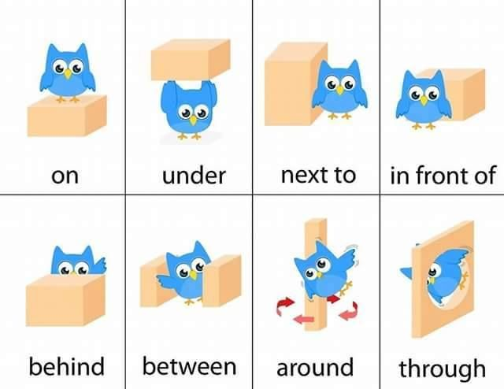

**Encontraras la gramática en español en los siguientes links:**

[**https://www.curso-ingles.com/aprender/cursos/nivel-basico/prepositions/prepositions**](https://www.curso-ingles.com/aprender/cursos/nivel-basico/prepositions/prepositions)

[**https://www.curso-ingles.com/aprender/cursos/nivel-basico/prepositions/prepositions-of-place**](https://www.curso-ingles.com/aprender/cursos/nivel-basico/prepositions/prepositions-of-place)

**Exercise 1**. Complete these sentences – Completa las siguientes oraciones, revisa el ejemplo.

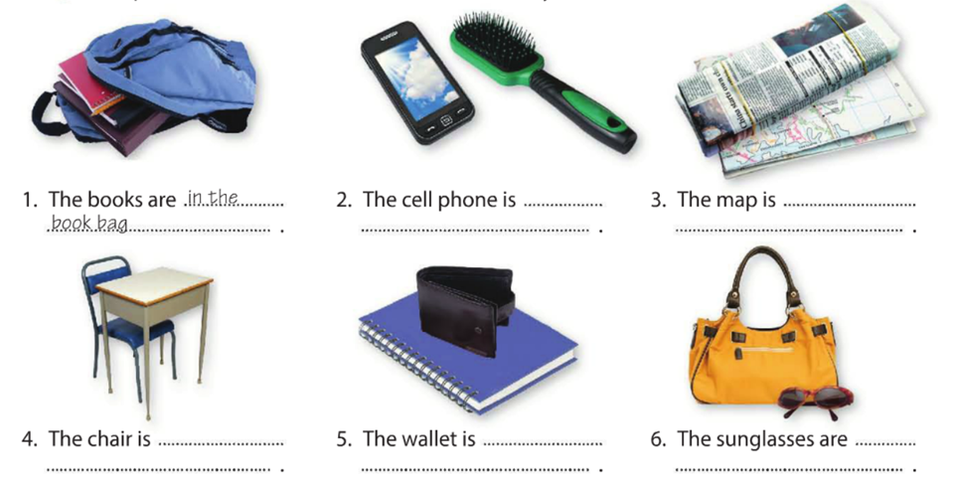

1. The books are in the book bag
2. The cell phone is NEXT TO THE BRUSH
3. The map is UNDER THE NEWS POPER
4. The chair is UNDER THE TABLE
5. The wallet is ON THE NOTE BOOK
6. The sunglasses are IN FRONT OF THE PURSE

**Exercise 2**. Complete these sentences – Completa las siguientes oraciones, revisa el ejemplo.

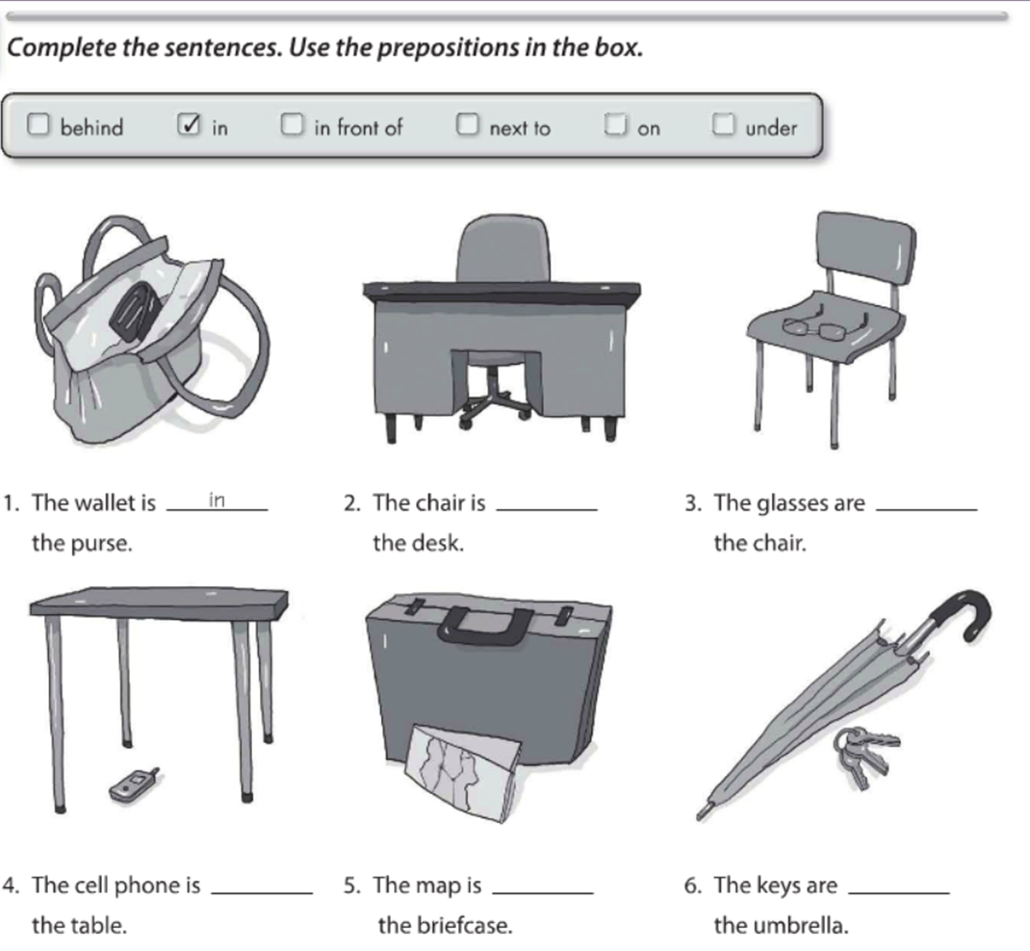

**resp**

**in**

**resp**

**resp**

**resp**

**resp**

BETWEEN

ON

UNDER

IN FRONT OF

NEXT TO

**Exercise 3**. Write questions and answers about the things in the parentheses – escribe preguntas y sus respuestas acerca de las cosas en parentesis.

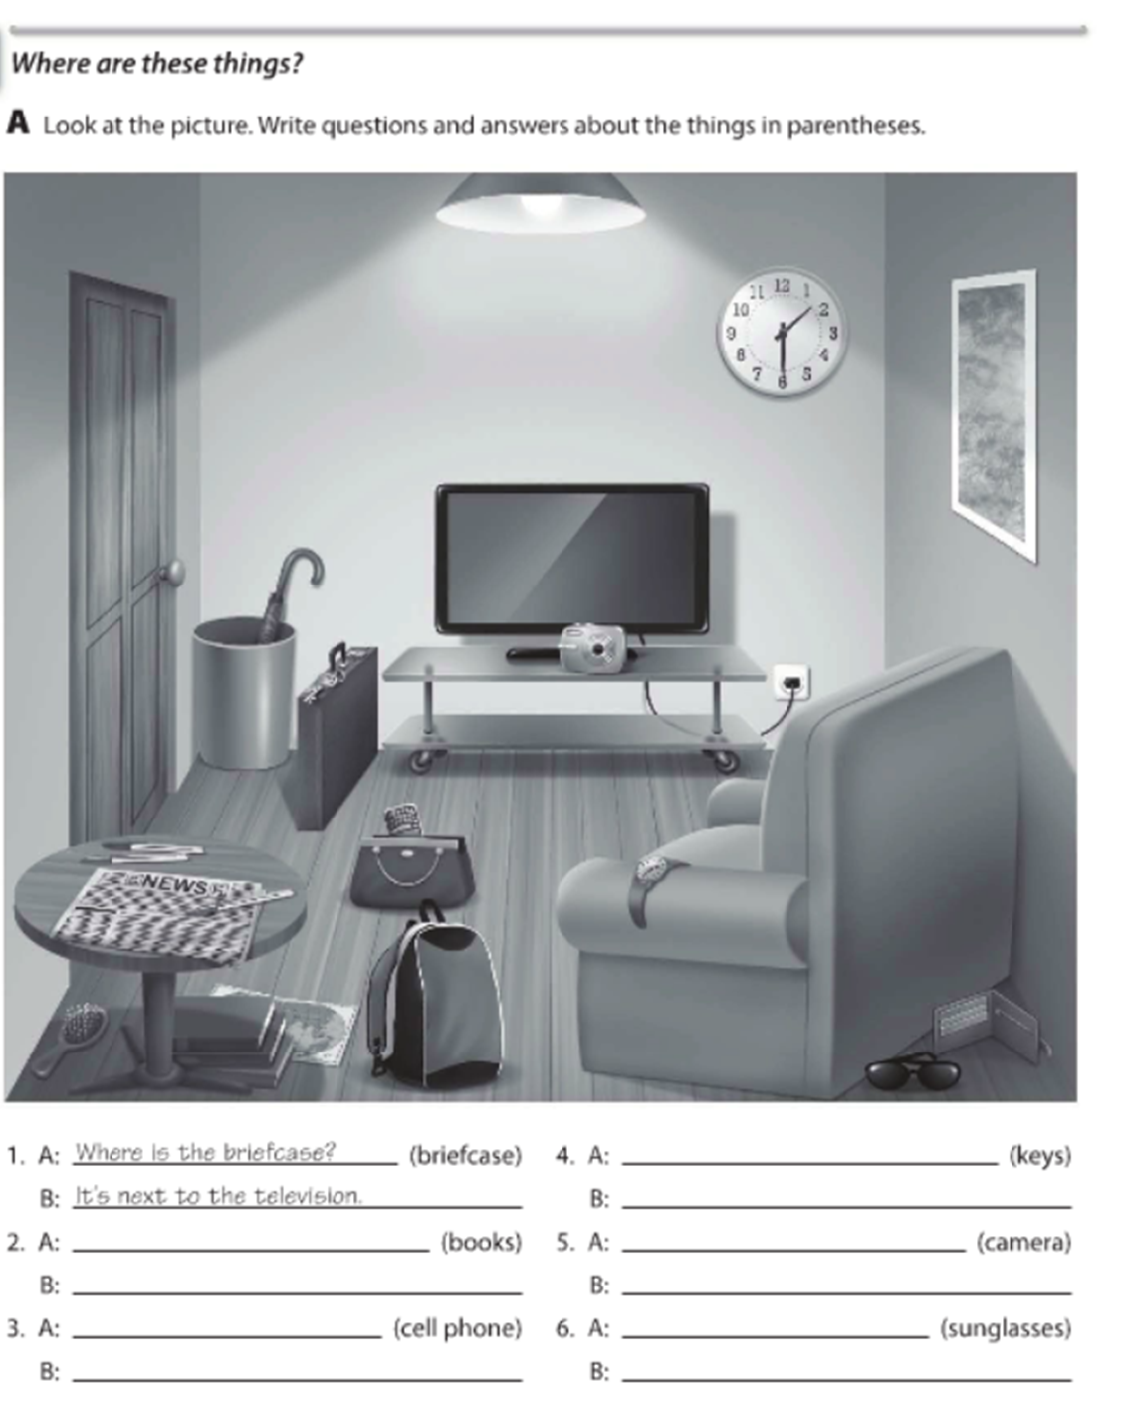

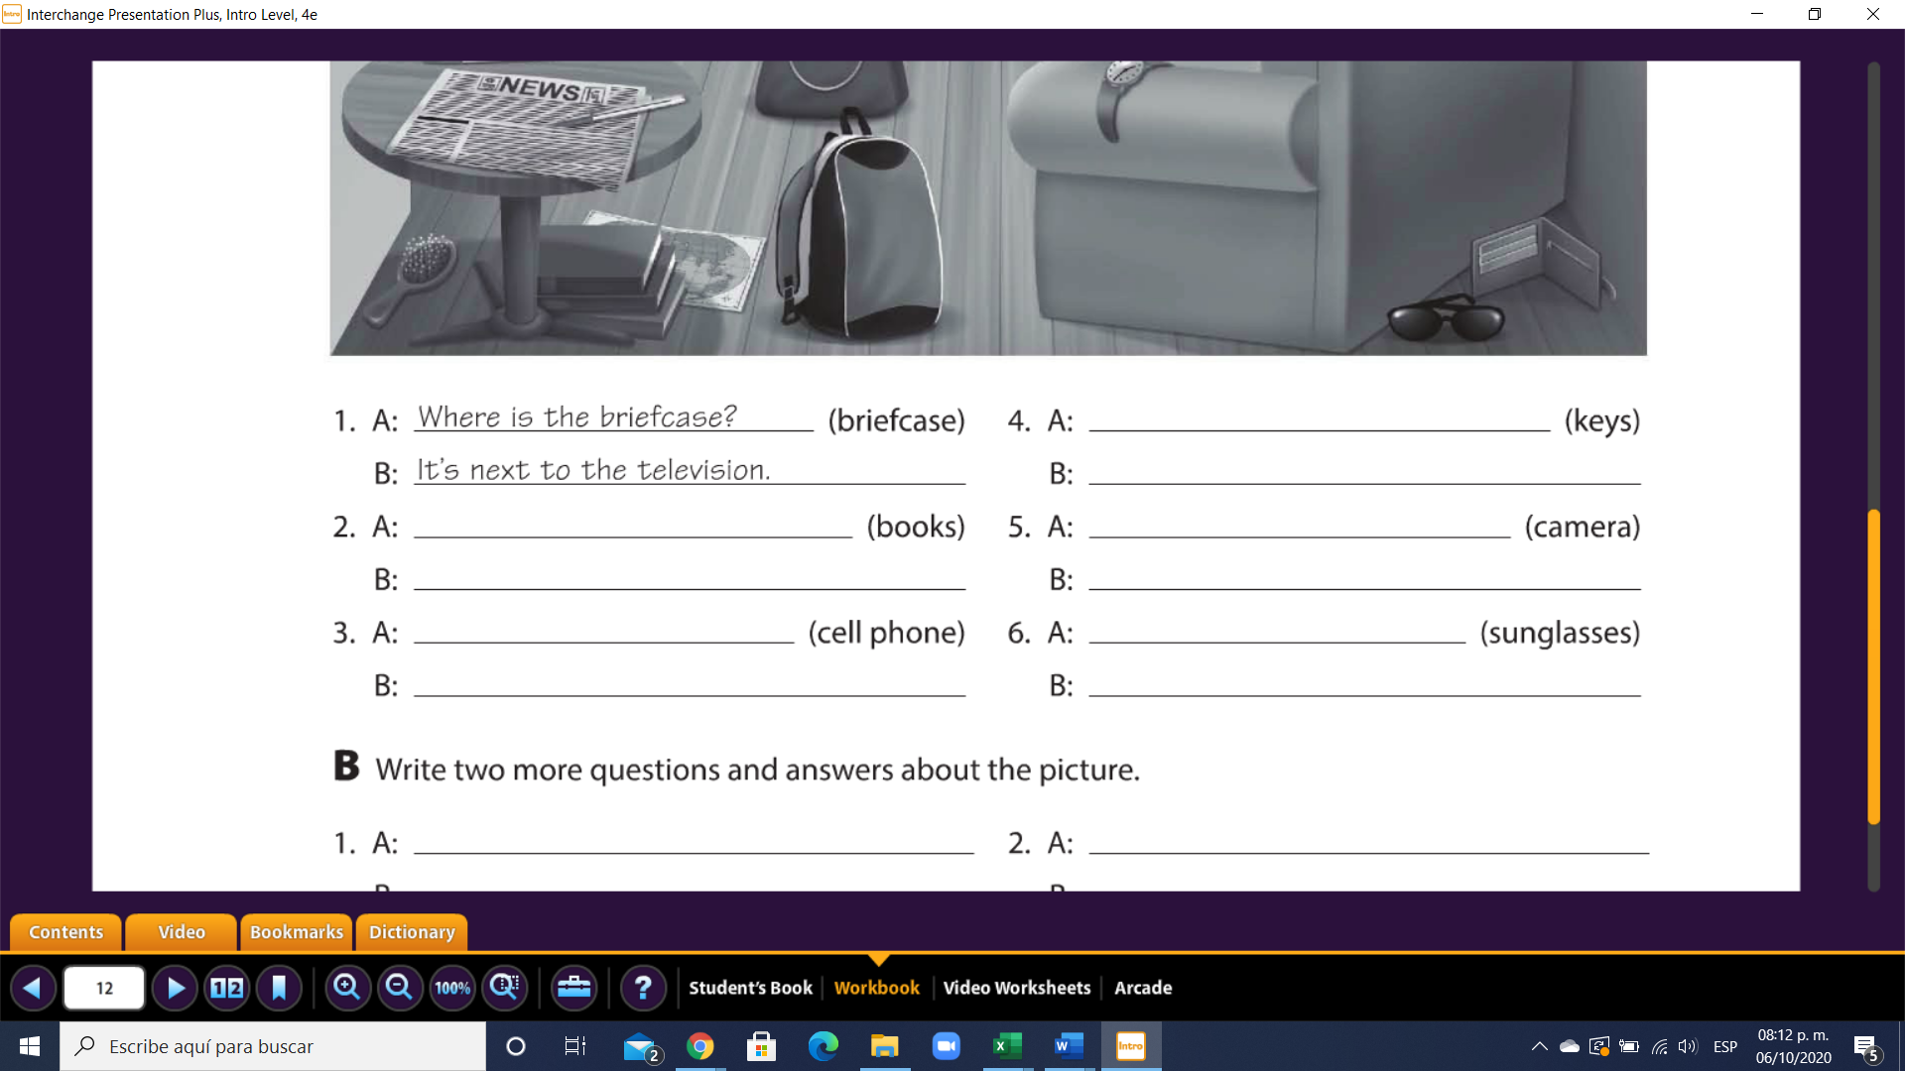

**ans**

**ans**

**ans**

**ans**

**ans**

**ans**

**ans**

**ans**

**ans**

**ans**

**GRAMMAR – Negative statements and yes/no questions with be**

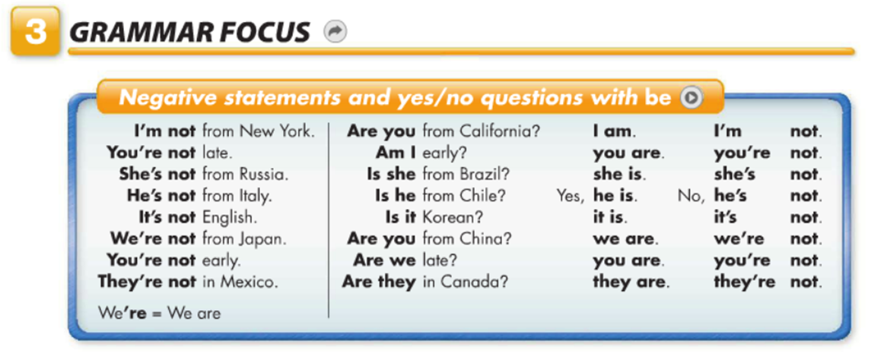

**Exercise 4**. Complete the convertation – completa la siguiente conversaciòn.

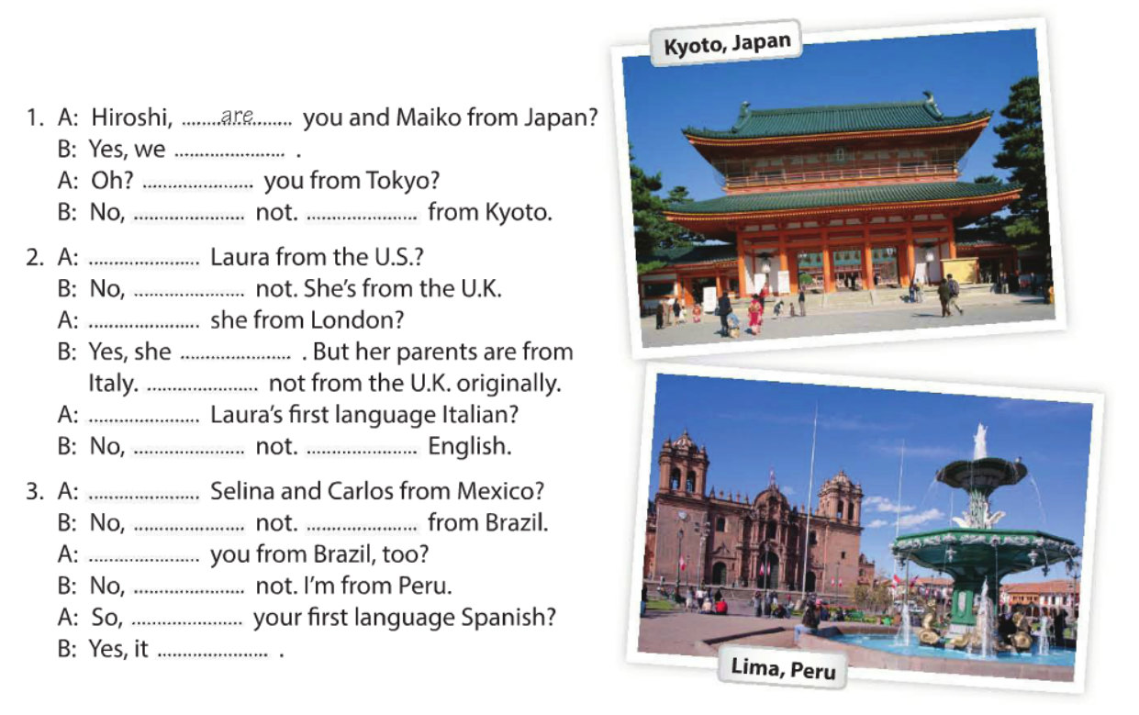

**resp**

**resp**

**resp**

**resp**

**resp**

**resp**

**resp**

**resp**

**resp**

**resp**

**resp**

**resp**

**resp**

**resp**

**resp**

**resp**

**resp**

**resp**

**are**

**are**

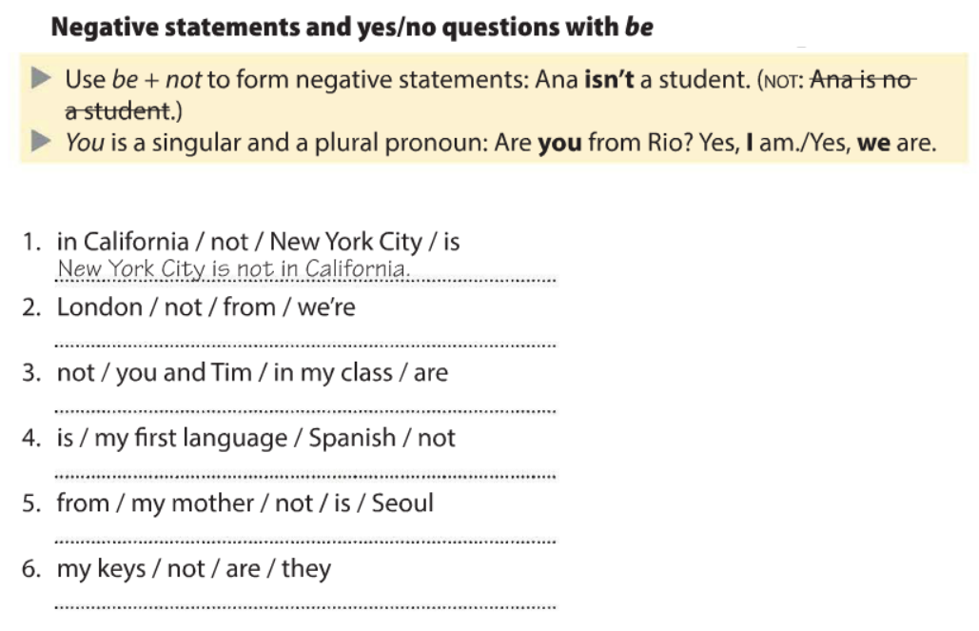

**Exercise 5**. Ordena las siguientes oraciones.



**resp**

**resp**

**resp**

**resp**

**resp**

**Exercise 6**. Ordena las siguientes oraciones.

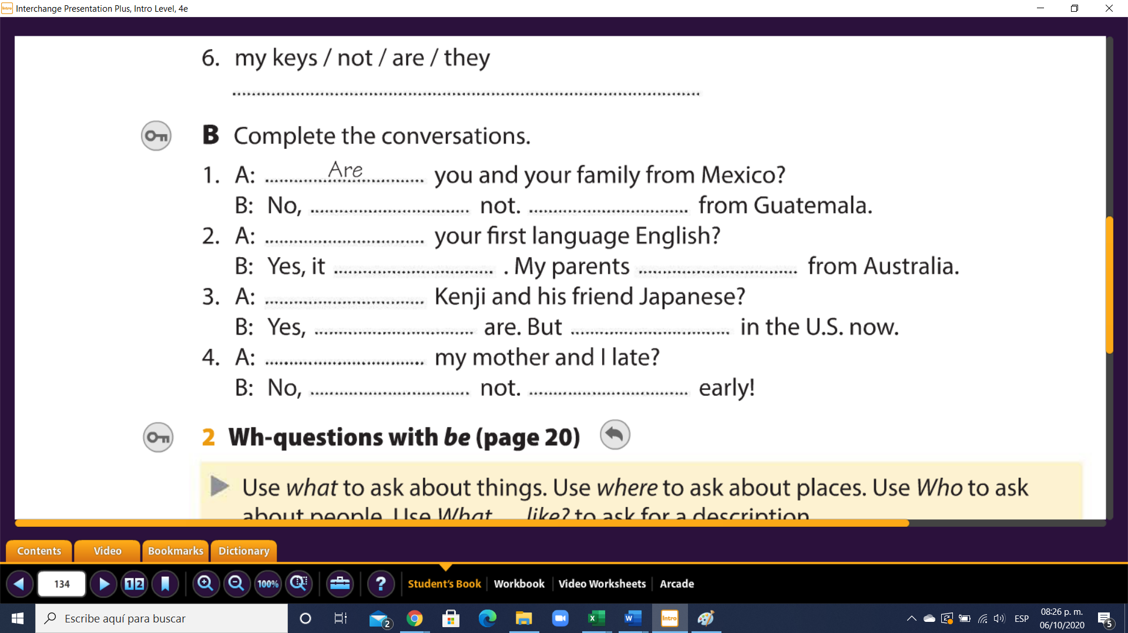

**resp**

**resp**

**resp**

**resp**

**resp**

**resp**

**resp**

**resp**

**resp**

**resp**

**resp**