

**Nombre de alumno: Marely Concepción Jiménez Gordillo**

**Nombre del profesor: Juan Manuel Jaime**



**Nombre del trabajo: Unit Activity#1 – U3 1BEN**

**Materia: English**

**Grado: 1**

**Grupo: A**

Comitán de Domínguez Chiapas a 07 de Noviembre de 2022.

**TOPIC 3: WHERE ARE THEY?**

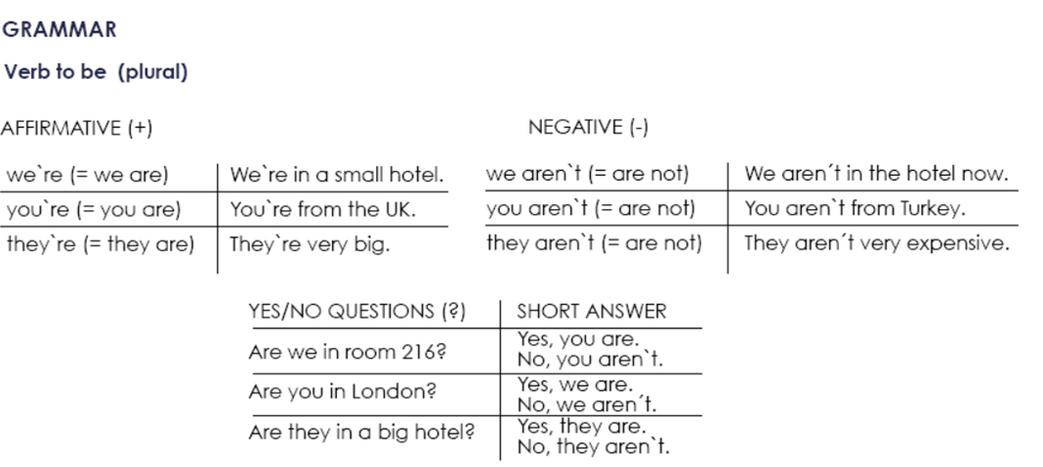

**Exercise 1.** Write the contractions: I`m, we`re, aren`t, etc.

1. We aren`t from Italy, we're from Spain.

2. It's a new hotel, but It isn’t very nice.

3. He's a doctor and he is married.

4. You are Australian, I’m American.

5. They’re a manager and aren't a musician.

**Exercise 2.** Complete each statement with a singular or plural form of “be”.

1. I am a writer.

2. She is not a pilot.

3. We are doctors.

4. They are not scientists.

5. We are managers.

6. He is a singer.

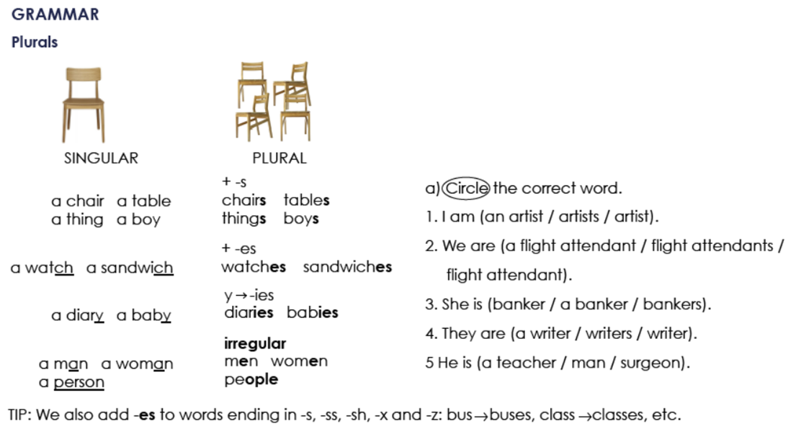

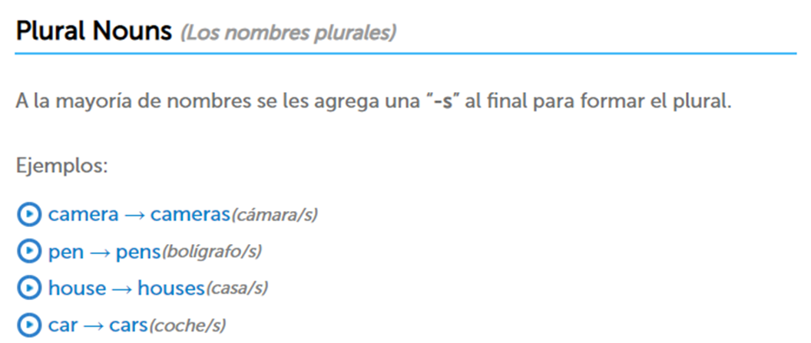

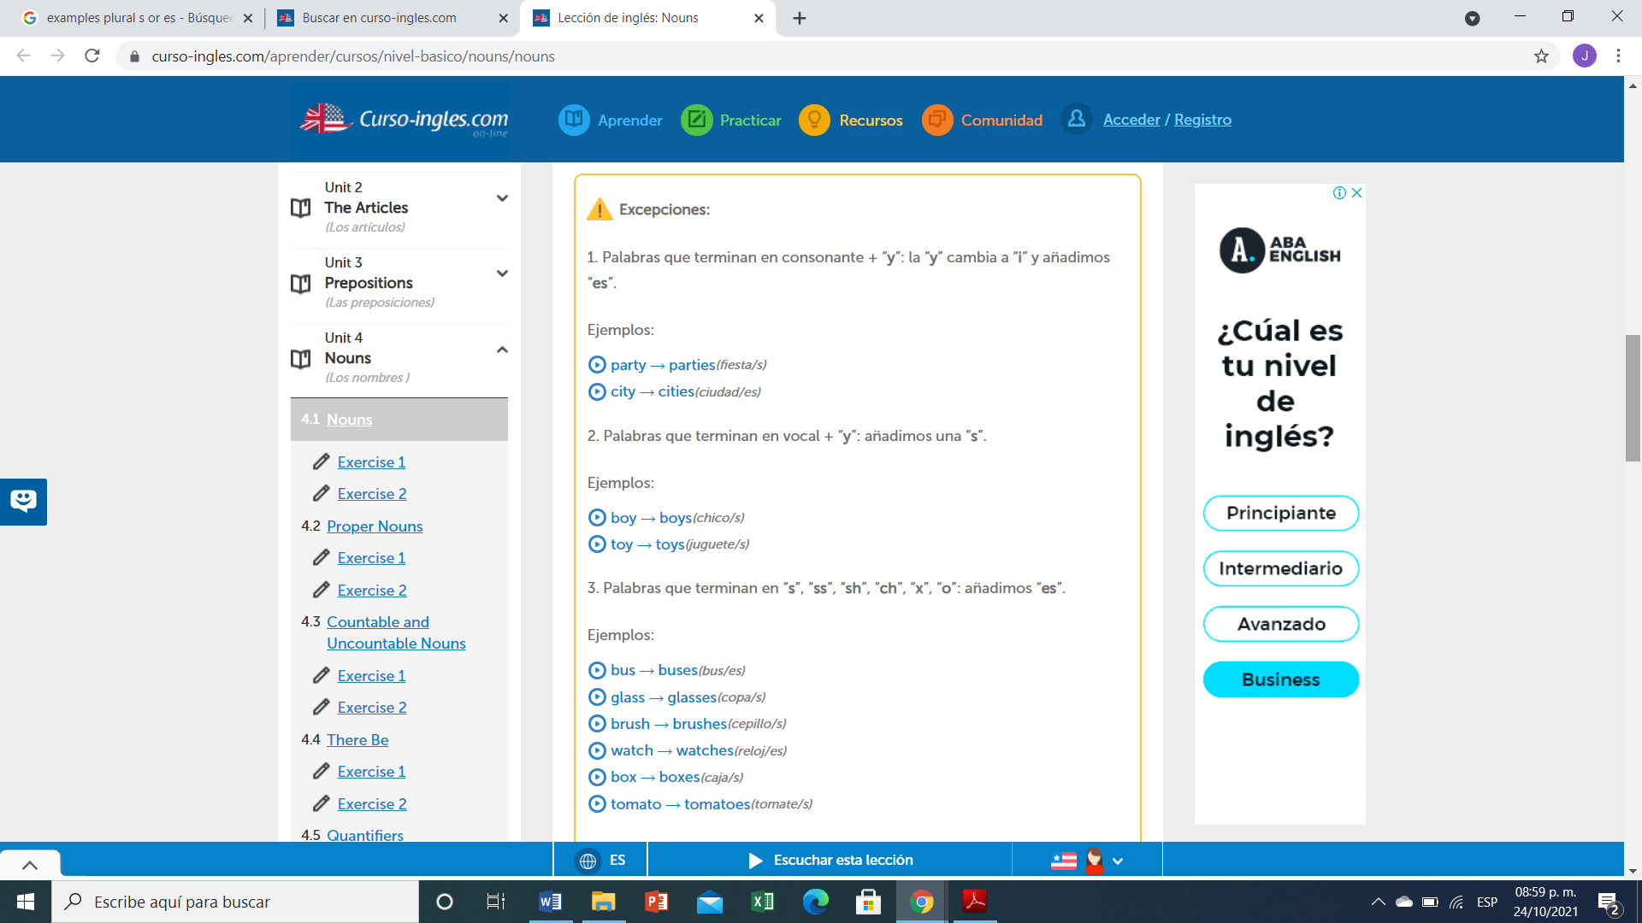

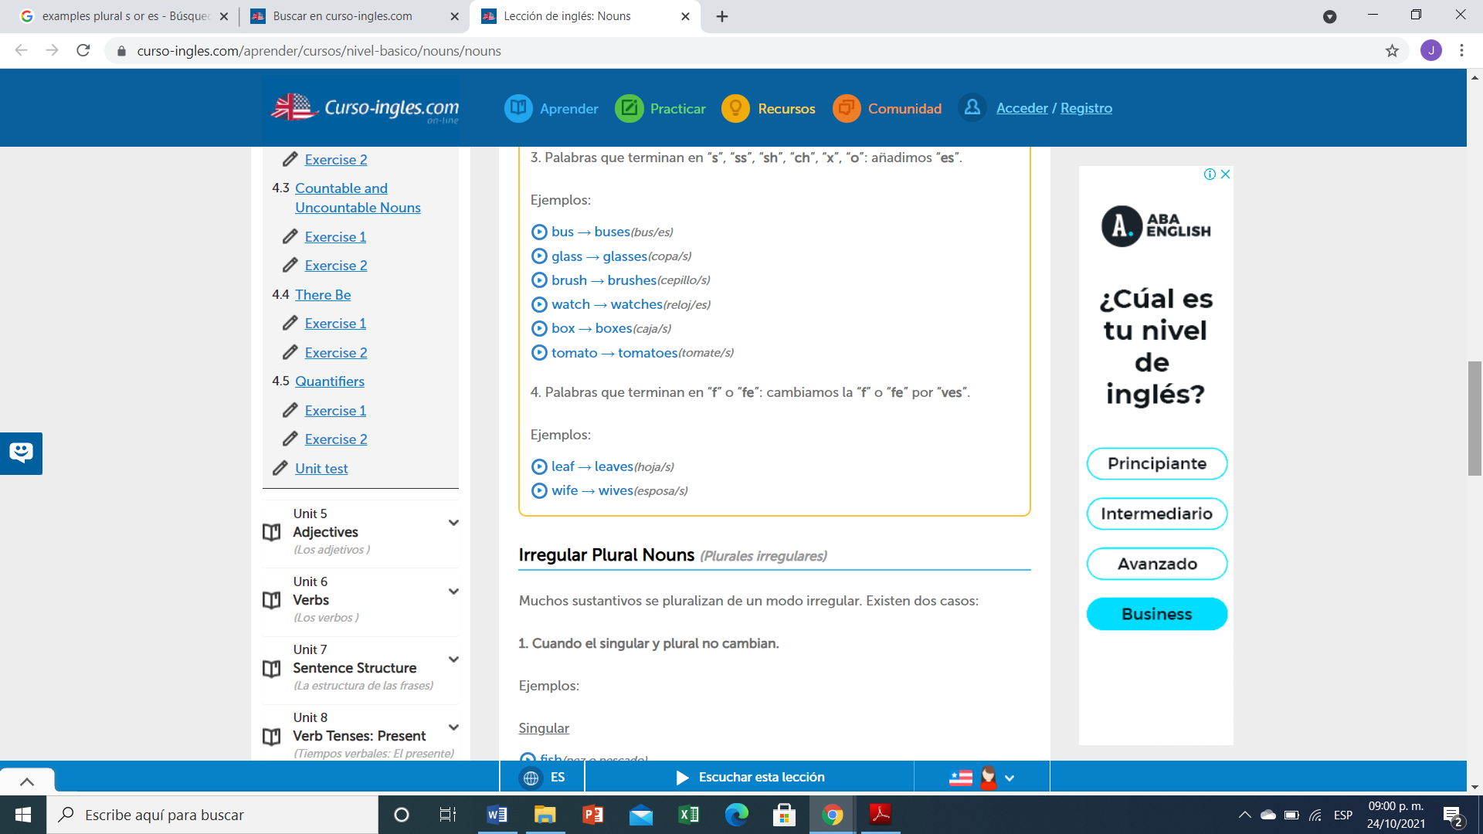

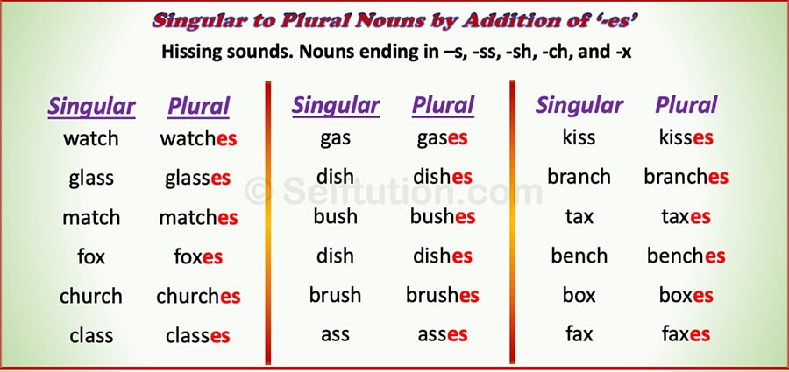

**Exercise 3.** Write the plural of:

1. Baby Babies
2. Cake Cakes
3. Church Churchs
4. Glass Glasses
5. Wife Wifes
6. Fish Fishes
7. Month Months
8. Child Children
9. Wish Wishes
10. Woman Womans
11. City Cities
12. Man Men
13. Box Boxes
14. Foot Footes
15. Mouse Mouses
16. Leaf Leaves
17. Sheep Sheeps
18. Tomato Tomatoes

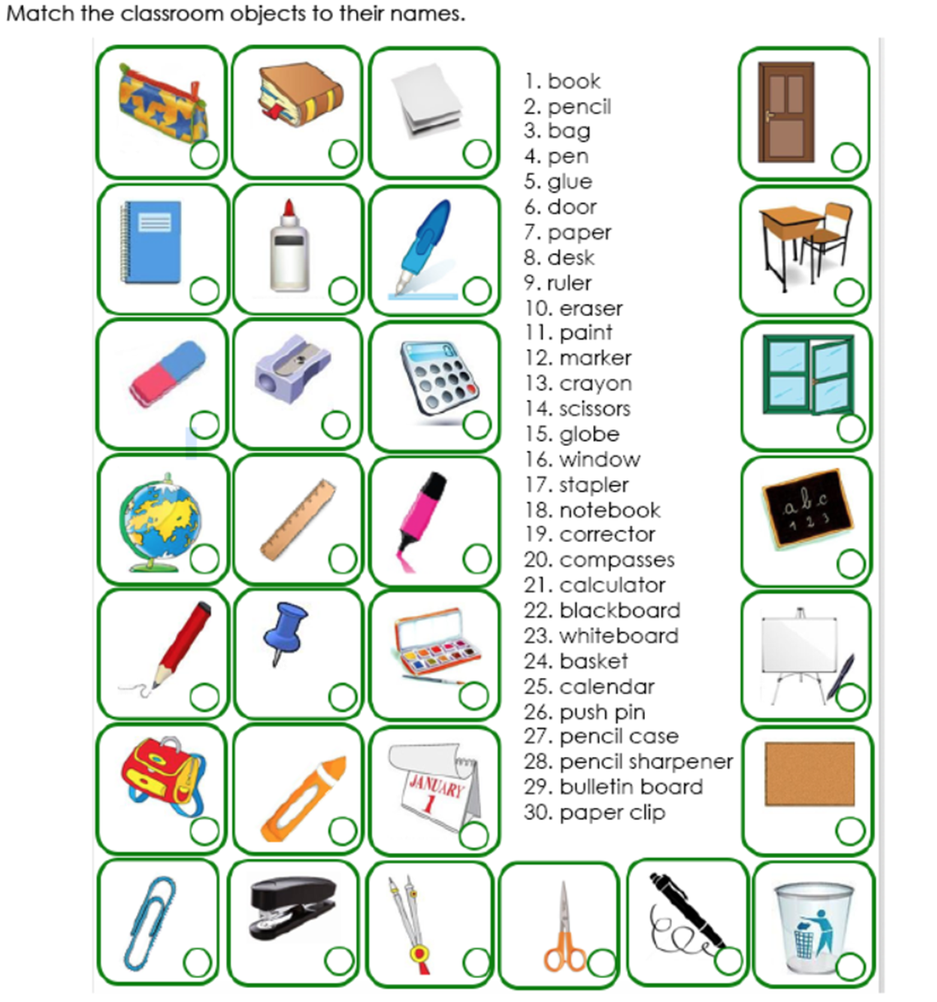

**1**

**1.Libro. 2.Lapiz. 3.Mochila. 4.Pluma. 5.Pegamento. 6.Puerta. 7.Papel. 8.Escritorio. 9.Regla. 10.Borrador. 11.Pinturas. 12.Marcador. 13.Crayon. 14.Tijeras. 15.Globo terráqueo. 16.Ventana. 17.Engrapadora. 18.Libreta. 19.Corrector. 20.Compas. 21.Calculadora. 22.Pizarron negro. 23.Pizarron blanco. 24.Cesto. 25.Calendario. 26.Tachuela. 27.Lapicera. 28.Zacapuntas. 29.Tabla de anuncios. 30.Clip**

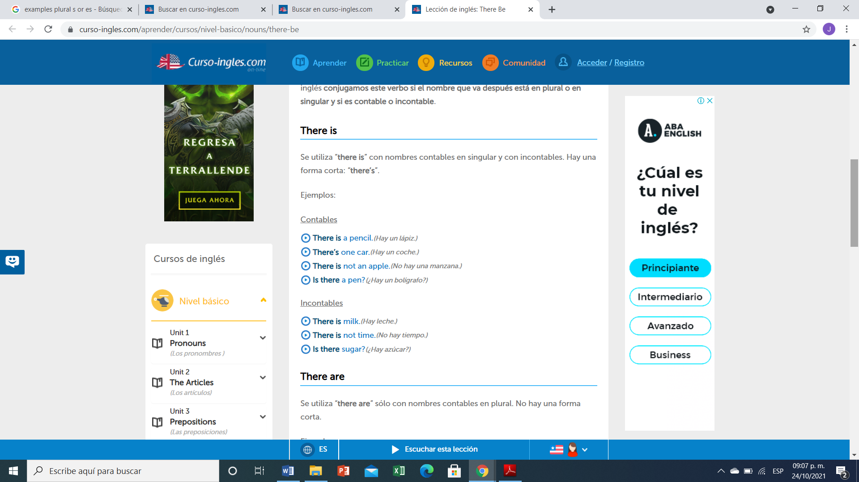

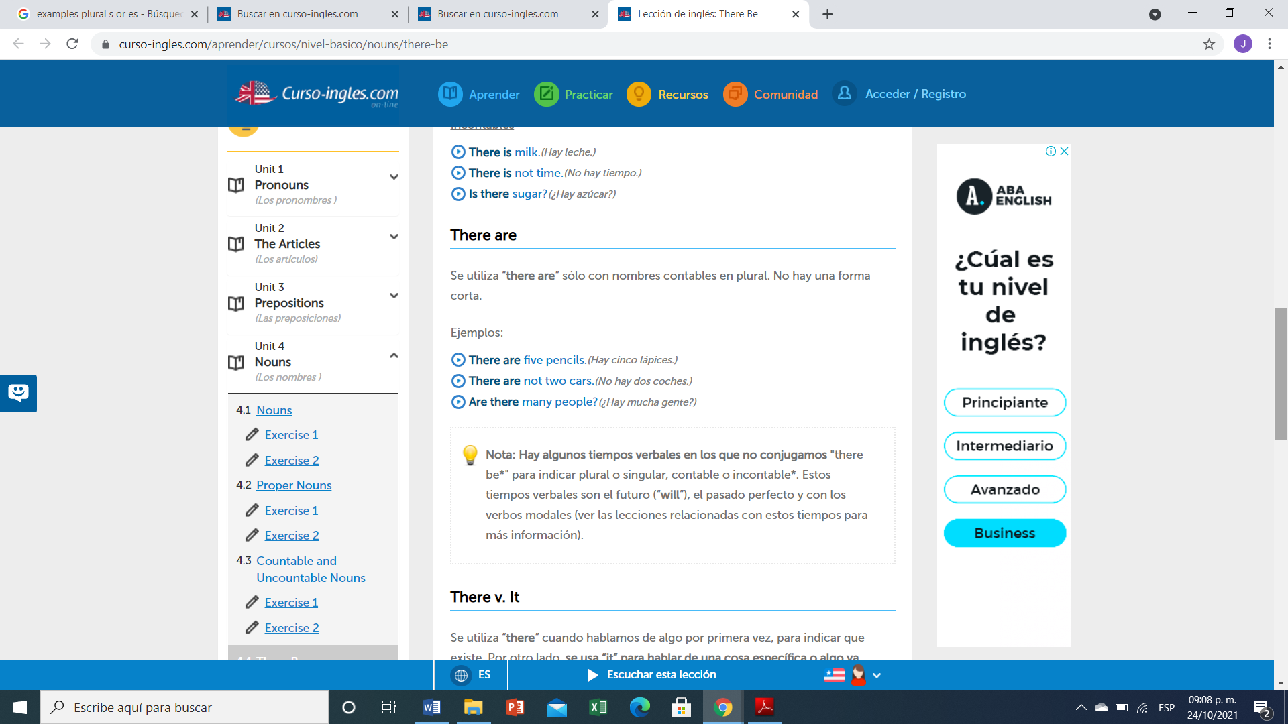

**Ejercicio #4 -** Completa las siguientes frases con la forma correcta de "there is or There are".

1. There are 5 apples in the bowl.
2. There is any water?
3. There isn't (not) any sugar in the coffee.
4. There aren't (not) any tomatoes in the salad.
5. There are some wine in the glass.
6. Is there any money in your wallet?
7. There are a problem with this phone.
8. Are there any vegetables in this recipe?

**Ejercicio #5 -** Escribe las palabras en el orden correcto.

many / aren’t / this / pages / there / in

R: there aren’t In this pages many

any / eggs / there / the / in / are / fridge / ?

R: there are any eggs In the fridge?

is / nearby / restaurant / nice / there / a

R: there is nearby a nice restaurant

dining / are / chairs / in / room / there / three / the

R: there are three chairs In The domingo room

hospital / there / this / isn't / a / in / town

R: there isn’t a hospital In this town

here / is / bank / there / a / near / ?

R: there is a bank near Here?

**TOPIC 4: PERSONAL INFORMATION**

**Exercise 1.** Contesta las siguientes preguntas.

1. What`s your first name?

A: my first Name is Marely

2. What`s your surname or last name?

A: my last Name is Jiménez

3. What`s your nationality?

A: I am mexican

4. What`s your address?

A: Av. Central north #137 neighborhood of the big cross

5. What`s your mobile number?

A: My number is 9631222515

6. What`s your mail address?.

A: my mail is marelyconcepcionjimenezgordill@gmail.com

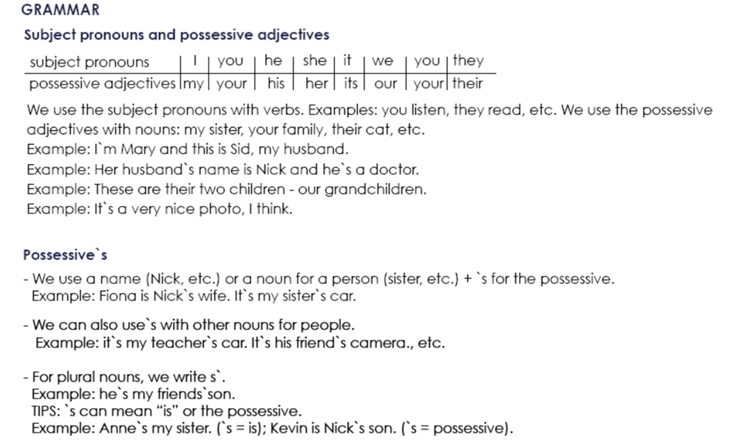

**Possessive Adjectives - Adjetivos Posesivos**

Se utilizan para indicar a quién pertenece el sujeto u objeto de la oración. Van seguidos de un sustantivo (o una cláusula nominal).

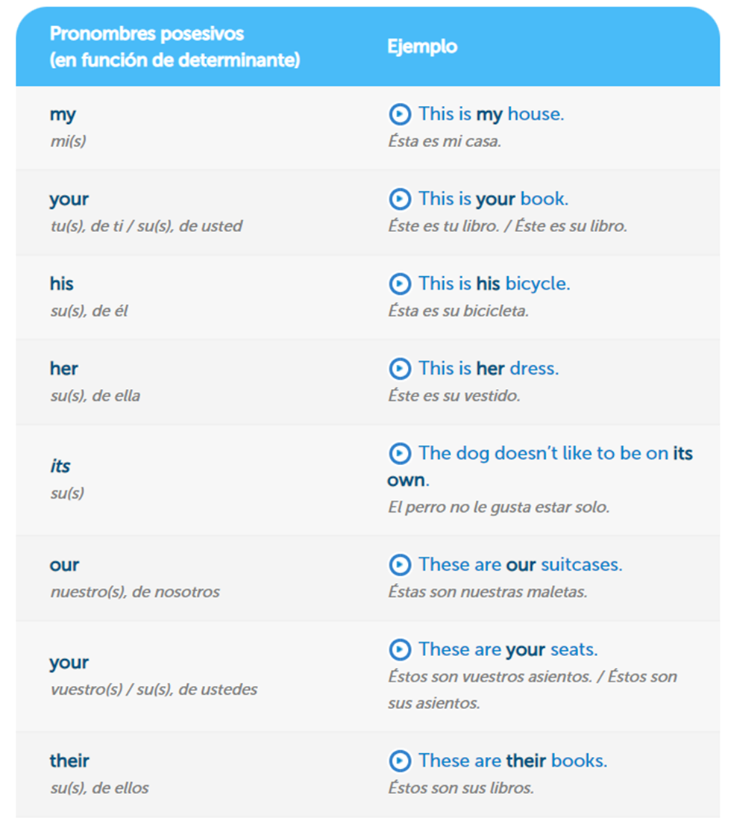

**Exercise 2.** Complete the sentences with a possessive adjective.

Example: My name´s Stephen.

1. Angela, please turn off your mobile phone.

2. The students are from Italy. Their names are Susanna and Carlo.

3. London is famous for its red buses.

4. She`s French, but Her mother is English.

5. We`re in Class 3. Our teacher is Bob.

6. His name is Ian. He`s from Scotland.

7. I`m Mike. His family are from Dublin.

**Exercise 3.** Write the questions.

Example: you how are ?: How are you?

1. his what`s name ? : What’s his Name?

2. German mother is her ? : Is her mother German?

3. from your are where parents ? : Where are you parents from?

4. surname Simpson is your ? : You surname is Simpson ?

5. spell do how your name you ? : How do You spell your name ?

**Exercise 4.** Traduce el siguiente vocabulario.

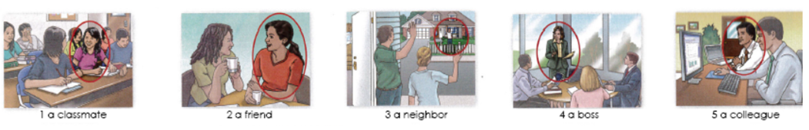

1. Compañero de clase

2. Amigo

3. Vecino

4. Jef@

5. Colega

**Exercise 5.** Circle the correct word or words to complete each sentence.

1. Mr. Thomas is ( my / I) boss.

2. Is Mrs. Cory (you / your )teacher.

3. Is (she / her Dr. Kim?

4. Are (they / their) Connie and Sam?

5. Are (your / you) Barry`s friend?

6. He`s (my / I) colleague.

7. Mr. Benson is (Alec / Alec`s) neighbor.

8. Jake is (Ms. Rose / Ms. Rose`s) student.

9. (He`s / His) an architect.

10 (Kyle / Kyle`s) and Ray`s classmate is Gail.