

**Nombre de alumno:**

**Nombre del profesor:**



**Nombre del trabajo: Unit Activity #1 - Unit 2**

**Materia:**

**Grado:**

**Grupo:**

Comitán de Domínguez Chiapas a 10 de Octubre de 2022.

**VOCABULARY**

**Abilities**

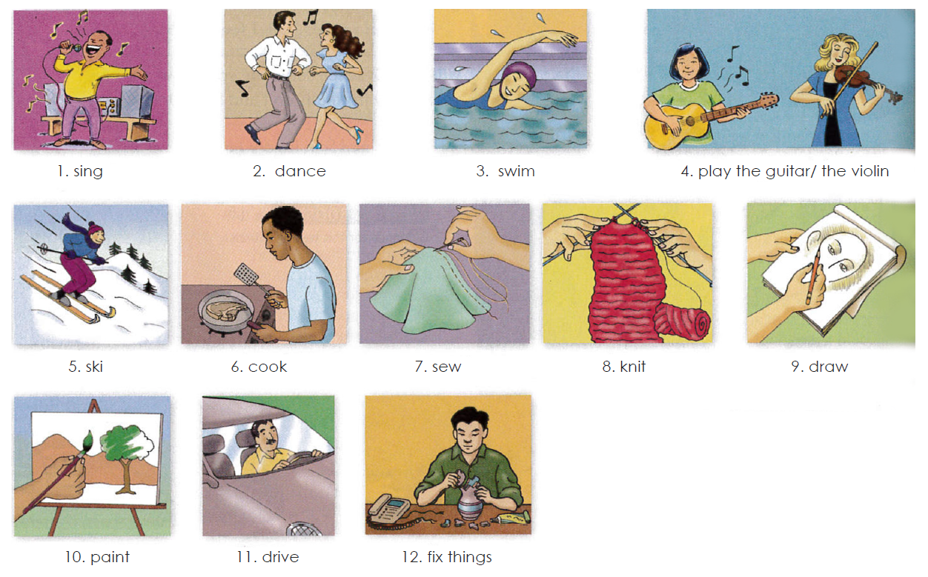

**Exercise 1.** Translate to Spanish the vocabulary above. Traduce al español el vocabulario de arriba.

1. Cantar 7. Coser

2. Bailar 8.Tejer

3. Nadar 9.Dibujar

4. Tocar la guitarra/el violin 10.Pintar

5. Esquiar 11.Manejar

6. Cocinar 12. Arreglar cosas

**Grammar - Adverbs “well” and “badly”**

Use **“badly”** if your sentence is active. You should determine if your sentence involves how an action is/was performed. This means it is active and requires an adverb, such as "badly."

For instance, in the sentence “I feel badly since my fingers were burned,” the word “feel” is used actively as an action. Instead of describing an emotional state, the sentence now describes a person’s ability to touch. Therefore, the adverb “badly” is used.

**Badly** es un adverbio, lo que significa que describe los verbos o las acciones además de otros adjetivos y adverbios. Por ejemplo, cuando alguien “habla mal”, cuando alguien “cocina mal”, cuando alguien “conduce mal” etc, usamos badly. Es decir, Badly cataloga lo mal que se realiza algo.

Ejs: Su novia canta bastante mal. His girlfriend sings pretty badly.

Él juega muy mal al fútbol. He plays football very badly*.

Él está mal vestido He’s badly dressed.

Use **“well”** if your sentence is active. Once you understand that the meaning of your sentence is active in nature, use the adverb “well” to further your explanation of how an action is/was performed.

For instance, in the sentence “I feel well now that my fingers have healed,” the word “feel” is used actively as an action. Instead of describing an emotional state, the sentence now describes a person’s ability to touch (or to “do” something well—which is an action). Therefore, the adverb “well” is used.

Un adverbio nos dice de que manera se hace la acción. Cuando **WELL** se usa como adverbio significa que la acción se hace bien, de manera adecuada, con claridad, etc.

I could not hear the teacher well. - No pude escuchar el profesor con claridad.

Things are going well. - Las cosas van bien.

He did his job well. - El hizo su trabajo bien/adecuadamente.

**Exercise 2.** Escribe 3 oraciones usando well y 3 oraciones usando badly usa el vocabulario de arriba

**Well**

1. I can´t play well since I broke up with my girlfriend

2. UDS is going well in the tournaments

3. My parents are working well with the house

**Badly**

1. I feel badly since I moved out

2. My brother do badly stuffs in middle school

3. I sing so badly

**Grammar - “Can” and “can´t” for ability**

We use “can” or “can’t” + the base form of a verb to talk about ability.

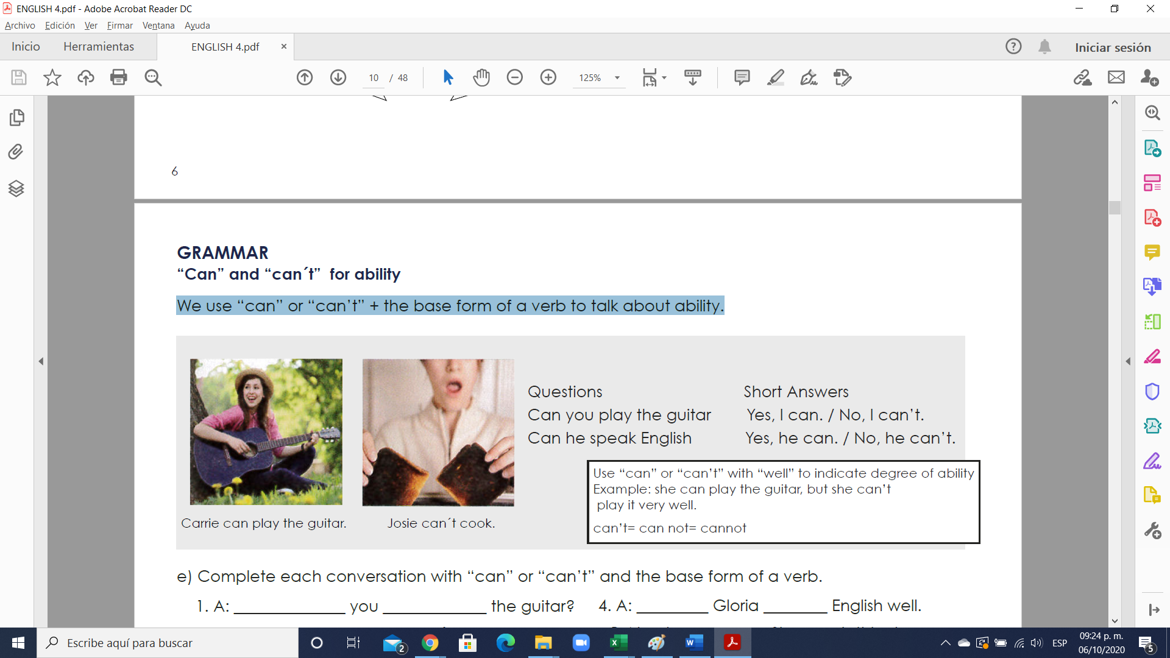

**Exercise 3.** Complete each conversation with “can” or “can’t” and the base form of a verb.

1. A: Can you play the guitar?

B: Yes, I can But I don´t play well.

2. A: can Gwen swim well?

B: Yes, she can. She swims very well.

3. A: can your brother cook?

B: My brother? No. He can´t cook at all.

4. A: can Gloria speak English well.

B: No, she can´t She needs this class.

5. A: can your mother ___knit?_______?

B: Yes. She knits very well.

6. A: Can your sisters ski?

B: Yes. They go skiing every weekend.

**Exercise 4.** Answer the questions with true information. Use short answers with “can” or “can’t”.

1. Can you play the piano? Yes, I can play alone or in a group

2. Can you ski? No, I can´t because my knee

3. Can your parents sing well? Yes, they can, we sing every weekend

4. Can your friend speak English? No, he can´t, He didn´t study any other language

5. Can you draw? No, I can´t, I didn´t learn how to do it

6. Can your father fix things? Yes He can, actually He fix his bike everyday

**Grammar - Too + adjective**

“Too” makes an adjective stronger. It usually gives it a negative meaning.

Example: I’m too busy. I can’t talk right now.

Example: I’m too tired. Let’s not go to the movies.

Example: It’s too late. I should go to bed.

**Exercise 5**.

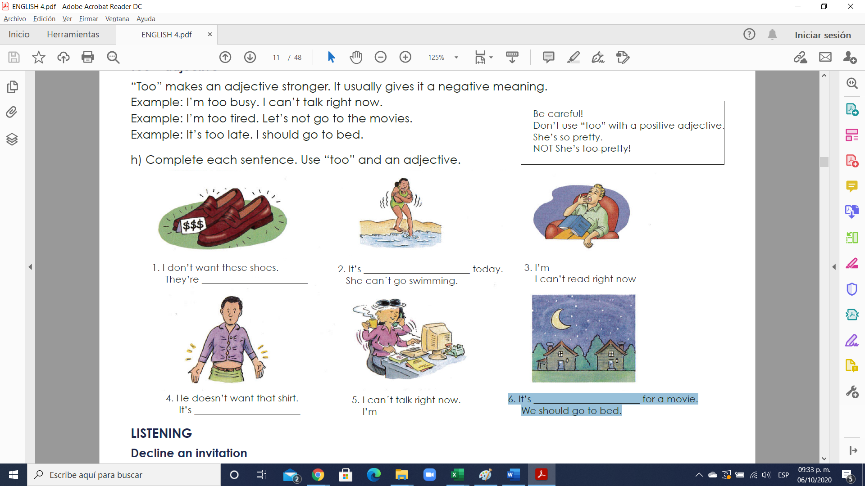1. I don’t want these shoes. They’re too expensive

 2. It’s too cool today. She can´t go swimming.

 3. I’m too tired I can’t read right now.

 4. He doesn’t want that shirt. It’s to tight

 5. I can´t talk right now. I’m too busy

 6. It’s too late for a movie. We should go to bed.

**Exercise 6.** Complete each sentence. Use “too” and an adjective.

1. I need a new dress. This dress is too old.

2.This skirt is ____too large____________ I want a short skirt.

3. His shirt is is too big . He needs size small.

4. I don’t want that suit. It’s too ugly

5. He needs size medium. This shirt is too short