

**Nombre de alumno: Oscar Cancino Flores**

**Nombre del profesor: Juan Manuel Jaime D**



**Nombre del trabajo: Unit Activity #1 - Unit 2**

**Materia: Ingles**

**Grado: 4rto cuatrimestre**

**Grupo: Recusos Humanos**

Comitán de Domínguez Chiapas a 10 de Octubre de 2022.

**VOCABULARY**

**Abilities**

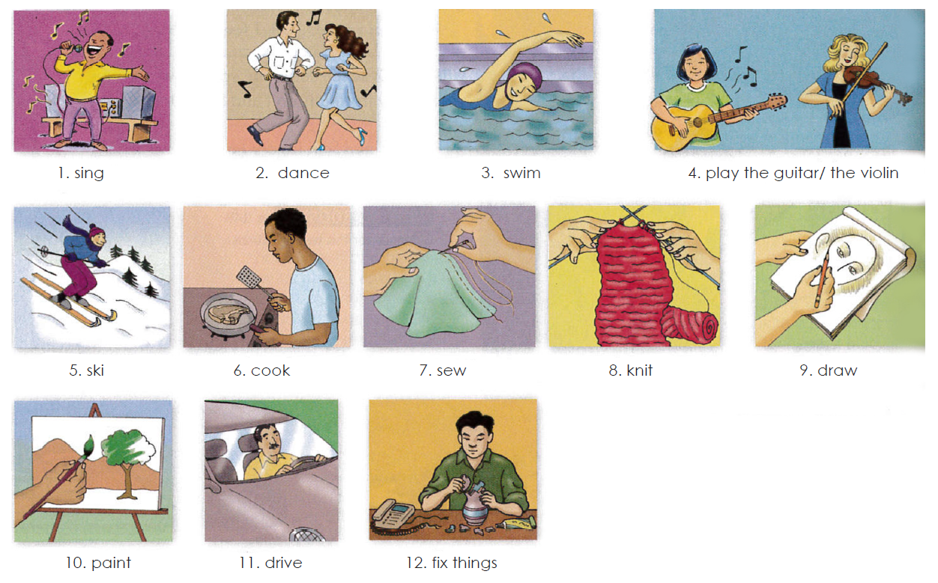

**Exercise 1.** Translate to Spanish the vocabulary above. Traduce al español el vocabulario de arriba.

1. cantar 7. coser

2. bailar 8. tejer

3. nadar 9. dibujar

4.tocar la guitarra / el violin 10. pintar

5. esqui 11. manejar

6. cocinar 12. arreglar cosas

**Grammar - Adverbs “well” and “badly”**

Use **“badly”** if your sentence is active. You should determine if your sentence involves how an action is/was performed. This means it is active and requires an adverb, such as "badly."

For instance, in the sentence “I feel badly since my fingers were burned,” the word “feel” is used actively as an action. Instead of describing an emotional state, the sentence now describes a person’s ability to touch. Therefore, the adverb “badly” is used.

**Badly** es un adverbio, lo que significa que describe los verbos o las acciones además de otros adjetivos y adverbios. Por ejemplo, cuando alguien “habla mal”, cuando alguien “cocina mal”, cuando alguien “conduce mal” etc, usamos badly. Es decir, Badly cataloga lo mal que se realiza algo.

Ejs: Su novia canta bastante mal. His girlfriend sings pretty badly.

Él juega muy mal al fútbol. He plays football very badly*.

Él está mal vestido He’s badly dressed.

Use **“well”** if your sentence is active. Once you understand that the meaning of your sentence is active in nature, use the adverb “well” to further your explanation of how an action is/was performed.

For instance, in the sentence “I feel well now that my fingers have healed,” the word “feel” is used actively as an action. Instead of describing an emotional state, the sentence now describes a person’s ability to touch (or to “do” something well—which is an action). Therefore, the adverb “well” is used.

Un adverbio nos dice de que manera se hace la acción. Cuando **WELL** se usa como adverbio significa que la acción se hace bien, de manera adecuada, con claridad, etc.

I could not hear the teacher well. - No pude escuchar el profesor con claridad.

Things are going well. - Las cosas van bien.

He did his job well. - El hizo su trabajo bien/adecuadamente.

**Exercise 2.** Escribe 3 oraciones usando well y 3 oraciones usando badly usa el vocabulario de arriba

**Well**

1. Cabañas play soccer well

2. Diego is a friend well

3. She drew me and she did well

**Badly**

1. Michelle cook too badly

2. Damian play soccer badly

3. Fernando sings badly

**Grammar - “Can” and “can´t” for ability**

We use “can” or “can’t” + the base form of a verb to talk about ability.

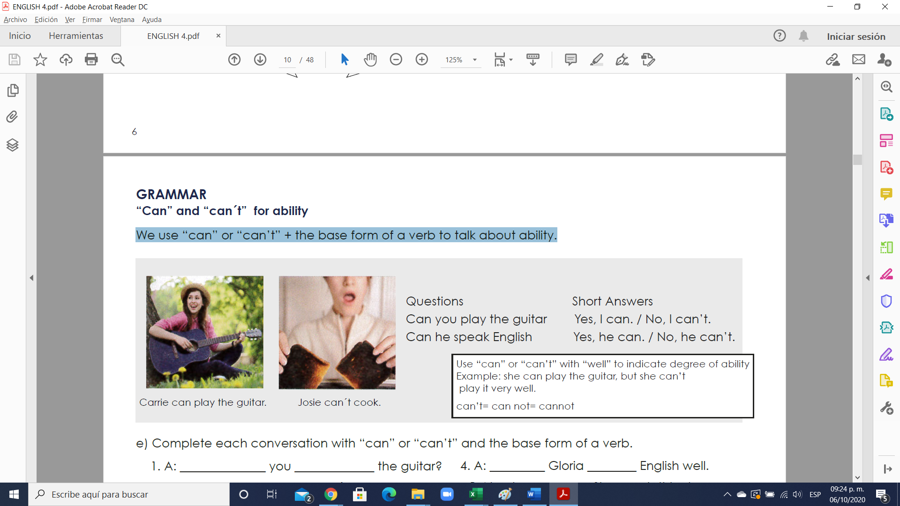

**Exercise 3.** Complete each conversation with “can” or “can’t” and the base form of a verb.

1. A: ______can________ you ______play_______ the guitar?

B: Yes, I ____can_______. But I don´t play well.

2. A: _____can______ Gwen _____swim___ well?

B: Yes, she _____can_____. She swims very well.

3. A: _______can_______ your brother ____cook______?

B: My brother? No. He ___can´t____ cook at all.

4. A: ___can______ Gloria ____speak____ English well.

B: No, she ____can_____. She needs this class.

5. A: ____can_____ your mother _____knits_____?

B: Yes. She knits very well.

6. A: _______can________ your sisters ______ski_____?

B: Yes. They go skiing every weekend.

**Exercise 4.** Answer the questions with true information. Use short answers with “can” or “can’t”.

1. Can you play the piano? _____Yes, I can play the piano________________________________________

2. Can you ski? ____Yes, I can ski_________________________________________________________

3. Can your parents sing well? ___No, my parents can´t, sing too badly________

4. Can your friend speak English? _Yes, my friend Agustin can speak English too well_______________

5. Can you draw? ___Yes, I can but I draw so badly____________________________________

6. Can your father fix things? ___Yes, my father can fix things_______________________________

**Grammar - Too + adjective**

“Too” makes an adjective stronger. It usually gives it a negative meaning.

Example: I’m too busy. I can’t talk right now.

Example: I’m too tired. Let’s not go to the movies.

Example: It’s too late. I should go to bed.

**Exercise 5**.

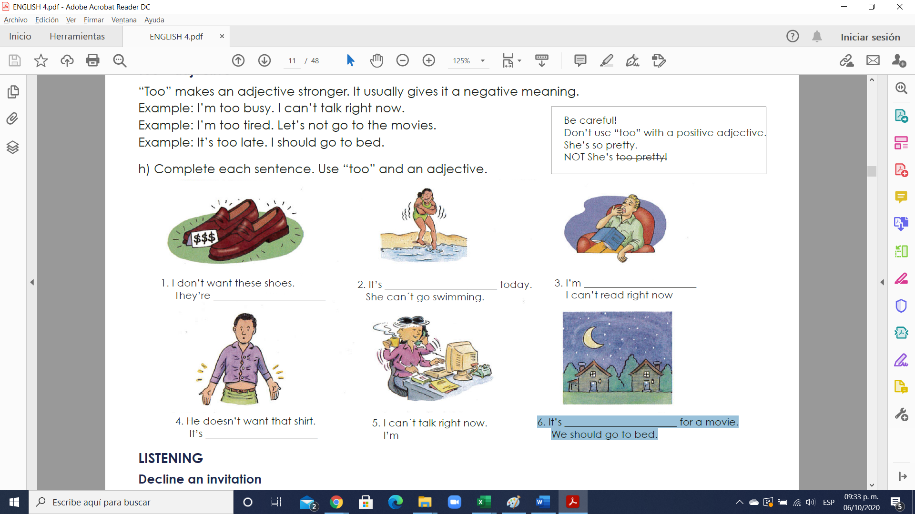1. I don’t want these shoes. They’re ___too expensive___________________.

 2. It’s ___too cold___________________ today. She can´t go swimming.

 3. I’m ____too tired__________________ I can’t read right now.

 4. He doesn’t want that shirt. It’s ___too small___________________.

 5. I can´t talk right now. I’m ___too busy___________________.

 6. It’s _____too late_________________ for a movie. We should go to bed.

**Exercise 6.** Complete each sentence. Use “too” and an adjective.

1. I need a new dress. This dress is too old.

2.This skirt is ____too big____________ I want a short skirt.

3. His shirt is _____too big___________. He needs size small.

4. I don’t want that suit. It’s _____too expensive___________.

5. He needs size medium. This shirt is ____too small____________.