

**Nombre de alumno:**

**Nombre del profesor:**



**Nombre del trabajo: Unit Activity #1 - U1 4BRH**

**Materia:**

**Grado:**

**Grupo:**

Comitán de Domínguez Chiapas a 19 de septiembre de 2022.

**APPEARANCE AND HEALTH - Vocabulary**

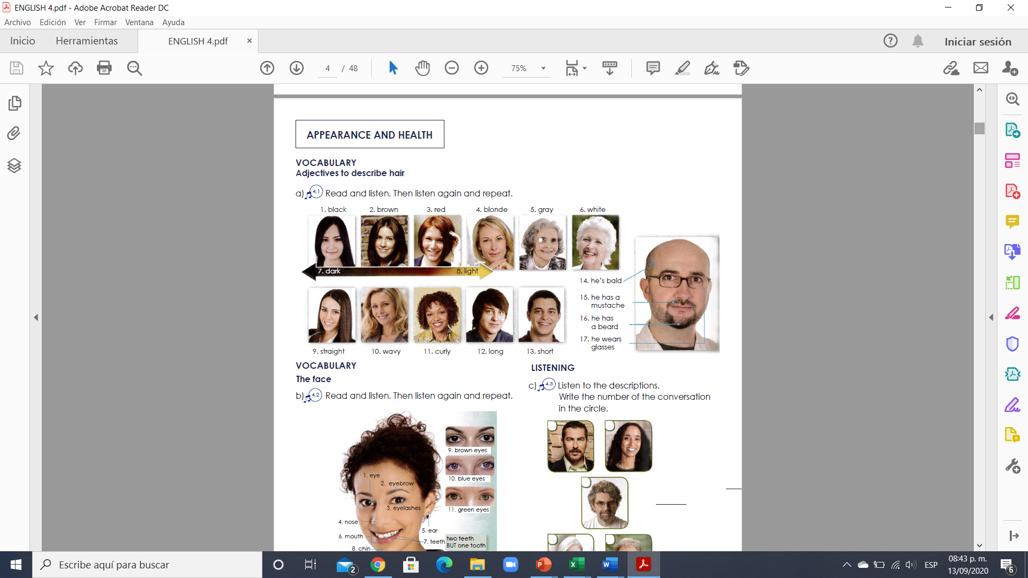

**Exercise 1.** Translate to spanish the vocabulary above. Traduce al español el vocabulario de arriba.

1. Negro 10. ONDULADO

2. Cafe 11.COLOCHO

3. Rojo 12.LARGO

4. rubia 13.CORTO

5. Gris 14.CALVO

6. BLANCO 15.EL TIENE UN BIGOTE

7. OSCURO 16.EL TIENE BARBA

8. CLARO 17. EL TIENE LENTES

9 LACIO.

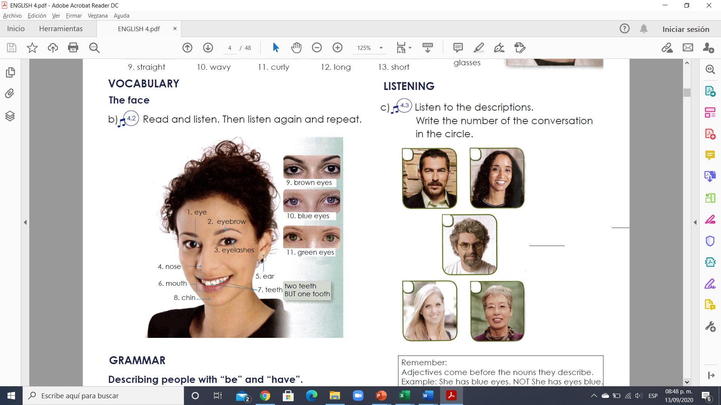

**Exercise 2.** Translate to spanish the vocabulary above. Traduce al español el vocabulario de arriba.

1. OJO 7. DIENTES

2. CEJA 8.BARBILLA

3. PESTAÑAS 9.OJOS CAFES

4. NARIZ 10.OJOS AZULES

5. OREJA 11.OJOS VERDES

6.BOCA

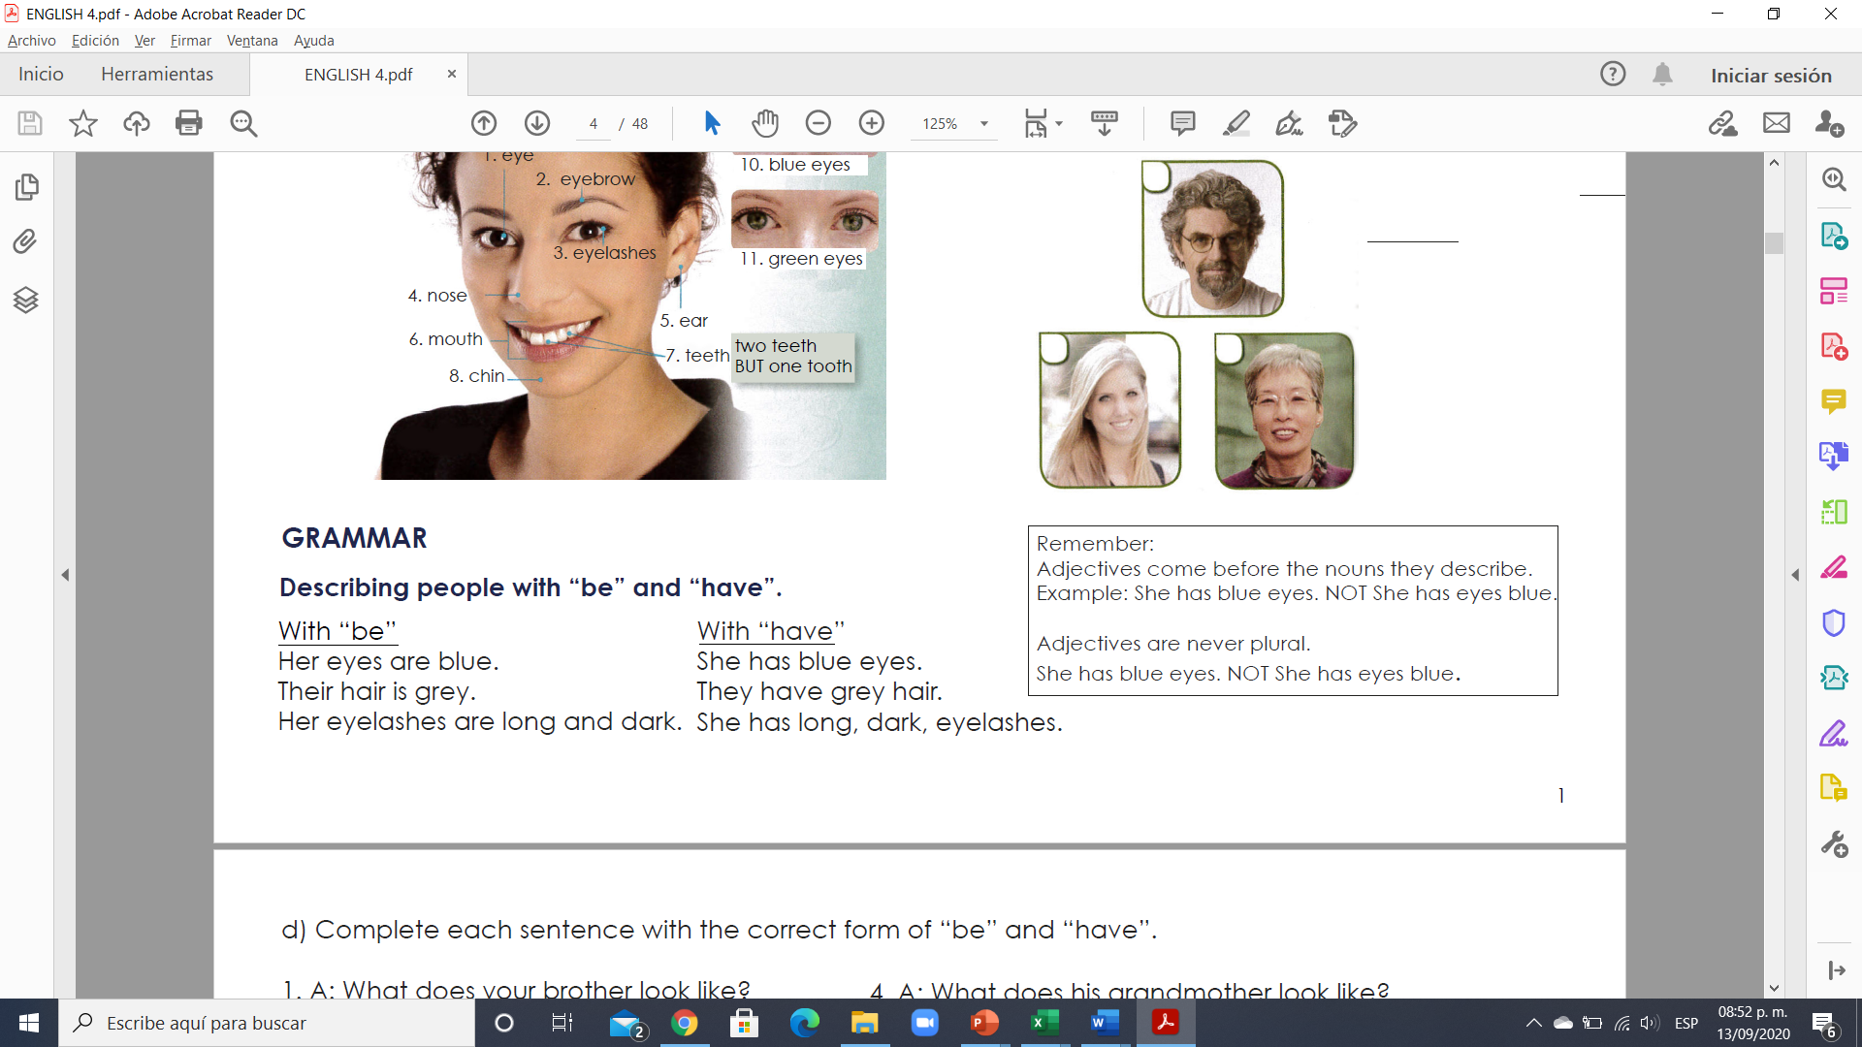

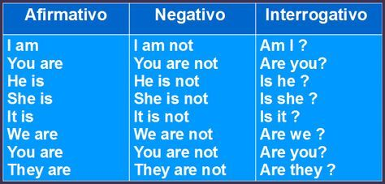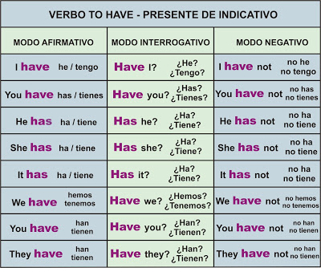

**VERBO TO BE**

**Exercise 3.** Complete each sentence with the correct form of “be” and “have”.

1. A: What does your brother look like?

B: Well, he HAS a mustache and wavy hair.

And he wears glasses.

2. A: What does your mother look like?

B: Her hair IS curly and black.

3. A: What does her father look like?

B: He HAS a short, gray beard.

4. A: What does his grandmother look like?

B: She IS curly, gray hair and beautiful eyes.

5. A: What does his sister look like?

B: His sister? Her hair IS long and pretty!

6. A: What do your brothers look like?

B: They ARE straight, black hair, and they wear glasses.

**Exercise 4.** Write a sentence with “be” and a sentence with “have”.

**Example:**

**1. Kate / hair/ long / straight**

(using “be”) a. Kate’s hair is long and straight

(using “have”) b. Kate has long straight hair

**2. George / short/ black hair**

(using “be”) a. GEORGES´S HAIR IS BLACK AND SHORT

(using “have”) b. GEORGE HAS SHORT BLACK HAIR

**3. Harry/ long / curly/ hair**

(using “be”) a. HARRY´S HAIR IS CURLY AND LONG

(using “have”) b. HARRY HAS LONG CURLY HAIR

**4. Mary/ eyes/ blue**

(using “be”) a. MARY´S EYES ARE BLUE

(using “have”) b. MARY HAS BLUE EYES

**5. Amy/ pretty/ eyes**

(using “be”) a. AMY´S EYES ARE PRETTY

(using “have”) b. AMY HAS PRETTY EYES

**VOCABULARY**

**Parts of the body**

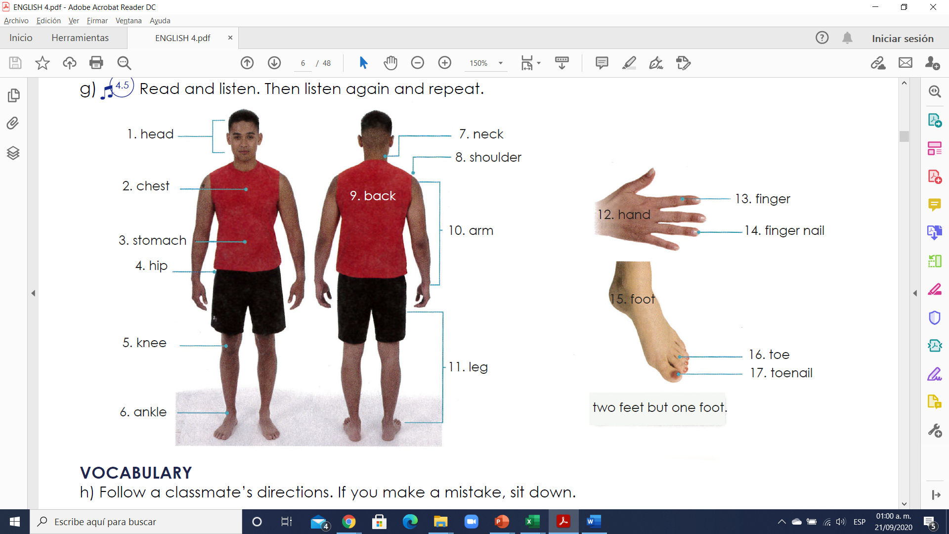

**Exercise 1.** Translate to Spanish the vocabulary above. Traduce al español el vocabulario de arriba.

1.CABEZA 10. BRAZO

2.PECHO 11.PERNA

3.ESTOMAGO 12.MANO

4.CADERA 13.DEDO

5.RODILLA 14.UÑA

6.TOBILLO 15.PIE

7.CUELLO 16.DEDO DEL PIE

8.HOMBRO 17.UÑA DEL DEDO DEL PIE

9.ESPALDA

**VOCABULARY -Ailments (Enfermedades/Dolores)**

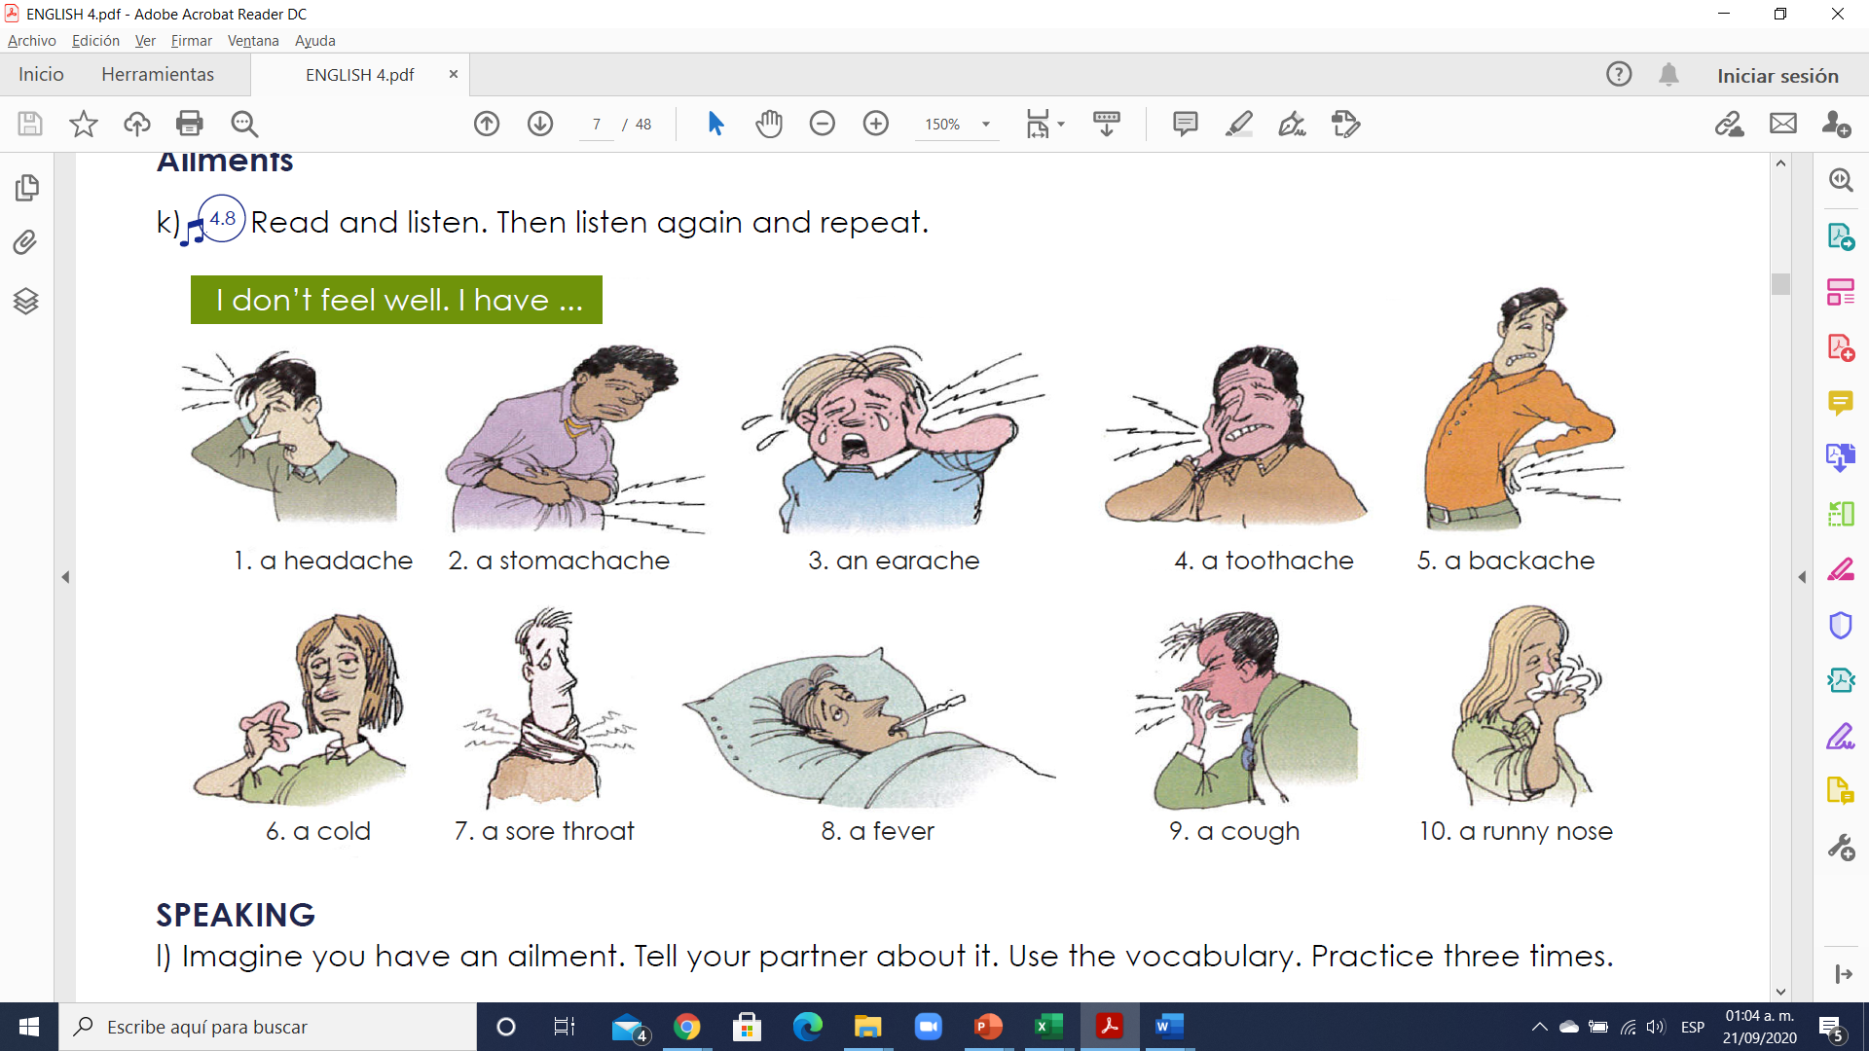

**Exercise 2.** Translate to Spanish the vocabulary above. Traduce al español el vocabulario de arriba.

1.DOLOR DE CABEZA 6. RESFRIADO

2.DOLOR DE ESTOMAGO 7.DOLOR DE GARGANTA

3.DOLOR DE OIDO 8.FIEBRE

4.DOLORDE MUELAS 9.TOS

5.DOLOR DE ESPALDA 10.MOQUEO

**VOCABULARY - Remedies**

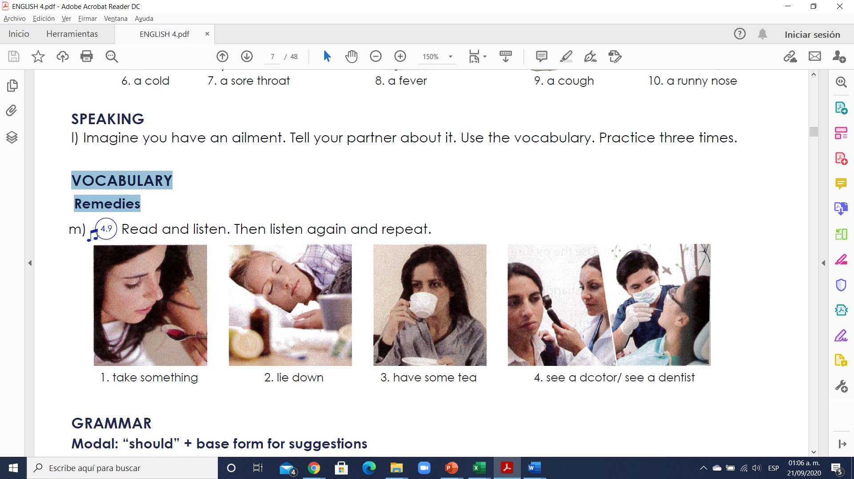

1.Toma algo.

2. Recuéstate.

3. Toma un té.

4. Ve un doctor / ve un dentista.

**Exercise 3. Escribe 8 oraciones usando el vocabulario de arriba**

Example: I have a cold; I should see a doctor.

1.I HAVE A STRONG HEADACHE

2.I´LL GET A STOMACHACHE IF I EAT THIS

3.I GOT ANEARACHE AFTER USING MY HEADPHONES

4.I HAVE A THOOTACHE

5.I HAVE A BACKACHE, I SHOULD GET A MASSAGE

6.I GET A COLD BY THE WEATHER

7.I GOT A SORE THROAT BECAUSE I ATE COLD FOOD

8.I GET FEVER BECAUSE THE RAIN

**GRAMMAR - Modal: “should” + base form for suggestions**

Should: deber

Shouldn’t: no deber

Should not: no deber

**Usos**

1. **Dar consejos** (**give advice**); ejemplo:

-I think you should go to the doctor. (Creo que debes ir al médico)

-You shouldn’t drink alcohol. (No deberías beber alcohol)

2. **Mostrar obligación** o deber (obligation or duty) para decir qué el lo correcto

–You should wear a helmet when riding a motorcycle. (Usted debe usar un casco cuando conduzca una motocicleta)

-You shouldn’t smoke in here. (No deberías fumar aquí)

3. **Mostrar probabilidad o expectativa** (probability or expectation)

-They should be here soon. (Deberían esta aquí pronto)

-I believe 200 dollars should be enough for the trip. (Creo que 200 dólares deberían ser suficientes para el viaje)

**Estructura**

**a) Affirmative:** después de SHOULD el verbo no debe tener TO, sólo la forma base.

He should call an ambulance right now. (El debería llamar una ambulancia ahora mismo)

**b) Negative:** la forma sin es contracción es **SHOULD NOT** y con contracción es **SHOULDN’T**; ambas formas son correctas.

-They shouldn’t cheat on the Spanish exam. (Ellos no deben hacer trampa en el examen de español)

-That soccer player should not dive all the time; it´s not fair play. (Ese jugador de futbol no debería fingir/echarse a la piscina todo el tiempo; no es juego limpio)

**c) Interrogative:** debemos usar SHOULD antes del SUJETO.

–Should I take a summer course at college? (¿Debo tomar un curso de verano en la universidad?)

-Yes, you should. (Sí) -No, you shouldn’t. (No)

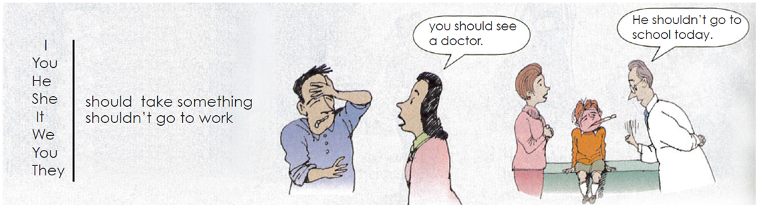

**Exercise 4.** Complete each sentence with **“should o shouldn´t”** and a verb form the box.

1. It’s your birthday. You should go out for dinner!

2. I’m sorry you have a toothache. You SHOULD SEE **(see)** a dentist.

3. There’s a movie on TV tonight. We SHOULD WATCH **(watch)** it.

4. You have a cold? You SHOULDN´T EXERCISE **(not exercise)** today.

5. We have tomatoes, potatoes, and onions. We SHOULD MAKE **(make)** tomato potato soup for dinner tonight!

6. Pam’s taking a shower right now. You SHOULD CALL **(call)** back later.

7. Martin has a headache. He SHOULDN´T PLAY **(not play)** soccer tonight.

8. It’s time for bed. You SHOULD GET **(get)** undressed.