

**Nombre de alumno: Erick Ramírez C.**

**Nombre del profesor:**



**Nombre del trabajo: Unit Activity#1 – U3 1BRH**

**Materia: Ingles**

**Grado: 1er Semestre**

**Grupo: Recursos Humanos**

Comitán de Domínguez Chiapas a 07 de Noviembre de 2022.

**TOPIC 3: WHERE ARE THEY?**

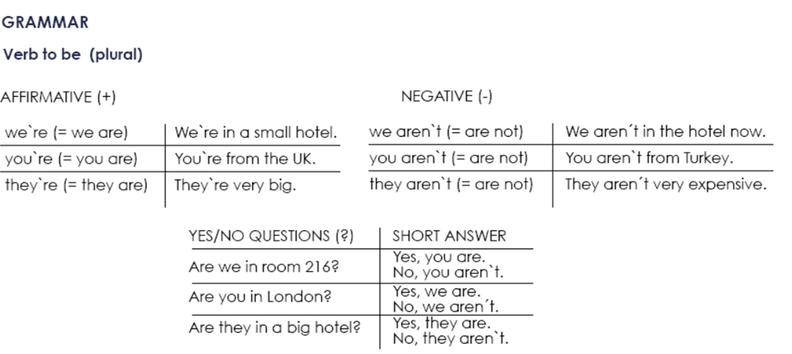

**Exercise 1.** Write the contractions: I`m, we`re, aren`t, etc.

1. We aren`t from Italy, __im______ from Spain.

2. ___Theyre____ a new hotel, but it___arent___ very nice.

3. ____Theyre___ a doctor and he __arent_____ married.

4. You __arent____ Australian, ___youre ____ American.

5. ___theyre_____ a manager and ___youre____ a musician.

**Exercise 2.** Complete each statement with a singular or plural form of “be”.

1. I___am___ a writer.

2. She ___is__ not a pilot.

3. We __are___ doctors.

4. They ___are__ not scientists.

5. We __are____ managers.

6. He ___is___ a singer.

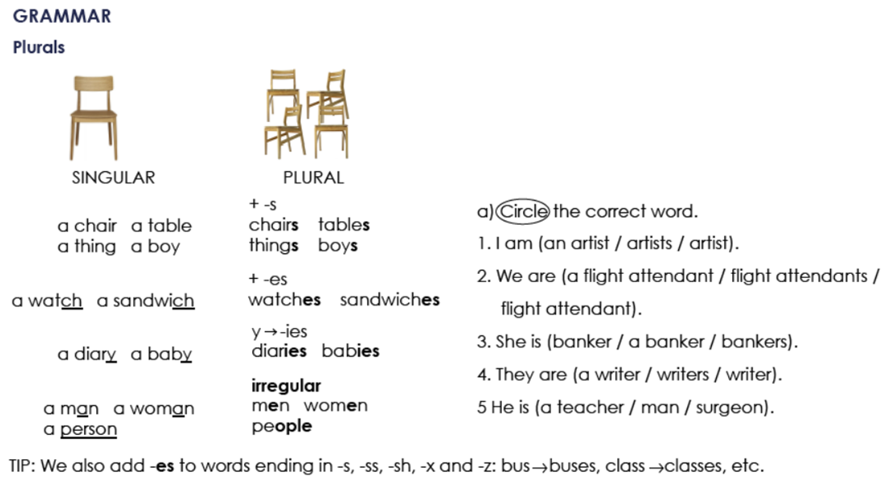

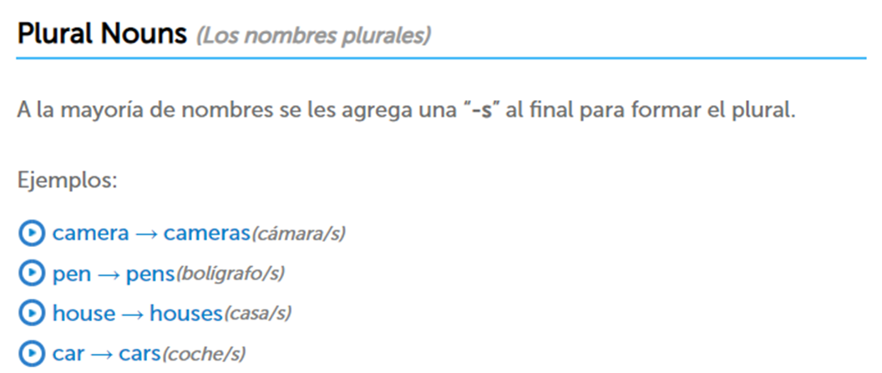

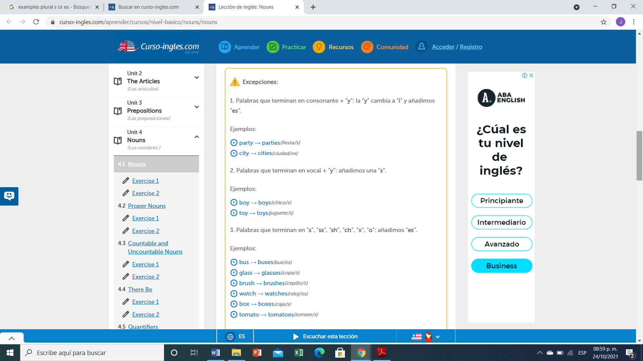

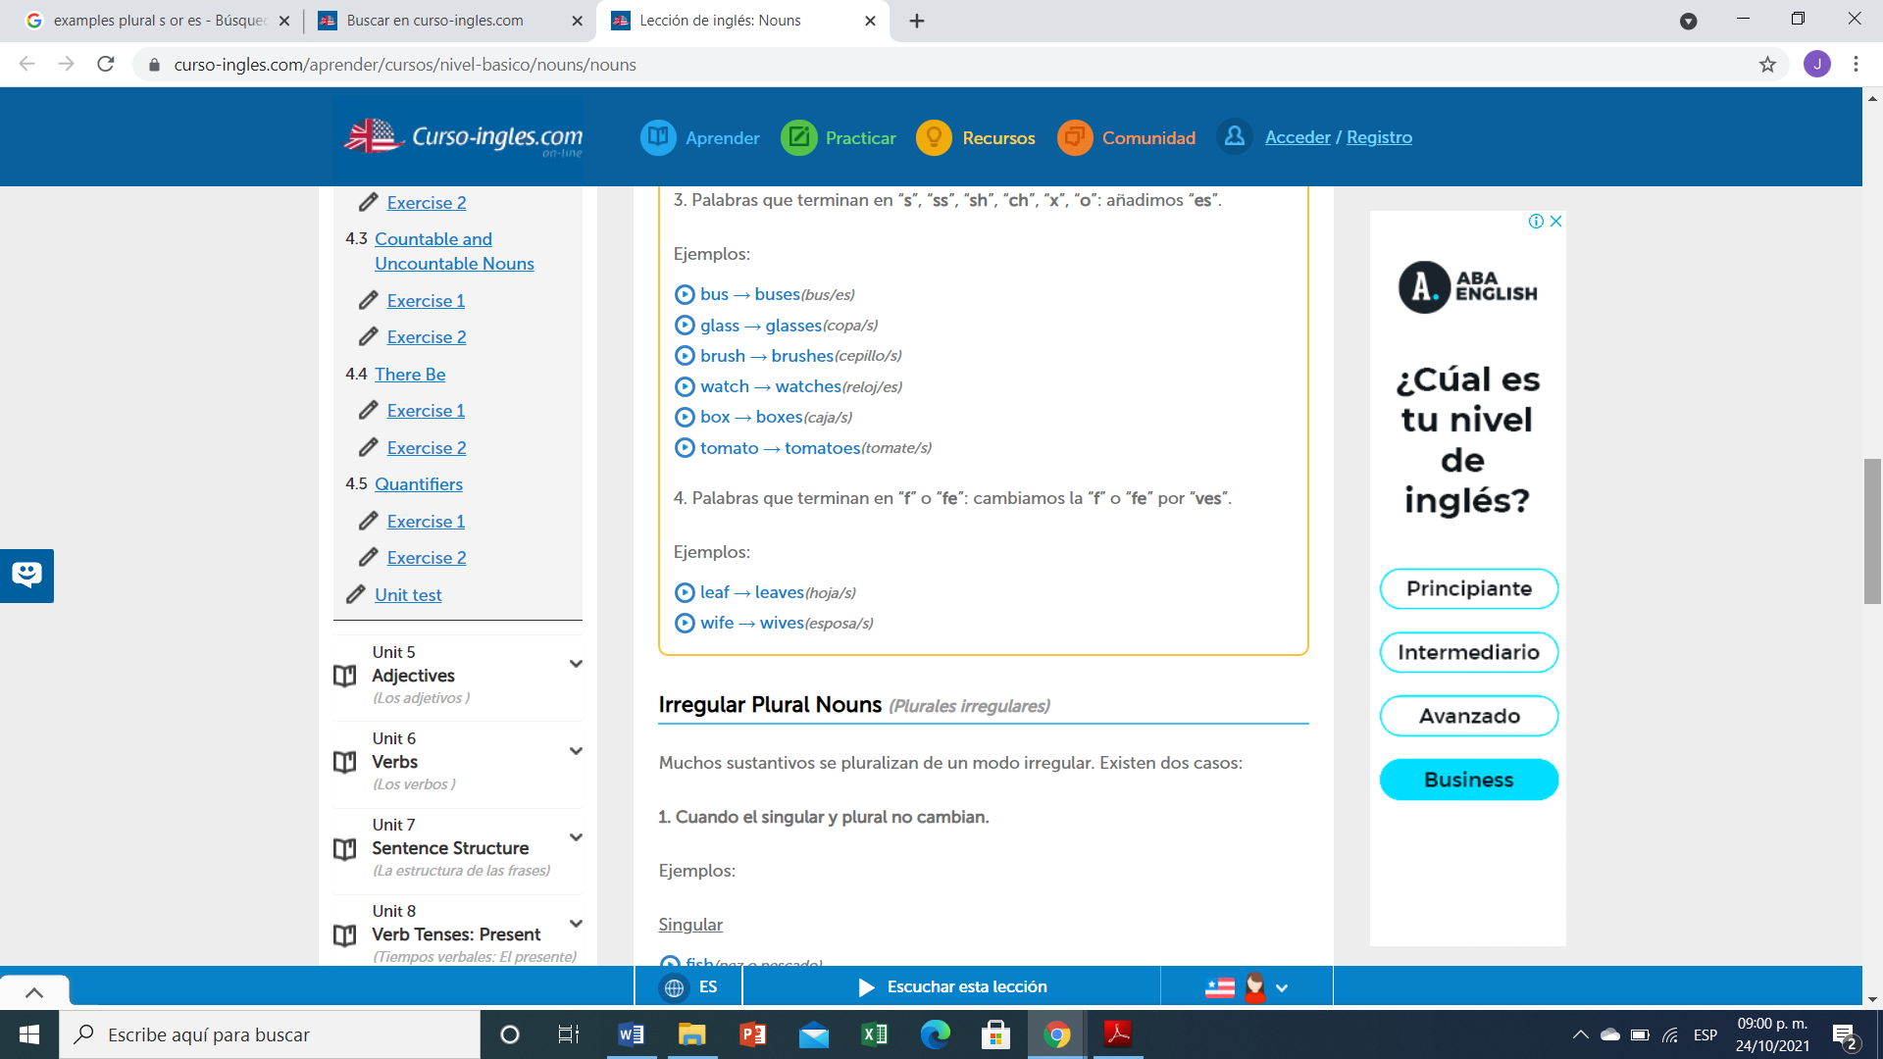

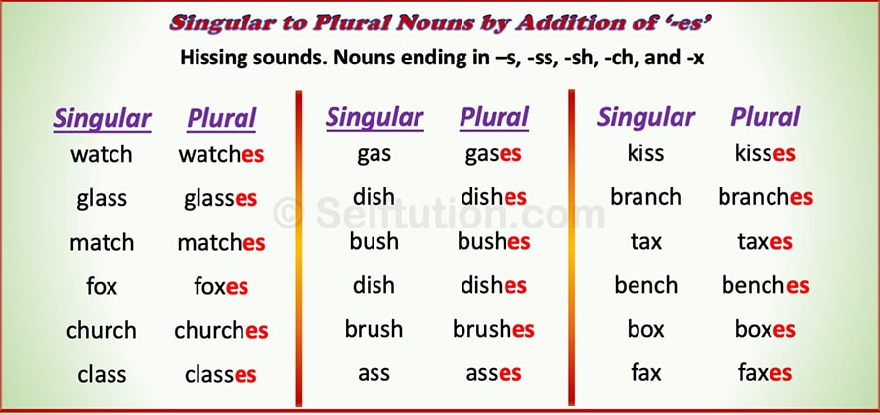

**Exercise 3.** Write the plural of:

1. Baby---Babys
2. Cake----Cakes
3. Church-----Churches
4. Glass----Glasses
5. Wife----Wives
6. Fish---Fishes
7. Month----Months
8. Child----Childrens
9. Wish----Wishes
10. Woman----Womens
11. City---Cities
12. Man----Mens
13. Box---Boxes
14. Foot----Foots
15. Mouse---Mouses
16. Leaf----Leaves
17. Sheep-----Sheeps
18. Tomato---Tomatoes

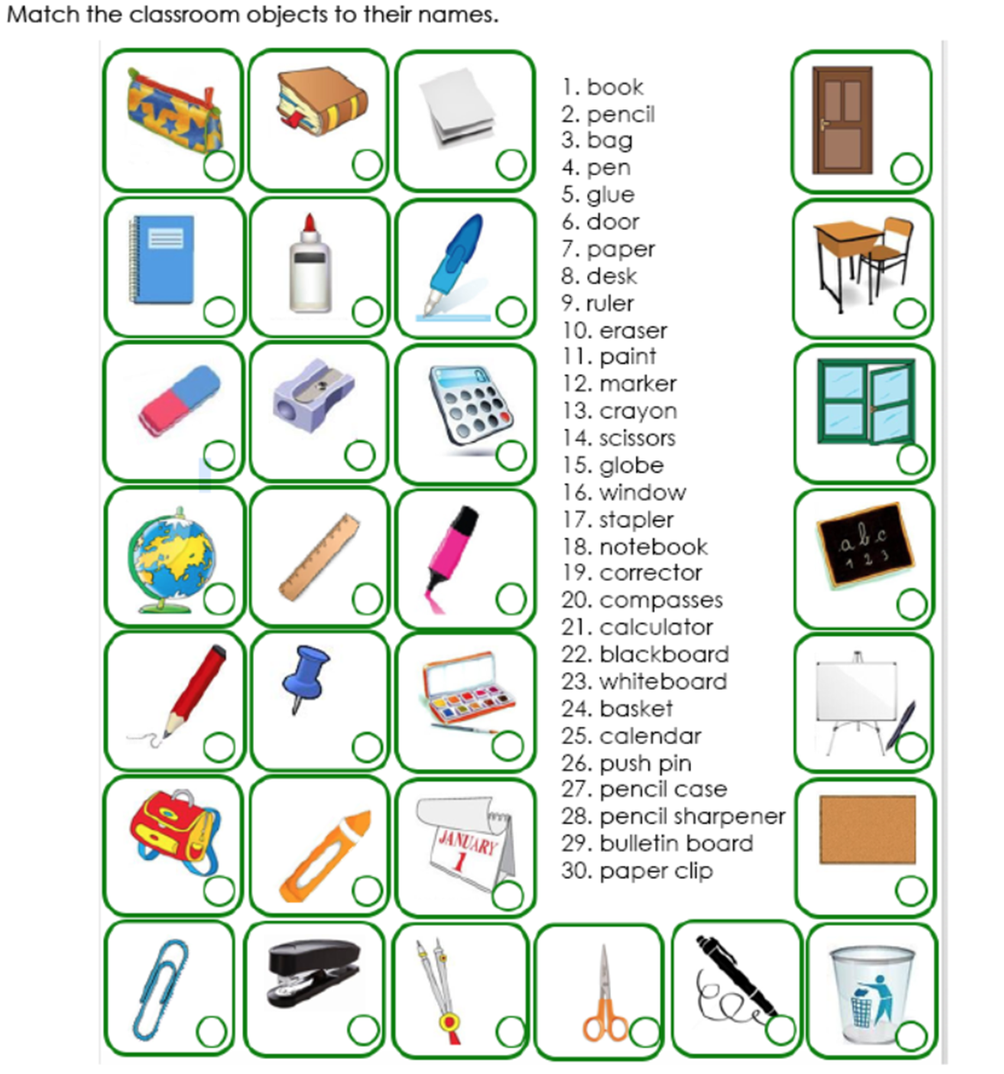

**1**

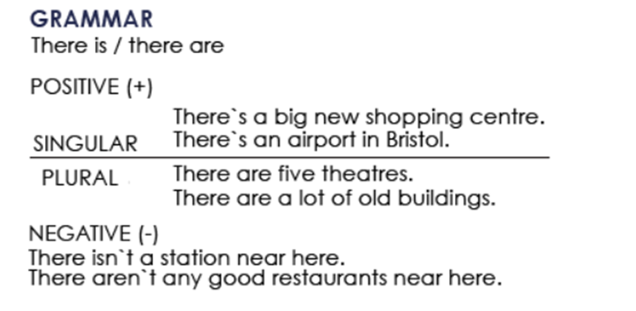

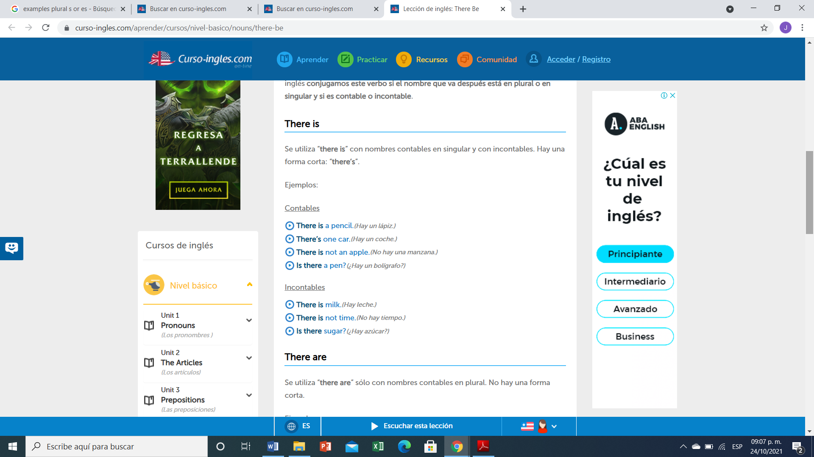

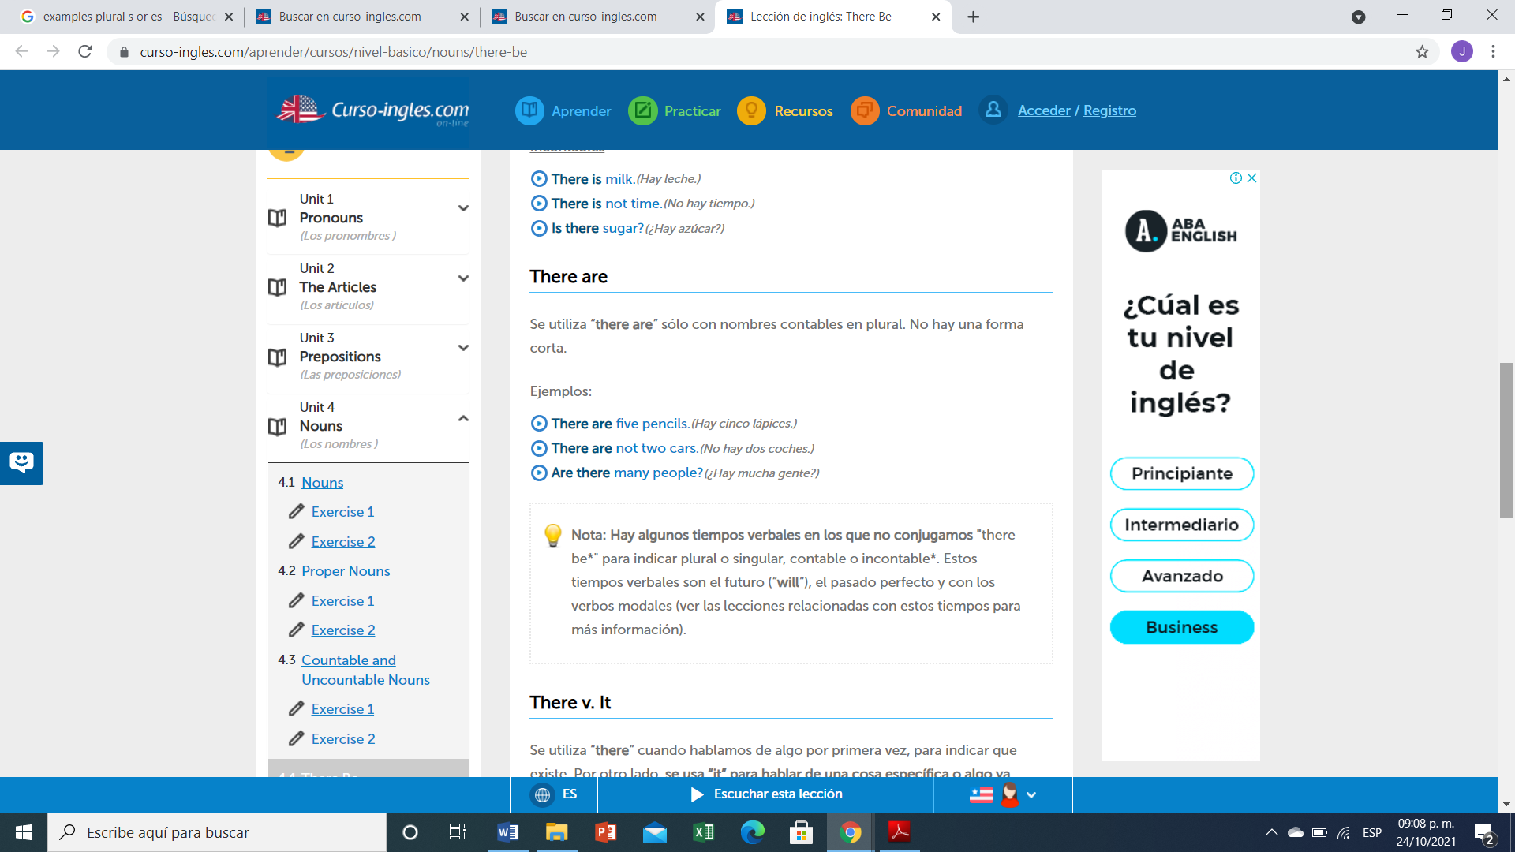

**Ejercicio #4 -** Completa las siguientes frases con la forma correcta de "there is or There are".

1. ____There are_______ 5 apples in the bowl.
2. Is there _______ any water?
3. __There isnt_________ (not) any sugar in the coffee.
4. _There arent _________ (not) any tomatoes in the salad.
5. __There is_________ some wine in the glass.
6. __is there _________ any money in your wallet?
7. ___There is ________ a problem with this phone.
8. _are there _________ any vegetables in this recipe?

**Ejercicio #5 -** Escribe las palabras en el orden correcto.

many / aren’t / this / pages / there / in

R: there arent many pages in this

any / eggs / there / the / in / are / fridge / ?

R: Are there any eggs un the fridge?

is / nearby / restaurant / nice / there / a

R: There is a nearby nice restaurant

dining / are / chairs / in / room / there / three / the

R: There are three chairs in the daining room

hospital / there / this / isn't / a / in / town

R: There isnt a hospital in this town

here / is / bank / there / a / near / ?

R: is there a bank near here?

**TOPIC 4: PERSONAL INFORMATION**

**Exercise 1.** Contesta las siguientes preguntas.

1. What`s your first name?

A: My Name is Erick

2. What`s your surname or last name?

A: My last surname is Caballero

3. What`s your nationality?

A: Im Mexican

4. What`s your address?

A: San Sebastian

5. What`s your mobile number?

A: My mobile number is 9631237184

6. What`s your mail address?.

A: My email address is erickk_07HOTMAIL.ES

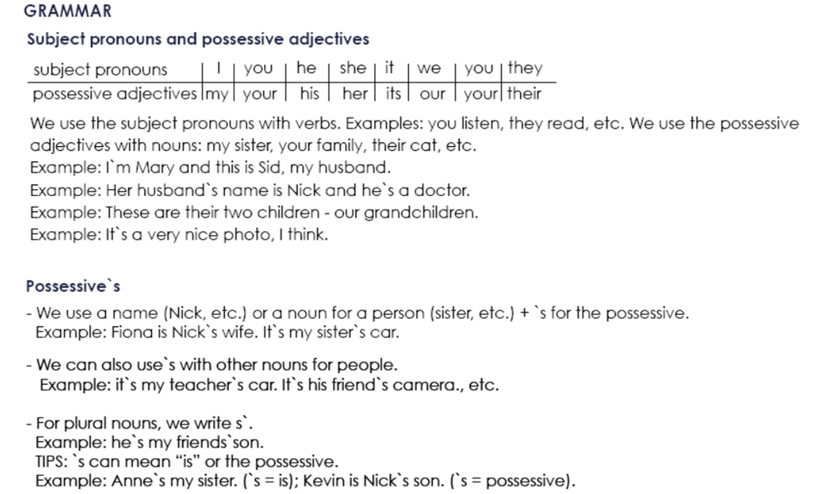

**Possessive Adjectives - Adjetivos Posesivos**

Se utilizan para indicar a quién pertenece el sujeto u objeto de la oración. Van seguidos de un sustantivo (o una cláusula nominal).

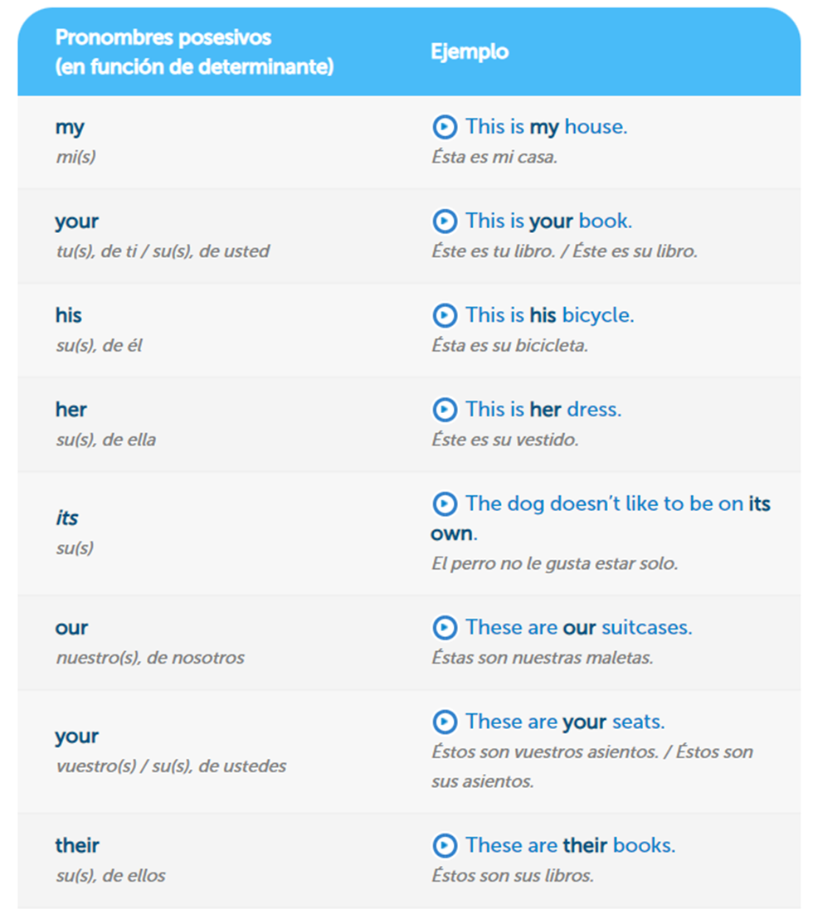

**Exercise 2.** Complete the sentences with a possessive adjective.

Example: My name´s Stephen.

1. Angela, please turn off ______your_____ mobile phone.

2. The students are from Italy.____their_______ names are Susanna and Carlo.

3. London is famous for _____his______ red buses.

4. She`s French, but____her_______ mother is English.

5. We`re in Class 3.___your________ teacher is Bob.

6. ______my_____ name is Ian. He`s from Scotland.

7. I`m Mike.____my_______ family are from Dublin.

**Exercise 3.** Write the questions.

Example: you how are ?: How are you?

1. his what`s name ? : what is name?_____________________

2. German mother is her ? : _____her mother is german?_______________

3. from your are where parents ? : _____where are your parents from?________________

4. surname Simpson is your ? : ________your surname is Simpson?_________________

5. spell do how your name you ? : ________how do you spell your name?_________________

**Exercise 4.** Traduce el siguiente vocabulario.

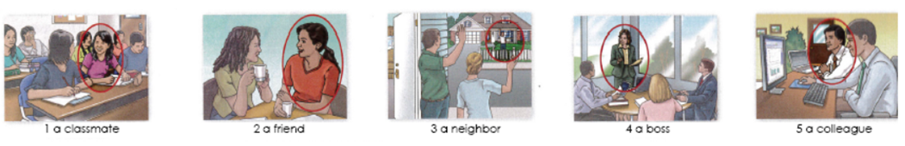

1. Un compañero de clase

2. Un amigo

3.Un amigo

4. un jefe

5. un colega

**Exercise 5.** Circle the correct word or words to complete each sentence.

1. Mr. Thomas is ( my / I) boss.

2. Is Mrs. Cory (you / your) teacher.

3. Is (she / her) Dr. Kim?

4. Are (they / their) Connie and Sam?

5. Are (your / you) Barry`s friend?

6. He`s (my / I) colleague.

7. Mr. Benson is (Alec / Alec`s) neighbor.

8. Jake is (Ms. Rose / Ms. Rose`s) student.

9. (He`s / His) an architect.

10 (Kyle / Kyle`s) and Ray`s classmate is Gail.