

**Nombre de alumno:**

**Nombre del profesor:**



**Nombre del trabajo: Unit Activity#1 – U3 1BRH**

**Materia:**

**Grado:**

**Grupo:**

Comitán de Domínguez Chiapas a 07 de Noviembre de 2022.

**TOPIC 3: WHERE ARE THEY?**

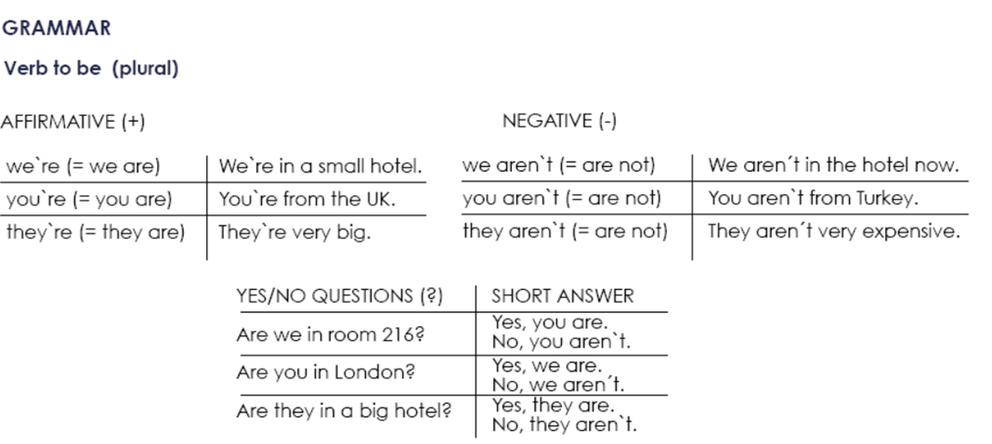

**Exercise 1.** Write the contractions: I`m, we`re, aren`t, etc.

1. We aren`t from Italy, _I’m_______ from Spain.

2. ___we´re____ a new hotel, but it___aren´t___ very nice.

3. ___i´m____ a doctor and he ___is____ married.

4. You ___aren´t___ Australian, ___i´m____ American.

5. ____I´m____ a manager and ___I´m not____ a musician.

**Exercise 2.** Complete each statement with a singular or plural form of “be”.

1. I´m___ a writer.

2. She __is___ not a pilot.

3. We ___are__ doctors.

4. They ___are__ not scientists.

5. We __are____ managers.

6. He ___is___ a singer.

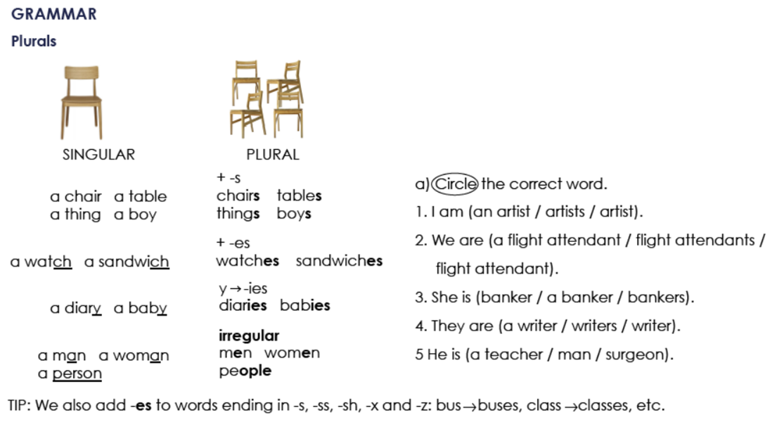

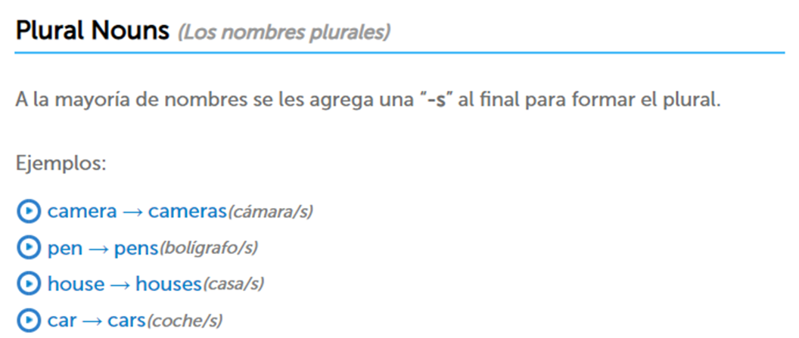

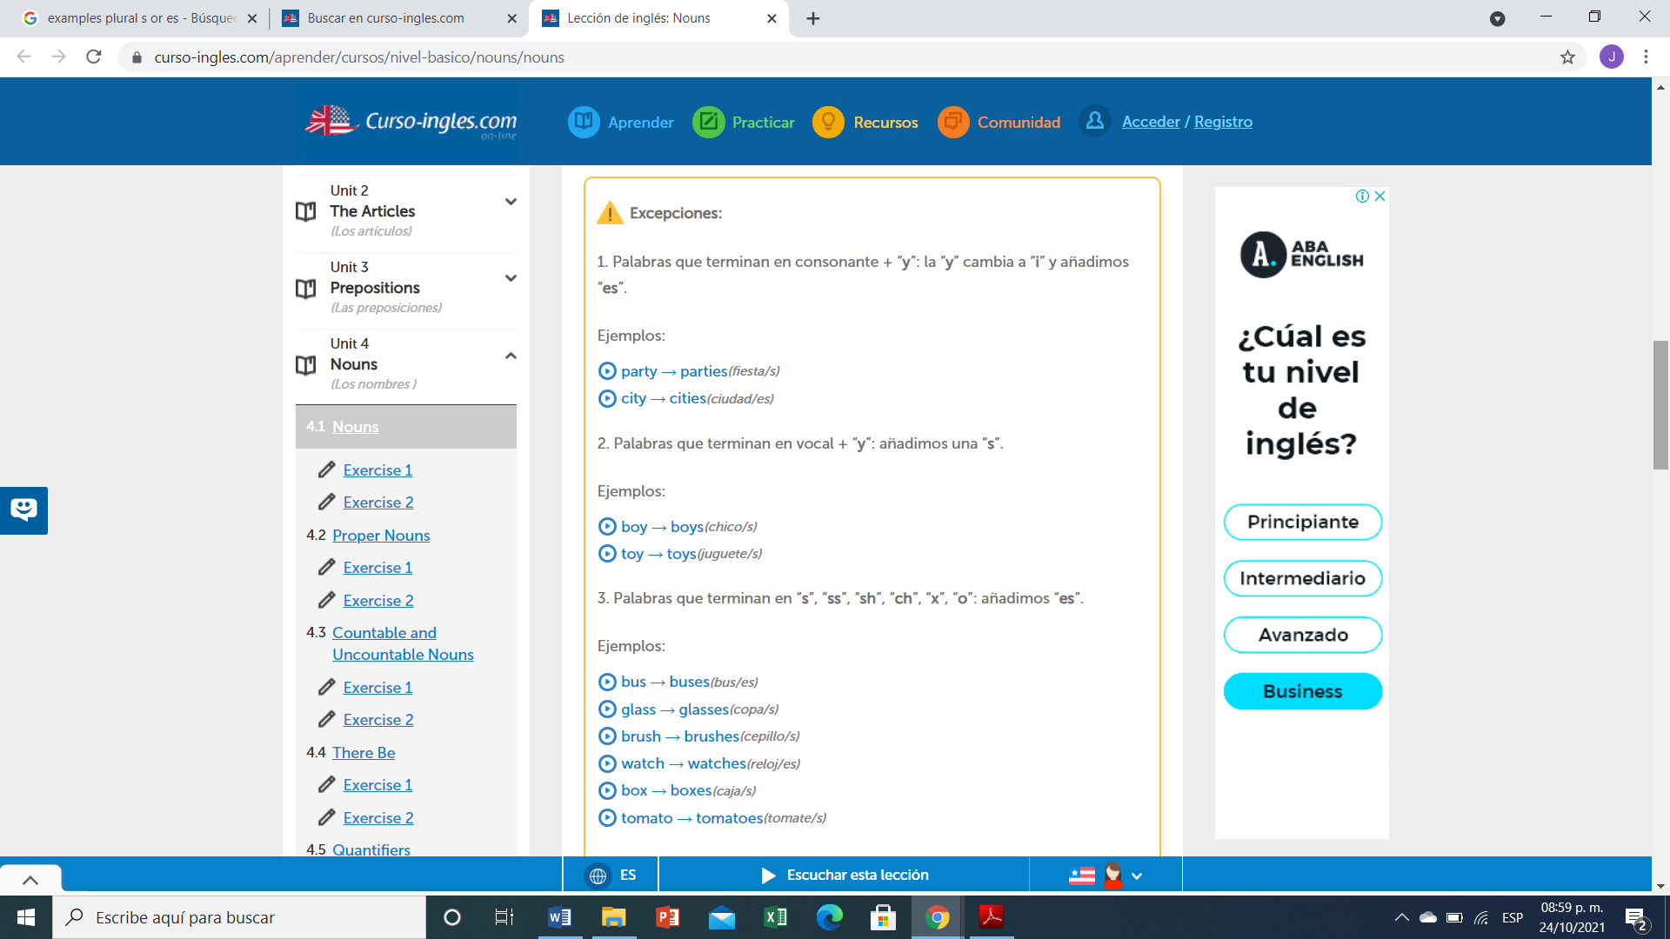

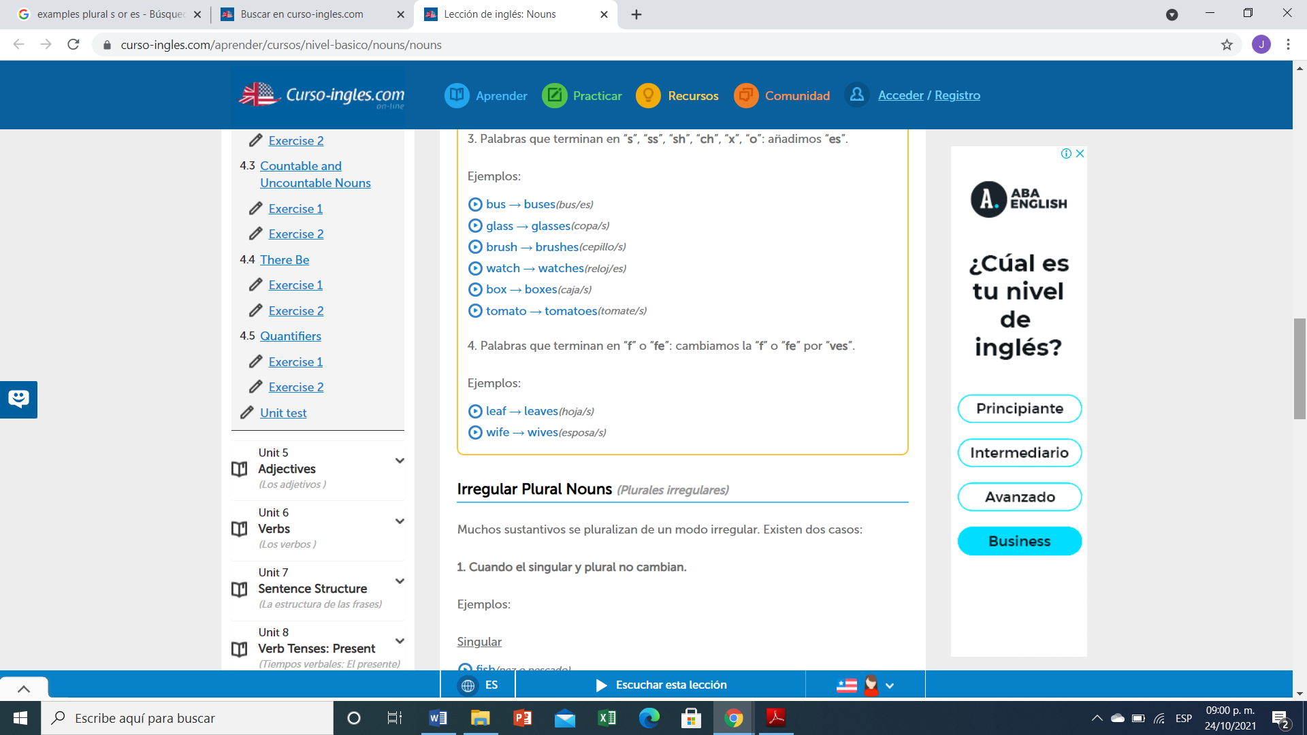

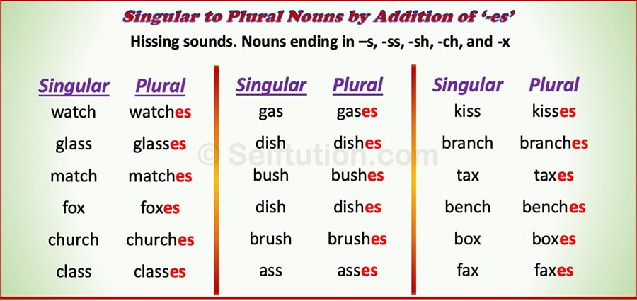

**Exercise 3.** Write the plural of:

1. Babies
2. Cakees
3. Churches
4. Glasses
5. Wivez
6. Fishes
7. Monthes
8. Childes
9. Wishes
10. Womans
11. Cities
12. Men
13. Boxes
14. Footes
15. Mouses
16. Leavez
17. Sheep
18. Tomatoes

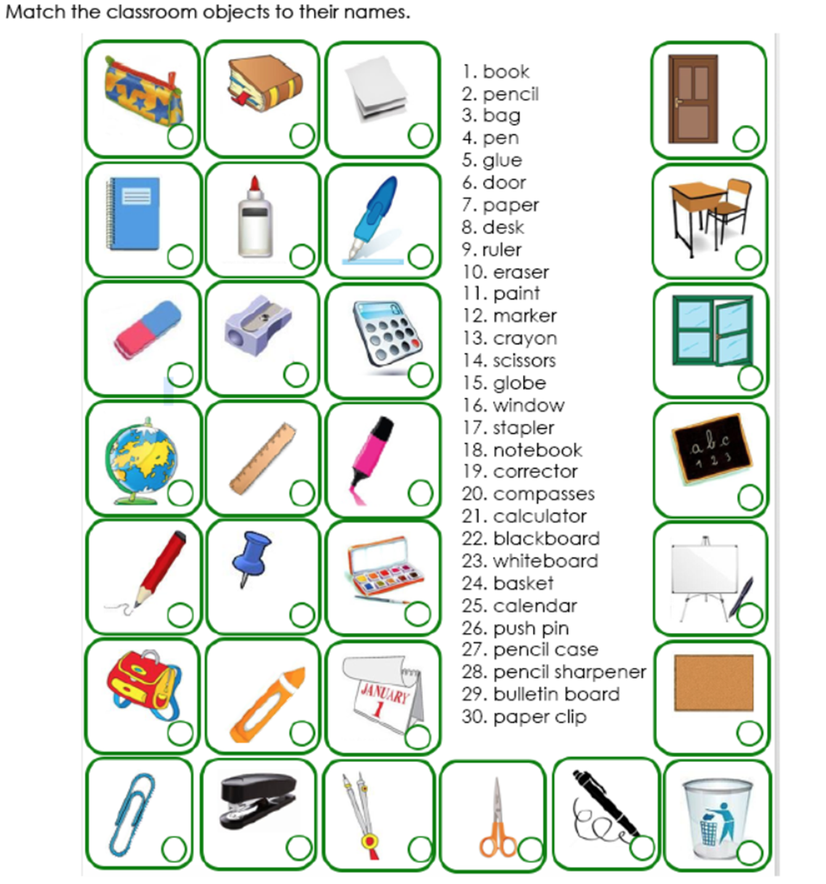

**1**

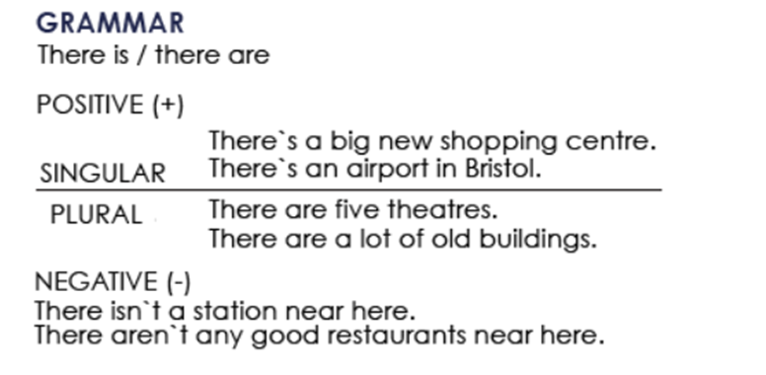

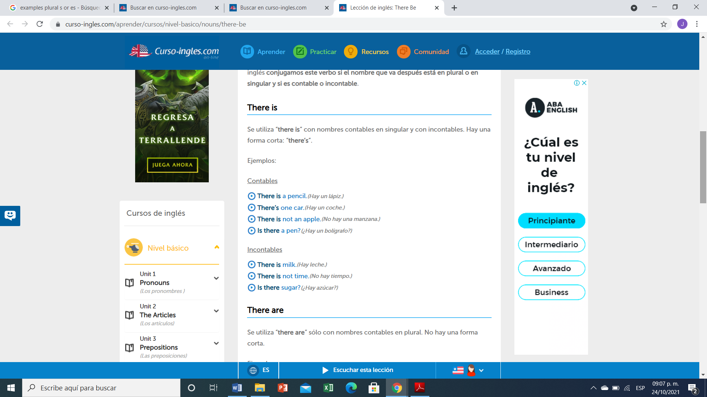

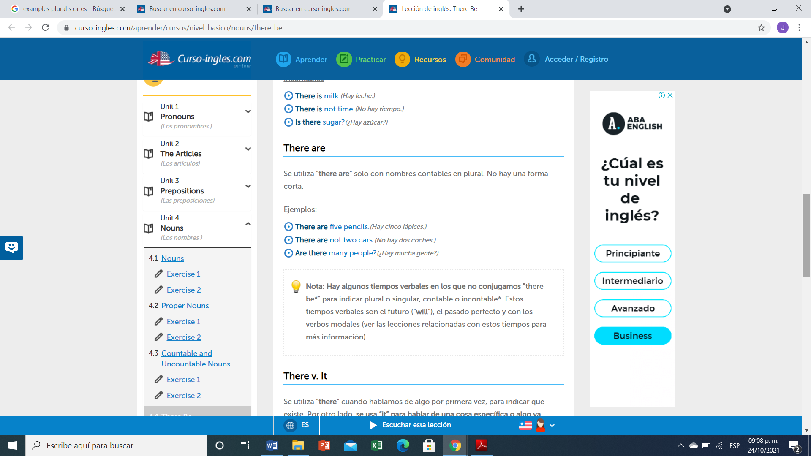

**Ejercicio #4 -** Completa las siguientes frases con la forma correcta de "there is or There are".

1. ____there are_______ 5 apples in the bowl.
2. _____there is______ any water?
3. ___there are____ (not) any sugar in the coffee.
4. ____there are____ (not) any tomatoes in the salad.
5. ____there is_____ some wine in the glass.
6. ___there are____ any money in your wallet?
7. ___there is__ a problem with this phone.
8. ___there are___ any vegetables in this recipe?

**Ejercicio #5 -** Escribe las palabras en el orden correcto.

many / aren’t / this / pages / there / in

R:there aren’t many in the pages

any / eggs / there / the / in / are / fridge / ?

R: there are eggs in the fridge

is / nearby / restaurant / nice / there / a

R: there is a restaurant nearby

dining / are / chairs / in / room / there / three / the

R: there are three in the chairs dining

hospital / there / this / isn't / a / in / town

R: there isn’t in hospital in this town

here / is / bank / there / a / near / ?

R: there is a bank near here

**TOPIC 4: PERSONAL INFORMATION**

**Exercise 1.** Contesta las siguientes preguntas.

1. What`s your first name?

A: IAN

2. What`s your surname or last name?

A: SANTIZ LOPEZ

3. What`s your nationality?

A: MEXICO

4. What`s your address?

A: BARRIO LOS OLIVOS

5. What`s your mobile number?

A: 919 169 2994

6. What`s your mail address?.

## A: ianandresantizlopezgmail.com

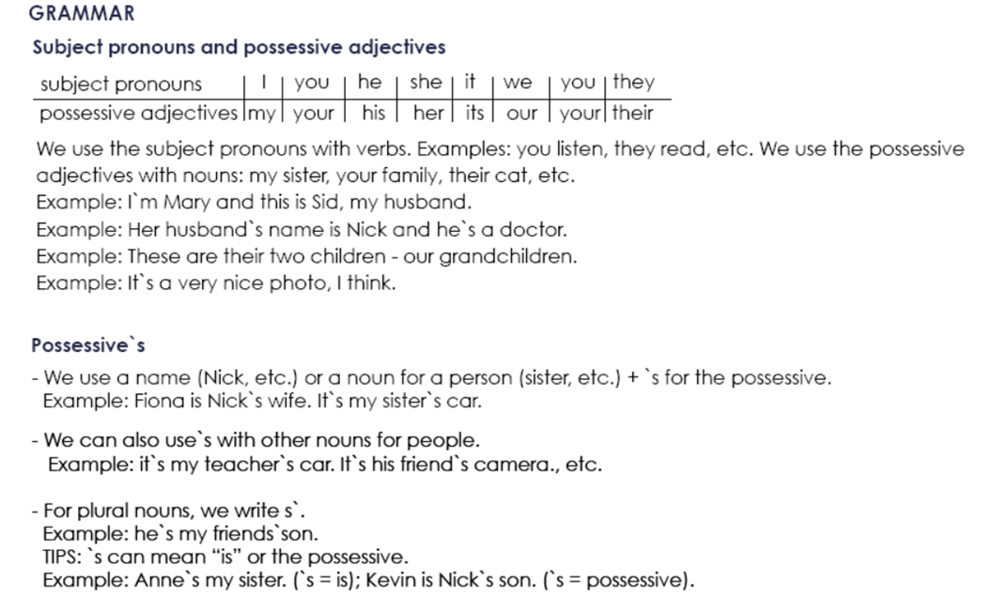

**Possessive Adjectives - Adjetivos Posesivos**

Se utilizan para indicar a quién pertenece el sujeto u objeto de la oración. Van seguidos de un sustantivo (o una cláusula nominal).possessives adjectives

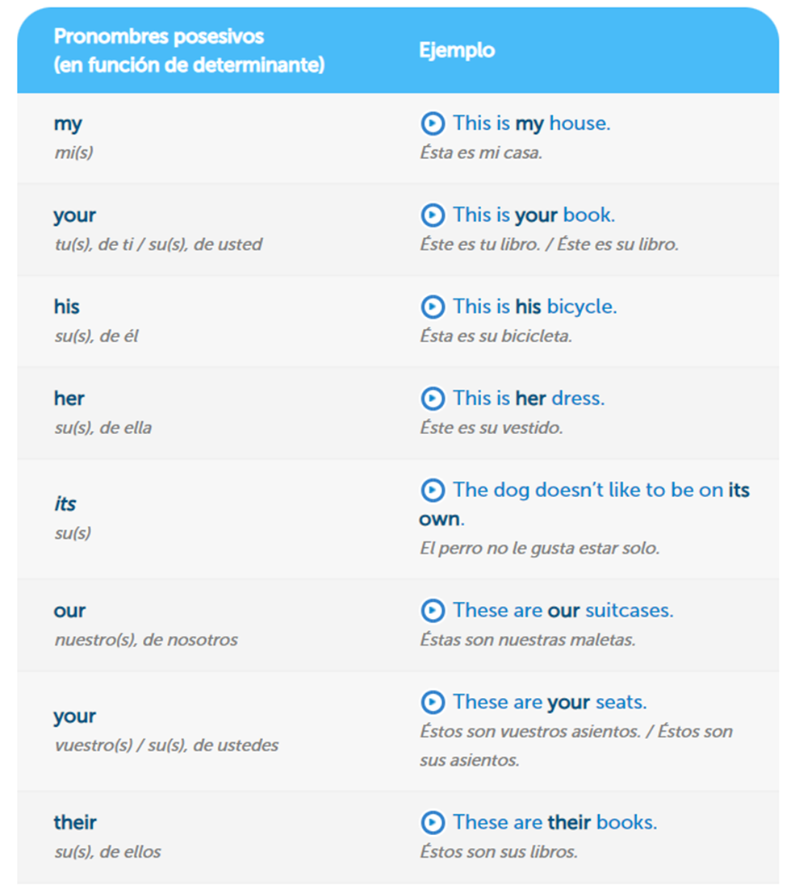

**Exercise 2.** Complete the sentences with a possessive adjective.

Example: My name´s Stephen.

1. Angela, please turn off ___the________ mobile phone.

2. The students are from Italy.____my_______ names are Susanna and Carlo.

3. London is famous for ____the_______ red buses.

4. She`s French, but_____it is the______ mother is English.

5. We`re in Class 3._____the______ teacher is Bob.

6. _____my______ name is Ian. He`s from Scotland.

7. I`m Mike._____and my______ family are from Dublin.

**Exercise 3.** Write the questions.

Example: you how are ?: How are you?

1. his what`s name ? : __what’s his name_____

2. German mother is her ? : ___German is her mother____

3. from your are where parents ? : ___where are your from parents___

4. surname Simpson is your ? : __Simpson is your name___

5. spell do how your name you ? : __how you name do your spell___

**Exercise 4.** Traduce el siguiente vocabulario.

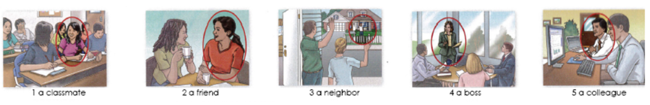

1.una compañera de clase

2.una amiga

3.una vecina

4.una jefa

5.una colega

**Exercise 5.** Circle the correct word or words to complete each sentence.

1. Mr. Thomas is ( my / I) boss.

2. Is Mrs. Cory (you / your) teacher.



3. Is (she / her) Dr. Kim?



4. Are (they / their) Connie and Sam?



5. Are (your / you) Barry`s friend?



6. He`s (my / I) colleague.



7. Mr. Benson is (Alec / Alec`s) neighbor.



8. Jake is (Ms. Rose / Ms. Rose`s) student.



9. (He`s / His) an architect.



10 (Kyle / Kyle`s) and Ray`s classmate is Gail.

