

**Nombre de alumno: Erick Ramírez C.**

**Nombre del profesor:**



**Nombre del trabajo: Unit Activity #1– U4 1BRH**

**Materia: Ingles**

**Grado: Bachillerato**

**Grupo: Recursos Humanos**

Comitán de Domínguez Chiapas a 28 de diciembre de 2022.

**TOPIC 4**

**Exercise 1.** Write the name of the numbers.

1 - One 11 - Eleven 30 - Thirtee

2 - Two 12 - Twelve 40 -Fourty

3 - Three 13 - Thirteen 50 - Fifty

4 - Four 14 - Fourteen 60 -Sixty

5 – Five 15 - Fivteen 70 - Seventy

6 – Six 16 - Sixteen 80 - Eighty

7 – Seven 17 - Seventeen 90 - Ninety

8 – Eight 18 - Eighteen 100 – One hundred

9 – Nine 19 - Nineteen 135 – One hundred thirtee five

10 – Ten 20 - Twenty 192 – One hundred ninety two

**Exercise 2.**  Complete with “am”, “is”, or, “are”.

1. My surname ___is____ López.

2. We ___are___ from Madrid.

3. I __am_____ Anna.

4. Antonio and Juan ____are____ in room 7.

5. He __is_____ the English teacher.

6. You ___are___ in Class 3.

7. She __is____ a student.

**Exercise 3.** Complete the questions with “who”, “what”, “where” or “how”.

1. ___what____`s your favorite sport?

2. ____who___`s Roberta from?

3. __who_____`s your favorite teacher?

4. ___how____are you?

5. ___what____time is it?

6. ___what____grade are you in?

7. ____what___`s your last name?

8. ____how___old is Mark?

**Exercise 4.** Translate to English:

1. Grandfather-Abuelo
2. Grandmother-Abuela
3. Grandson-Nieto
4. Granddaughter-Nieta
5. Father-Papa
6. Mother-Mama
7. Wife-Esposa
8. Husband-marido
9. Son- Hijo
10. Daughter- Hija
11. Sister-Hermana
12. Brother-Hermano
13. Aunt-Tia
14. Uncle-Tio
15. Niece-Sobrina
16. Nephew-Sobrino

**Exercise 5.** Complete the questions. Use “how old is” or “how old are”.

1.____How old are___________ your sisters?

2. ____How old are___________ Matt`s parents?

3. _____How old is__________ your grandfather?

4._____How old is __________ Helen`s husband?

5. ____How old is ___________ her children?

6. _How old is ______________ his son?

**Exercise 6.** Circle the correct word or words to complete each sentence.

1. Mr. Thomas is ( my / I) boss.

2. Is Mrs. Cory (you / your) teacher.

3. Is (she / her) Dr. Kim?

4. Are (they / their) Connie and Sam?

5. Are (your / you) Barry`s friend?

6. He`s (my / I) colleague.

7. Mr. Benson is (Alec / Alec`s) neighbor.

8. Jake is (Ms. Rose / Ms. Rose`s) student.

9. (He`s / His) an architect.

10 (Kyle / Kyle`s) and Ray`s classmate is Gail.

**Exercise 7.** Read about some famous actors and their families and friends.

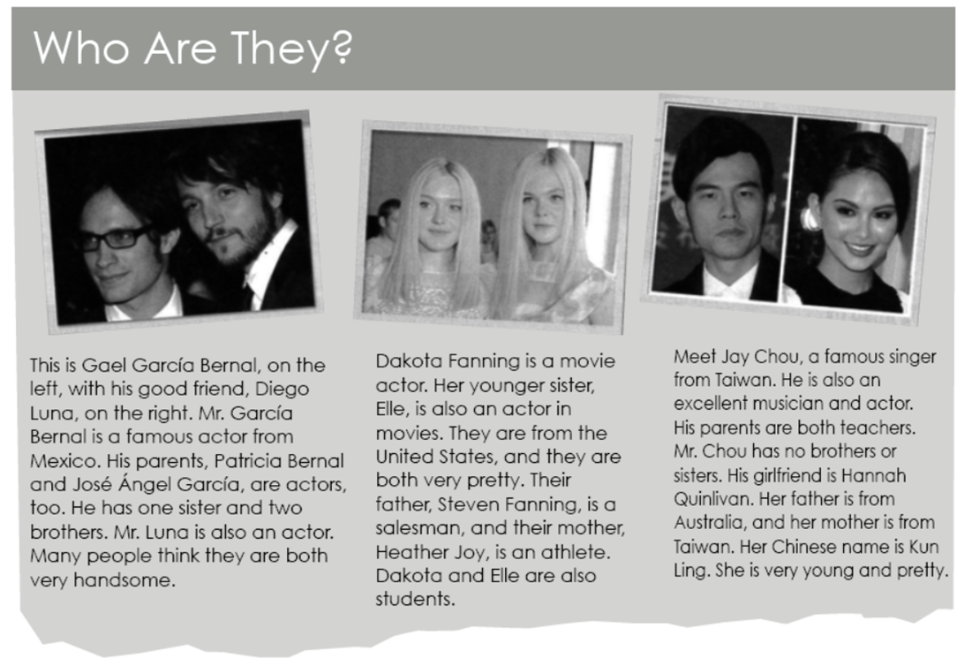

Now, complete the sentences.

1. Gael García Bernal is Diego Luna`s _Friends ________.

2. Patricia Bernal, José Ángel García, and Diego

Luna are all _____Brohters_____________.

3. Heather Joy is Steven Fanning`s _____Husband______.

4. Elle Fanning is Heather Joy`s____Daughter _____________.

5. Mr. Chou`s ________________ is good-looking.

6. Jay Chou`s parents have one _______________.

**Exercise 8.** Complete each sentence with “have” or “has”. Then choose the correct response. Circle the letter.

1. Matthew ___has_________ two sisters.

a. How old is she? b. How old are they?

2. Mark and Jamie __have________ a daughter.

a. How old is her? b. How old is she?

3. I ____have______ a brother and sister.

a. How old is your brother? b. How old is my sister?

4. We____have____ a son.

a What`s your name? b. What`s his name?

**Exercise 9.** Unscramble the words. Write sentences.

1. brother / tall / is / My / very

2. handsome / He / too / very / is

3. your / Are / pretty / sisters / ?

4. Is / daughter / young / Her

5. cute / so / is / she

1.-My brother is very tall

2.-He is very Handsome too

3.-Are your sisters pretty?

4.- is her daugther young?

5.-she is so cute