

**student's name**: Alessandro robledo herrera

**Teacher's name**: Enrique Eduardo Arreola Jiménez

**subject name**: English

**name of the job**: irregular verbs and infographic

**date**: december/date09/ 2022

**place**: Tapachula Chiapas México

**BASE FROM/ SIMPLE PAST**

Be : he is a student

We/were: eh was a student

Become : she become a teacher

Bacame: she became a teacher

Bite : the gat bites when upset

Bit: the gat bit annoyed

Bleed: I got mouth bleed

Bled: I got mouth bled

Break: this machine sometimes breaks down

Broke: this machine sometimes broke down

Bring:b web ring several gifts for hallowen

Brought:we brougth several gifts for hallowin

Build: it was build b yan mister

Built: it was built by an mister

Bume: I m going to bum some marsmallows

Bumed: I burmed some marsmallows

Buy: buy the groceries of the week

Bought: bought the pantry a week ago

Catch: my grandfhater catch fish

Caught: my grandfather caught fish

Choose: choose somes seasonal fruit

Chose: I chose seasonal fruits

Come: they come to parties for the sweets

Came: they came the parties for the sweets

Do:I do my homework in the aftermoon

Did: I did my homework in the afthermoon

Draw: I like to draw the sky

Drew I drow some landscapes

Dream: miguel dreams of being fotball

Dreamed: miguel dreamed of being fotball

Drink: she drink every moorning

Drank:she drank in the moorning

Drive: my sister drives motorcicles and cars

Droves: my sister drove motorcicles and cars

Eat: go out toe at at bar

Ate:they ate in the bar

Fall: the plane can fall from a great heiht

Fell: the plan fell from a great height

Feed: on the farm i feed horses

Fed: on the farm i fed horses

Feel: he feel a dream

Felt: he felt sleepy

Fight: he fights hard

Fought: he fought hard

Find: she is goin to find a dog

Found: th foun hr dog

Fit:he fit in to his new schedulce

Fit: he fit in to his new schedulce

Flee: she flee ah house

Fled: she fled a house

Fly: the airpantes can fly

Flew: the plane flew

Forbid:she forbid entry

Forbade : she forbade entry

Forget: she forgets her job

Forgot: she forgot her job

Get: he wants to got his gift

Got: he wants to got his gift

Give: they give all their effort

Gave: they gave all their effort

Go: she goes : shopping

Went: she went shopping

Grow: she grows up too fast

Grew: she grew up too fast

Have: they are going the have a party

Had: they to had a party

Hear: he wants to hear the music

Heard: he Heard to music

Hit: they hit a wall

Hit: thye hit a pared

Hold: they hold a dog

Held: they held a dog

Hurt: he s hurt

Hurt: he was hurt

Keep: he seeks to keep his job

Kept: he kept his job

Know: they know want to know english

Knew: they wanted to knew english

Lend: my syster lends some kitchen utensils

Lent: my sister lent kitchen utensils

Let: always let the house clean

Let: always left the house clean

Lose: in the shower i lose my earrings

Lost: in the shower I lost my earrings

Make: I like make food

Made: I like to have food made

Mean:sings mean certain things

Meant: the sings meant other things

Meet: people shuold meet in family

Met: the people met as family

Pay: they go to the store top ay for services

Paid: go to the store and leave paid

Put: they put flowers in the base

Put: thye put flowers in the base

Quit: eople quit the idea of purchasing

Quit:people quit the idea of purchasing a car

Read: the book is very well writen and easy t oread

Read: the book was easy to read

Ring: when he rides he gets exhauseted

Rode: when I rode was I was exhaused

Rise: loud noises make my ears ring

Rang: loud ears rang ears

Run: the planes rise

Rose: the planes rose

Run: in races ha can run very fast

Ran: in races he ran fast

Say:can say difficult Works

Said: said difficult Works

See: you can see the house from afar

Saw: the house was seeen far away

Sell: vegetables are sold there

Sold vegetales were sold there

Send: send the gift is easy

Sent: the gift is already sent

Sew: clothes are se won the machine

Sewed: the clothes were sewed early

Shake: the earhth shake hard

Shook: the earth shook strongly

Sing: Carlos sing in a bar

Sang: Carlos sang in a bar

Sit: hr sit confortable

Sat: he sat in the ugly chair

Sleep: leo sleeps in the work meetings

Slept: leo slept in the work meetings

Speak: carol speaks in all classes

Spoke: carol spoke in class

Spend:my uncle spends the money on drinks

Spent: my uncle the money on drinks

Spread:ángel apreads a loto f jam on his bread

Spread ángel spread a loto f am on his bread

Stand :I stand on the beach to see the sun

Stoo: I stood on the beach t osee the sun

Steal : my brother steals my chocolates

Stole: my brother stole my chocolates

Stick: bees Sting mary

Stund: maría was student by bees

Strike: in the school they go on strike change the prinpal

Struck: at school they struck rude people

Swim: going swim in the pools

Swam: swam in the pools

Take: they are going to take pills

Took: they already took pills

Teach: in the clas they teach chemmistry

Taugh: in the clas they taugth chemistry

Tell: my grandmother tell that alcohol is bad

Told: my grandmother told that alcohol is bad

Think : I think family is very importand

Tougth: my tougth is always be friendly

Throw: hunters throw weapons ah their victims

Threw : the hunters threw bullets at the animals

Understand: it is easier to understand in practice

Understood: is understood in practice

Wake: I find it hard to wake up early

Woke: I had a hard time woke up early

Wear: I am wearing a dress for the party

Wore: she wore a dress to the party

Win: I always win the video game

Won I won gain in my video game

Write: they can write a book

Wrote: they grote a book

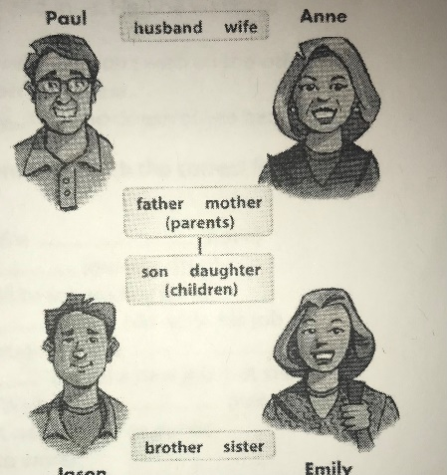

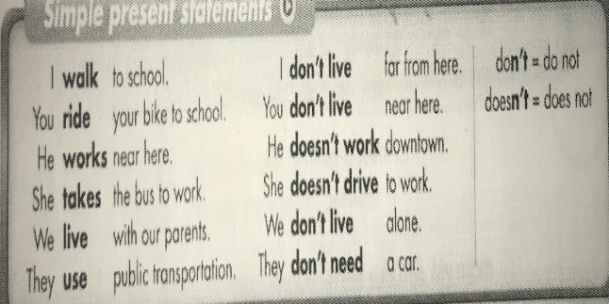 **SIMPLE PRESENT**

SIMPLE PRESENT EXAMBLE:

(she become a teacher)

(she is goin to find a dog)

(he eats fruit)

* **Anne is paul ( wife)**
* **Jason and emily are their (children)**
* **Paul is Anne (husband)**
* **Jason is Anne (father)**
* **Emily is Pauls (sister)**

**WORD POWER**

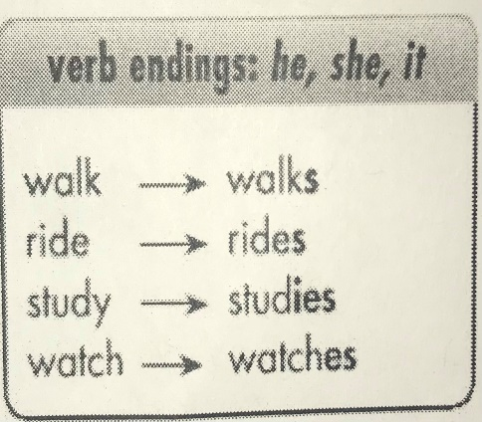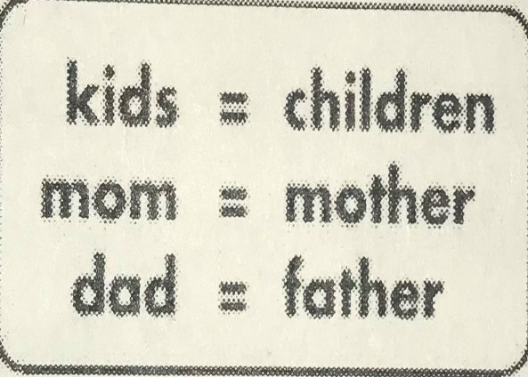

Terminaciones verbales

Kids: (niños) children: ( niños)

Mom: (mama) mother: ( madre)

Dad: ( papa) father: ( padre)