

**Nombre de alumno: Paula Aguila Morales**

**Nombre del profesor: Juan Manuel Jaime Díaz**



**Nombre del trabajo: Unit Activity #1 Unit 4**

**Materia: Ingles III**

**Grado: 3ro**

**Grupo: A**

Comitán de Domínguez Chiapas a 31 de julio de 2022.

**VOCABULARY - Types of clothing and shoes**

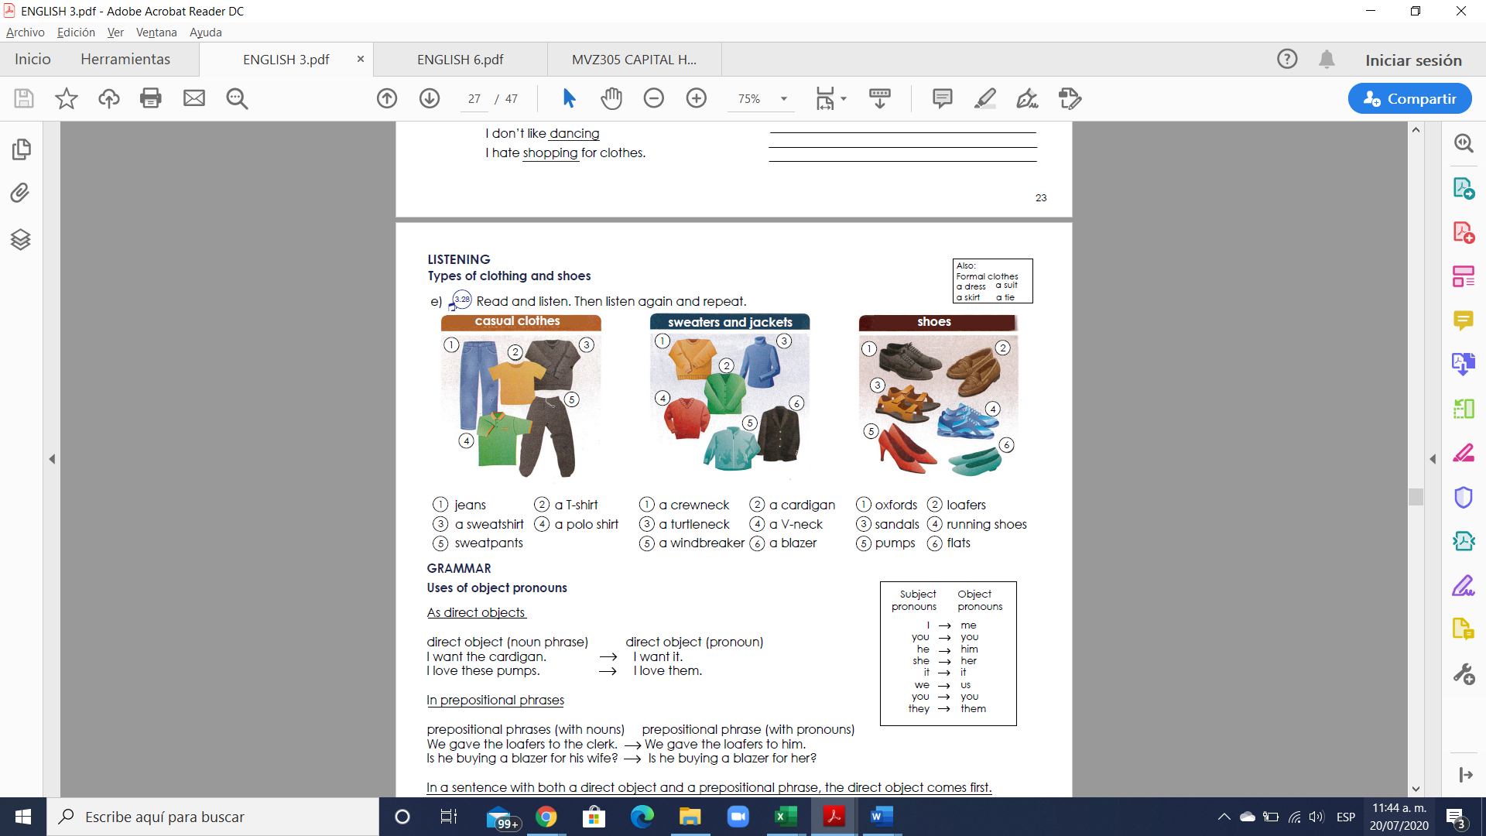

**Exercise 1.** Translate the vocabulary. (Traduce el vocabulario de la parte de arriba)

Casual clothes

1. Pantalones

2. Playera

3. Sudadera

4. Camisa polo

5. pants deportivos.

Sweaters and jackets Shoes

1. sueter de cuello Redondo 1. Zapatos de vestir

2. sueter de botones 2. Zapato sin agujeta

3. sueter cuello de Tortuga 3. Sandalias

4. sueter cuello v 4. Zapatos de correr

5. sudadera rompeviento 5. Zapatillas

6. un saco. 6. Zapatos bajos.

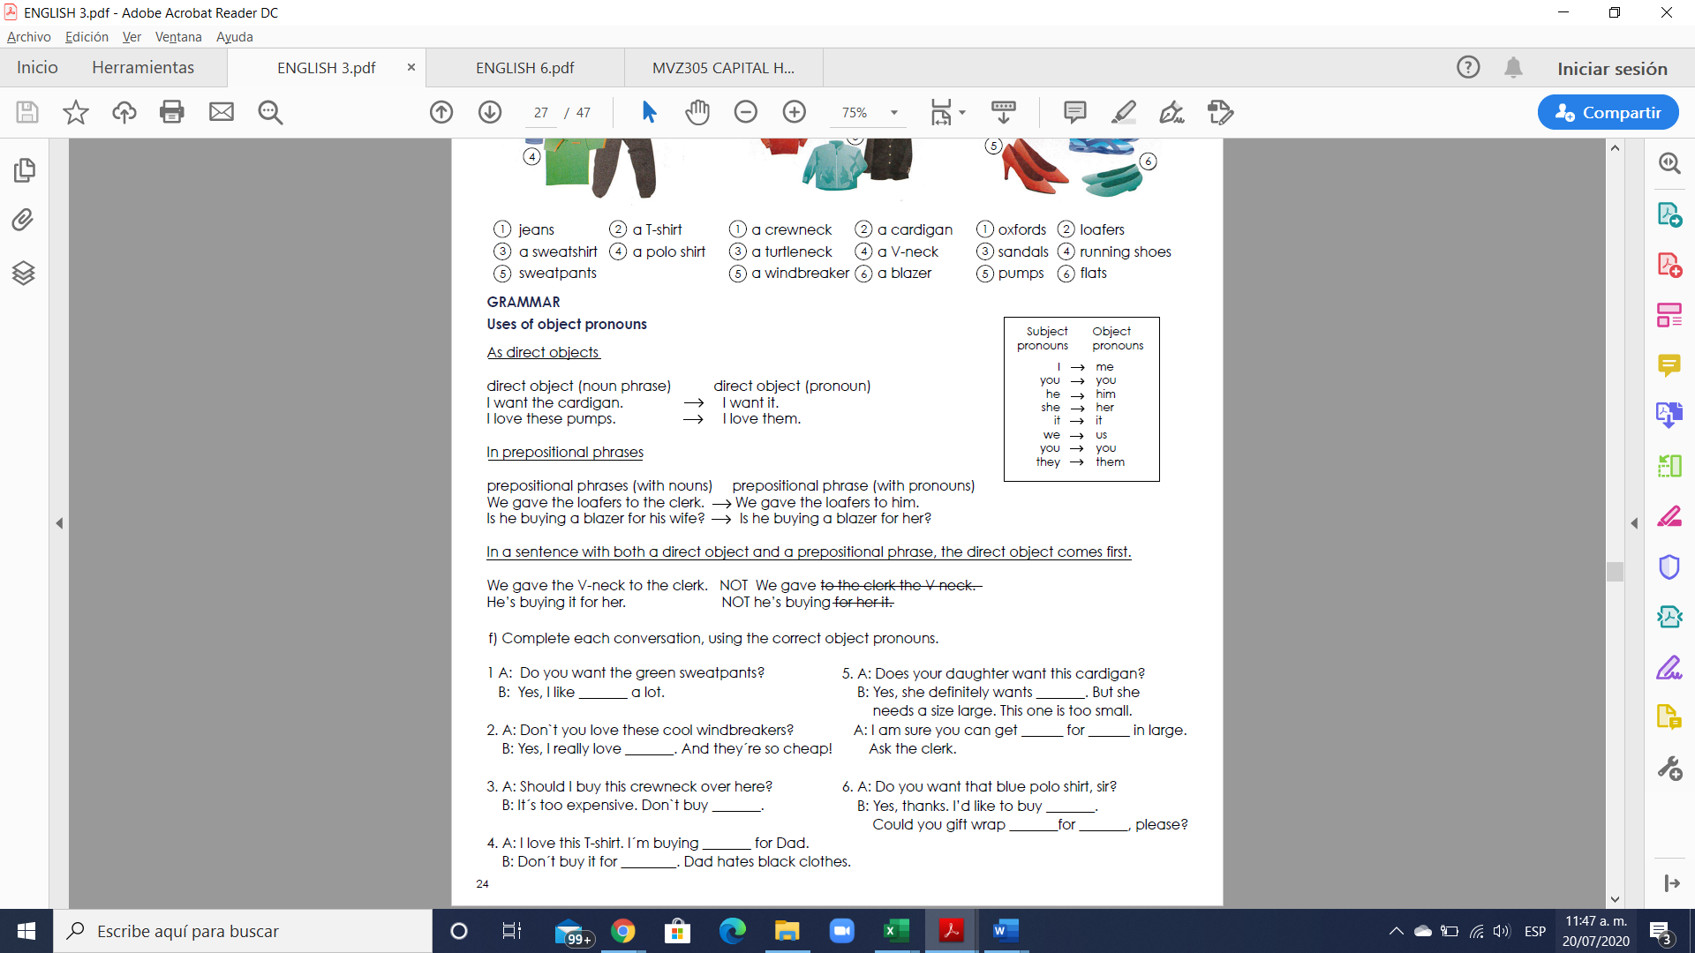

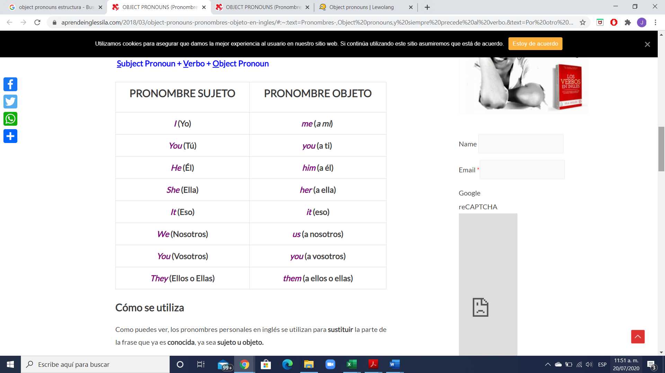

Los personal object pronouns son palabras que se utilizan para sustituir a un nombre y así evitar repeticiones. La principal diferencia entre los personal pronouns y los personal object prononuns es que mientras que los primeros reemplazan a un nombre que hace la función de sujeto, los segundos sustituyen a un nombre que no hace función de sujeto.

Una de las principales características de los personal object pronouns es que se sitúan detrás del verbo o bien detrás de una preposición (at, for, with, etc.)

Los personal object pronouns sustituyen a los nombres que hacen función de objeto, es decir, a la persona, animal o cosa que recibe directa o indirectamente la acción expresada por el verbo. Siempre se colocan detrás de un verbo o una preposición.

**Exercise 2.** Complete each conversation, using the correct object pronouns

1 A: Do you want the green sweatpants?

B: Yes, I like __them___ a lot.

2. A: Don`t you love these cool windbreakers?

B: Yes, I really love ____them___. And they´re so cheap!

3. A: Should I buy this crewneck over here?

B: It´s too expensive. Don`t buy ___it____.

4. A: I love this T-shirt. I´m buying ____it___ for Dad.

B: Don´t buy it for __him____. Dad hates black clothes.

5. A: Does your daughter want this cardigan?

B: Yes, she definitely wants ___it____. But she needs a size large. This one is too small.

A: I am sure you can get __it__ for __her__ in large. Ask the clerk.

6. A: Do you want that blue polo shirt, sir?

B: Yes, thanks. I’d like to buy __it___. Could you gift wrap __it__for ___me____, please?

**Exercise 3.** Fill in the gaps with object pronouns.

1. A: Do you like studying English?

B: Yes, I love __it___ .

2. A: Do you like Lady Gaga?

B: Yes, I like ___her___ a lot.

3. A: Do you like getting up early?

B: No, I hate ___it___.

4. A: Do you like Johnny Depp?

B: Yes, I love ___him_____!

5. A: Do you like soap operas?

B: No, I hate ____them___.

6. A: Do you like dogs?

B: Yes, but they don´t like ___me____!

**Exercise 4.** Select the correct answer**.**

1. The teacher wants to talk to __you____ about your homework.

a) him

b) her

c) you

2. Be careful; he lied to __us___ before and he may do it again.

a) us

b) they

c) we

3. Where are Andres and Maria? Didn´t invite ___them____.

a) us

b) them

c) we

4. The spider bit _me___ on my ankle.

a) us

b) they

c) me

5.The movie was great!! We really liked ___it___.

a) him

b) them

c) it

**Exercise 5.** Write 5 sentences using the object pronouns.

1. He cooked dinner today for you.

2. She doesn’t like to go with me.

3. The gift is not for you; it is for your brother.

4. She don’t like go to cinema with us.

5. He don’t watch movies with you.

**VOCABULARY - Food**

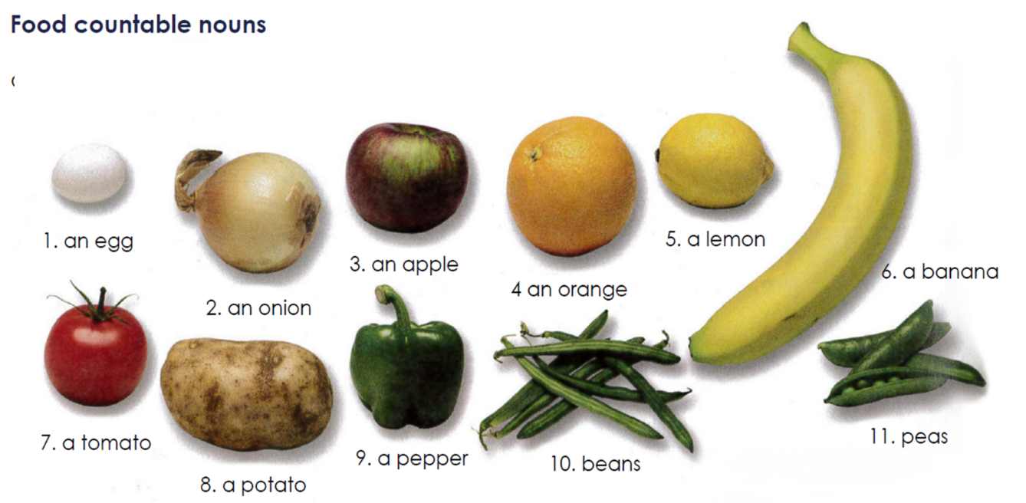

**Exercise #6.** Translate the vocabulary above. (Traduce el vocabulario de la parte de arriba)

1. Un huevo

2. Una cebolla

3. Una manzana

4. Una naranja

5. Un limon

6. Un platano

7. Un tomate

8. Una papá

9. Un pimiento

10. Frijoles

11. Chicharos.

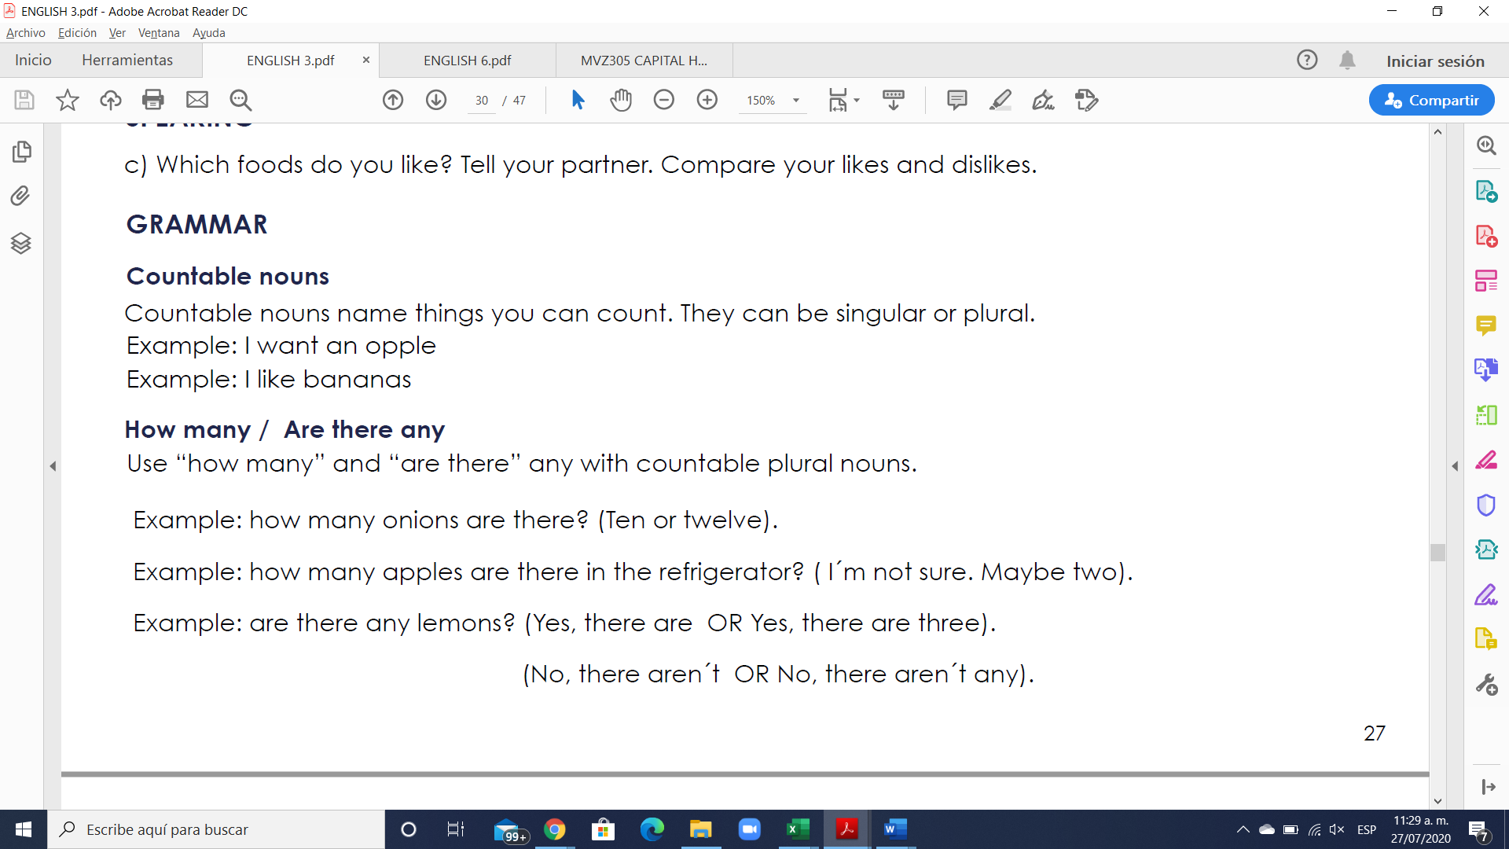

**Los countable nouns** son aquellos elementos que pueden ser contados de uno en uno utilizando los números.

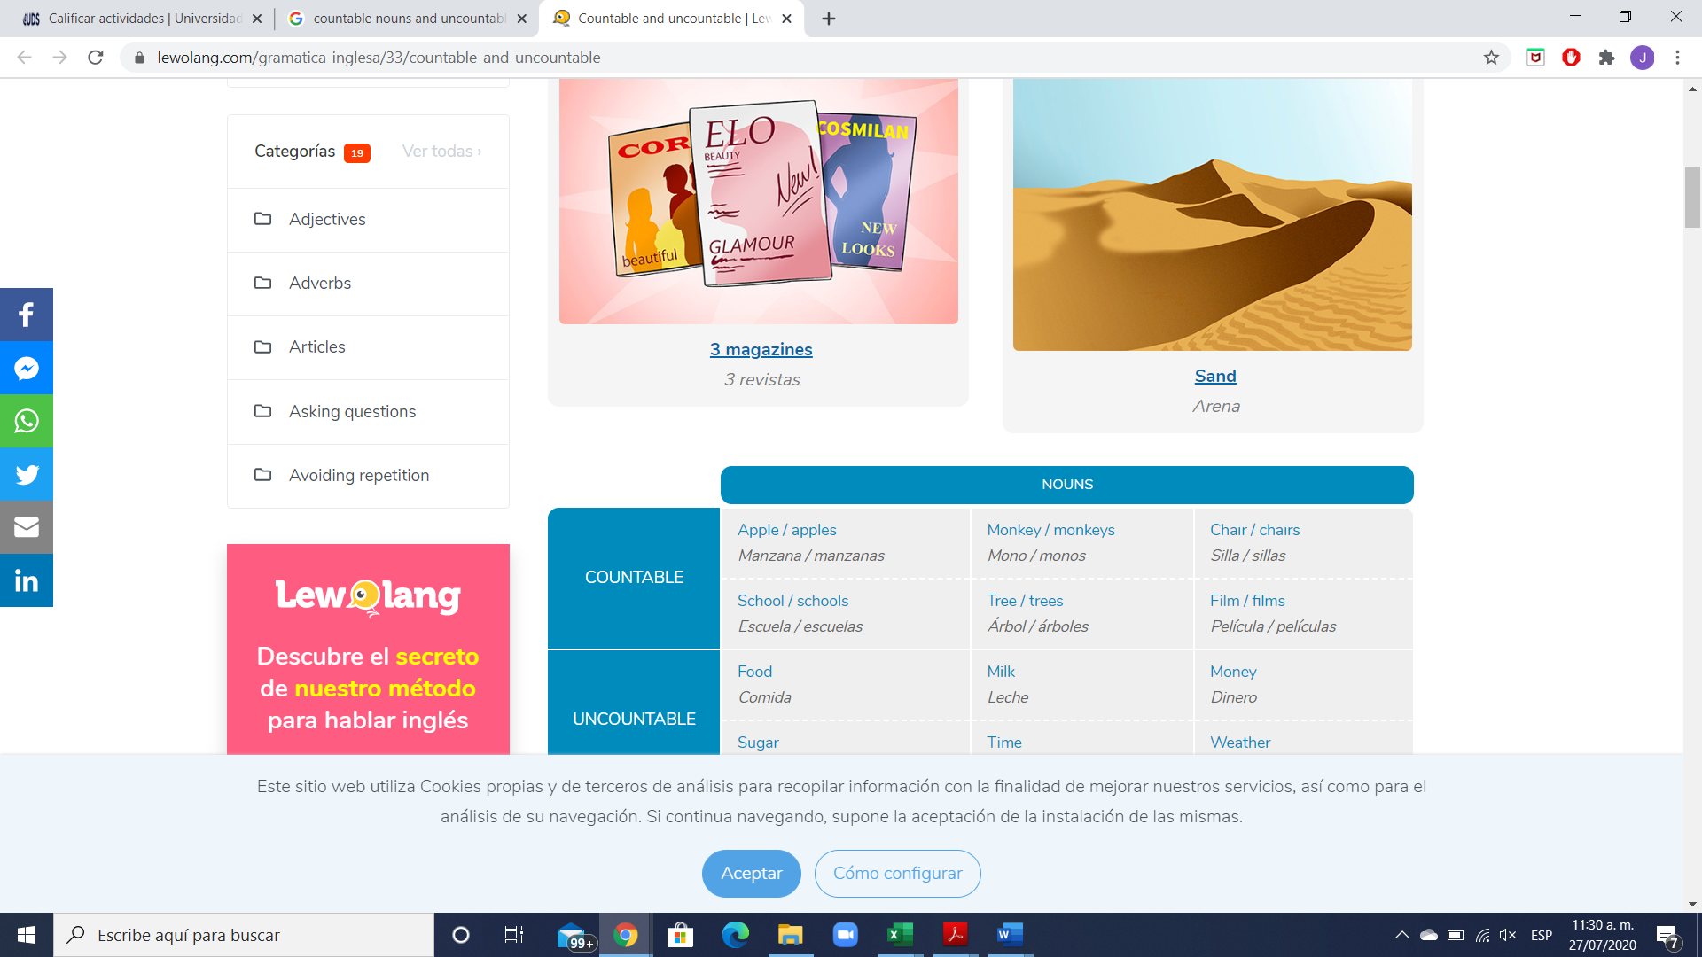

**Los nombres contables** tienen forma de singular y plural. Cuando nos referimos a los nombres contables en singular, estos pueden ir precedidos por el artículo indeterminado **a/an.**

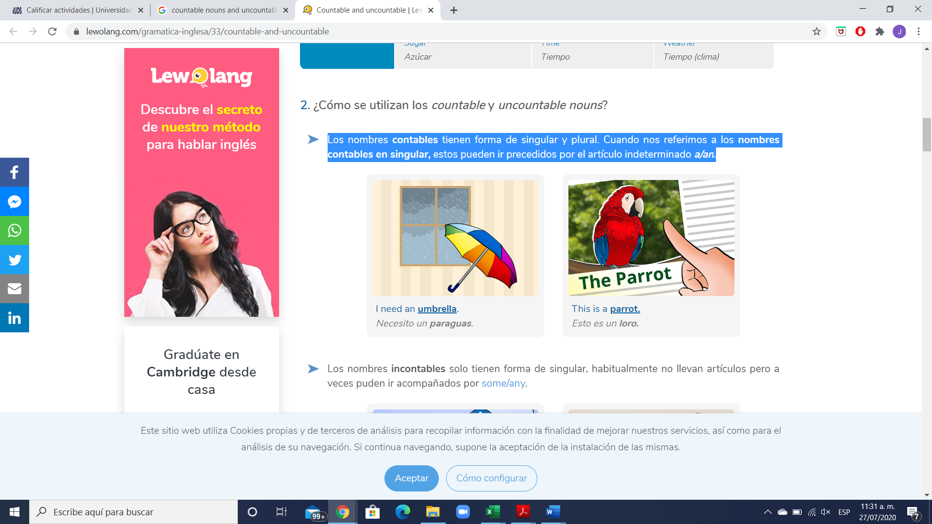

**Exercise #7.** Write 5 sentences using countable nouns. Escribe 5 oraciones usando nombres contables.

1. I want an apple.

2. I need an onion for dinner.

3. I want a couples of tomatoes.

4. She wants a cat.

5. They need a lemon for breakfast.

**GRAMMAR**



**How many** = Cuantos… ? (se usa solo para nombres contables)

**Are there any** = Hay algunos…? (se usa solo para nombres contables)

There are any + plural noun = Are there any + plural noun?

Example: “Are there any trains to London this morning?”

**Exercise #8.** Write 6 sentences using How many / Are there any. Escribe 5 oraciones.

1. How many apples do you have?

2. How many cars are there in the parking lot?

3. How many chairs are there in the school?

4. Are there any beans to sell? No, they aren’t

5. Are there any onions? Yes, they are two

6. Are there any lemons for dinner? Yes, but not many.

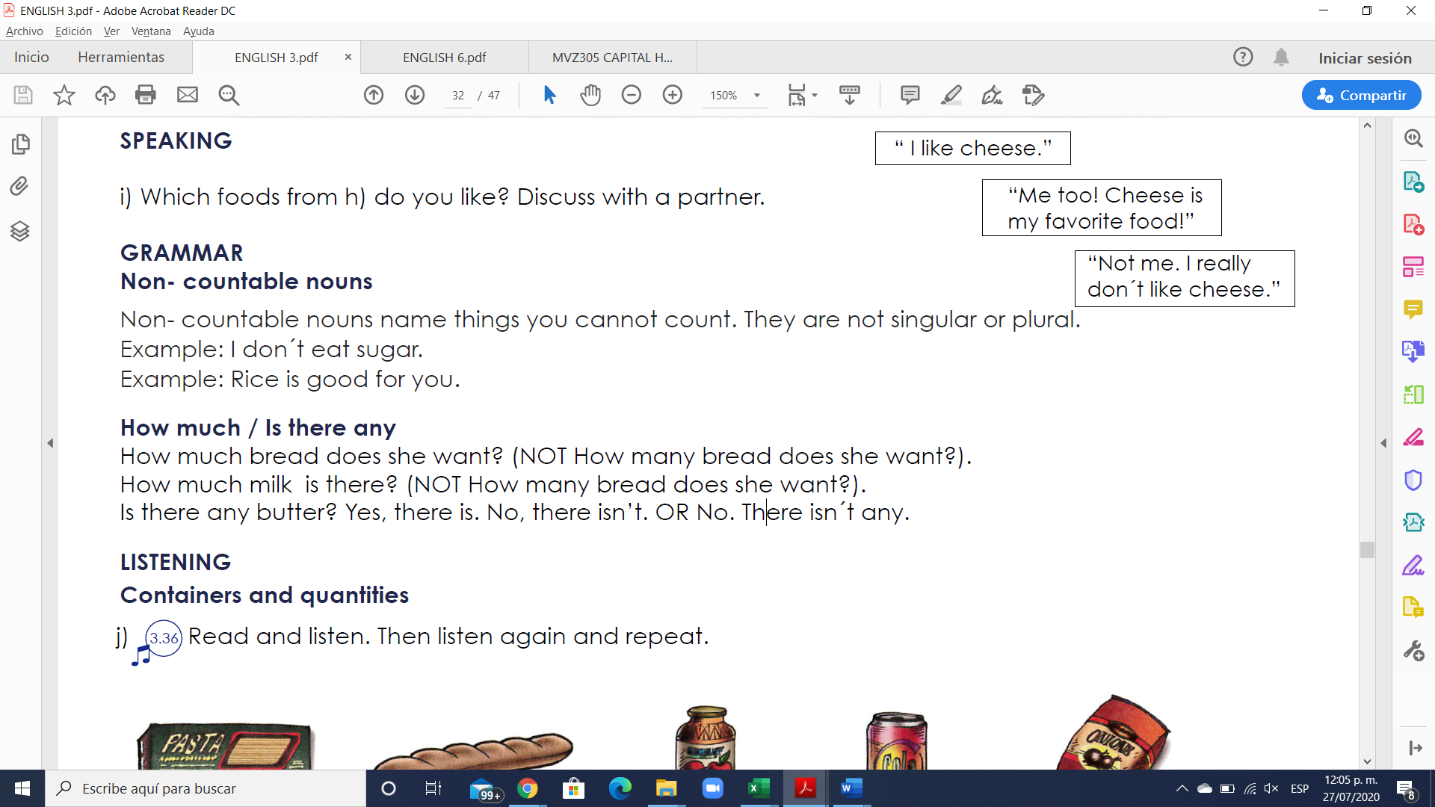

Los **uncountable nouns** son aquellos elementos que no podemos contar usando números, pero sí utilizando cuantificadores o partitivos.

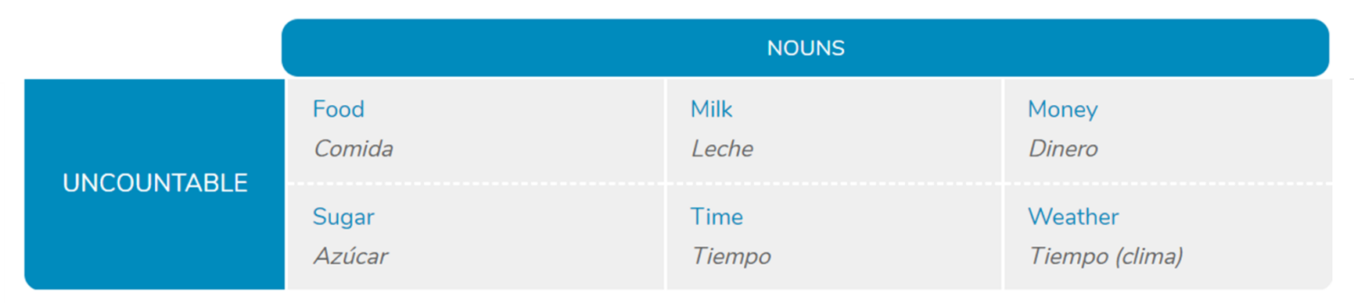

**Los nombres incontables** solo tienen forma de singular, habitualmente no llevan artículos, pero a veces pueden ir acompañados por **some/any**.

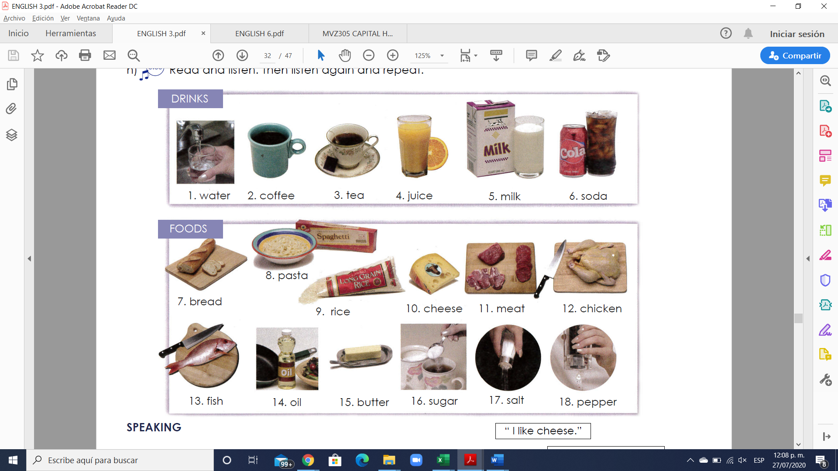

**Exercise #9.** Write 5 sentences using uncountable nouns. Escribe 5 oraciones usando nombres incontables.

1. I need some juice

2. There is some rice for dinner

3. You have to buy some bread

4. There is not any bread

5. Is there any fish?

**GRAMMAR**

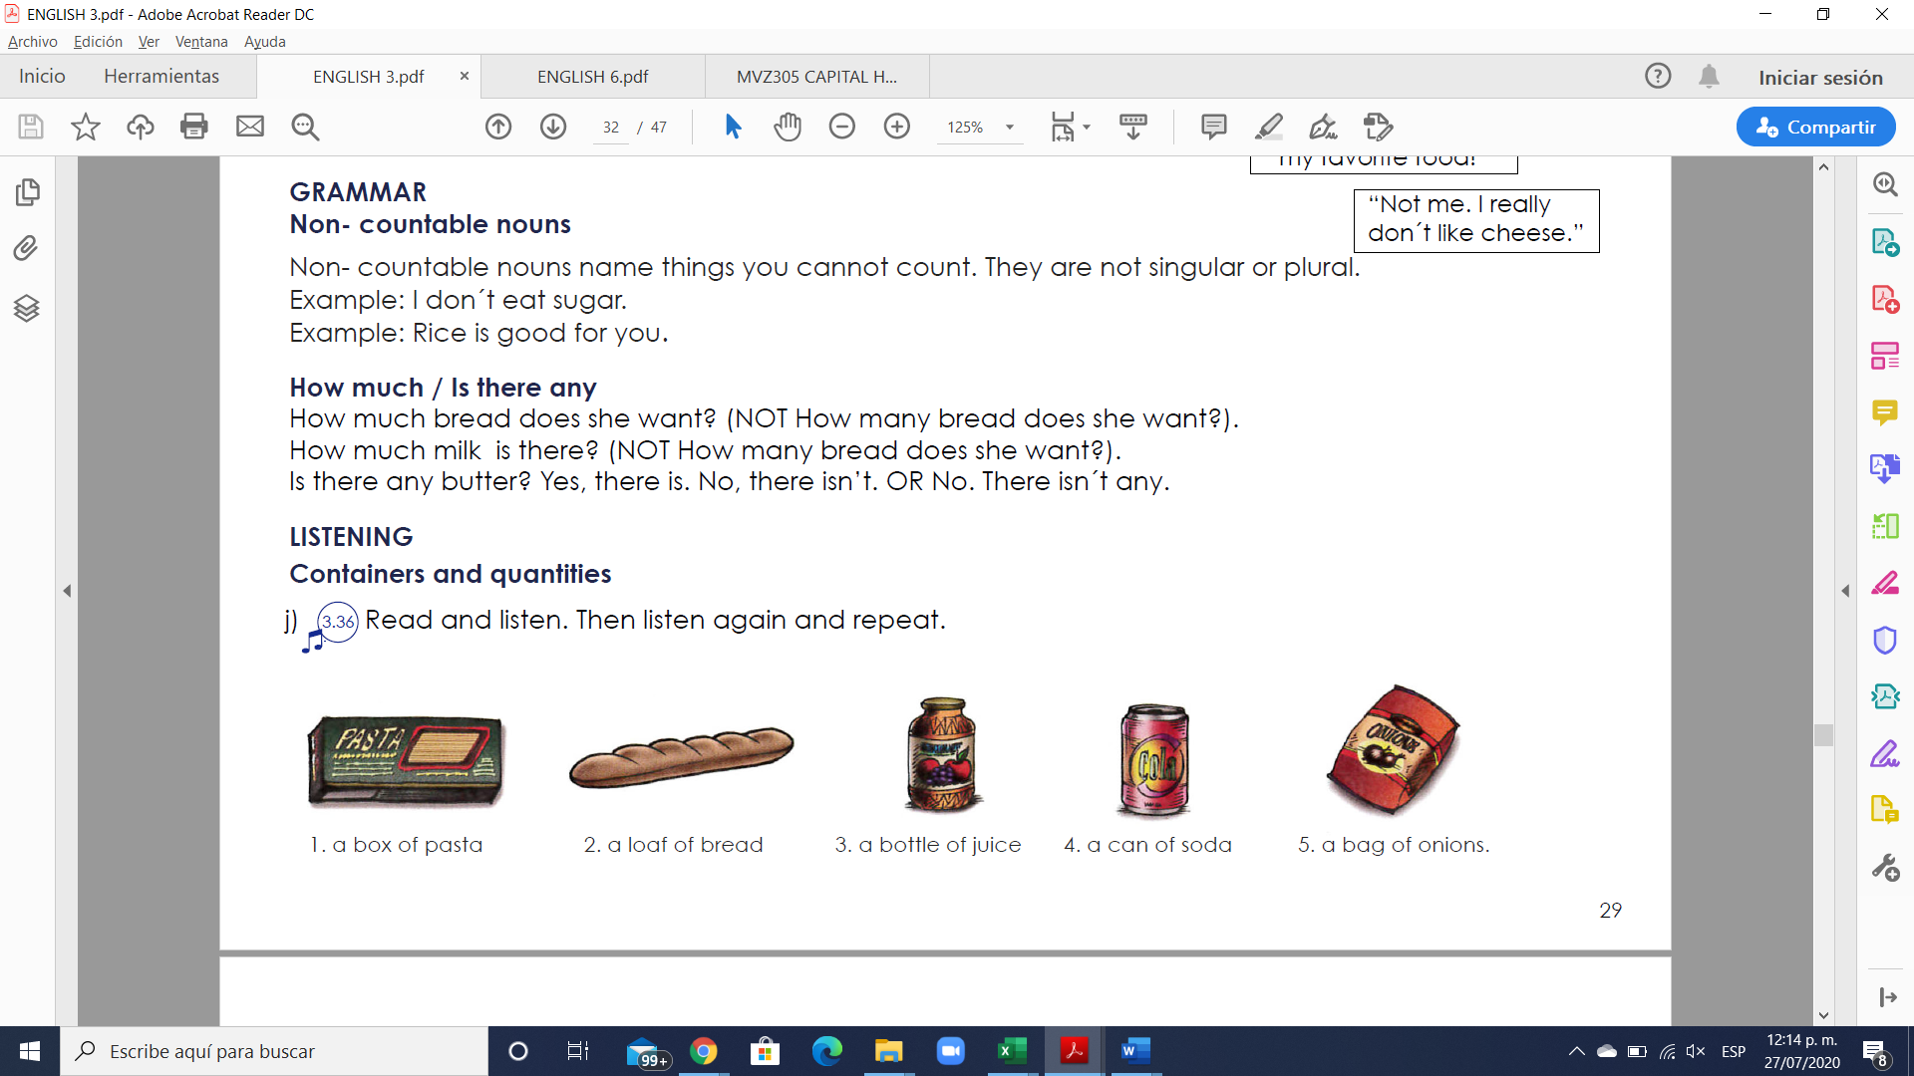

**How much** = Cuantos… ? (se usa solo para nombres incontables)

**Are there any** = Hay algunos…? (se usa solo para nombres incontables)

There is any + uncountable noun = Is there any + uncountable noun?

Example: “Is there any time to go shopping?”

**Exercise #10.** Write 6 sentences using How much / Is there any. Escribe 5 oraciones.

1. How much coffee does she want?

2. How much fish do you eat today?

3. How much cake do you want for your birthday?

4. Is there any sugar? Yes, there is

5. Is there any oil? There isn’t

6. Is there any juice you like? Yes, the red one.

**Exercise #11.** Complete the questions with “how much” or “how many”.

1. ____how many____ loaves of bread do you need?

2. ____how many____ bags of potatoes do we have?

3. ____how much____ cheese is there in the fridge?

4. ____how much___ sugar do you want in your tea?

5. _____how many__ eggs are there for the potato pancakes?

6. ___how many______ cans of tomatoes are there on the shelf?

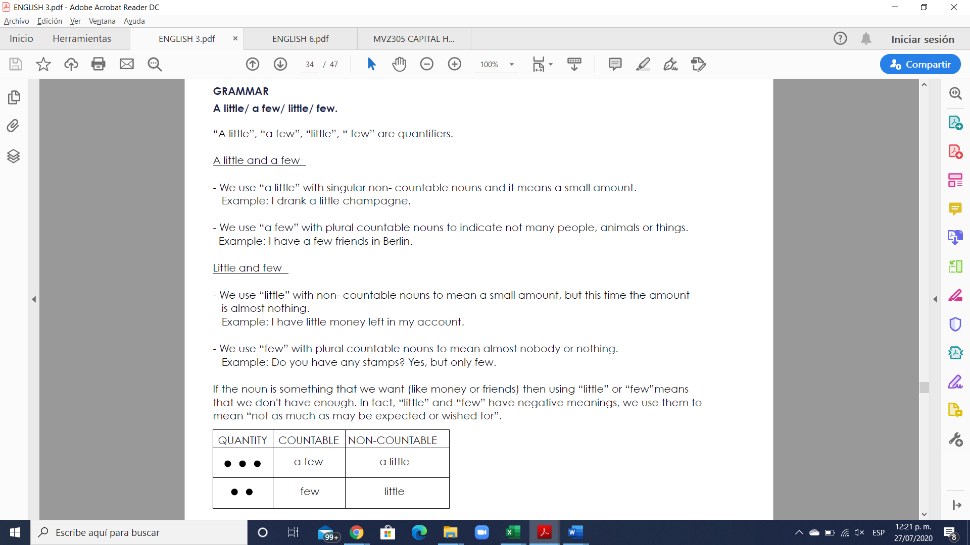

**Exercise #12.** Rewrite the sentences using few/ little.

1. We don`t have much bread left. ______We have a few bread__________________

2. The twins don’t eat many vegetables. _________The twins eat few vegetables_______

3. These students don’t ask many questions. ____The students ask little many questions_____

4. They don’t have much opportunity to talk with him. __They a little opportunity to talk to him

5. The guests aren’t drinking much wine with their meal. ___The guests a little drinking wine with their meal

6. Not many people come here. _____________Few people come here________________

**Exercise #13.** Answer the questions using “a few”/ “a little.

1. Have you visited many churches? Only a few.

2. Does she make many mistakes in English? __a few________________________

3. Do you have many friends in your building? ___a few_________________________

4. Do you have any money left? __a little_______________________________________

5. Would you like something to eat? ___a little______________________________________

6. Do you speak German? ____a little_____________________________________________