

**Nombre de alumno:** **Alexa Odisley Solórzano Aguilar**

**Nombre del profesor: Juan Manuel Jaime Díaz**



**Nombre del trabajo: Actividad 1**

**Materia: Ingles III**

**Grado: 3ro**

**Grupo: A**

Comitán de Domínguez Chiapas a 20 de mayo de 2022.

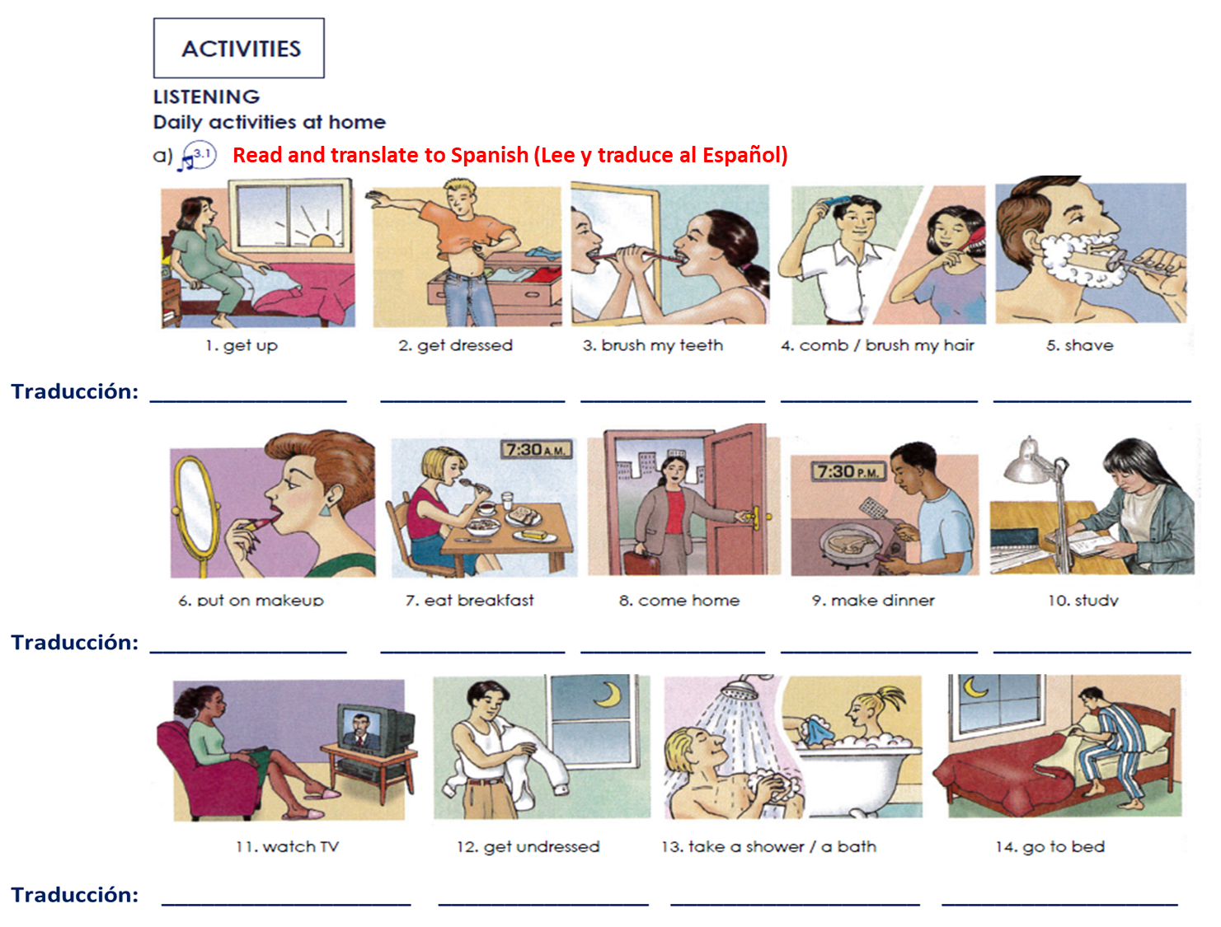

Ir a la cama

Tomar un baño/ bañarse

Desvestirse

Ver televisión

Estudiar

Hacer la cena

Llegar a casa

Desayunar

Maquillarse

Afeitarse

Peinarse/ cepillarse el pelo

Cepillarse los dientes

Vestirse

Levantarse

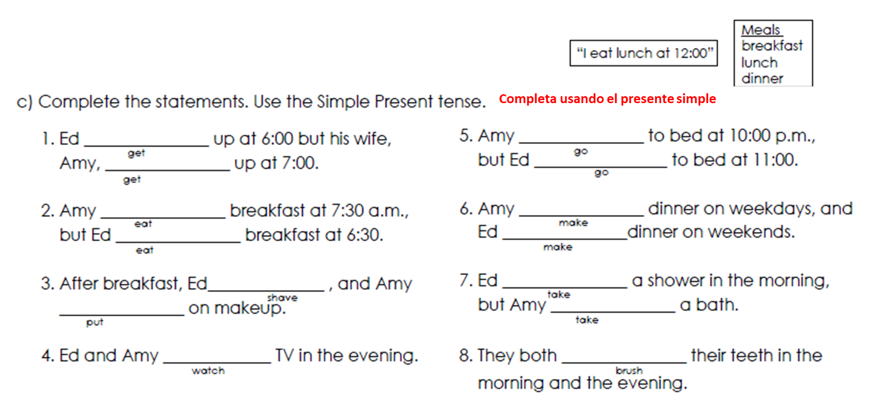

brush

takes

takes

makes

makes

goes

goes

watch

puts

shaves

eats

eats

gets

gets

**d) Write 7 sentences using the next vocabulary (escribe 7 oraciones usando el vocabulario en listado)**

1. get up: I always get up at 7:00 A.M.

2. get dressed: I dress up to go to school

3. brush my teeth: I brush every morning

4. comb / brush my hair: I comb my hair when I leave home

5. shave: I shave frequently

6. go to bed: I go to be late

7. watch TV: I see the TV everyday

**Vocabulary**

**Exercise 2. Read and translate.**

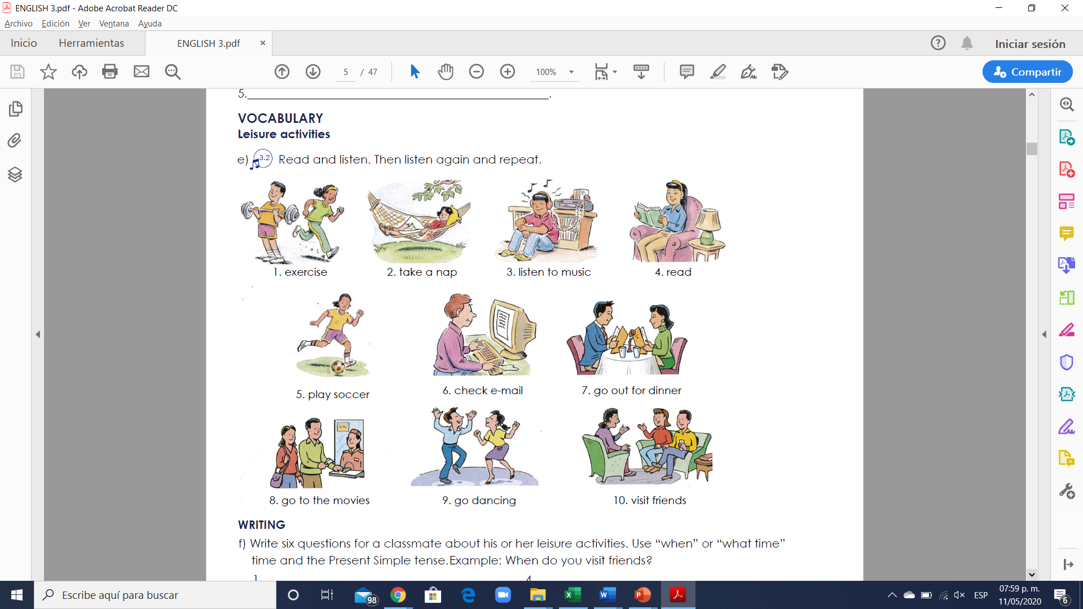

**Translation**

1. Ejercicio

2. tomar una siesta

3. Escuchar musica

4. Leer

5. Jugar futbol

6. Revisar correo electronico

7. Salir a cenar

8. Ir al cine

9. Ir a bailar

10. Visitar amigos.

**Exercise 3. Write six questions using the vocabulary upside. Use “when” or “what time” and the Present Simple tense. (Escribe 6 oraciones usando el vocabulario de arriba y usando las preguntas “when” ó “what time”)**

Example: When do you visit friends?

1. ________What time does he watch at TV? __________.

2. _____When do you shave? _______________.

3. _______When do you home? ____________________.

4. _________________What time does she study? _________.

5. ____What time do you make dinner? _________________.

6. _________What time are you coming? _______________.

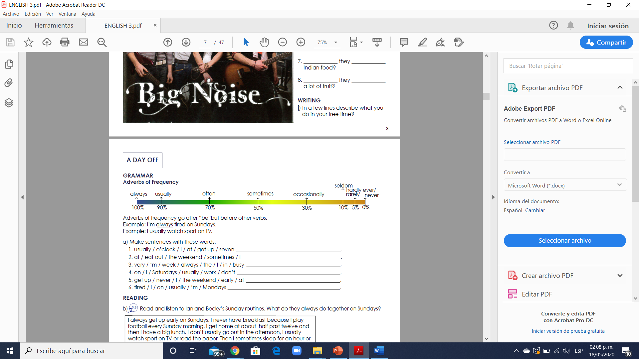

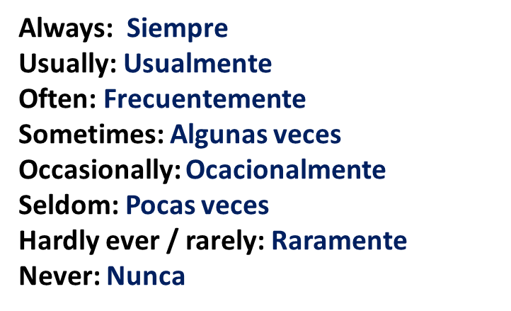

**Exercise 1. Make sentences with these words. (Realiza las oraciones usando las palabras debajo)**

1. usually / o’clock / I / at / get up / seven

2. at / eat out / the weekend / sometimes / I

3. very / ‘m / week / always / the / I / in / busy

4. on / I / Saturdays / usually / work / don’t

5. get up / never / I / the weekend / early / at

6. tired / I / on / usually / ‘m / Mondays

**Answer:**

1. I usually get up at seven o’clock

2. I sometime eat out at the weekend

3. I’m always very busy in the week

4. I usually don’t work on Saturdays

5. I never get up early at the weekend

6. I’m usually tired on Mondays.

**Exercise 2. Select the correct adverb of frequency according to the sentences.**

1. I seldom visit my relatives, so I ___usually___ see my uncle John.

a) usually

b) almost never

c) almost always

2. I went to a restaurant last week, but I _almost never_____ eat at home.

a) usually

b) almost never

c) almost always

3. I’m never late for our English class. I´m ___always___ on time.

a) often

b) usually

c) always

4. She doesn’t __usually___ finish work early because she is often busy.

a) never

b) usually

c) always

5. James goes to the beach only once a year. He _almost never_____ goes to the beach.

a) almost never

b) never

c) sometimes

6. It __never___ snows where I live, so I never make a snowman.

a) sometimes

b) never

c) always





**Exercise 3. Write six sentences using the adverbs of frequency. Realiza 6 oraciones usando los adverbios de frecuencia.**

**Answer:**

1. I always travel

2. I almost always watch tv

3. Sometimes I make dinner

4. I usually read magazines

5. I always listen to music

6. I never do sports.

**Exercise 4. Read Ian and Becky’s Sunday routines. And answer with true or false. Correct the wrong sentences. (Lee las rutinas dominicales de Ian y Becky, contesta si son verdaderas o falsas las oraciones y corrige las oraciones que son falsas)**

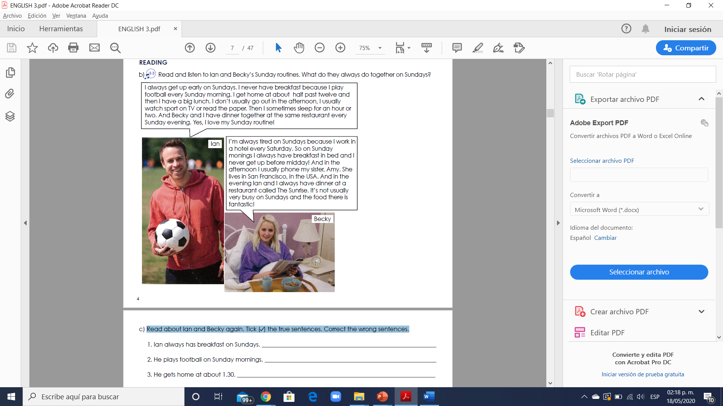

**True or False and correct the wrong sentences.**

(False) 1. Ian always has breakfast on Sundays. ___________Ian never have breakfast_________

(True) 2. He plays football on Sunday mornings. __________________________________________

(False) 3. He gets home at about 1.30. _______I get home at about half past twelve_________

(True) 4. He doesn’t usually go out in the afternoon. ______________________________________

(False) 5. He always sleeps for an hour or two. ____Sometimes sleep for an hour or two________