

Nombre de alumno:
Litzy Fernanda Domínguez León

Nombre del profesor:
Juan Manuel Jaime Díaz

Nombre del trabajo: Unit Activity #1 – U4 2BEN

Materia: English

Grado: “2do semestre

Grupo: A

GRAMMAR
Possessive pronouns / Whose
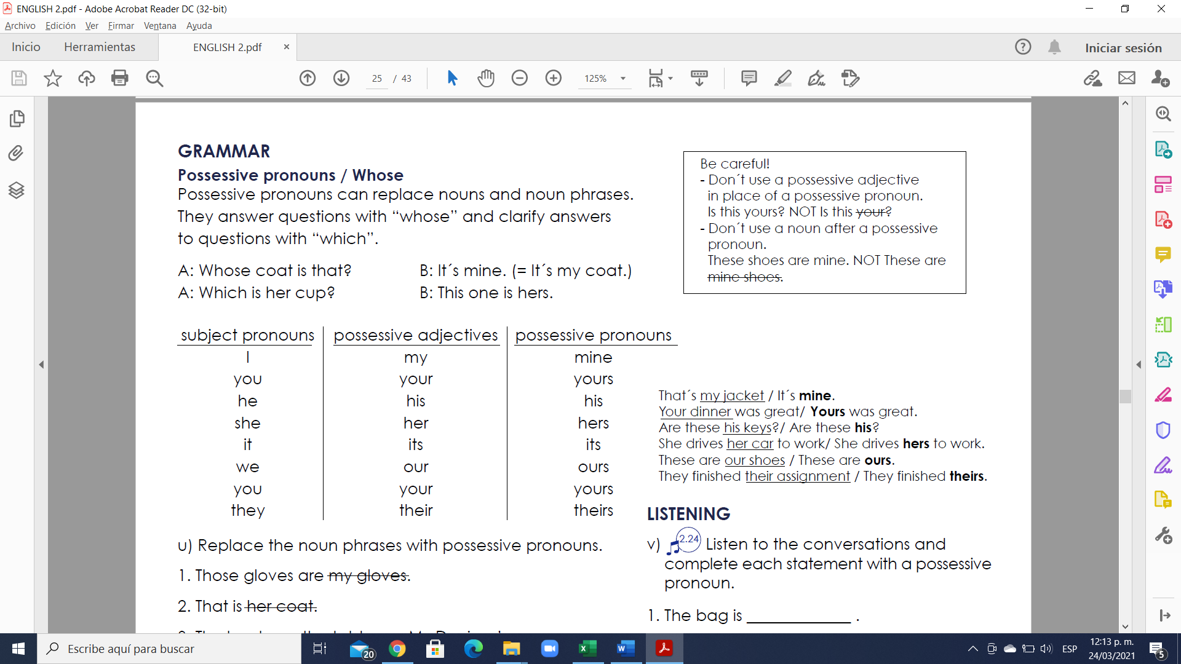
Possessive pronouns can replace nouns and noun phrases. They answer questions with “whose” and clarify answers to questions with “which”.
A: Whose coat is that? B: It´s mine. (= It´s my coat.)
A: Which is her cup? B: This one is hers.

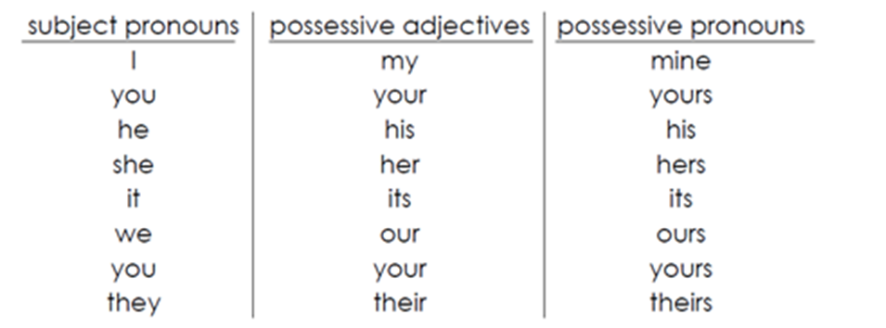
Examples:
That´s my jacket / It´s mine.
Your dinner was great/ Yours was great.
Are these his keys? / Are these his?
She drives her car to work/ She drives hers to work.
These are our shoes / These are ours.
They finished their assignment / They finished theirs.

Exercise 1. Replace the noun phrases with possessive pronouns
- Those gloves are my gloves.
Answer: mine
2. That is her coat.
Answer: hers
3. The books on the table are Mr. Davison’s.
Answer: his
4. Their car and our car are parked on the same street.
Answer: ours
5. Are those my tickets or her tickets?
Answer: hers
6. The white house is my mother’s house.
Answer: hers
7. Is this painting your painting or her brother’s painting?
Answer: yours, his
8. The newspaper under the chair is his daughter’s paper.
Answer: hers
9. Is this DVD your DVD or your friends’?
Answer: theirs
10. Are these your son’s shoes?
Answer: yours

Exercise 2. Contesta correctamente
1. This car is ____ car. This car is his.
- he
- her
- his
- hers

2. This house is our house. This house is ____.
- our
- ours
- we
- its

3. This hat is my hat. This hat is ____.
- I
- me
- mine
- its

4. This is your bike. This bike is ____.
- you
- your
- yous
- yours

5. This is ____ dog. This dog is hers.
- her
- his
- hers
- she

6. These are ____ children. These children are theirs.
- theirs
- them
- they
- their

Vocabulary
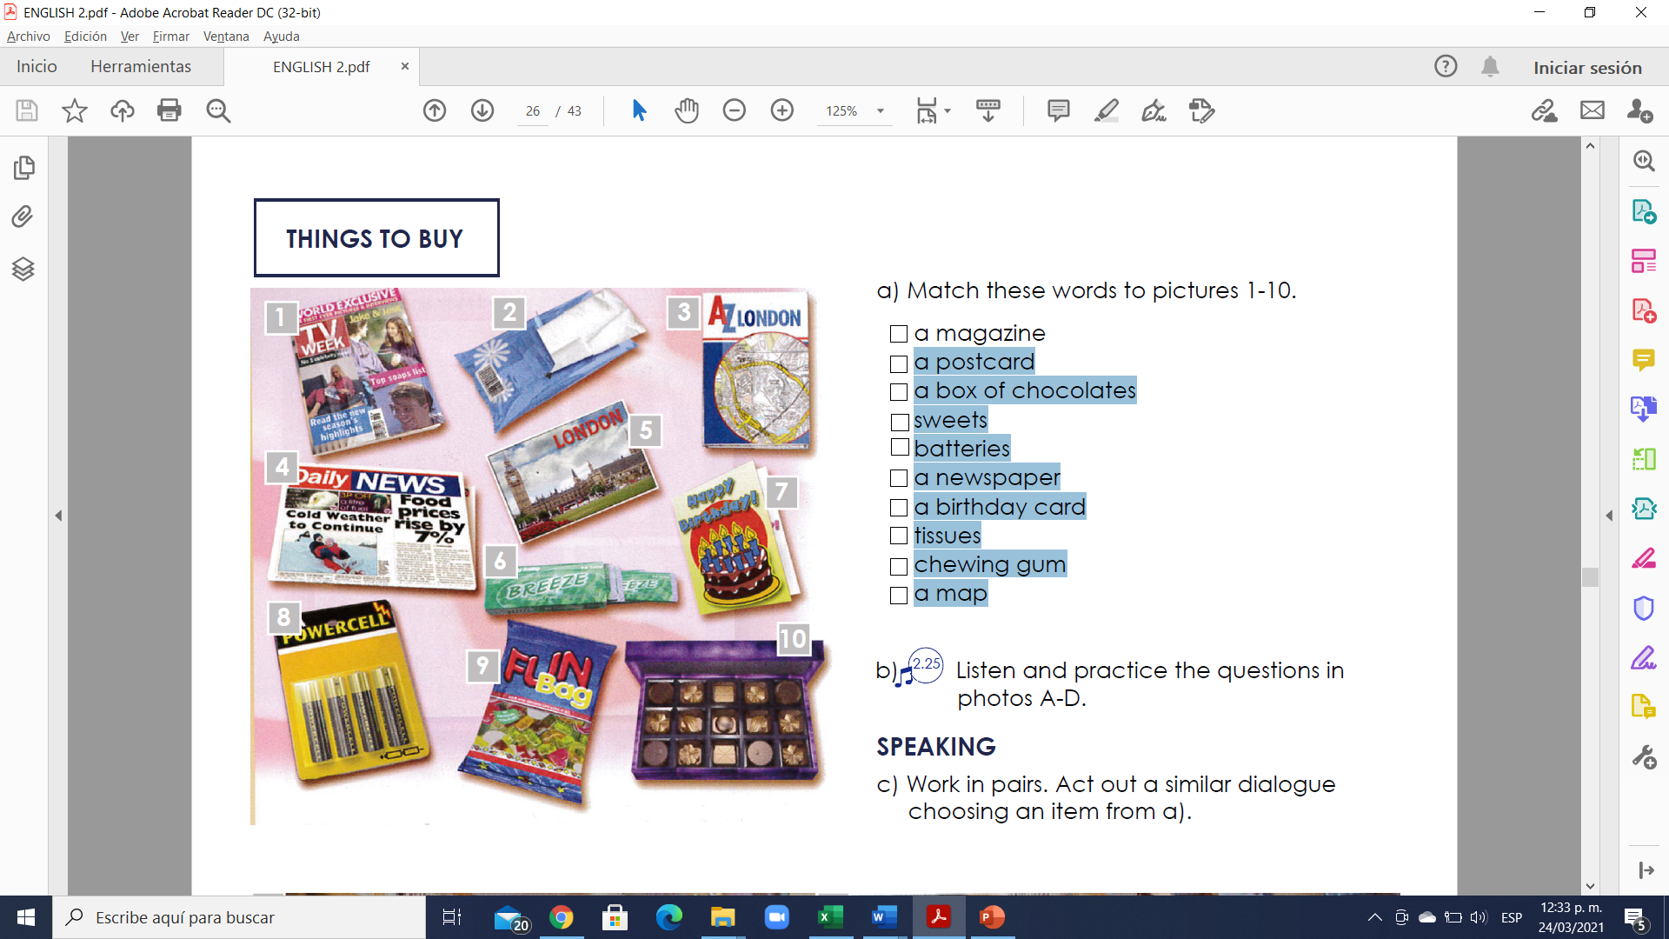
Exercise 3. Match the adjectives to pictures 1-10. (Escribe la letra de la figura que concuerda con la palabra)
(1) - a magazine
(5) - a postcard
(10) - a box of chocolates
(9) - sweets
(8) - batteries
(4) - a newspaper
(7) - a birthday card
(2) - tissues
(6) - chewing gum
(3) - a map

EVENTS AND TIMES
VOCABULARY
What time is it?
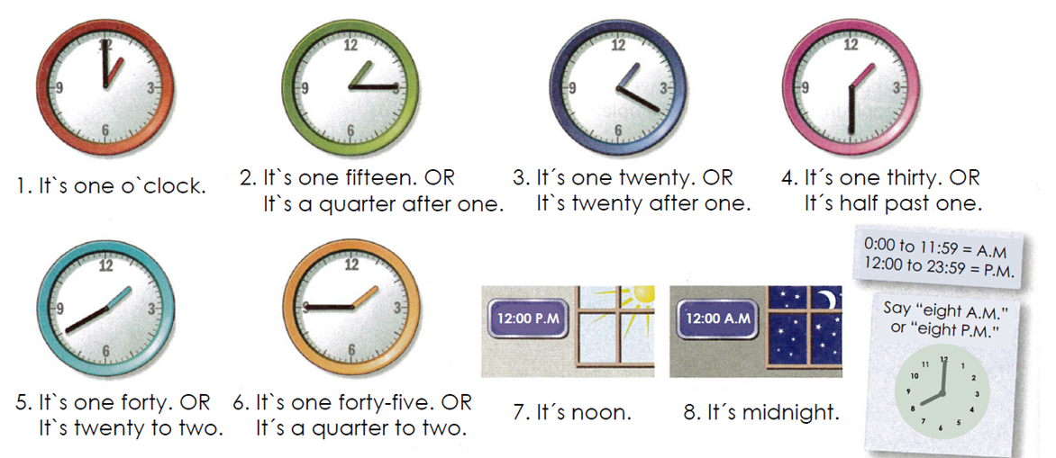

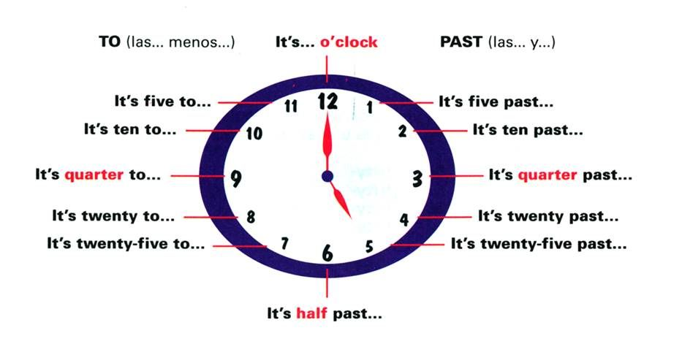
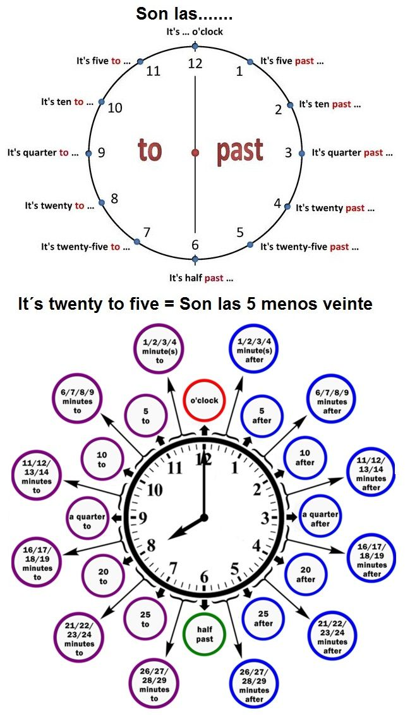
Ver video en youtube para la explicación de las horas:
https://www.youtube.com/watch?v=ItXtQGHnp1E&feature=emb_logo&ab_channel=DianaPerez
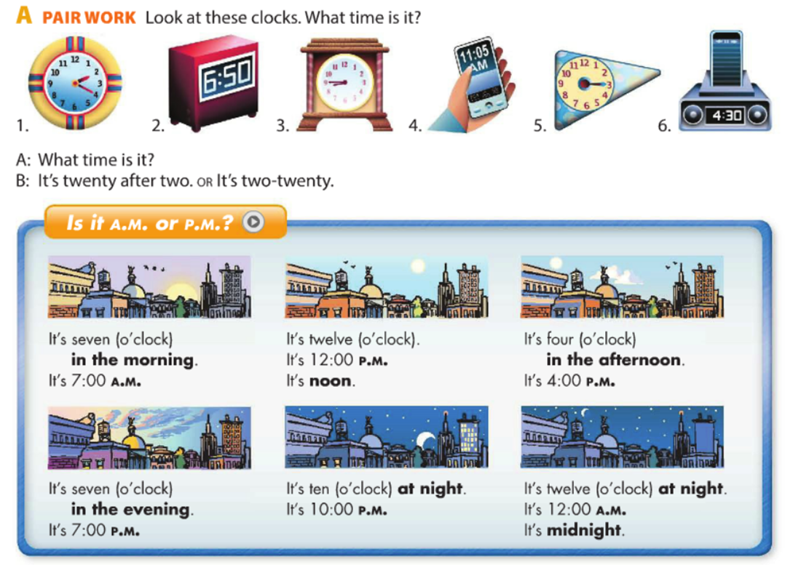

Exercise 4. What time is it?. Use the sentences in the box. ¿Qué hora es?, usa las oraciones en la caja.
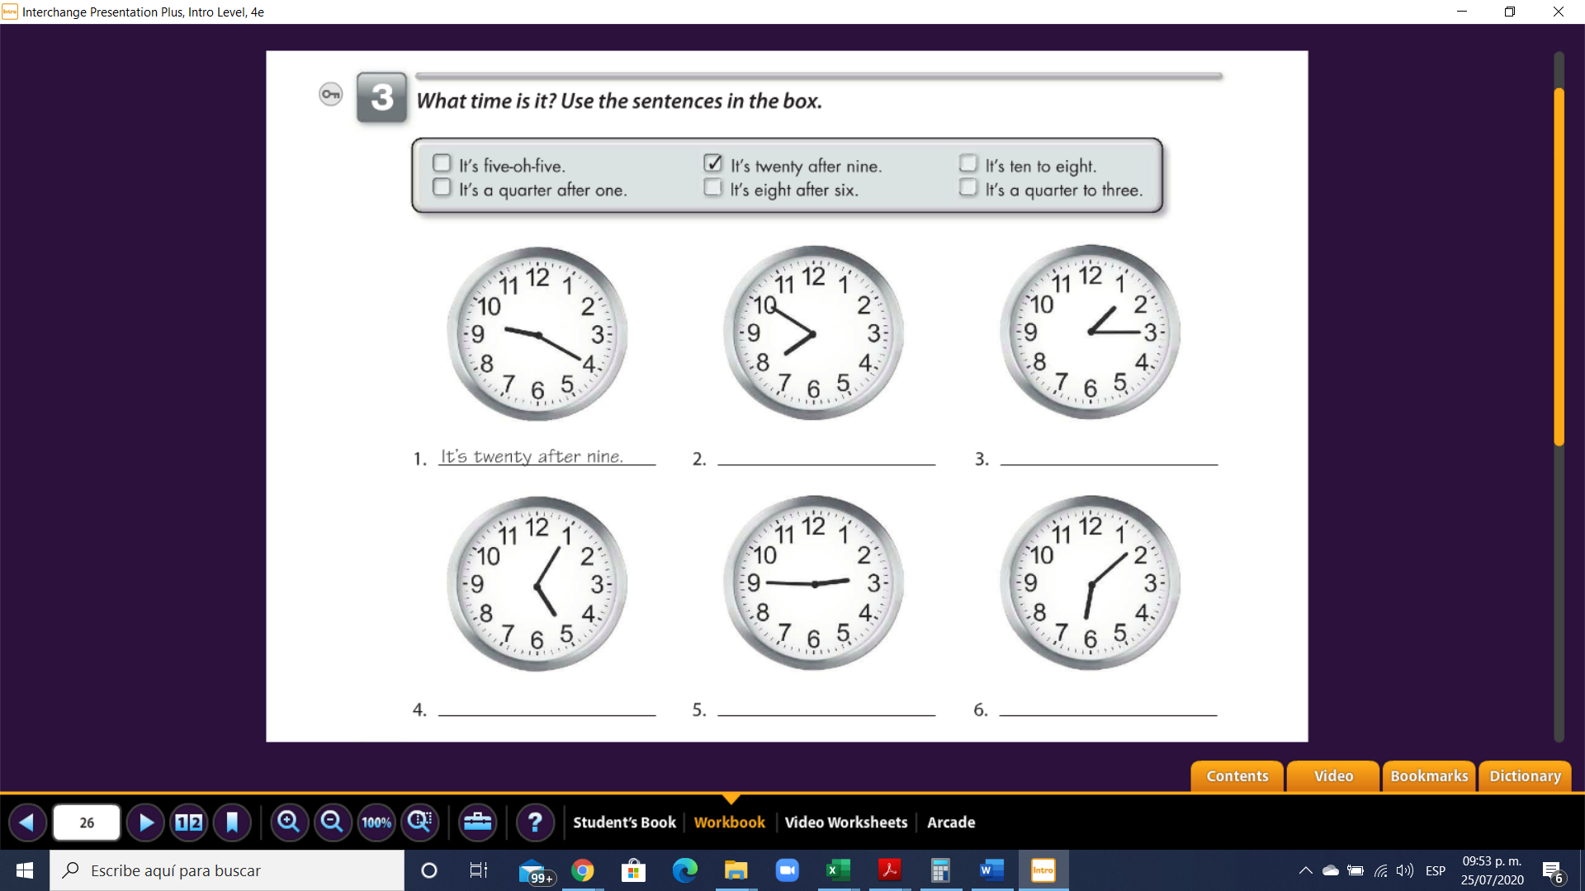
- It´s twenty after nine 2. it´s ten to eigt 3. It´s a quarter after one

- It´s five-oh-five 5. It´s a quarter to three 6. It´s eight after six

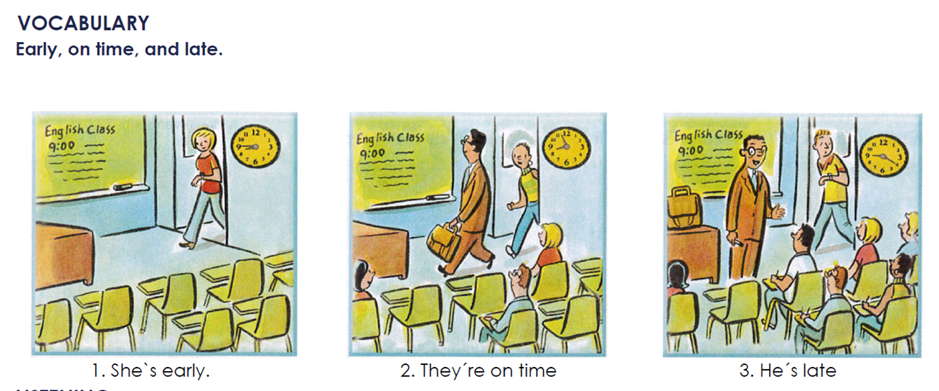

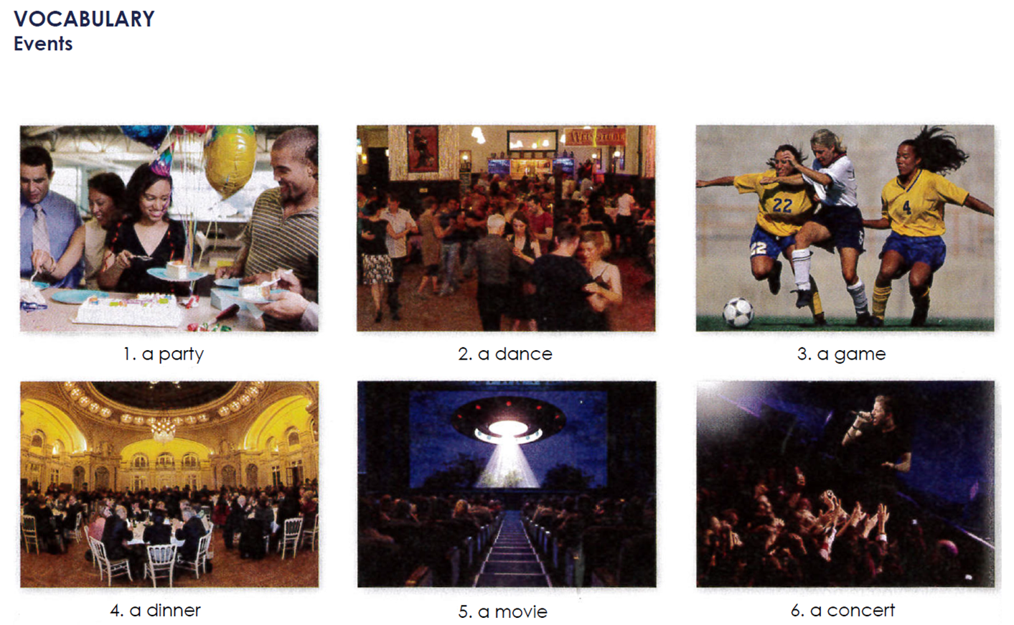

GRAMMAR
“Be”: questions about time / Prepositions “at” and “on”.
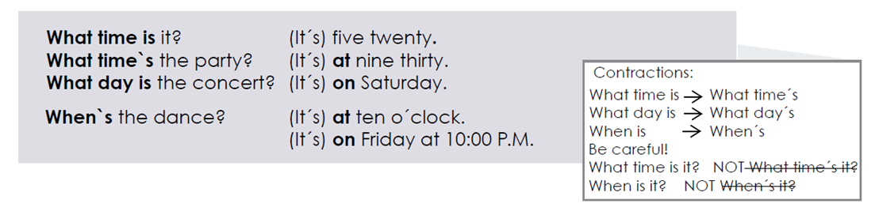

Exercise 5. Complete the questions and answers. Use contractions when possible.

1. A: When __is__ the party? B: It’s __at__ 11:00 p.m.

2: A: __what__ day’s the game? B: It’s __on__ Saturday.

3. A: What ___time___ the concert? B: It’s ___at___ 8:30.

4. A: What __day´s__ the dinner? B: It’s __on__ Tuesday.

5. A: ___when’s___ the dance? B: It’s __on__ Friday at 9:00.

6. A: What ___time___ the class? B: It’s ___at___ noon.

GRAMMAR
Prepositions “in”, “on” and “at” for dates and times.
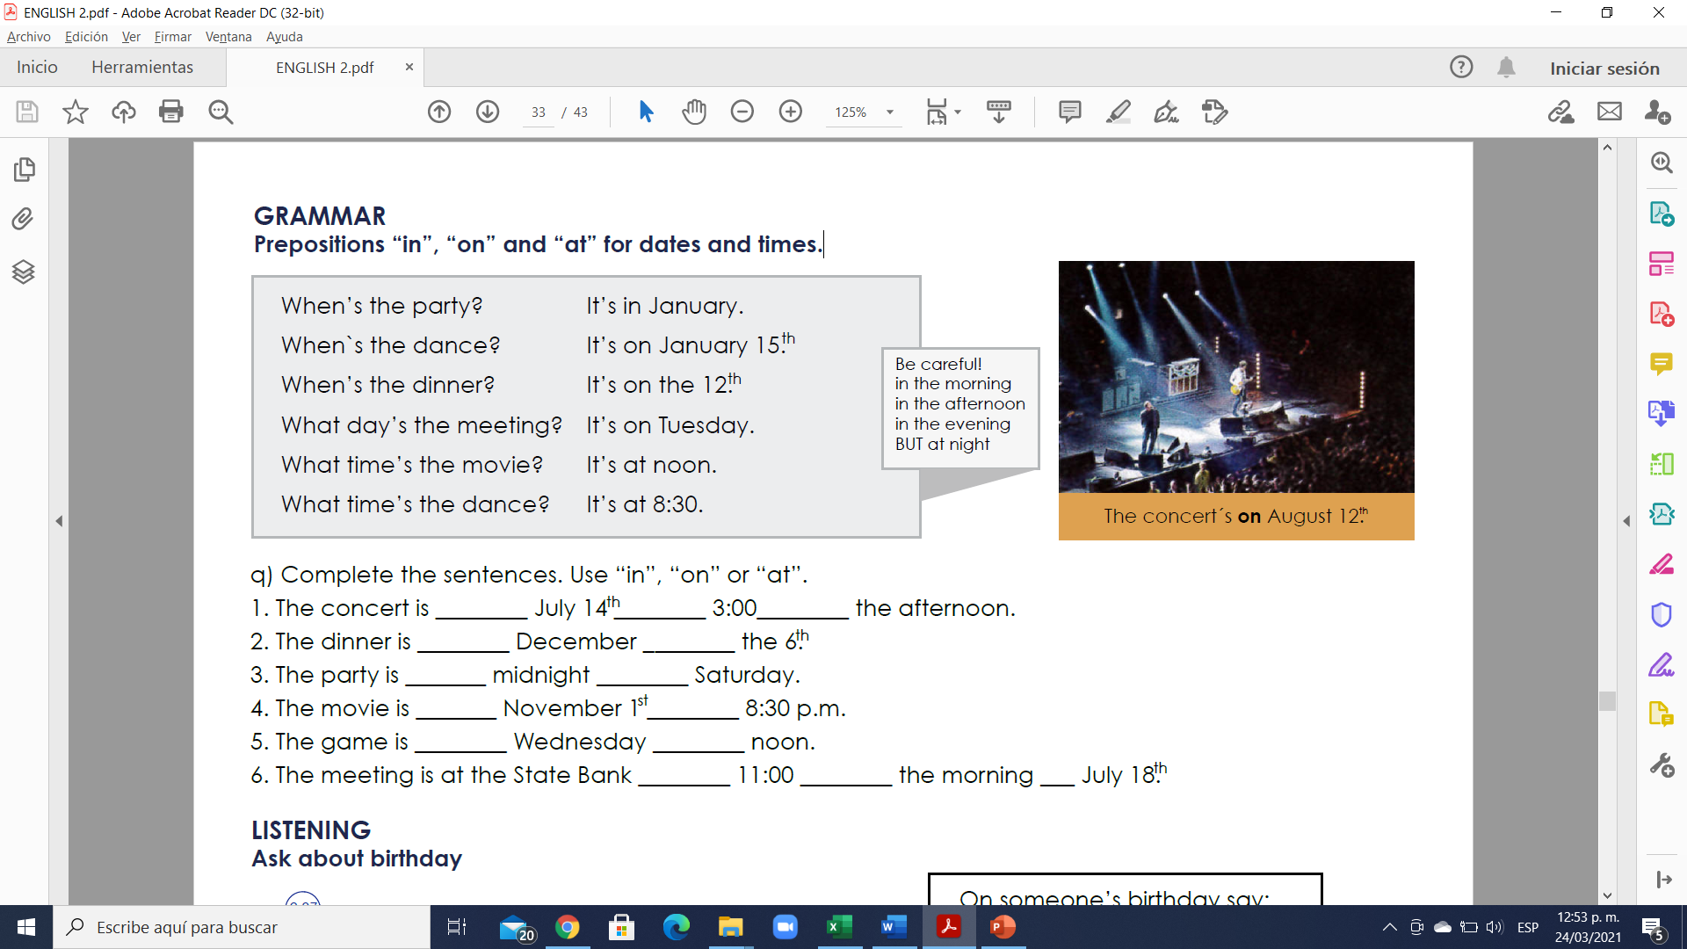

Exercise 6. Complete the sentences. Use “in”, “on” or “at”.

1. The concert is __on__ July 14 __at__ 3:00__in__ the afternoon.

2. The dinner is __in__ December __on__ the 6.

3. The party is __at__ midnight __on__ Saturday.

4. The movie is __on__ November 1 __at__ 8:30 p.m.

5. The game is __on__ Wednesday __on__ noon.

6. The meeting is at the State Bank __at__ 11:00 __in__ the morning _on_ July 18.

