**Nombre de alumno:**

**Litzy Fernanda Domínguez león**

**Nombre del profesor:**

**Juan Manuel Jaime Díaz**



**Nombre del trabajo:**

**Unit Activity #2 - U1 2BEN**

**ENGLISH 2**

**Grado: 2do semestre**

**Grupo:**

**Bachillerato en Enfermería**

**Comitán de Domínguez Chiapas a 21 de febrero de 2022.**

**Exercise 5.** Read the sentences. Write questions and answers. Answer with “it`s”. (Lee las oraciones y escribe la pregunta y la respuesta, la respuesta usando “it`s”)

1. The pharmacy is across the street.

**A: Where´s the pharmacy?**

**B: it´s across the street**

2. Billy`s Restaurant is around the corner.

**A: where is Billy’s restaurant?**

**B: it’s around the corner**

3. The newsstand is on the left.

**A: where is the newsstand?**

**B: it’s on the left**

4. The bookstore is next to the school.

**A: where is the bookstore?**

**B: it’s next to the school**

**GRAMMAR - The imperative**

Use imperatives to give instructions and directions.

**Affirmative imperatives**

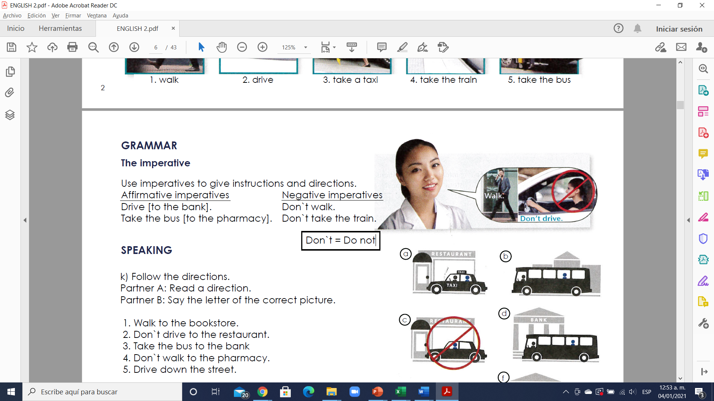Drive [to the bank].

Take the bus [to the pharmacy].

**Negative imperatives ( Don`t = Do not )**

Don`t walk.

Don`t take the train.

**Exercise 6.** Match these imperative sentences to picture a-j. (Escibe la letra de la figura que concuerda con la palabra)

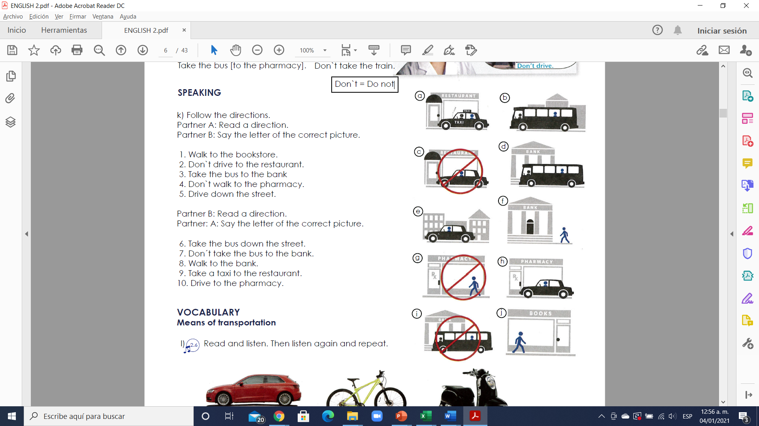

(**j**) - Walk to the bookstore.

(**c**) - Don`t drive to the restaurant.

(**d**) - Take the bus to the bank

(**g**) - Don`t walk to the pharmacy.

(**e**) - Drive down the street.

(**b**) - Take the bus down the street.

(**i**) - Don´t take the bus to the bank.

(**f**) - Walk to the bank.

(**a**) - Take a taxi to the restaurant.

(**h**) - Drive to the pharmacy.

**VOCABULARY - Means of transportation**

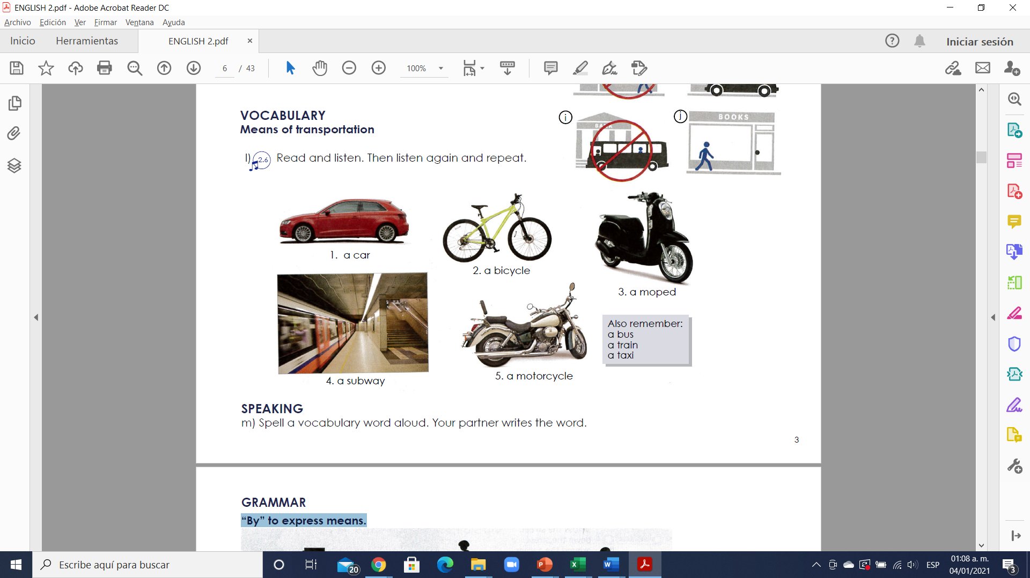

**Exercise 7.** Translate to Spanish the vocabulary (Traduce al español el vocabulario siguiente).

**1. a car -** un carro **5. a motorcycle –** una motocicleta

**2. a bicycle –** una bicicleta  **6. a bus –** un autobus

**3. a moped –** una motoneta **7. a train –** un tren

4. a subway – un metro 8. a taxi – un taxi

**GRAMMAR - “By” to express means.**

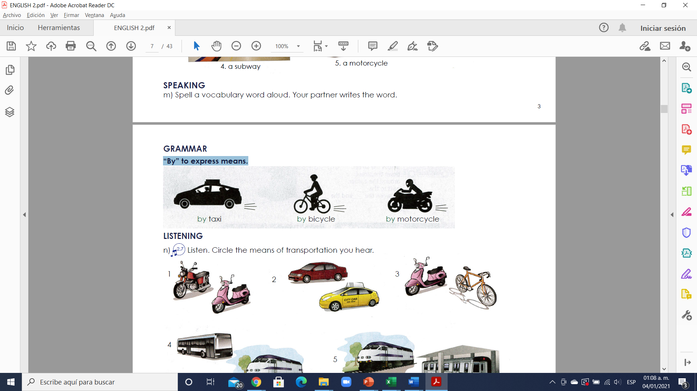

**Destinations**

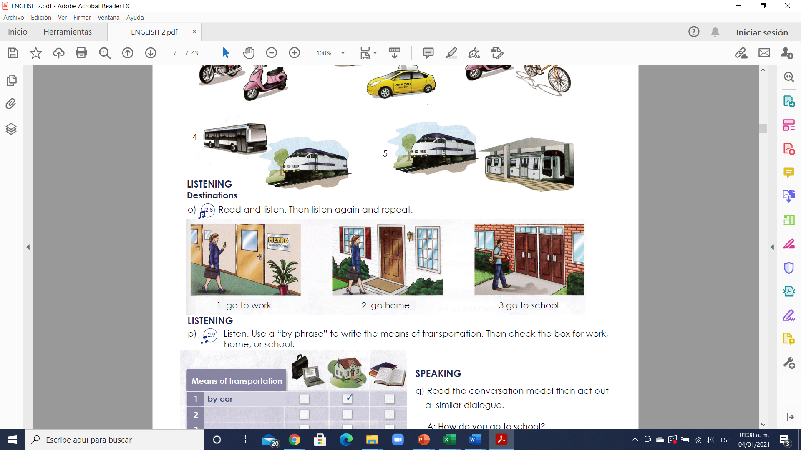

<https://test-english.com/explanation/a2/prepositions-of-movement/>

**Exercise 8.** Look at the pictures. Answer the questions. Use a “by phrase”. (Observa las imagenes y contesta las preguntas) usa la frase “by”.

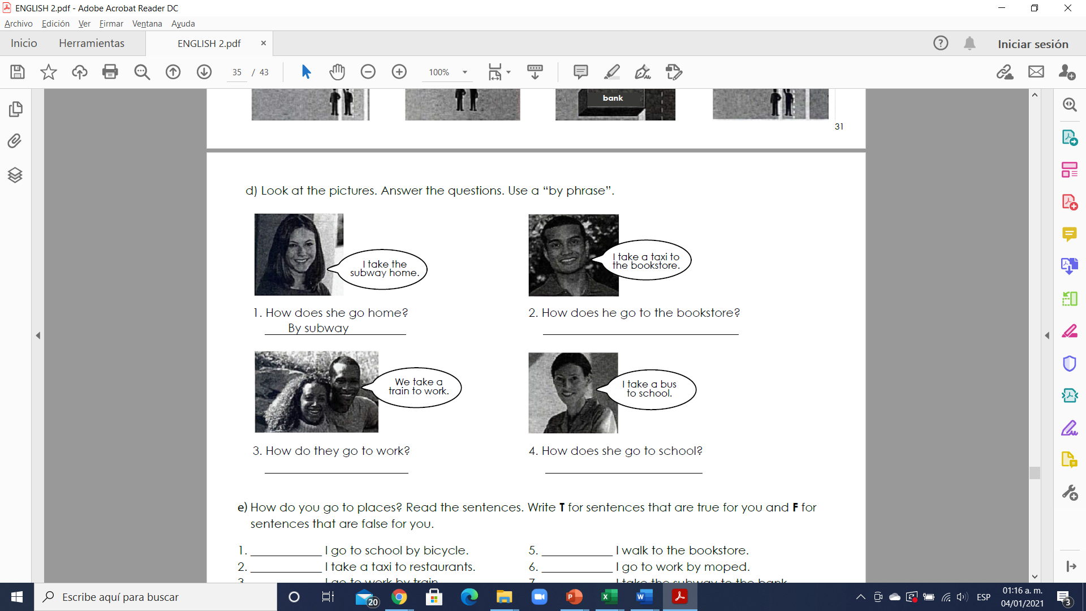

By car

By taxi by bus

**By subway**

**Exercise 9.** Read the text below about how people go to work and school. Then, answer the questions. (Lee el texto de abajo acerca de como las personas van a trabajar y a la escuela, después contesta las preguntas de abajo)

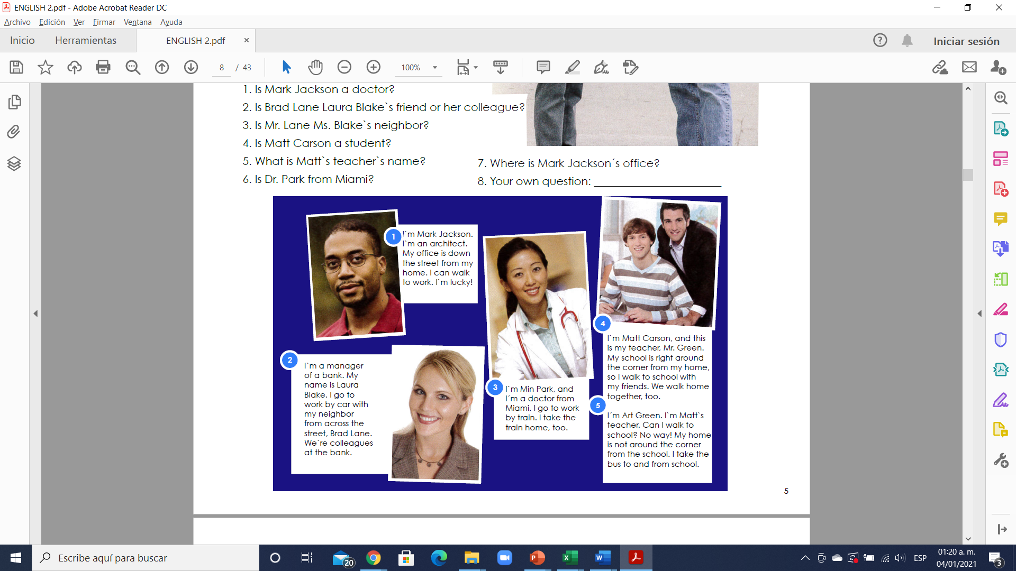

1. Is Mark Jackson a doctor?

A: No, he is not, he is an architect.

2. Is Brad Lane Laura Blake`s friend or her colleague?

A: he is her collegue

3. Is Mr. Lane Ms. Blake`s neighbor?

A: he is her neighbor

4. Is Matt Carson a student?

A: he is a student

5. What is Matt`s teacher`s name?

A:mr green

6. Is Dr. Park from Miami?

A: she is of miami

7. Where is Mark Jackson´s office?

A: the office is down the street