

Nombre de alumno:
Litzy Fernanda Domínguez León

Nombre del profesor:
Juan Manuel Jaime Díaz

Nombre del trabajo: Unit Activity #1 – U3 2BEN

Materia: English

Grado: “2do semestre

Grupo: A

Comitán de Domínguez Chiapas a 16 de mayo de 2022.
TOURIST INFORMATION - CLOTHES
VOCABULARY
Exercise 1. Match the adjectives to pictures a-h. (Escribe la letra de la figura que concuerda con la palabra)
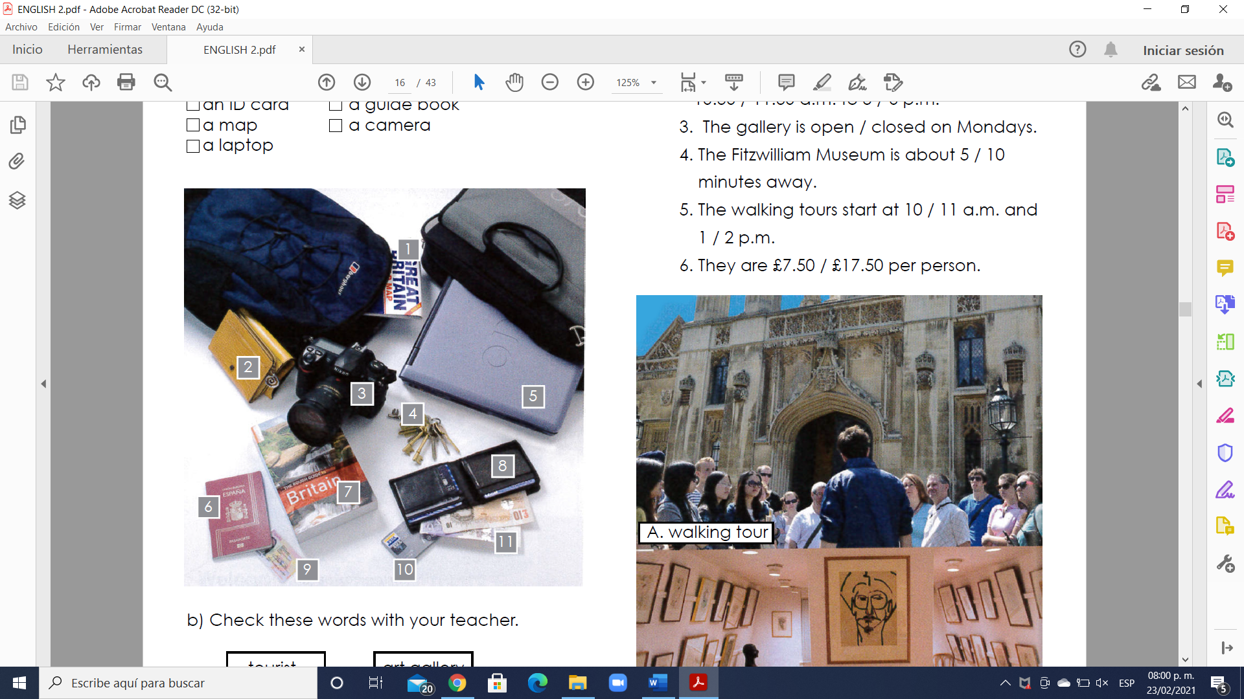
8 - a wallet
4 - keys.
11 - a money
9 - an ID card
1 - a map
5 - a laptop
2 - a purse
10- a credit card
6 - a passport
7- a guide book
3- a camera
Vocabulary - Clothes
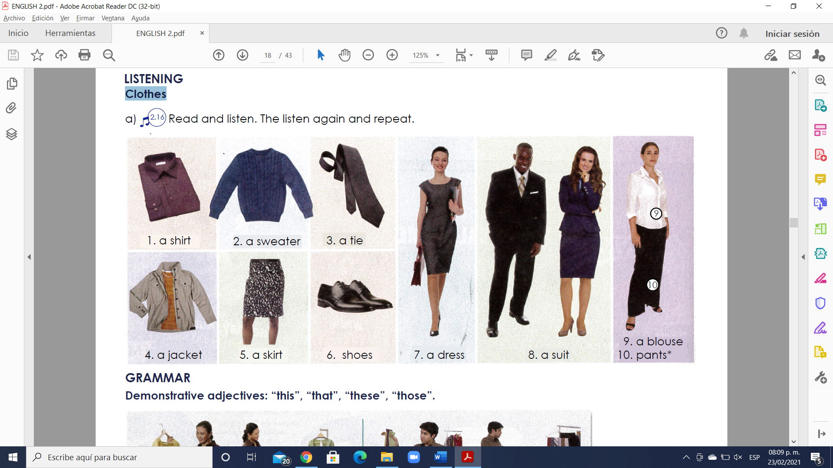
GRAMMAR - Demonstrative adjectives: “this”, “that”, “these”, “those”.
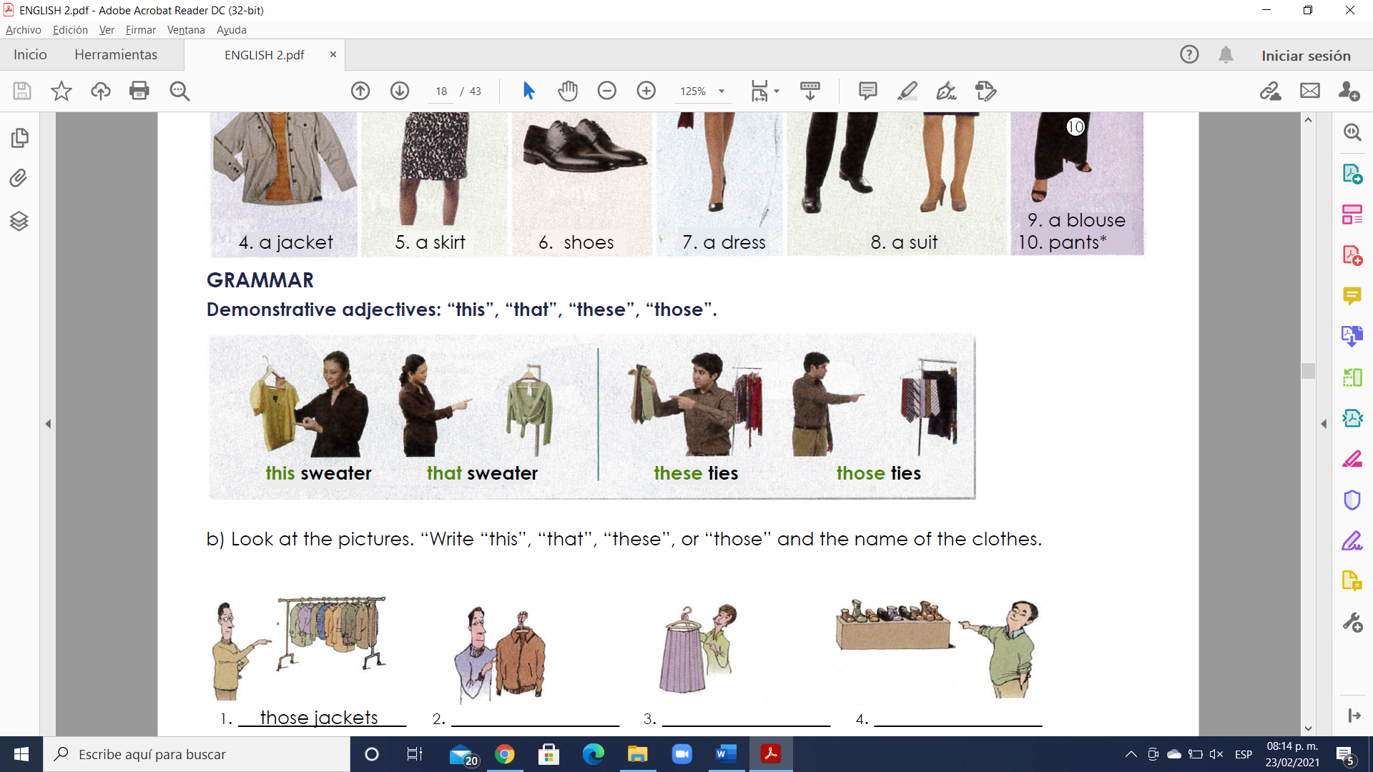
Es importante comenzar señalando que los pronombres pueden estar en singular o plural y que pueden hacer referencia a la distancia.
This (este/a/o)
That (ese/a/o, aquél, aquello/a)
These (estos/as)
Those (esos/as, aquellos/as)
Ejemplos:
Singular and this (singular y aquí):
I like this car. (Me gusta este coche.)
Singular and there (singular y allí):
I like that car. (Me gusta ese coche.)

Plural and here (plural y aquí):
I like these cars.(Me gustan estos coches.)
Plural and there (plural y allí):
I like those cars.(Me gustan aquellos coches.)

Los pronombres demostrativos pueden ir acompañados de un nombre como vemos en los ejemplos anteriores, o pueden ir solos como en los siguientes ejemplos:
This is a good book. (Éste es un buen libro.)
What is that? (¿Qué es eso?)
Other Uses of Demonstrative Pronouns (Otros usos de los demostrativos)
1. Podemos utilizarlos “this” para presentarnos por teléfono.
Hello. This is Alicia. (Hola. Soy Alicia.)
2. Para preguntar quién hay al otro lado de la línea telefónica o en un lugar oscuro, usamos “that”.
Peter, is that you? (¿Eres tú, Peter?)
3. También usamos “this” cuando presentamos personas.
Lucy, this is my friend Jill. (Lucy, ésta es mi amiga Jill.)
4.“That” también lo podemos utilizar para referirnos a algo del pasado.
That pizza was delicious. (Aquella pizza estaba riquísima.)

Exercise 2. Look at the pictures. “Write “this”, “that”, “these”, or “those” and the name of the clothes.
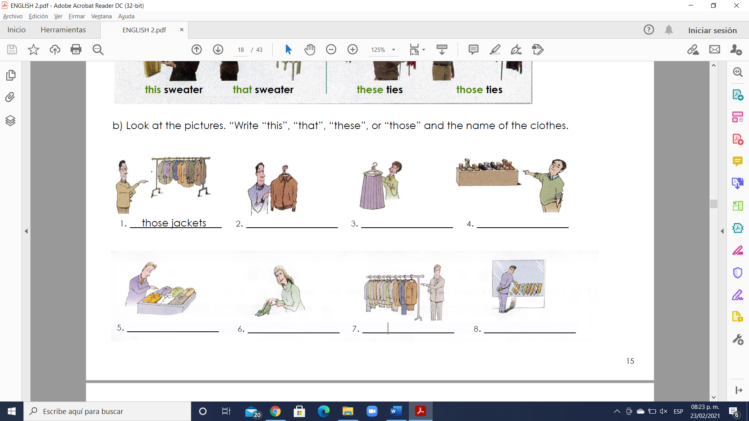
- Those jackets 2. This jacket 3. This skirt 4. those shoes

5. these shirts 6. these shoes 7. these suits 8. those ties

Exercise 3. Escribe 8 oraciones usando “this”, “that”, “these”, and “those”.

1. this house is very big
2.this car is very expensive
3. that backpack is very heavy
4.that jacket is dirty
5.these shoes are very expensive
6.these suits are very nice
7. those computers are very expensive
8. those wheels are too big

GRAMMAR - The Present Simple tense: affirmative statements with “like”, “want”, “need” and “have”.
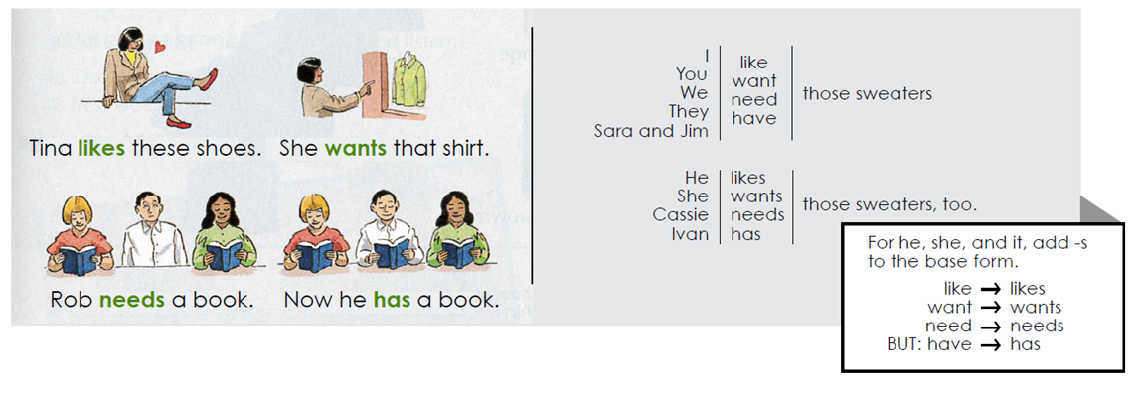

Exercise 3. Complete each statement with the correct form of the verb.
1. I (like/likes) your tie.
2. My friends (want/ wants) this suit.
3. Janet (need / needs) this skirt.
4. Peter (have / has) that jacket.
5. We (like / likes) our dresses.
6. Sue and Tara (want/ wants) those suits.

VOCABULARY – Colors and Sizes
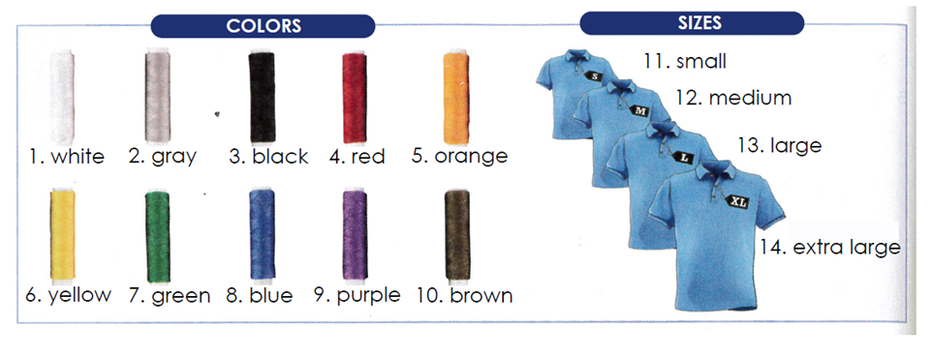
Exercise 4. Complete the sentences with the correct form of the verb. Use contractions.
1. A: (Do/Does) your children _have_(have) sweaters for school?
B: My daughter (do/does), but my son (don´t/doesn´t).
2. A: (Do/Does) your husband _need_(need) a black tie?
B: No, he (don´t/doesn´t). He _has_(have) two black ties.
3: A: I_ need_ (need) a blue suit for work. (Do/Does) you _need_(need) one too?
B: Yes, I (do/does).
4. A: (Do/Does) you _like_(like) that green shirt?
B: Actually, no, I _don´t like_(don´t/doesn´t).
5. A: We _don´t like_ (not like) the clothes in this store.
B: Really? that`s too bad. We (do/does).
6. A: (Do/Does) you _have_(have)this black jacket in size 34?
B: No, I’m sorry. We (don´t/doesn´t).
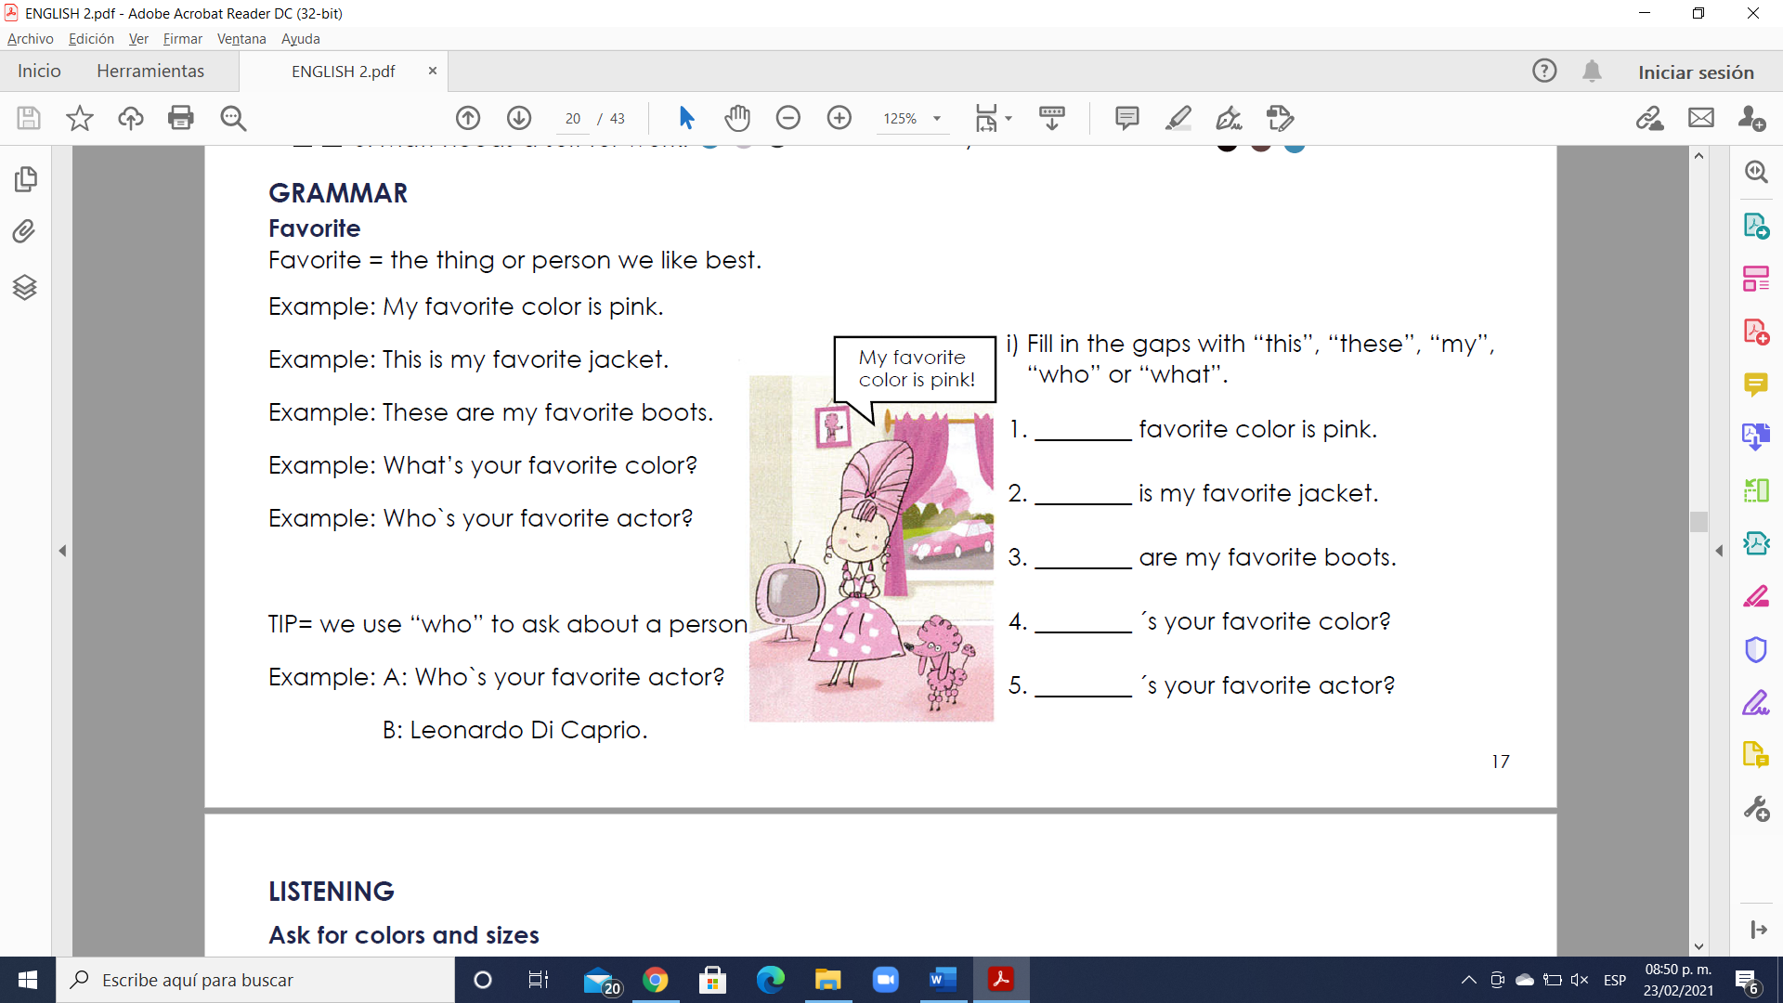
My
who
what
these
this

VOCABULARY- Opposite adjectives to describe clothes
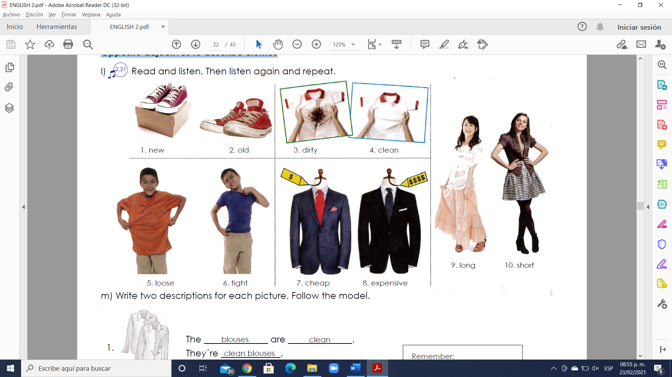

GRAMMAR - The Present Simple tense: questions with “what”, “what color”, “what size”, “why”, “which one” and “which ones”.
- Use a question word and “do” or “does” to ask information questions in the Present Simple tense.
Example: What do you need? (A blue and white tie).
Example: What does she want? (New shoes).
- Use “because” to answer questions with “why”.
Example: Why do they want that suit? (Because it’s nice).
- Use “what color” or “what size” to ask about color and size.
Example: What color do you want? (Black).
Example: What size does he need? (Extra large).
- Use “which” to ask about choice. Answer with “one” or “ones”.
Example: Which sweater do you want? (The blue one).
Example: Which shoes does he like? (The black ones).

Exercise 5. Complete the conversations in your own words.
1. A: Which skirt (she / want)?
B: The red one.
2. A: What (your friend / need)?
B: l need a suit.
3. A: What color shoes (you / like)?
B: red color.
4. A: Why (you / want) new shoes?
B: for going to a party.
5. A: Which shirts (you / like)?
B: The gray color.
6. A: What size shoes (you / need)?
B: size 24.

