

Nombre del alumno: Sofía Carolina Esteban Hernández.

Nombre de la materia: inglés.

Nombre de la licenciatura: psicología general.

Nombre del maestro: Heydi Janeth Cruz Zurita

Cosas que puedo hacer en las diferentes estaciones del año

Spring

In spring I can have a picnic, I can go to the countryside to relax

I can see the flowers or eat a lot of fruit

Summer

in summer I can go to the beach or to the swimming pools,

can i have cold drinks

Autumn

in autumn i can see the leaves of the trees falling, I can wear cool clothes

Winter

In winter I can wear warm clothes, and drink hot chocolate

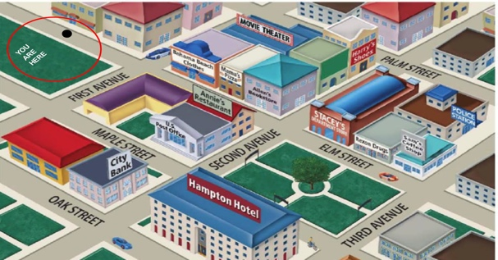

How do i get to the sam's coffee shop?

Go straight until Elm street, the Sam's coffee shop is next to Rexon Drugs.

How can i get to the post office?

walk up one block until second avenue, the post office is in front of Annie's restaurant

How can i get to the park?

go past Elm street, the park is behind Hampton Hotel, opposite Rexon Drugs