# WORKBOOK

bathroom

yard

closet

kitchen

dining room

living room

garage

No, it only has two rooms.

Yes, it has a great view of the city.

yes, I do. I love it!

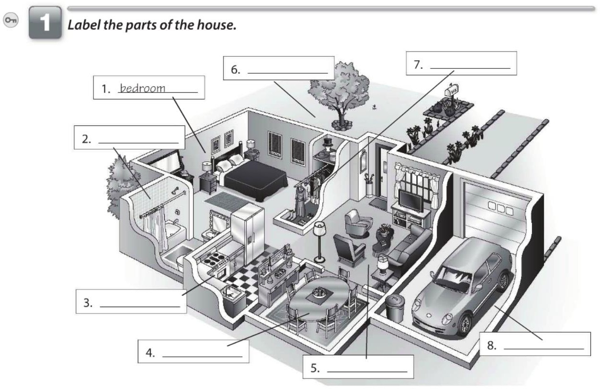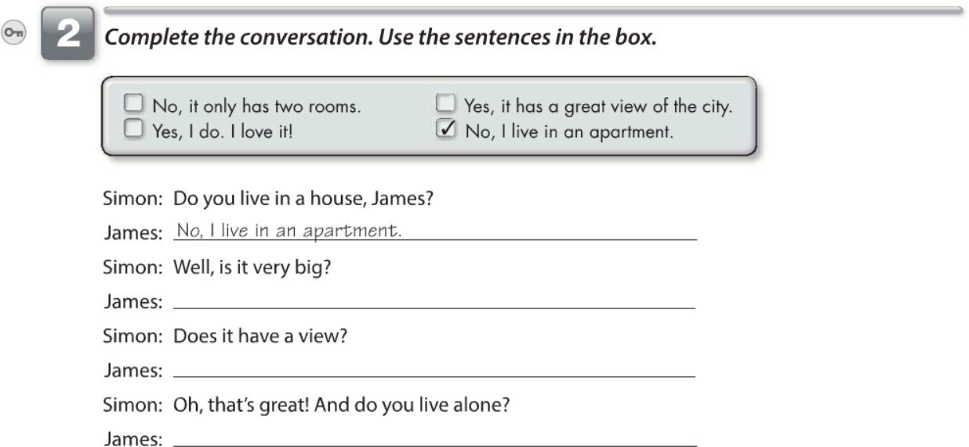

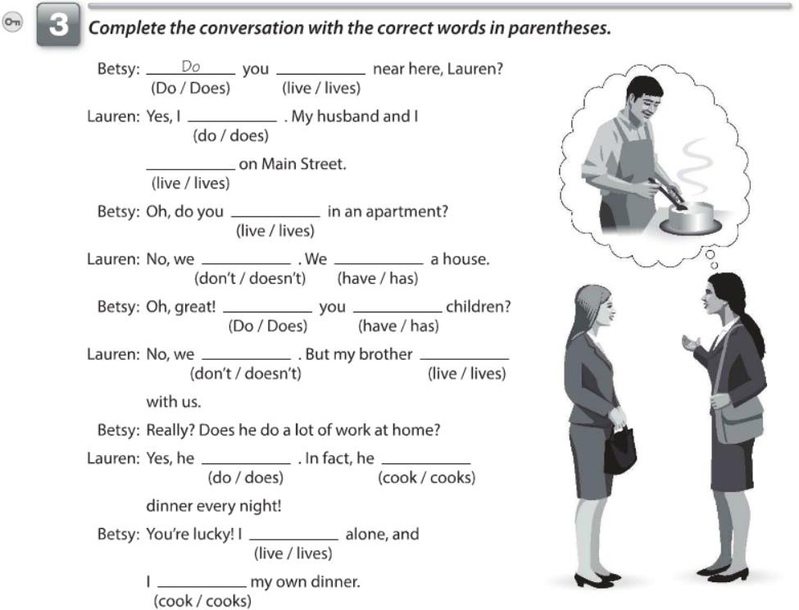

live

do

live

live

don't have

do have

don't lives

does

cooks

live

cook

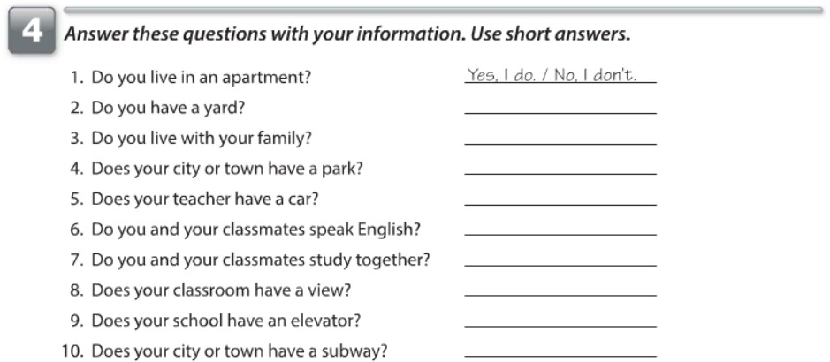

No, I don't Yes, I do

Yes, it has a little park

Yes, he has a car

Yes, we do No, we don't

I don't know I; don't know

Yes, it does

No, she don't need pictures.

Yes, they have a lamp.

No, they don't need a table.

No, they don't have chairs.

No, they don't need a clock

No, they don't have a mirror.

Yes, they need courtains.

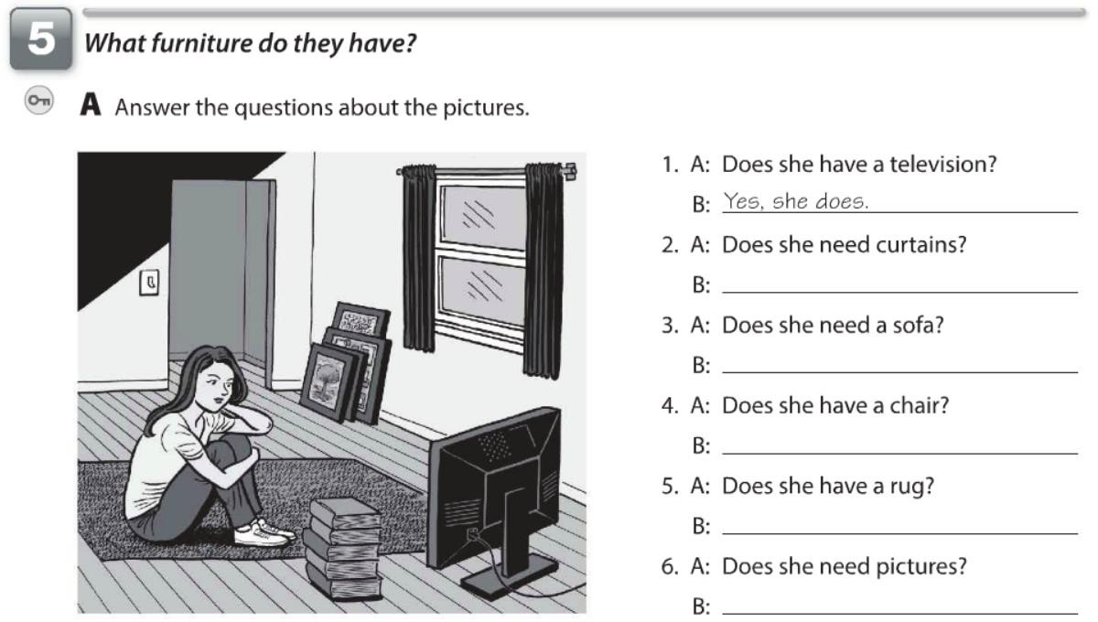

Yes, she needs courtain

Yes, she needs a sofa

No, she don't have a chair

Yes, she has a rug

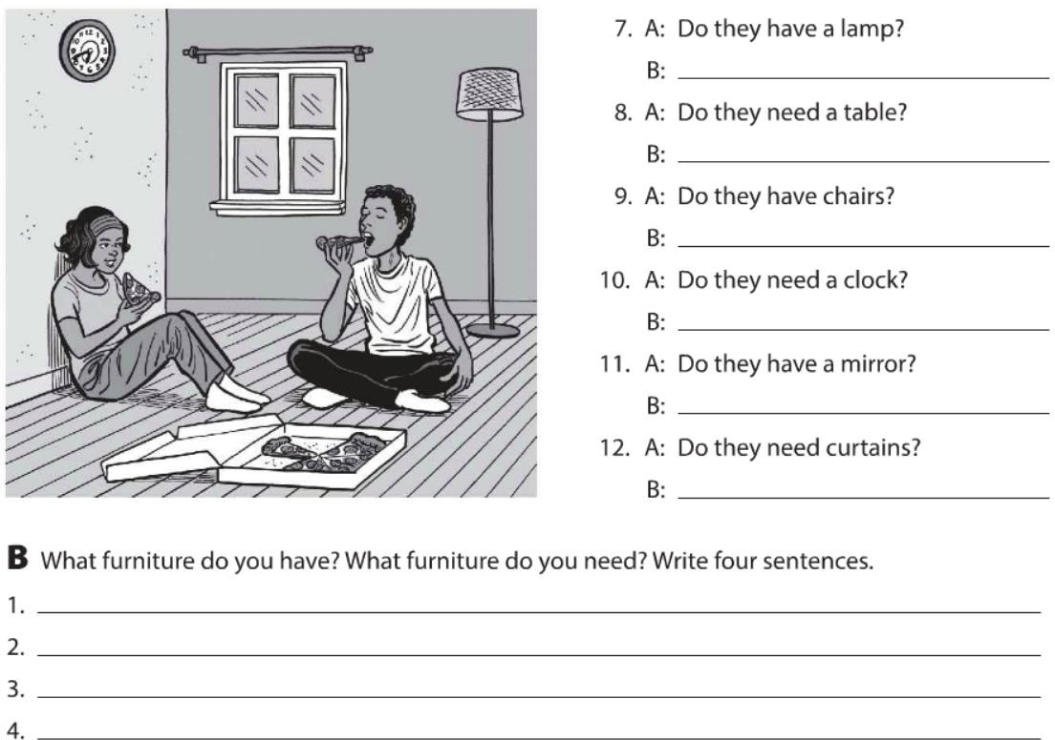

I have a gray sofa in my living room. I have a big bed in my bedroom.

I, don't have a big closet in my house.

I have small curtain in my windows.

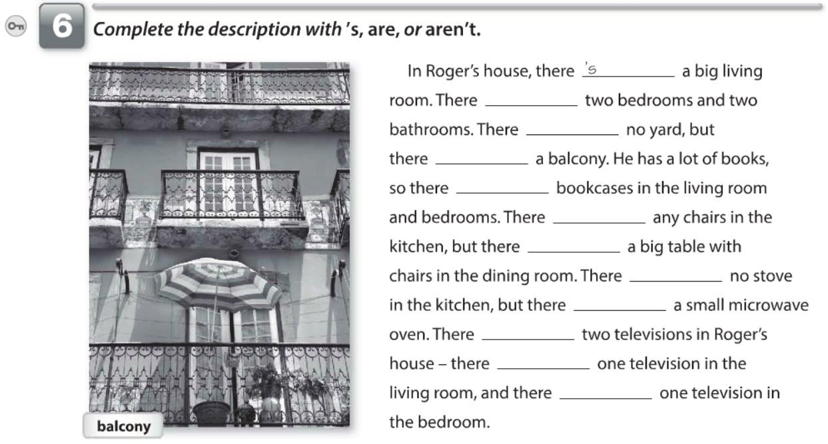

are

's

's

are

aren't

's

's

's

are

's

's

No,there's no clock in my kitchen.

Yes, there's a television in my living room.

No, there isn't a bookcase in my living room.

yes, there's a mirror in the bathroom.

Yes, there are some pictures in my bedroom.

Yes, there's a closet in my bedroom.

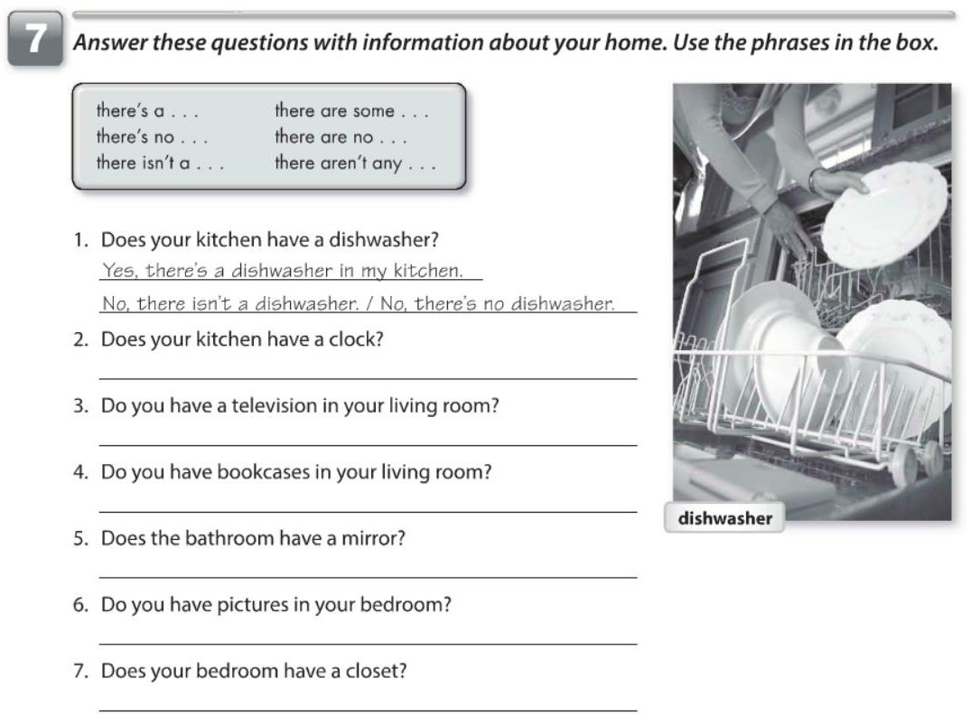

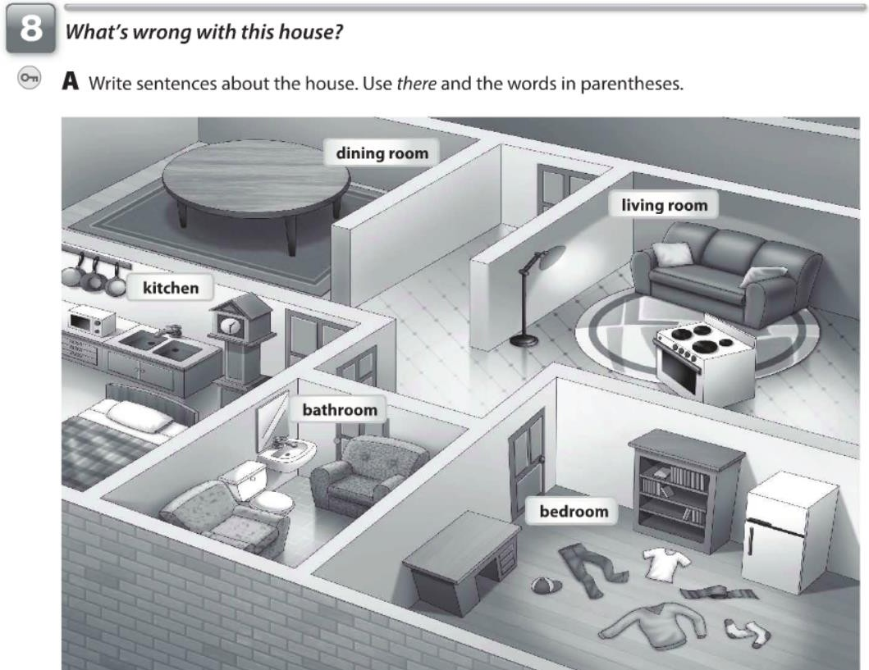

There are no chairs in the dining room.

There's a stove in the living room.

There is a refrigerator in the bedroom.

There's no bed in the bedroom.

there are armchairs in the batrhroom.

There's a clock in the kitchen.

There's no bookcases in the living room.

There are some clothes lying on the floor.

There's a bed in the kitchen.

There's a lamp in the living room.

there's a bookcase in the bedroom.

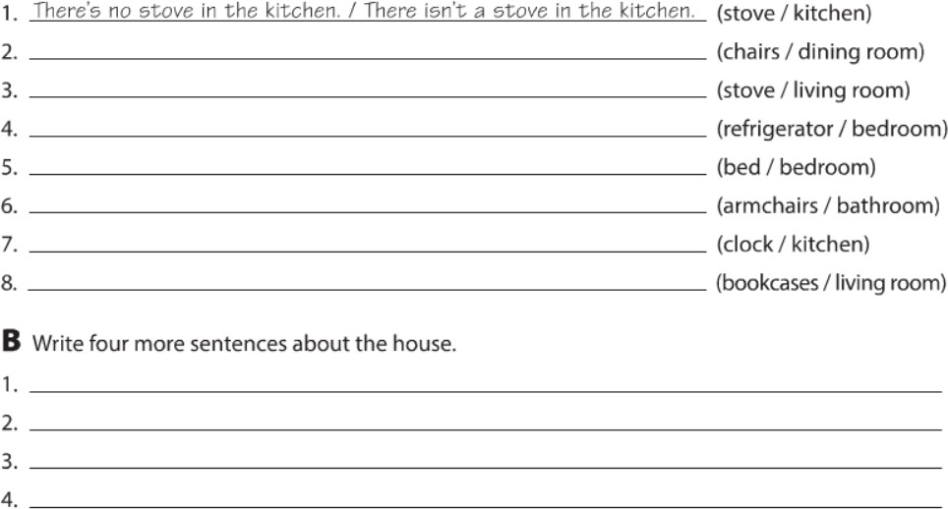

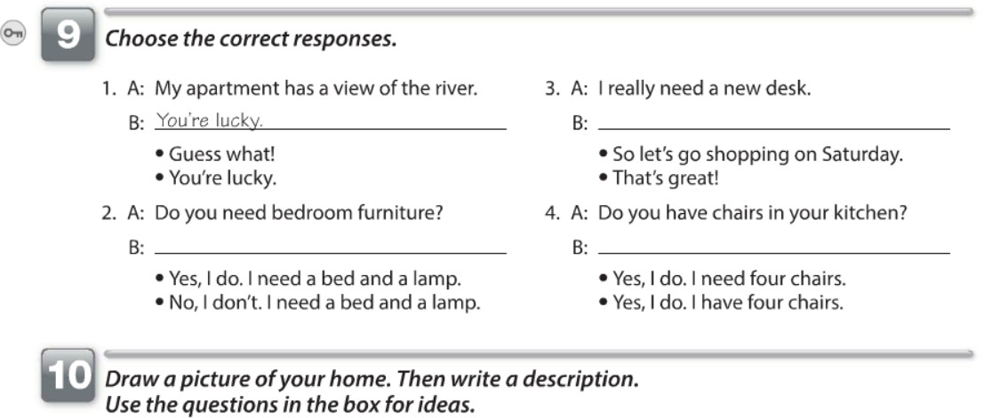

yes, I do. I need a bed and a lamp.

So let's go shopping on Saturday.

Yes, I do. I have four chairs.

I live in Dallas TX in a mobile home, it has two bedrooms and one bathroom. I have a small

Kitchen and a big living room. It is very comfortable for my family.

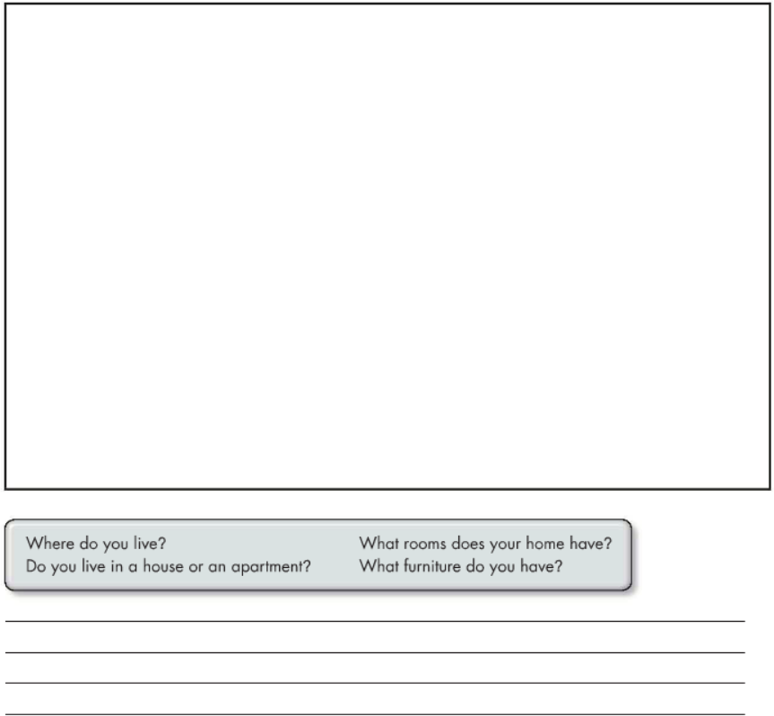

**WORKBOOK**

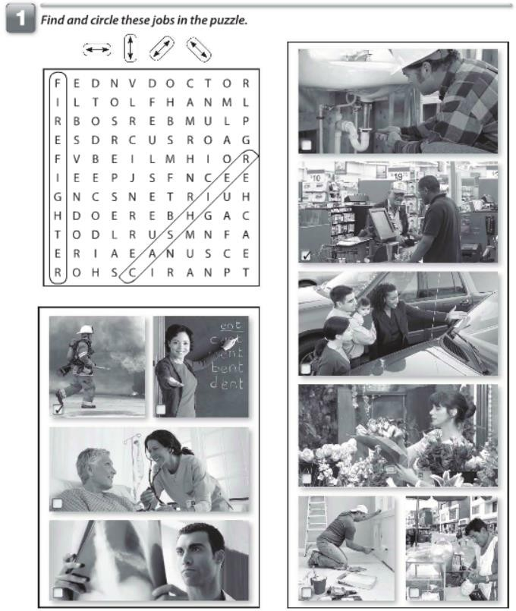

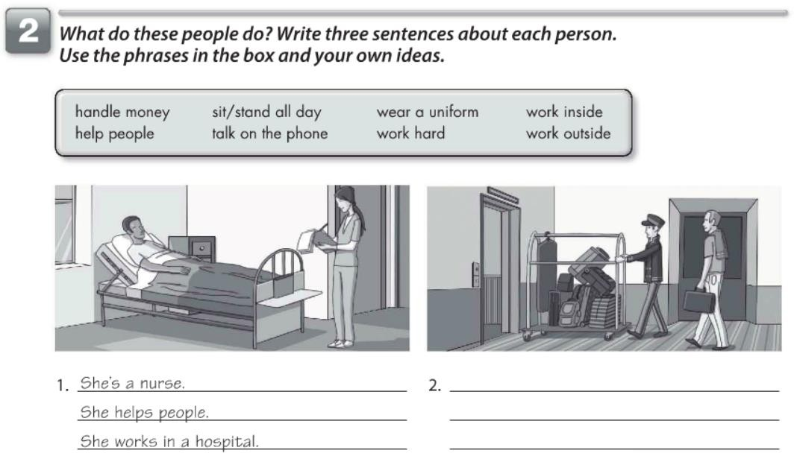

He's a police officer.

He's a receptionist.

He's a cashier.

He's a sales person.

He's a bellhop.

He helps carrying people's luggage.

He provides services to hotel guests.

A police officer issues citations for minor offenses.

He protects lives, enforce law and order in communities.

He orginize files for billing.

He makes appointment for all staff or for specific employees.

He helps customer about product or services.

He helps customer process sales transactions.

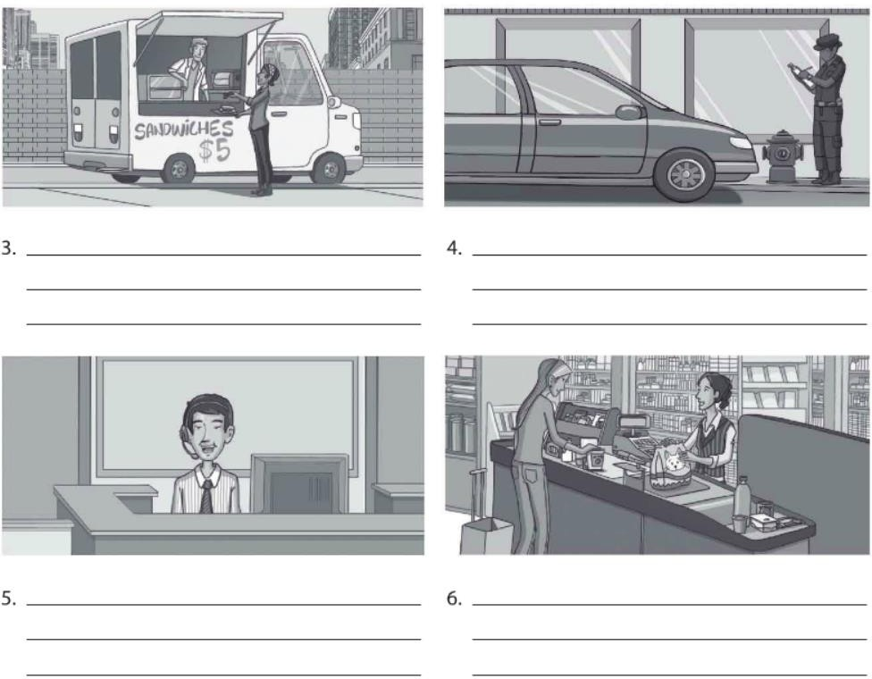

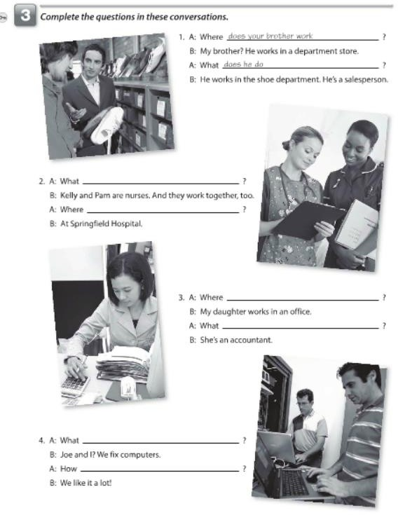

Kelly and Pam work

Where do they work

your daugther works.

does she do

do you do

## 27

do you like it

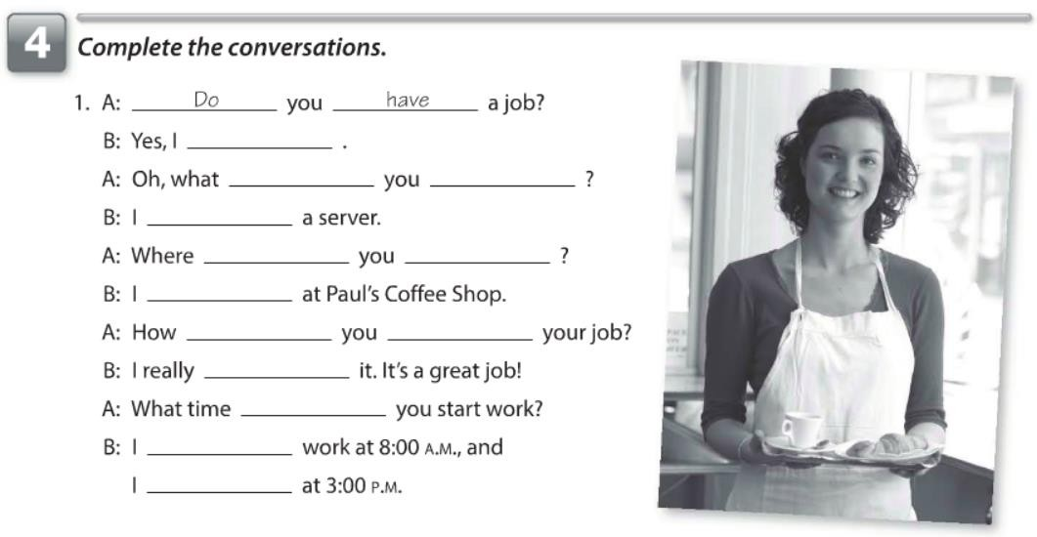

do

do

do

am

do

work

work

do

like

do

do

start to

finish

have

does works

works

does do

is

does

do

does

start to

starts

finish

like

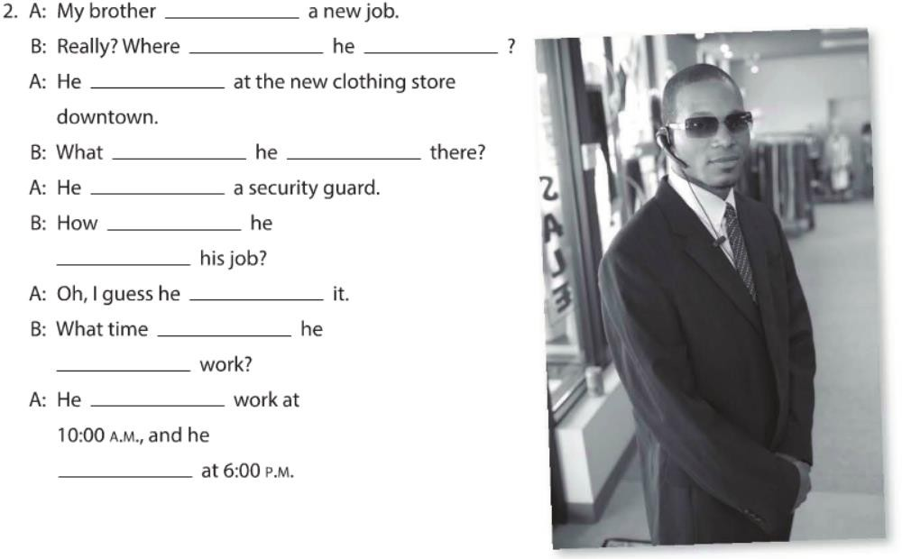

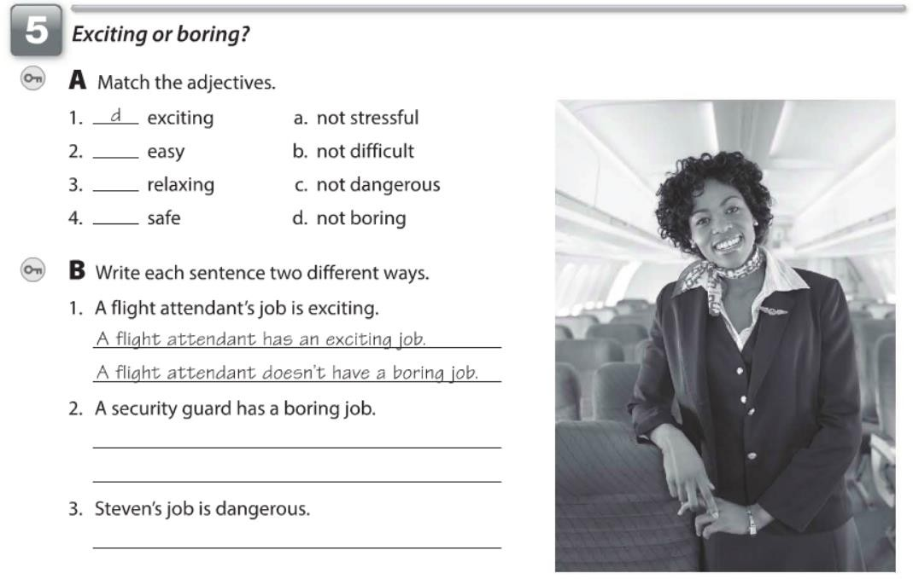

b

a

c

Steven job isn't dangerous.

A security guard doesn't have a boring job.

A security guard provide security and protection.

A front desk doesn't have a stressful job.

A front desk job is listen and be patient with patient or calls.

Linda doesn't have a small apartment.

Linda has a big apartment.

Martha's house isn't big.

Martha house is small.

Sarah doens't have a talkative sister.

Sarah has a quiet sister.

My job isn't easy.

My job is hard.

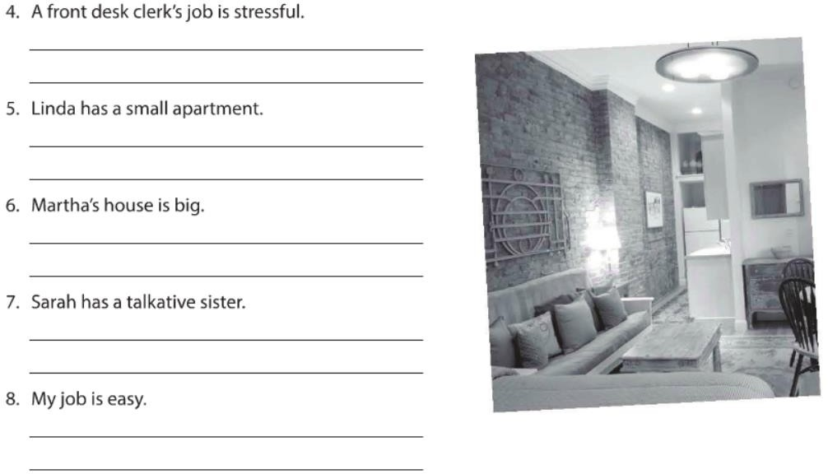

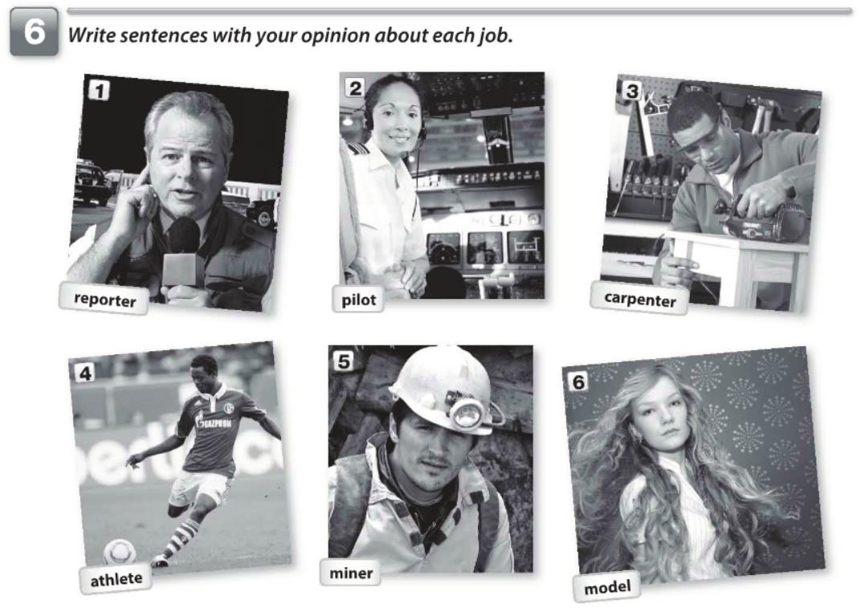

My dream job is to become a psychologist and help people to learn to cope with stressful situations, manage their chronic illnesses. Help about the way a person thinks, feels and behaves.

A pilot has a dangerous job. /

A pilot job is exciting.

A carpenter job is creative/

A athlete is a very active job/

A miner job is vary dangerous/

Be a model is very exited job/

