UNIVERSIDAD DEL SURESTE.

Name:

Dulce Navidad Hernandez García.

4to grupo A

Licenciatura en enfermeria.

Teacher:

Claudia Patricia Jaramillo.

15th /OCTOBER/2021

DESCRIPTION ABOUT YOUR FAVORITE PLACE IN THE WORLD

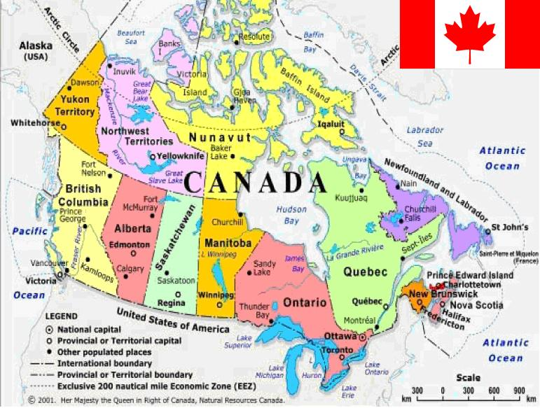LOCATION

Canada is a vast and rugged land. From north to south it spans more than half the Northern Hemisphere.

It is the second largest country in the world, but it has only one-half of one percent of the world's population. The capital is Ottawa.

The official languages are english and french. It´s money is the canadian dollar.

Their best rivers are st. Lawrence and Mackenzie.



The Canadian flag is red and white in the middle with a leaf.





FOOD typical of canada is varied as its poutine, tortiere and maple syrup, among others.

Some tourist places in Canada are niagara falls located in the city of Toronti,canada.

Another tourist site in this country is the Banff National park wich is the heart of the mountains where it is perfect for long walks.

