

inglés i

ACTIVIDAD 2



XOCHITL CONCEPCION PEREZ ALMEIDA

LIC EN ENFERMERIA

1ER CUATRIMESTRE

**Actividad:  
Consigue fotos de tu artista favorito y escribe acerca de él o ella utilizando el verbo “to be¨**

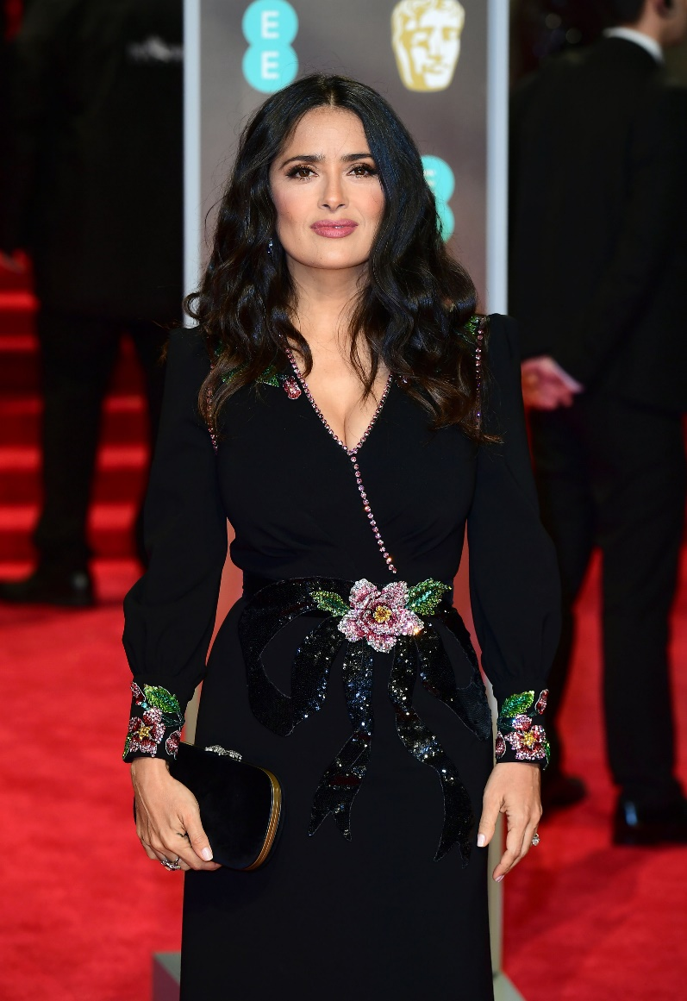**SALMA HAYEK** IS A MEXICAN,

SHE IS FROM COATZACOALCOS, VERACRUZ.

SHE´S AN ACTRESS, PRODUCER, BUSINESSWOMAN.

SHE´S FIFTY-FIVE YEARS OLD

SHE´S PRETTY

SHE´S MARRIED

SHE´S FAMOUSE FOR ITS MOVIE ¨THEY ARE LIKE CHILDREN¨