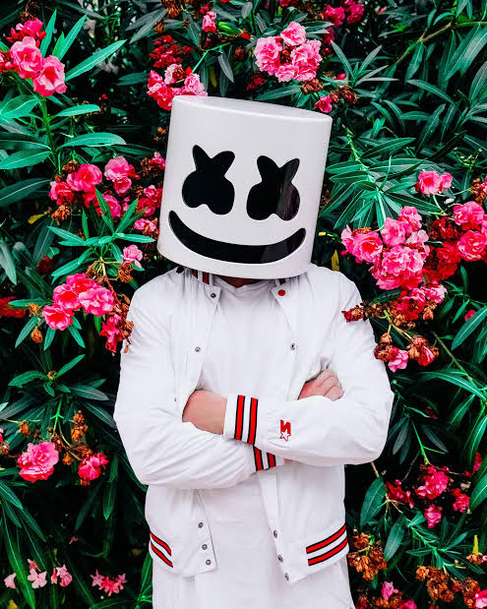

Marsmello is famouse

He´s 29 year old

He´s a single

His aocupation is a dj

He wear a mask

Luis fernando