

SUBJECT: ENGLISH ONE

CAREER: GENERAL NURSING

TEACHER’S NAME: ISAIAS GOMEZ BALLINAS

STUDENT’S NAME: ***LAURA ISABEL DE LA CRUZ MONTES***

GROUP: “ B ”

FIRST QUARTER

WORK: ***SUPER NOTE***

PICHUCALCO, CHIS. October 17 2021.

***6 example to learn to use prepositions***

**ON:**

**IN FRONT OF:**

*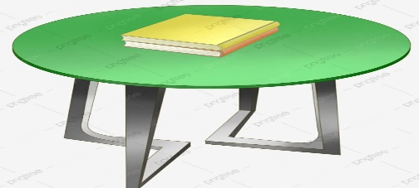The book is on the table. The car is in front of the house*



**BEHIND:**

**IN:**

*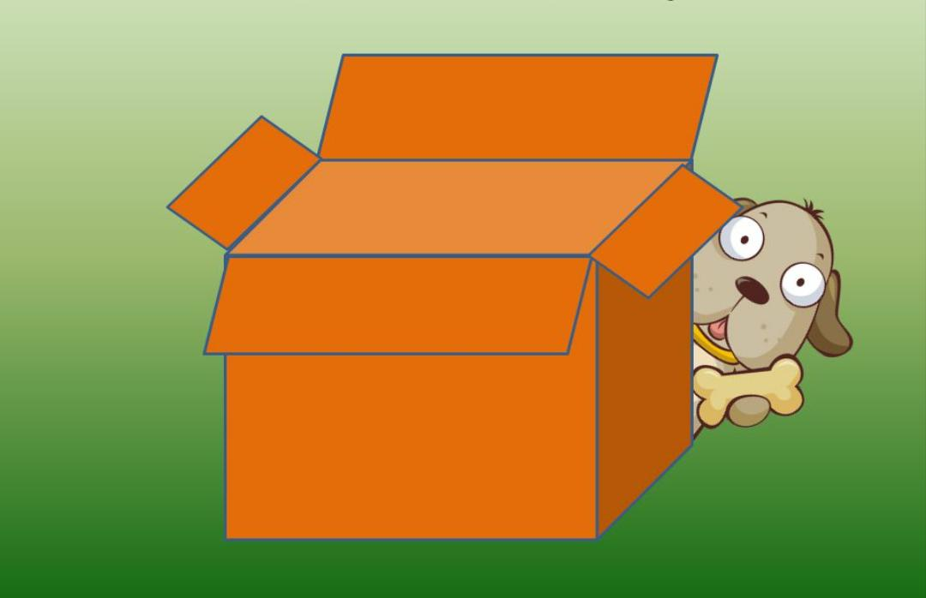They toys are in the box My dog is behind the box*

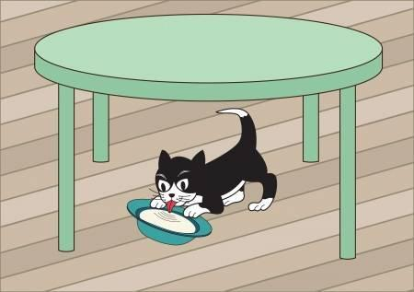

*My cat is under the table*

**UNDER:**

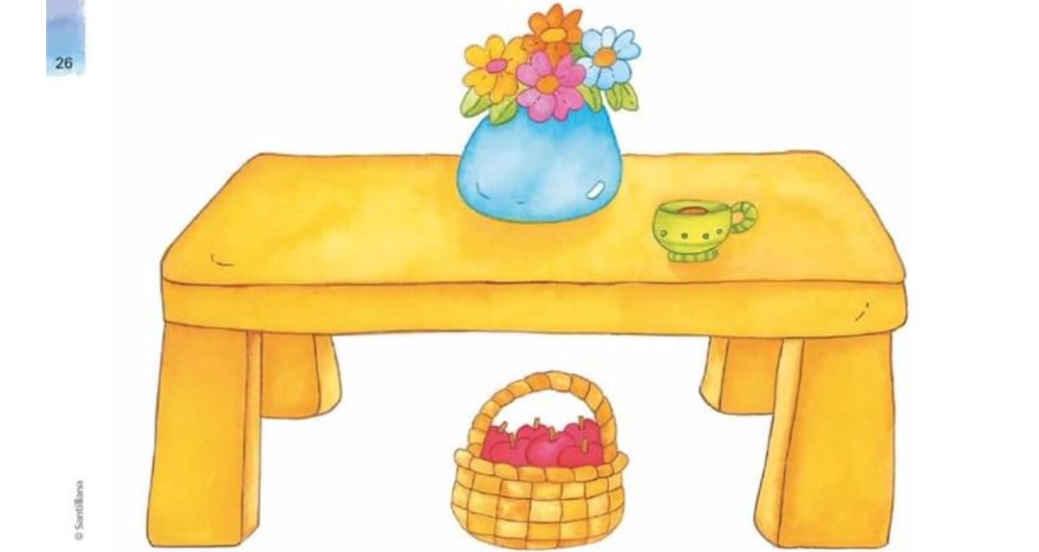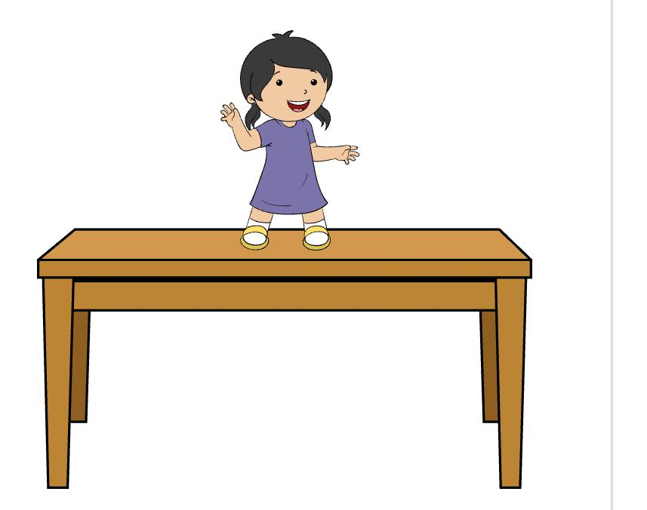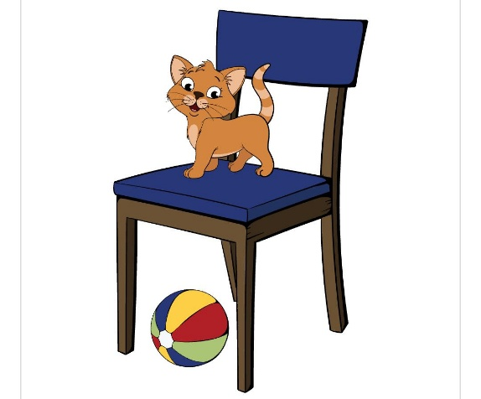

The vase is on the table

The glasses are on the book

Your cat is on the tree.

The girl is on the table

The cat is on the chair

***ON***

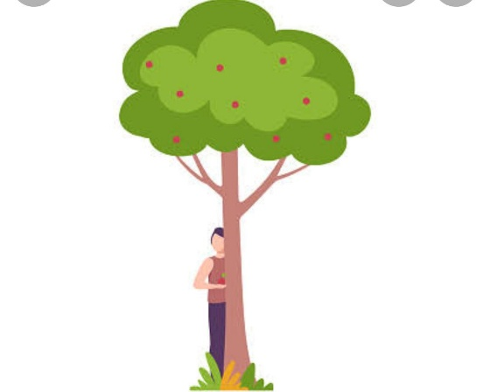

The tree is beahind my house

My rabbit is behind the bush.

The boy is behind the tree

The girl is behind the box

The sun is behind the clouds

***BEHIND***

***UNDER***

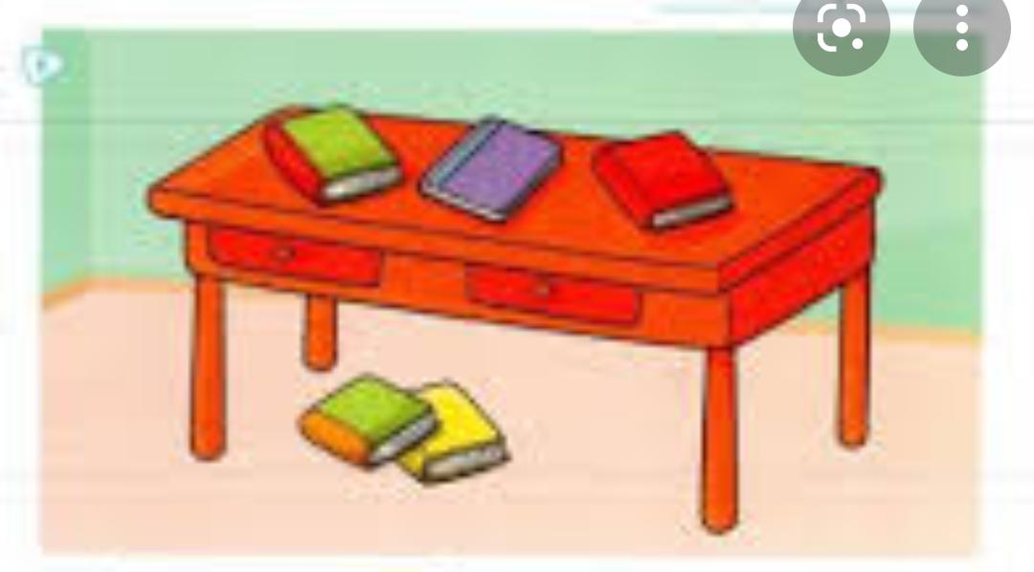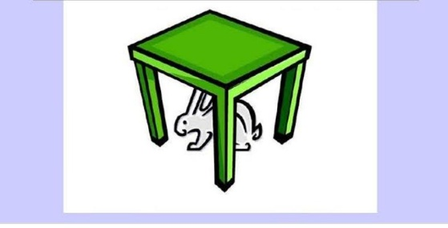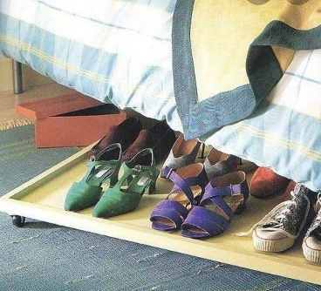

The Ball is under the table

The book is under the table

My rabbit is under the table

My shoes are under the bed

The boy is under the tree



The horse is in the corral.

The fruits are in the refrigerator

The cats are in the box

My dog is in your house

The books are in the backpack

***IN***



The pets are is in front of the cafeteria.

A bird is in front of the windows

The tree is in front of my house

The Child is in front of the school

The dog is in front of the house

***IN FRONT OF***