

**Nombre de alumno:** LUIS E. GUILLÉN M.

**Nombre del profesor:** JUAN MANUEL JAIME.



**Nombre del trabajo: Unit Activity - U1 2LIC**

**Materia:** INGLÉS II.

**Grado:** 2°.

**Grupo:** A.

Comitán de Domínguez Chiapas a 04 de enero de 2021.

**DOES IT HAVE A VIEW?**

**Exercise 1.** Write the parts of the house (Escribe las partes de la casa)

**closet**

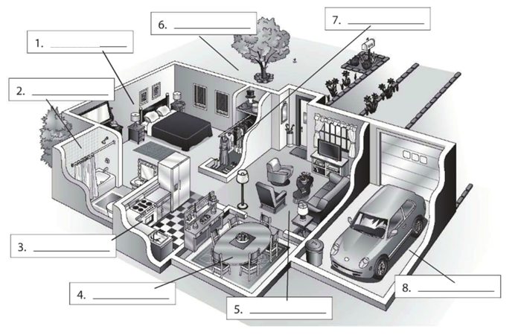

**Front yard**

**bathroom**

**DINNING ROOM**

**LIVING ROOM**

**kitchen**

**GARAGE**

**bedroom**

**Exercise 2.** Complete the conversation. Use the sentences in the box (Completa la conversación usa las oraciones de la caja)

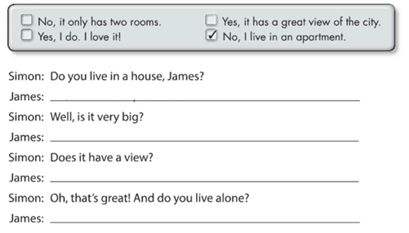

**No, it only has two rooms**

**Yes, it has a great view of the city**

**Yes, I do. I love it**

**No, I live in an apartment**

**Exercise 3.** Complete the conversation with the correct words in parenthese (Completa la conversación con las palabras correctas en parentesis)

**live**

**Do**

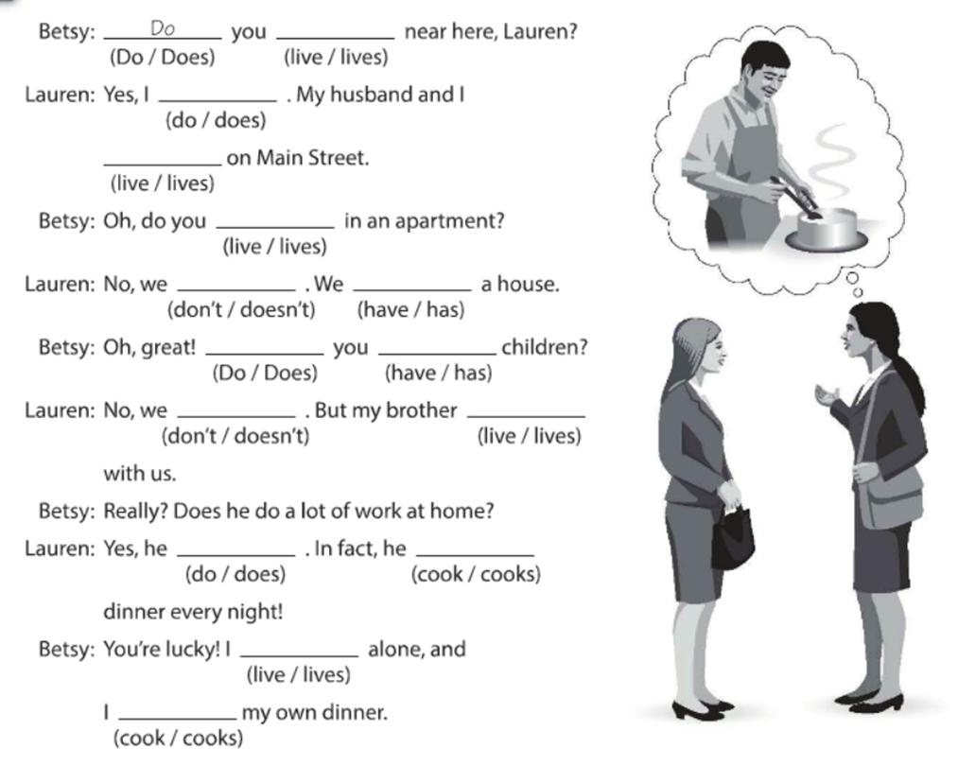

**Do**

**live**

**live**

**have**

**Don´t**

**Do**

**have**

**lives**

**Don´t**

**cooks**

**Does**

**live**

**cook**

**Exercise 4.** Answer these questions with your personal information Use short answers (Completa estas preguntas con tu información personal, usa respuestas cortas)

**No, I don´t**

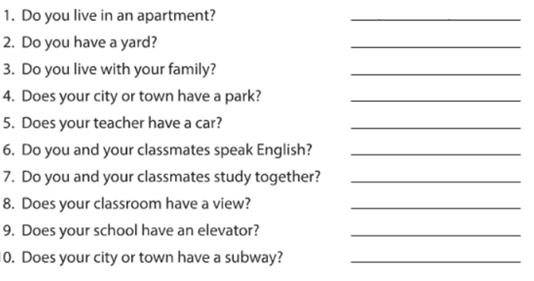

**Yes, I do.**

**Yes, I do**

**Yes, I do**

**Yes, he does.**

**Yes, they do**

**Yes, we do**

**Yes, It does**

**No, It doesn´t**

**No, It doesn´t**

**Exercise 5.** Answer these questions about the pictures. (Responde las preguntas de acuerdo a la imagen)

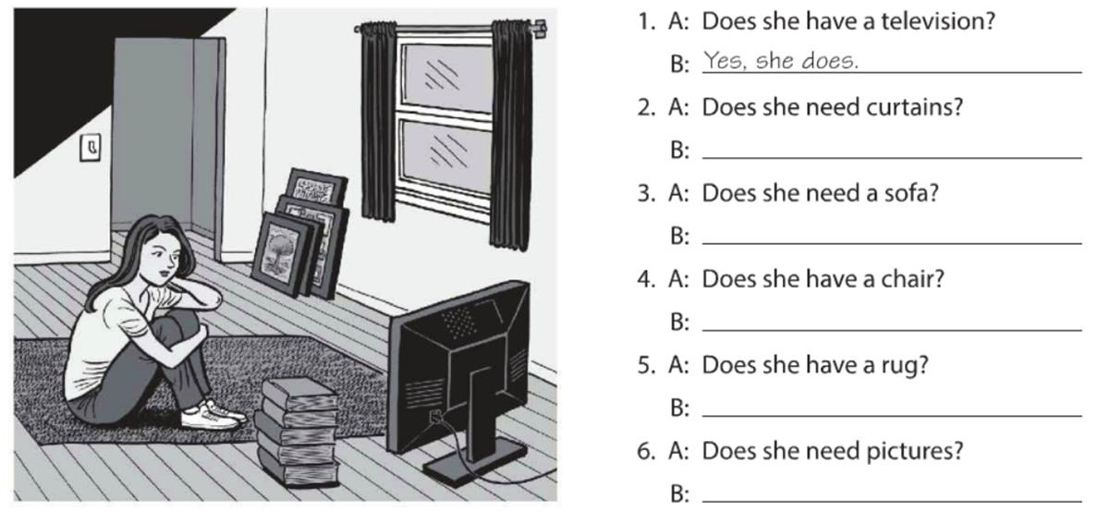

**Yes, she does**

**No, she doesn´t**

**Yes, she does**

**No, she doesn´t**

**No, she doesn´t**

**Yes, she does**

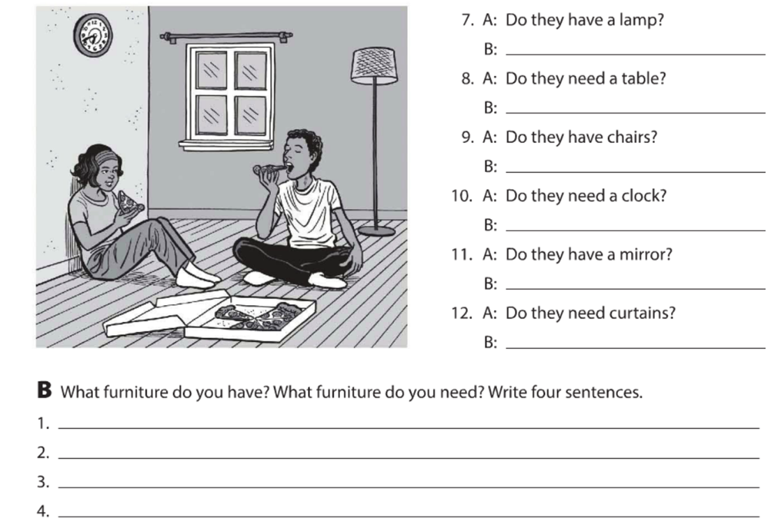

**I don´t have a very big closet.**

**I don´t have a lamp.**

**I don´t have a rug**

**I do have a mirror.**

**Yes, they do**

**No, they don´t**

**No, they don´t**

**No, they don´t**

**Yes, they do**

**Yes, they do**

**Exercise 6.** Complete the description with “ ´s, are or aren´t ”. (Completa la descripción con “ ´s, are or aren´t ”)

**‘s**

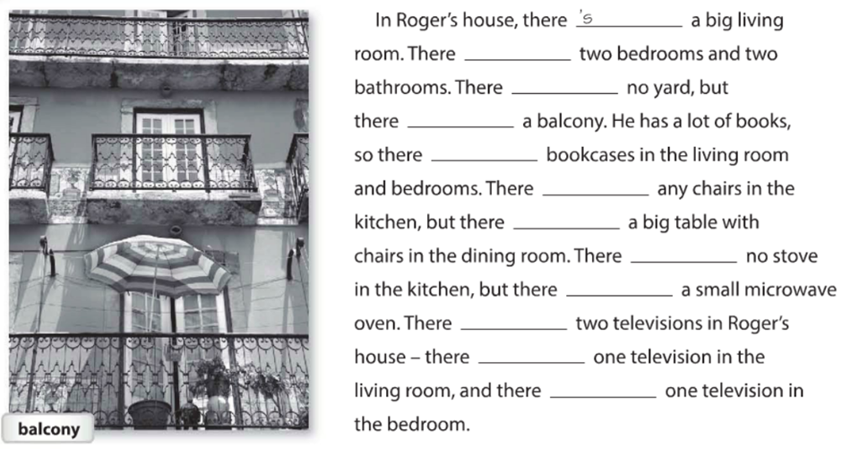

**´s**

**´s**

**are**

**Aren´t**

**is**

**´s**

**´s**

**are**

**´s**

**´s**

**are**

**Exercise 7.** Answer these questions with information about your home. Use the phases in the box. (Responde las preguntas con información acerca de tu casa, usa la información de la caja).

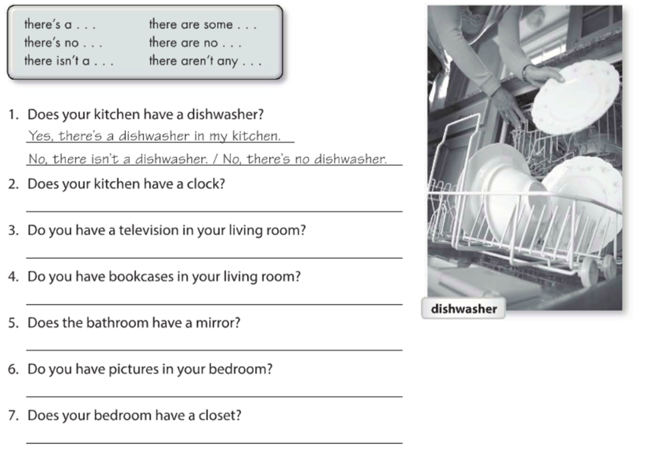

**Yes, there´s a tv in my living room**

**No, there aren´t any bookcases in my living room**

**Yes, there´s a mirror in my bathroom**

**Yes, there are some pictures in my bedroom**

**Yes, there´s a closet in my bedroom**

**No, there isn´t a clock in my kitchen**

**Exercise 8.** Write sentences about the house. Use “**there”** and the words in parentheses. (Escribe acerca de la casa, usa **“there”** y las palabras en parentesis).

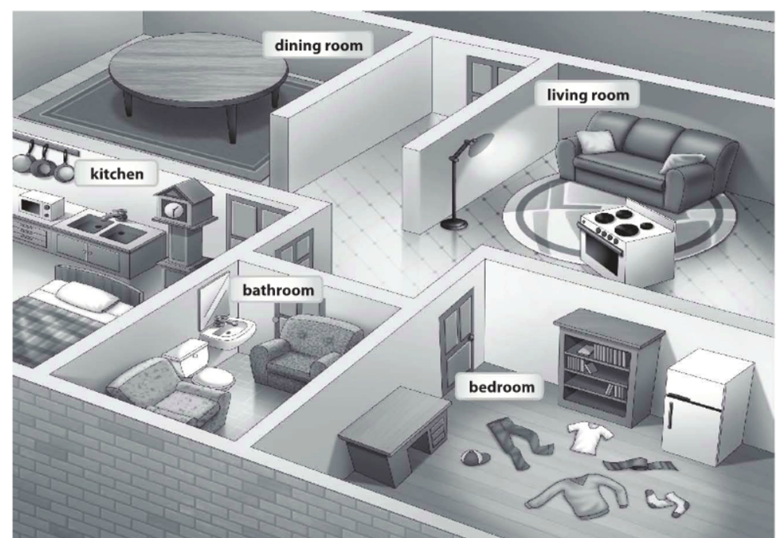

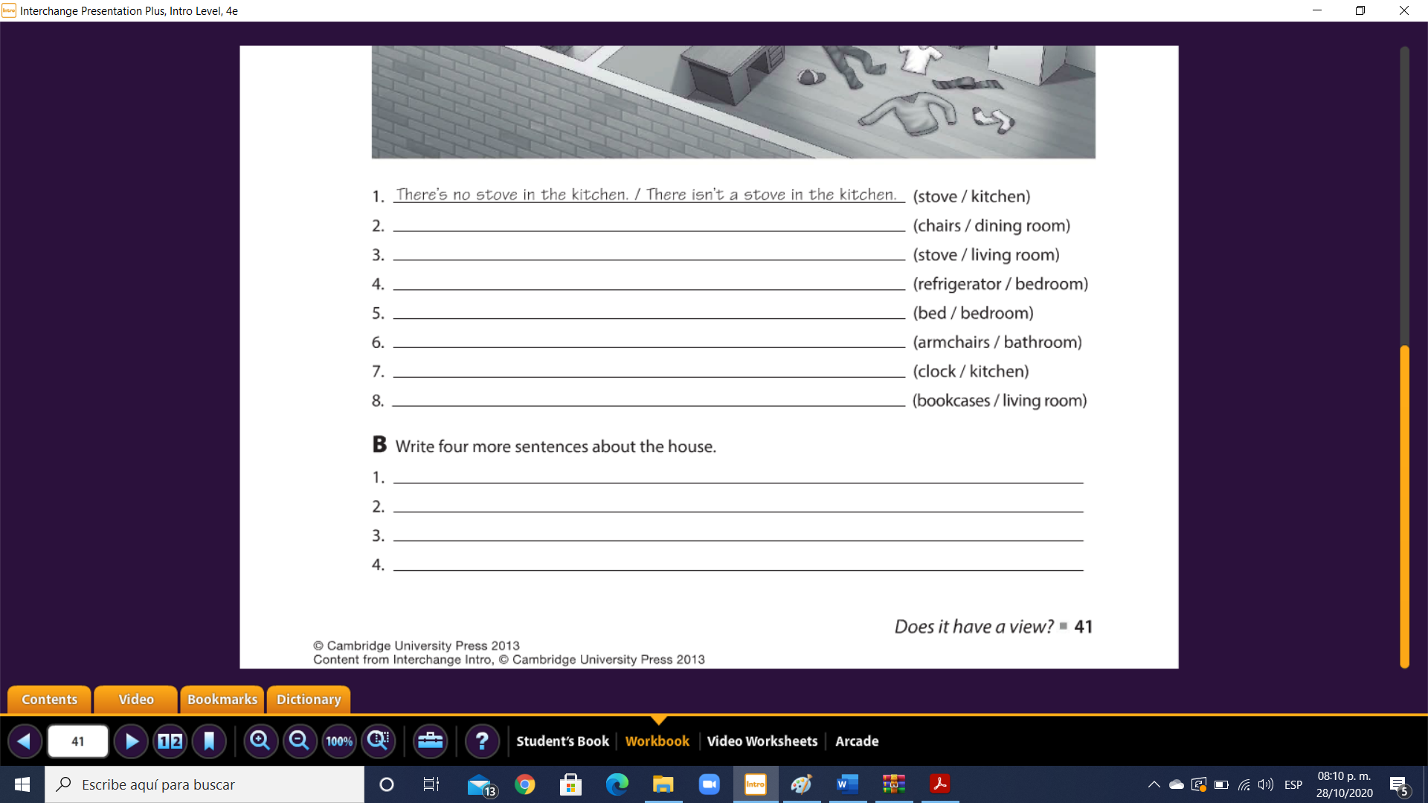

**There´s a closet in the bedroom**

**There are no books in the living room**

**There is not a tv in the bedroom**

**There´s a bed in the kitchen**

**There´s a stove in the living room**

**There´s a refrigerator in the bedroom**

**There isn´t a bed in the bedroom**

**There are armchairs in the bathroom**

**There´s a clock in the kitchen**

**There are no bookcases in the living room**

**There are no chairs in the dining room**

**Exercise 9.** Chose the correct responses. (Escoge las respuestas correctas).

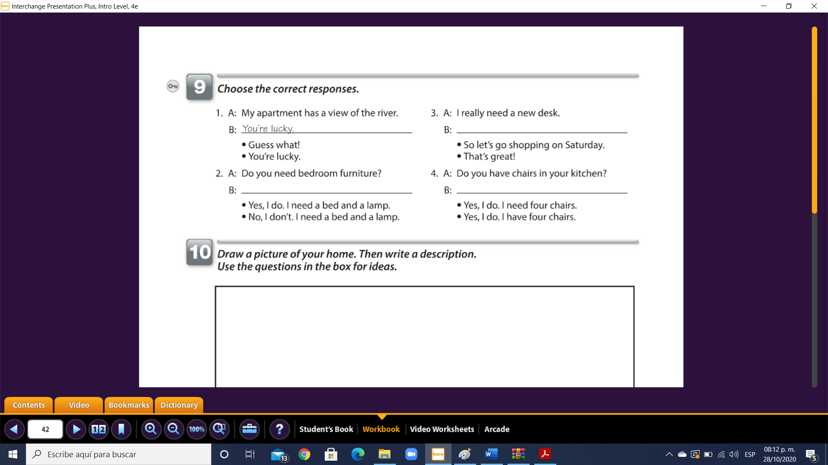

**Yes. I do. I have four chairs**

**No, I don´t. I need a bed and a lamp**

**So let´s go shopping on Saturday**

**Exercise 10.** Reading comprehension (Lectura de comprensión).

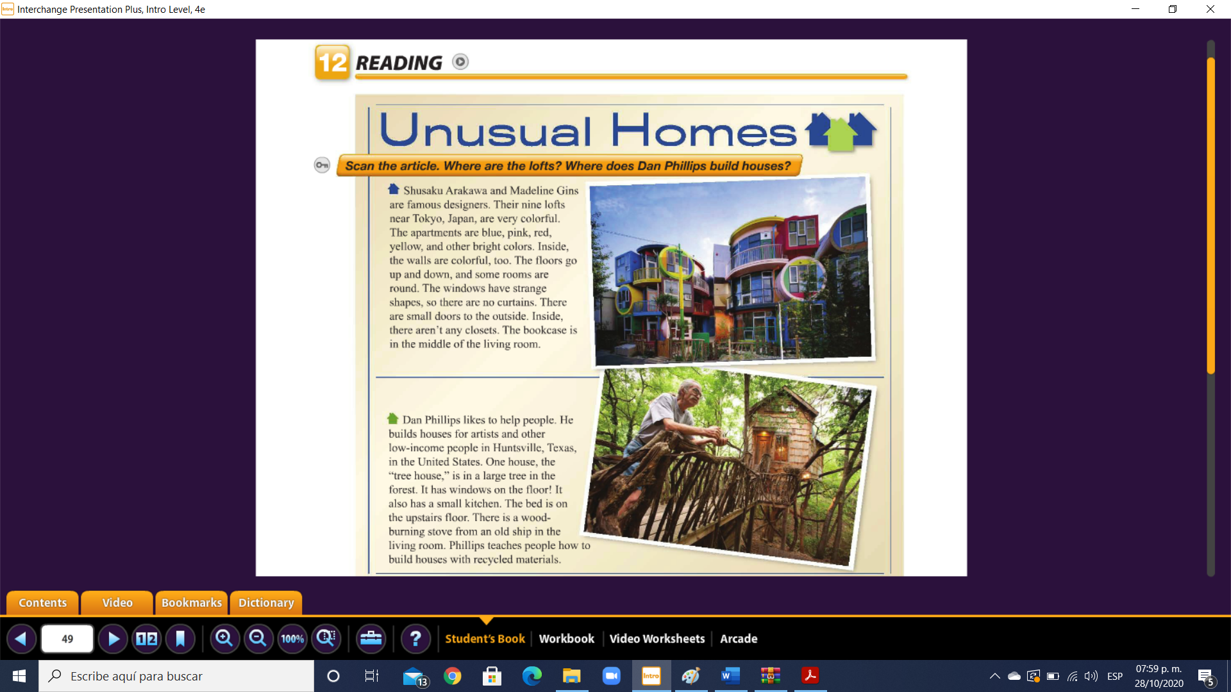

Complete the chart. (Completa la tabla).

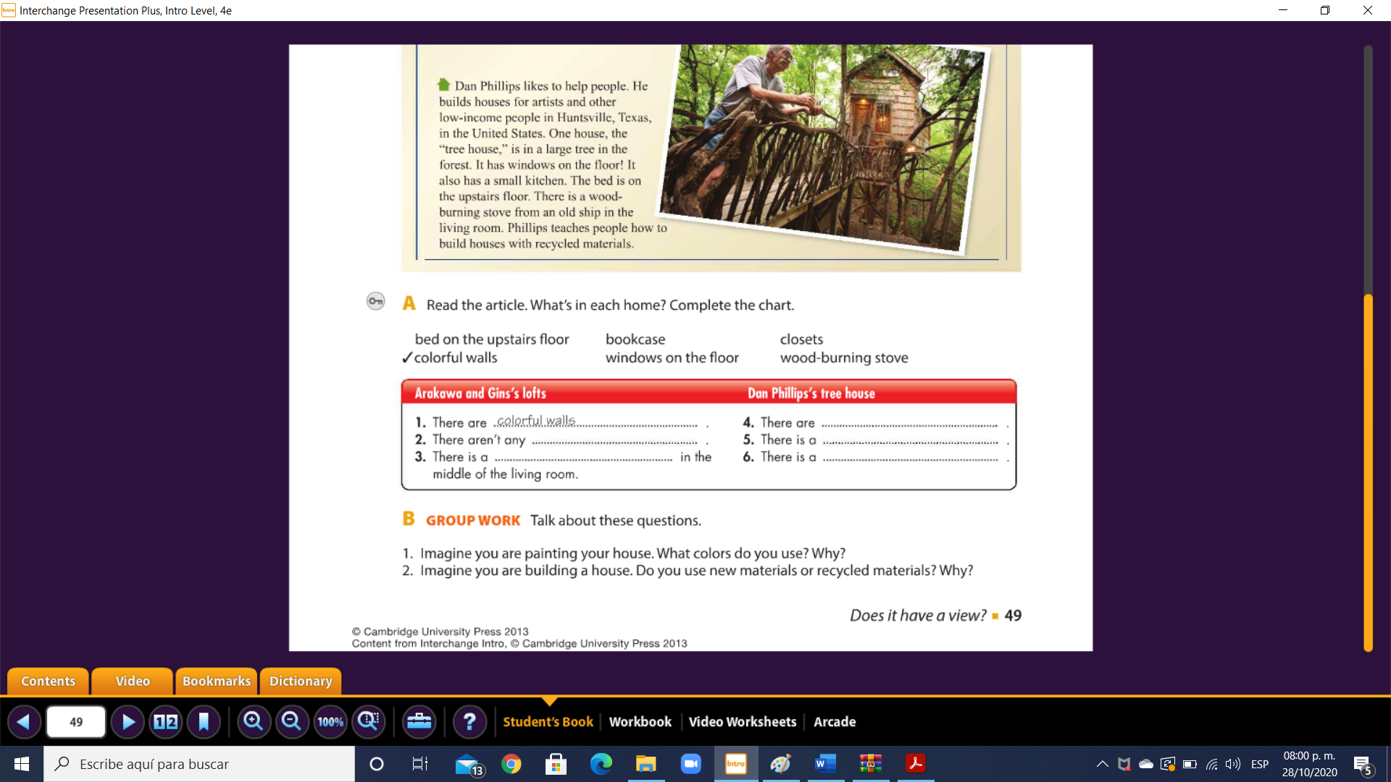

**bookcase**

**Windows on the floor**

**Wood-burning stove**

**Bed on the upstairs floor**

**closets**