

**Nombre de alumno: Cinthya Michelle González Rojas**

**Nombre del profesor: Ana Laura Culebro**



**Nombre del trabajo: English Activity**

**Materia: Ingles**

**Grado:2**

**Grupo: LNU17EMC0120-A**

Comitán de Domínguez Chiapas 2021.

**Do we need any eggs?**

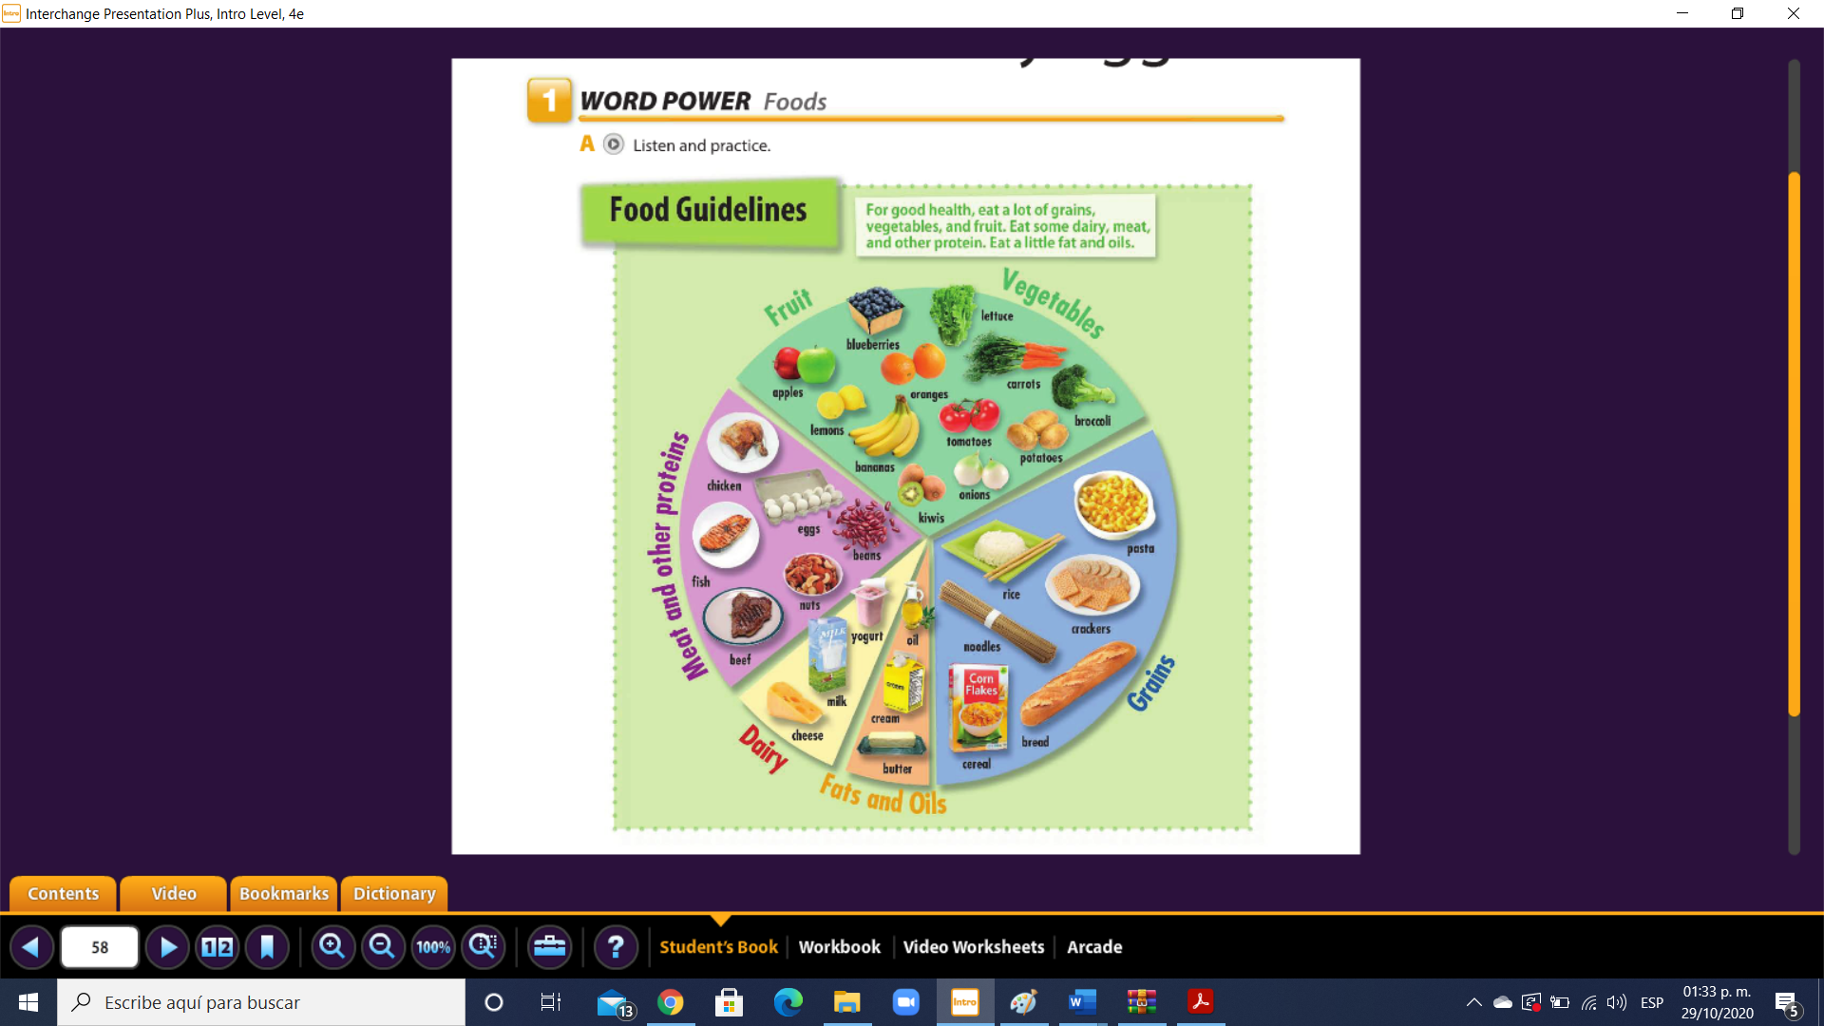

Vocabulario (traduce si no recuerdas el nombre en español)

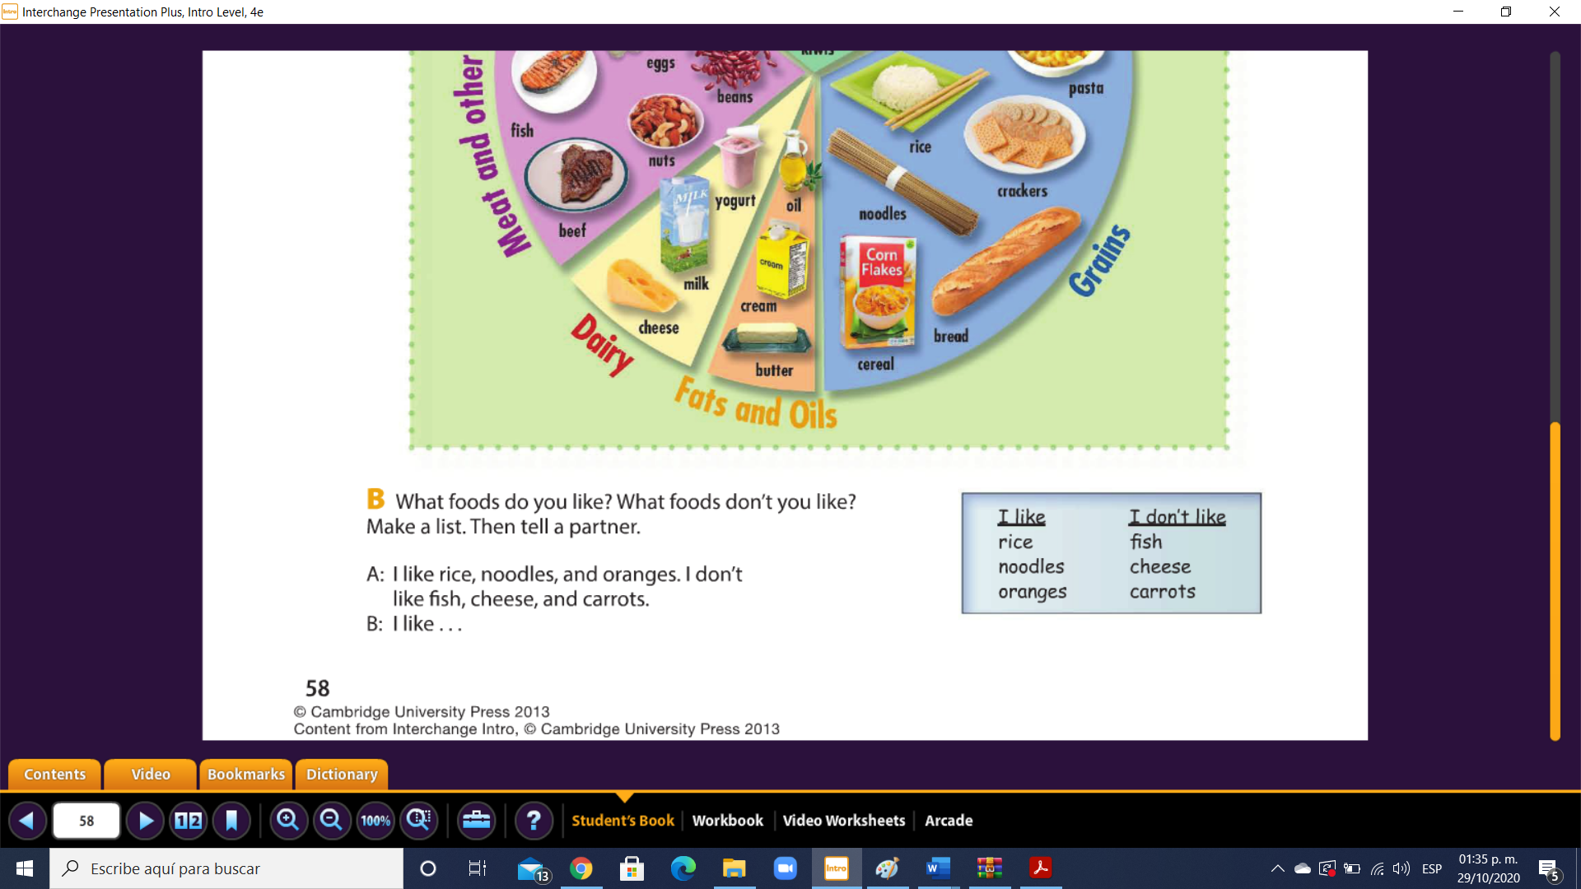31

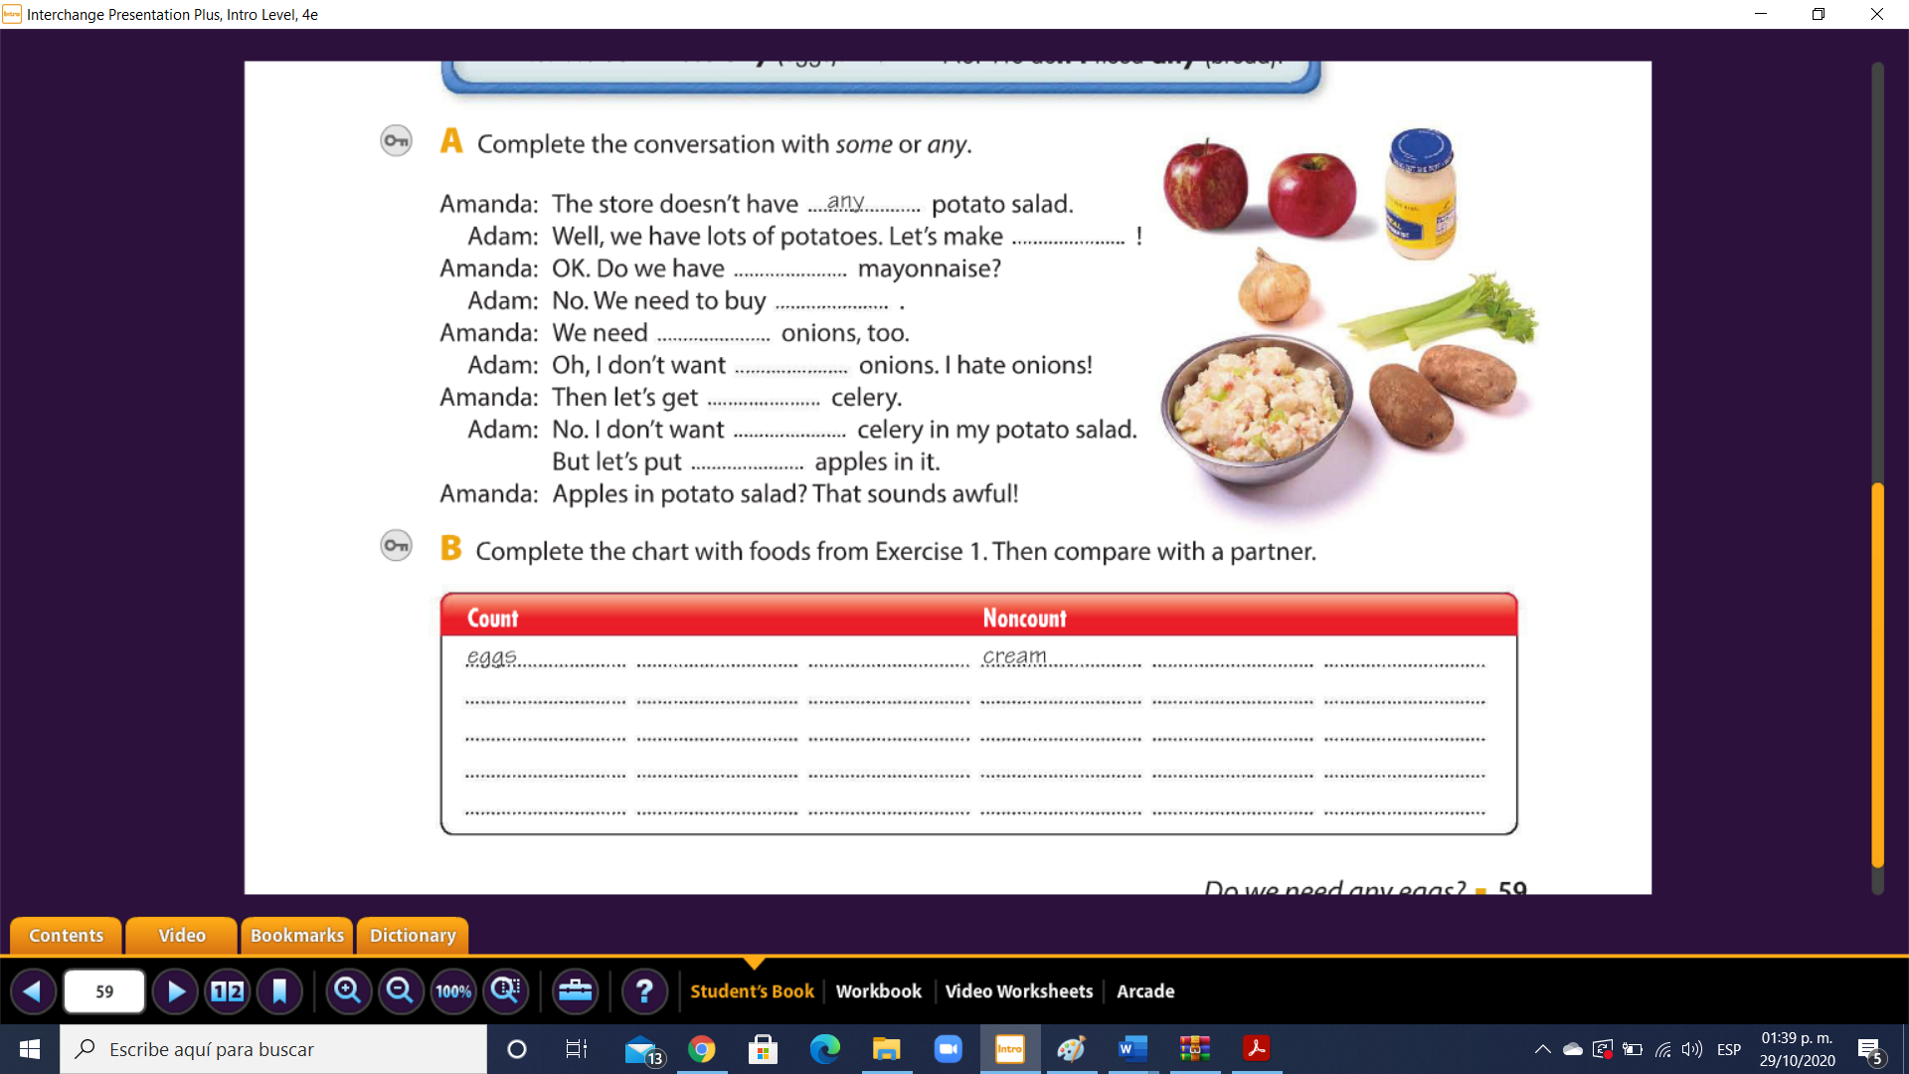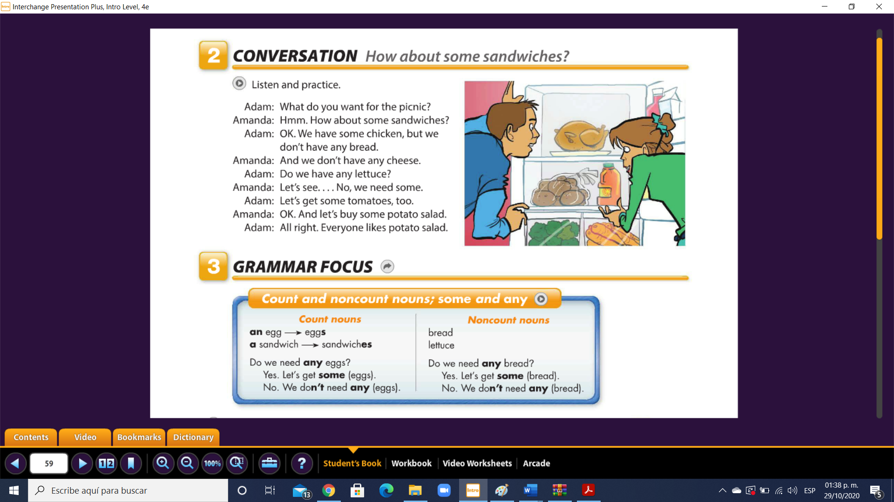  Any some some any any some any 32

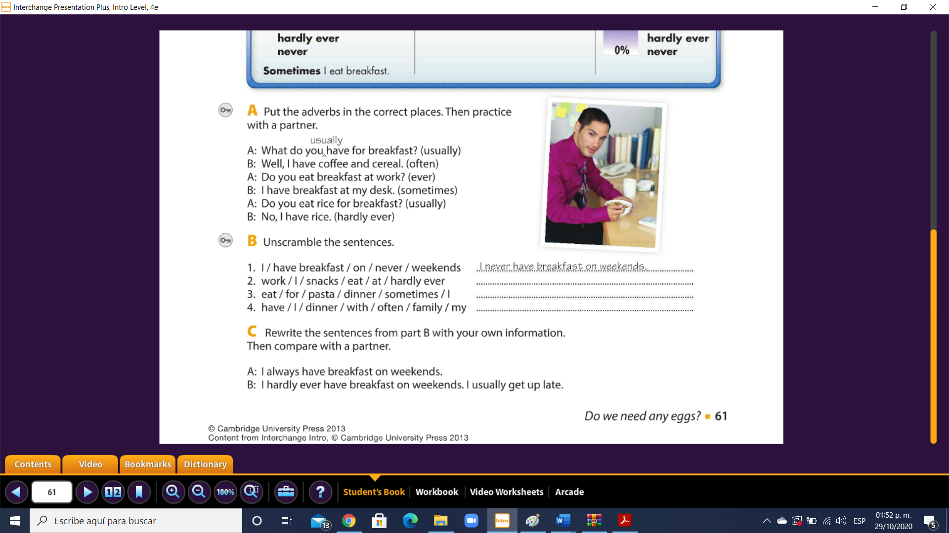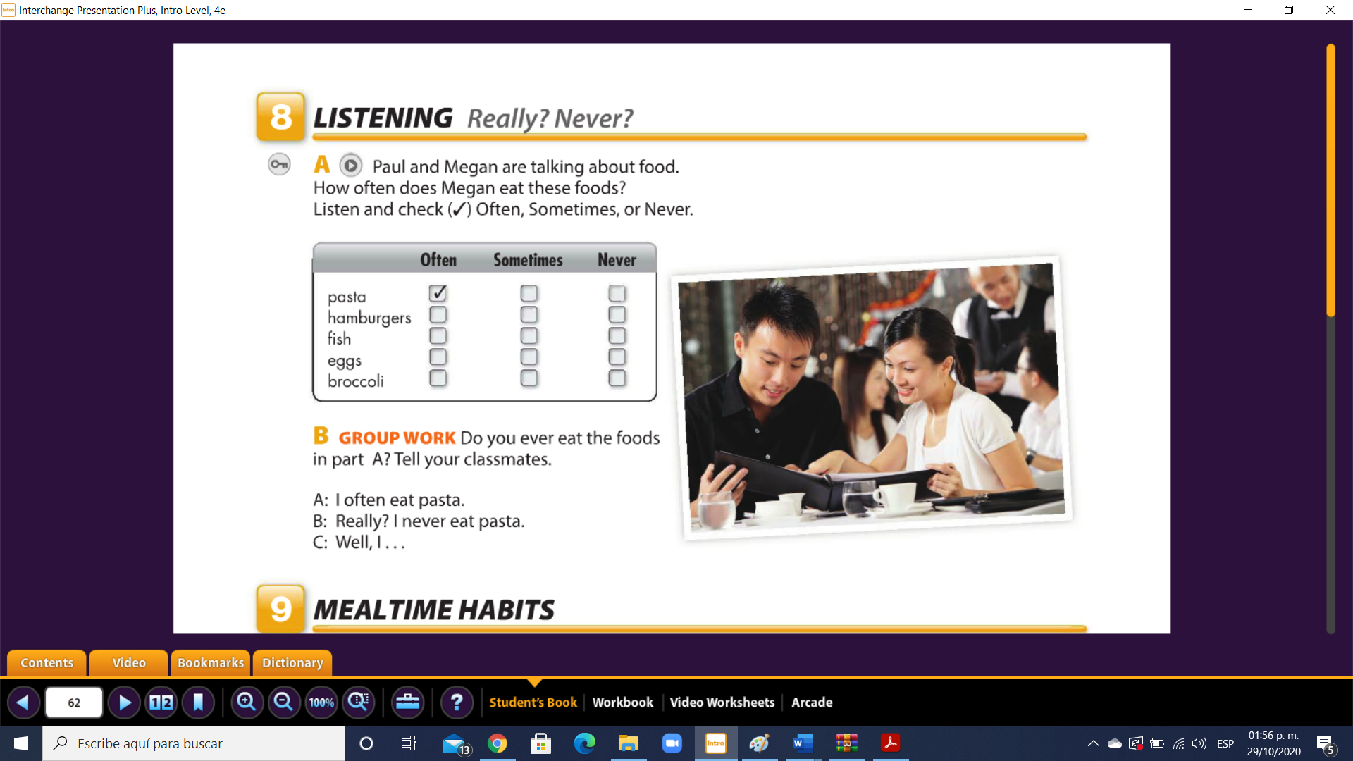36

I often have dinner with my family

I sometimes dinner for eat pasta

I hardly ever eat snacks at work

Work

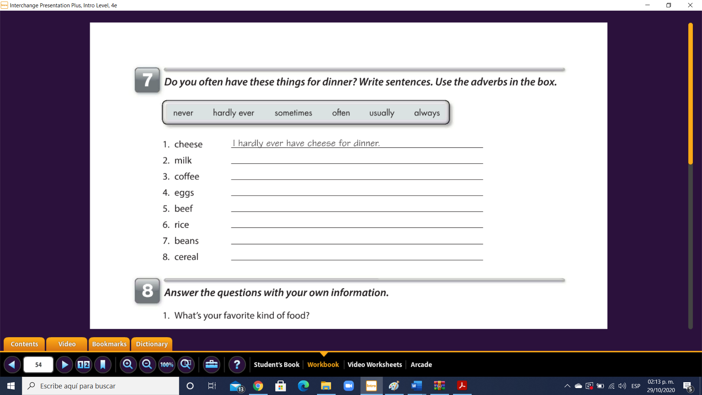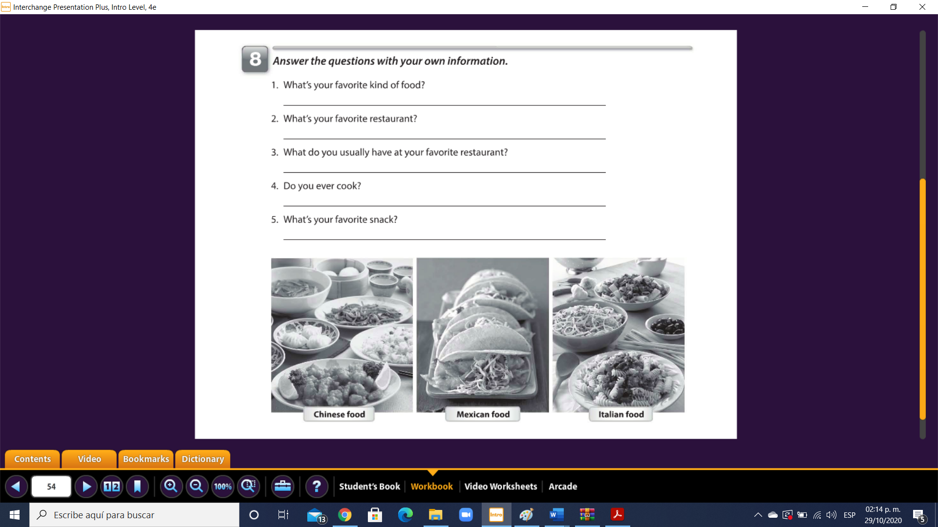

I hardly ever eat cerales

I never eat beans

i usually eat rice

I often eat eggs

I always drink coffee in the morning

i sometimes drink milk in the night

1.- noodles: fideos

2.-crackers: galletas

3.-beens; frijoles