Wilfrido Alfredo anleu gramajo

ingles

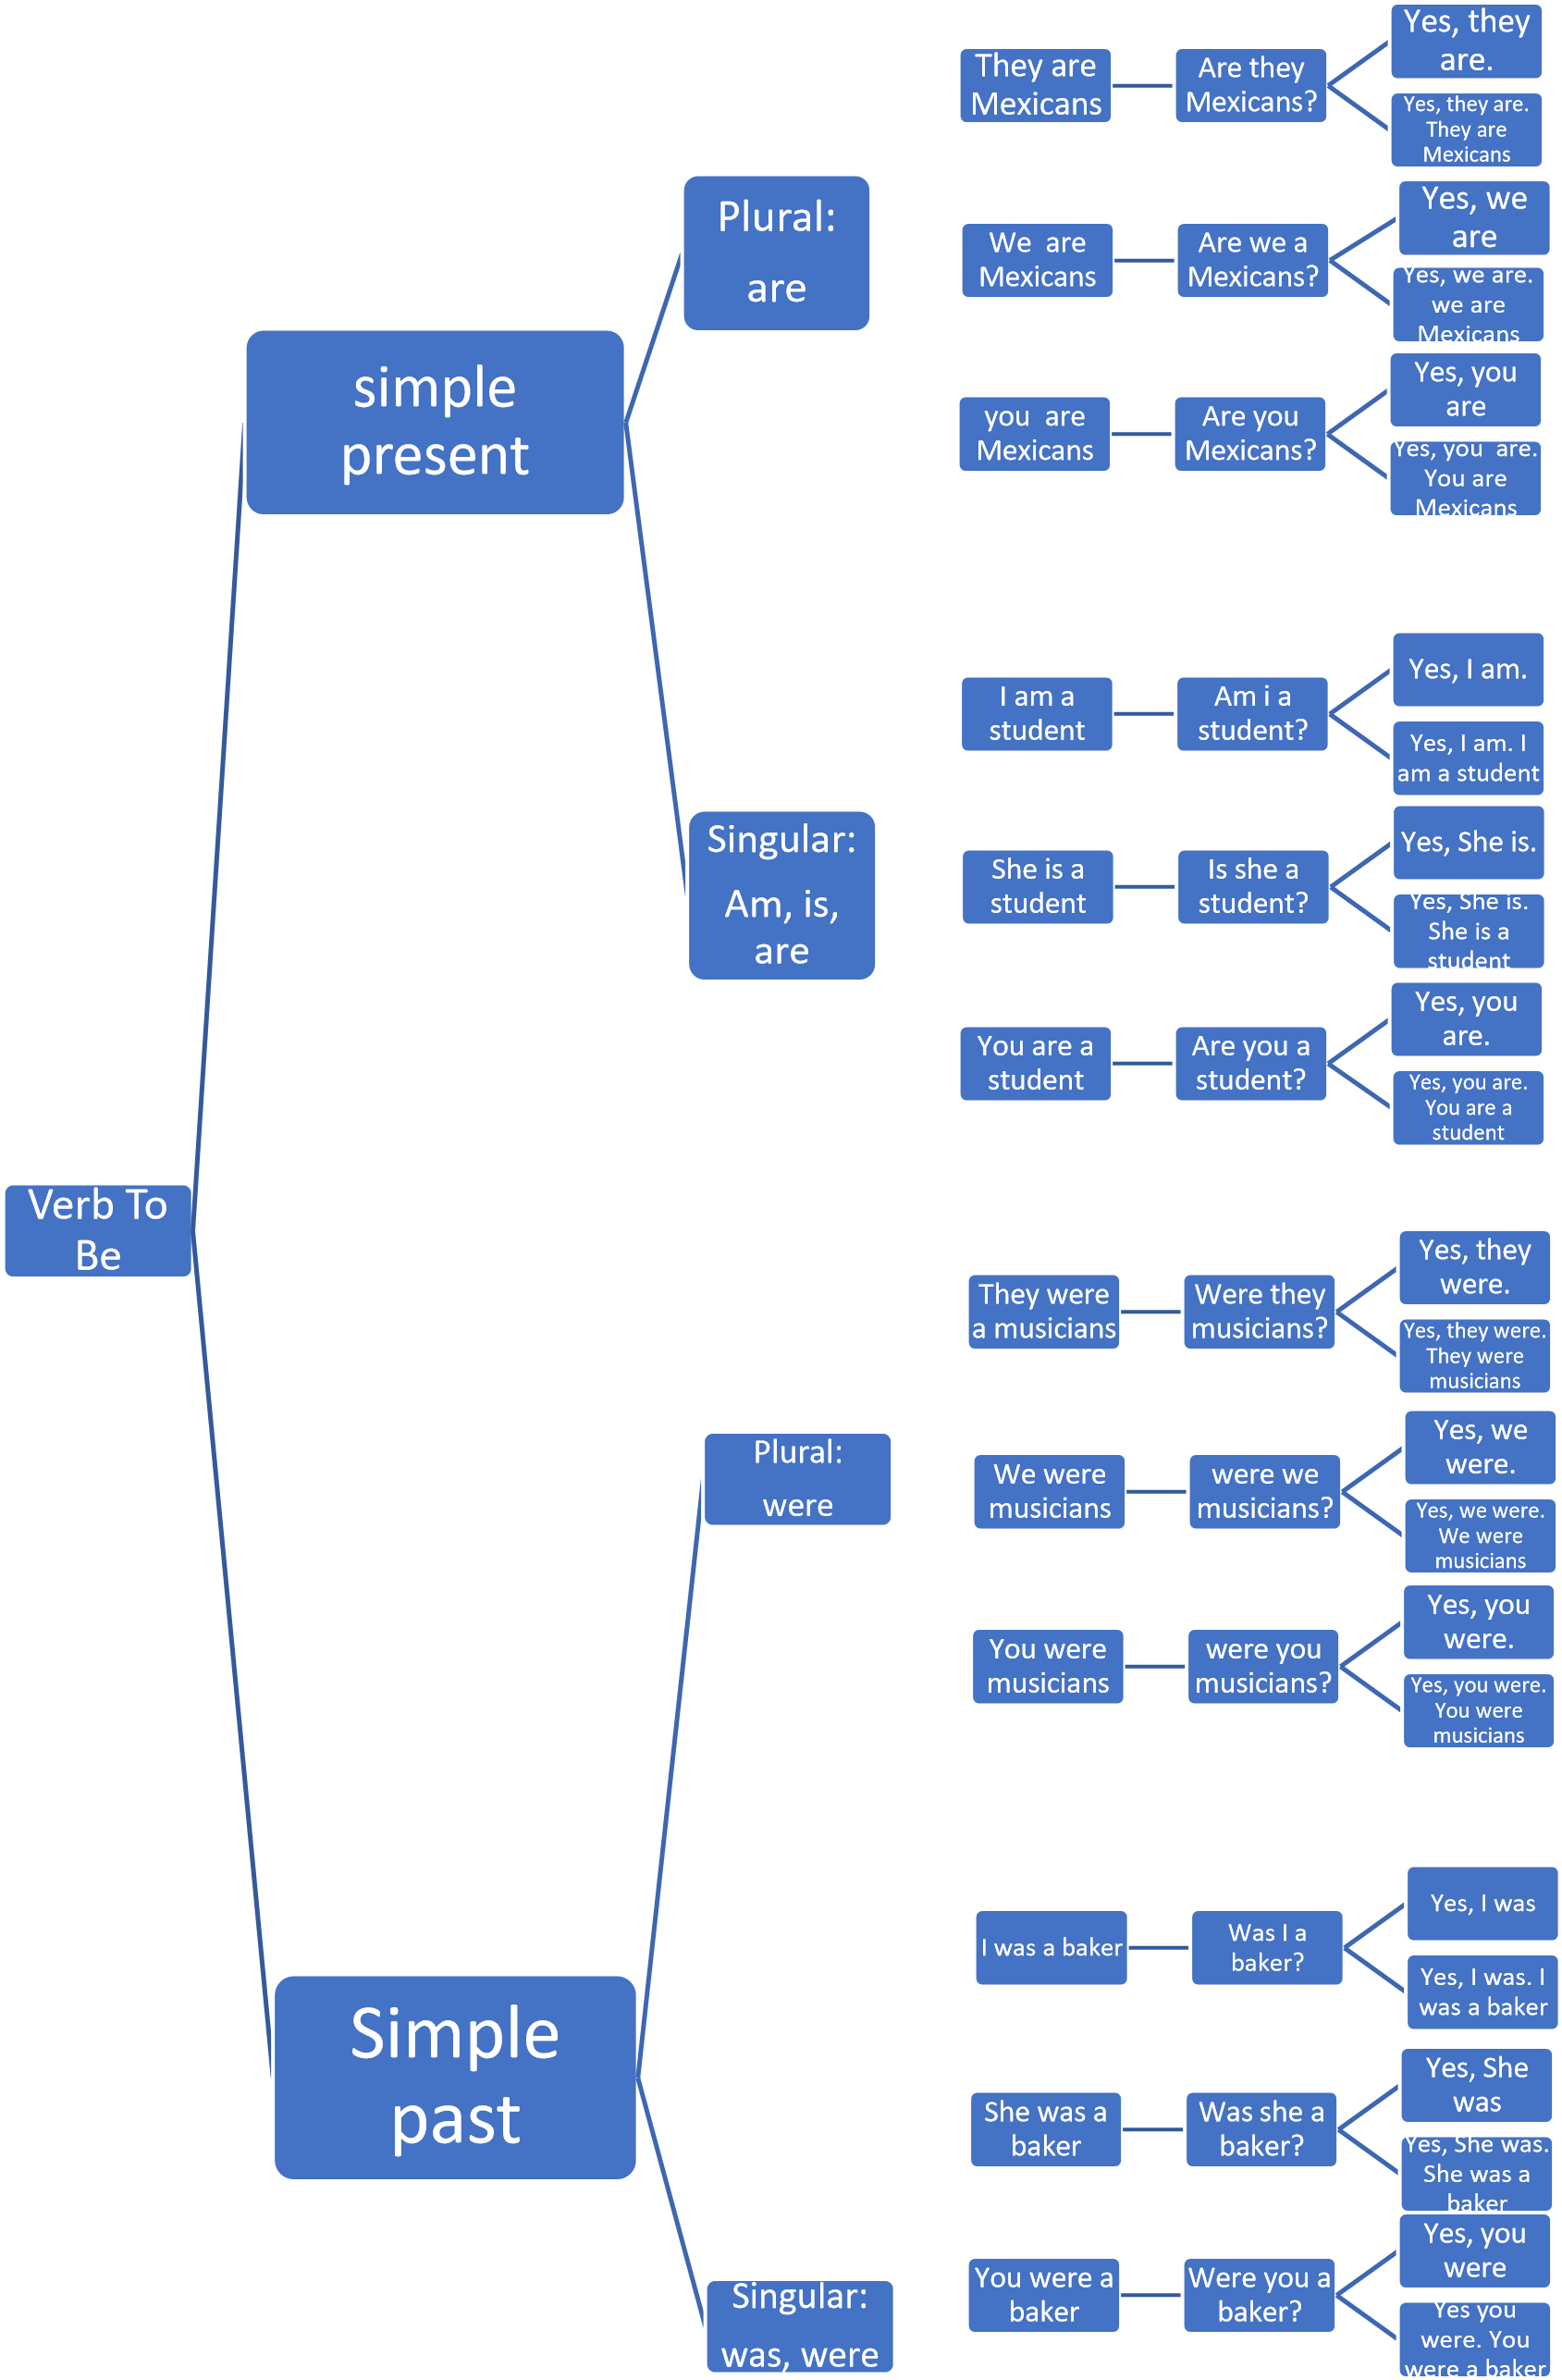

# **WORKBOOK**

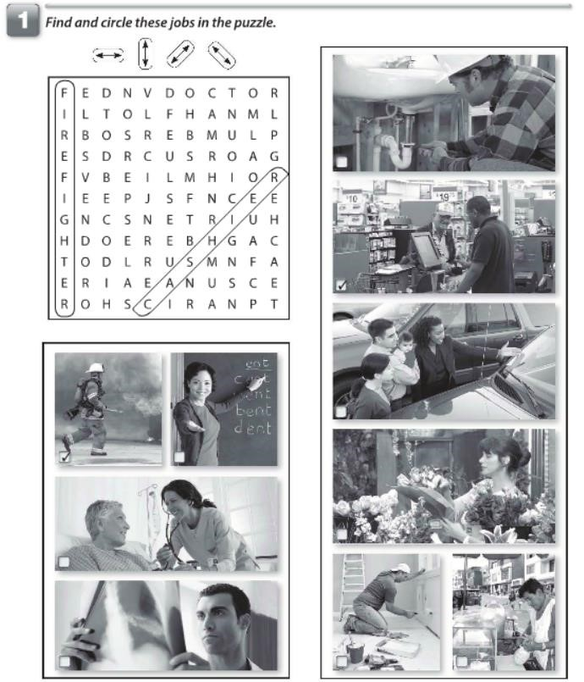

25

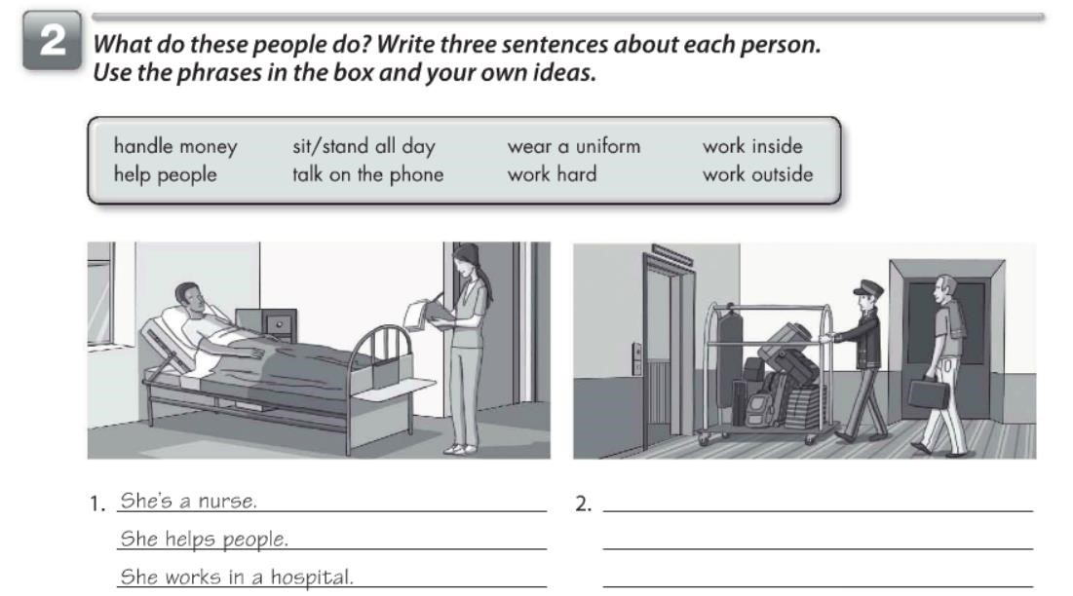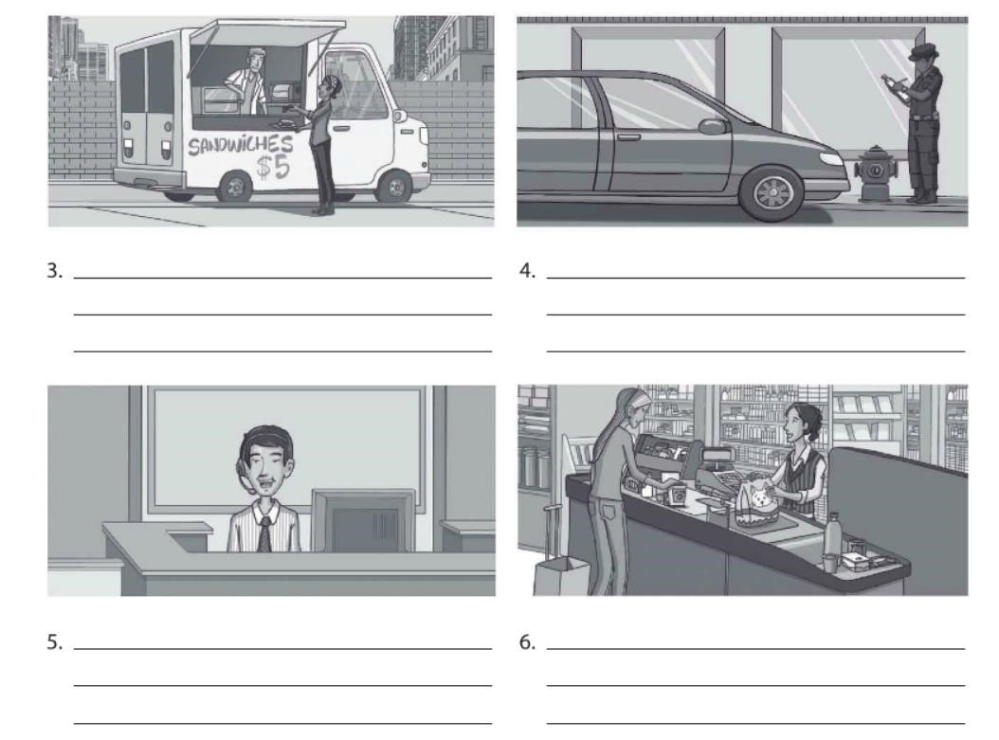

He helps people

He's a policeman

She's a cashier

She works inside

He's a receptionist

He works inside

He talks on the phone

He's a chef

He works outside

He works hard

He's a bellhop

He works inside

He wears a uniform

He wears a uniform

She handles money

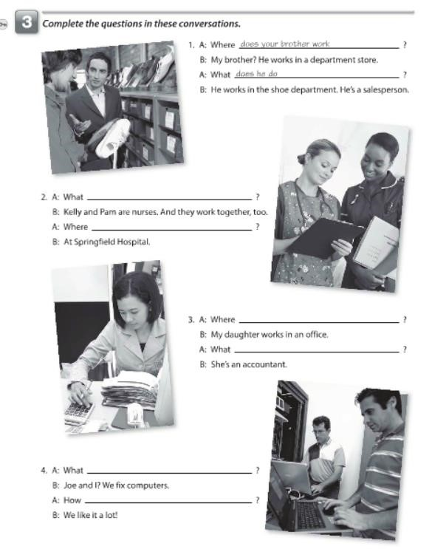

do Kelly and Pam do?

do they work?

does your daughter work

does she do?

do you and joe do

do you like it

27

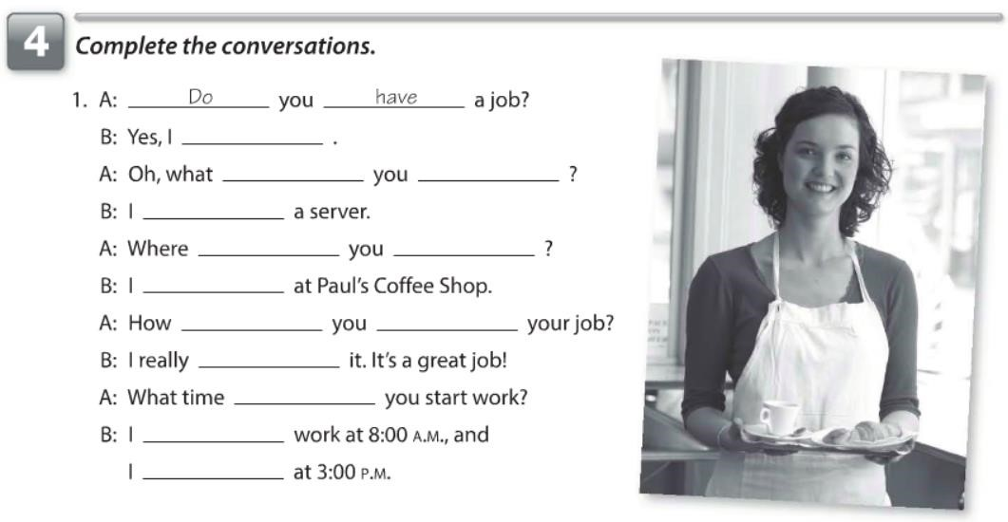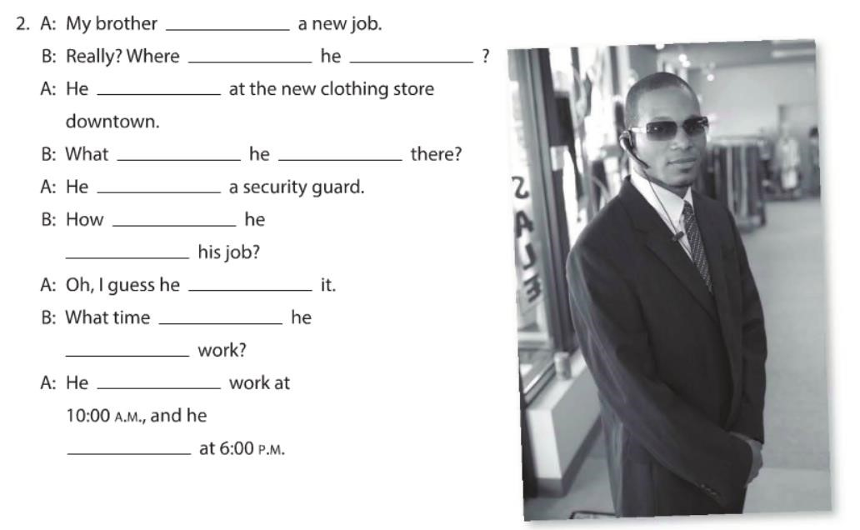

do

do

do

am

do

work

work

do

like

like

do

start

finish

has

does

work

works

does

do

is

does

like

like

does

start

starts

finishes

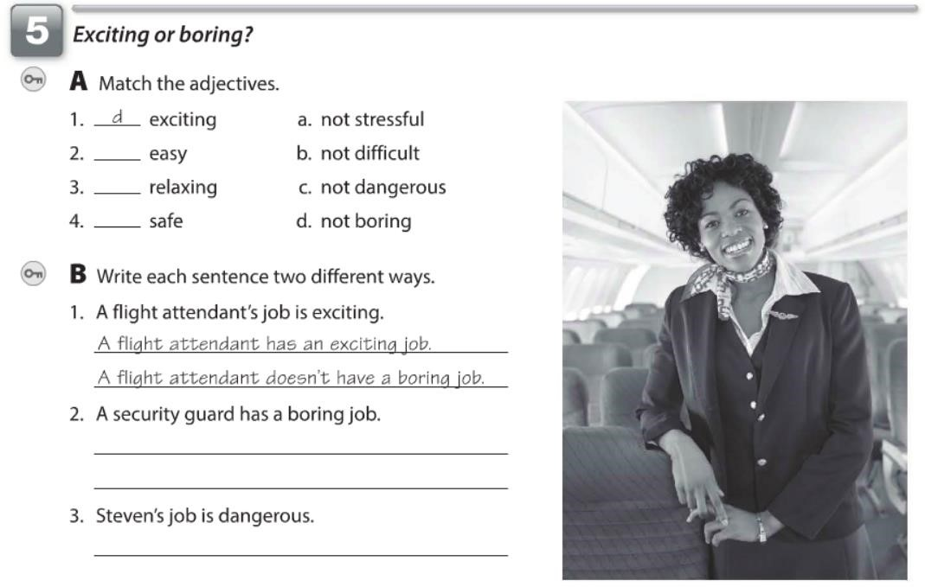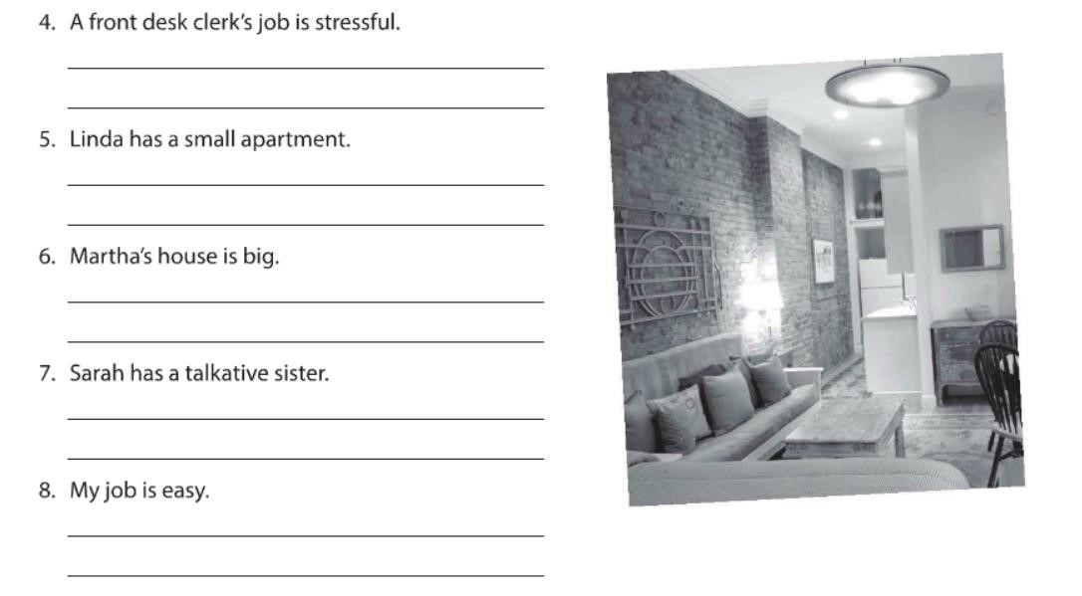

b

a

c

A security guard has an easy job

A security guard doesn't have an intersting job

Steven has an difficult job

Clerk has a difficult job

Clerk doesn't have an easy job

Steve doesn't have an easy job

Linda doesn't have a big apartment

Martha doesn't have a small house

Martha's house isn't small

Lisa's apartment isn't big

Sarah's sister isn't quiet

Sarah doesn't have a sister quiet

I don't have an difficult job

My job isn't intersting

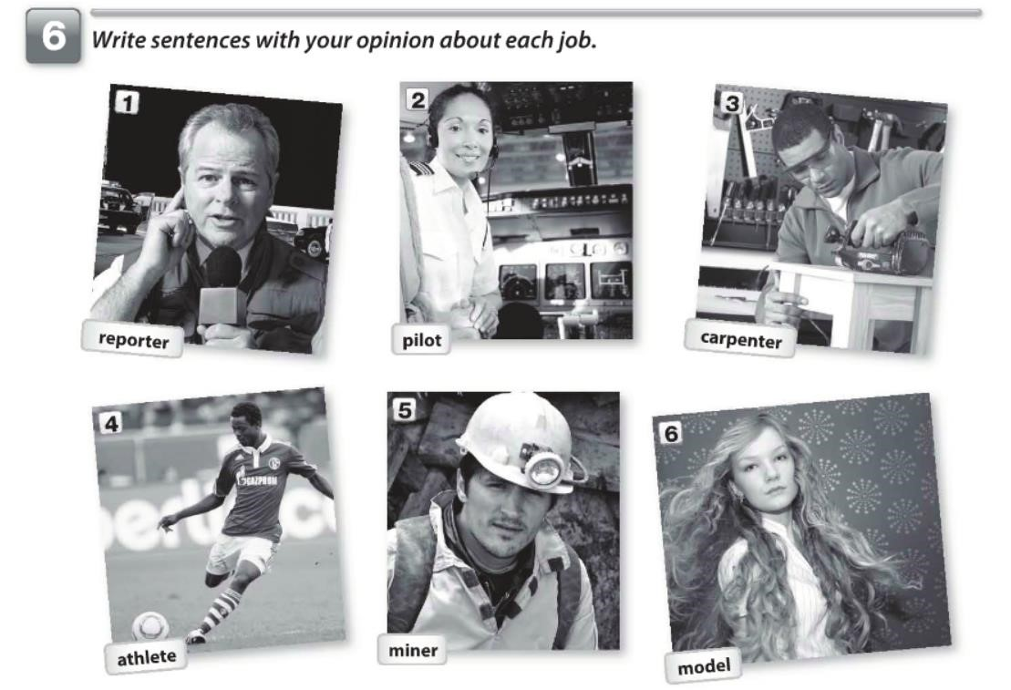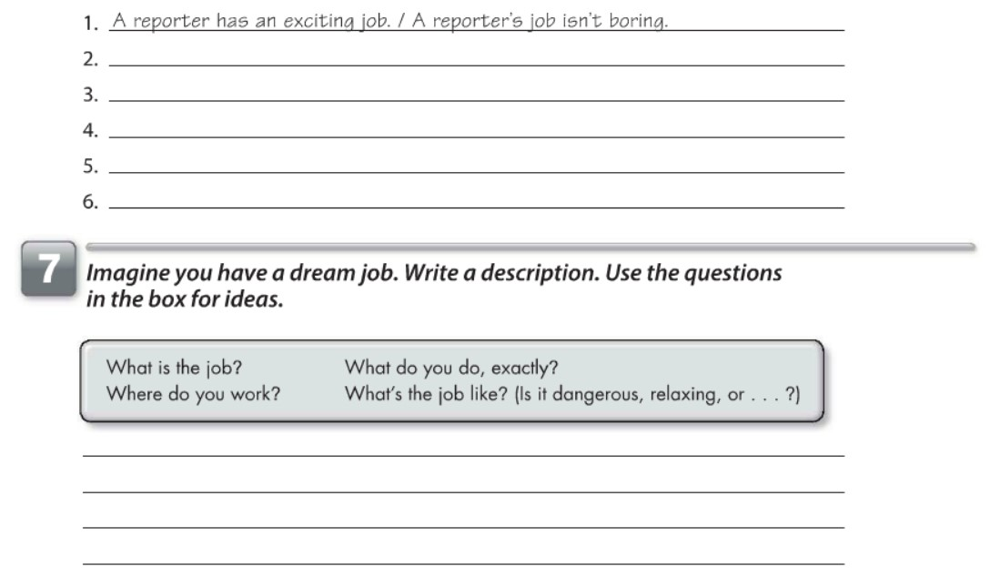

My dream job is exciting, I am a veterinarian. I'm work in a hospital of animals.

I'm save animales. I really like my job! it's great!

A pilot has a difficult job. / A pilot's job isn't easy

A carpenter has an intersting job. / A carpenter's job isn't monotonous

An athlete has a fun job. / An athlete's job isn't boring

A miner has a dangerous job. / A miner's job isn't easy

A model has an intersting job. / A model's job isn't boring