Elsy

[nombre de la empresa]

INGLES

DONALDO LOPEZ PEREZ

# **WORKBOOK**

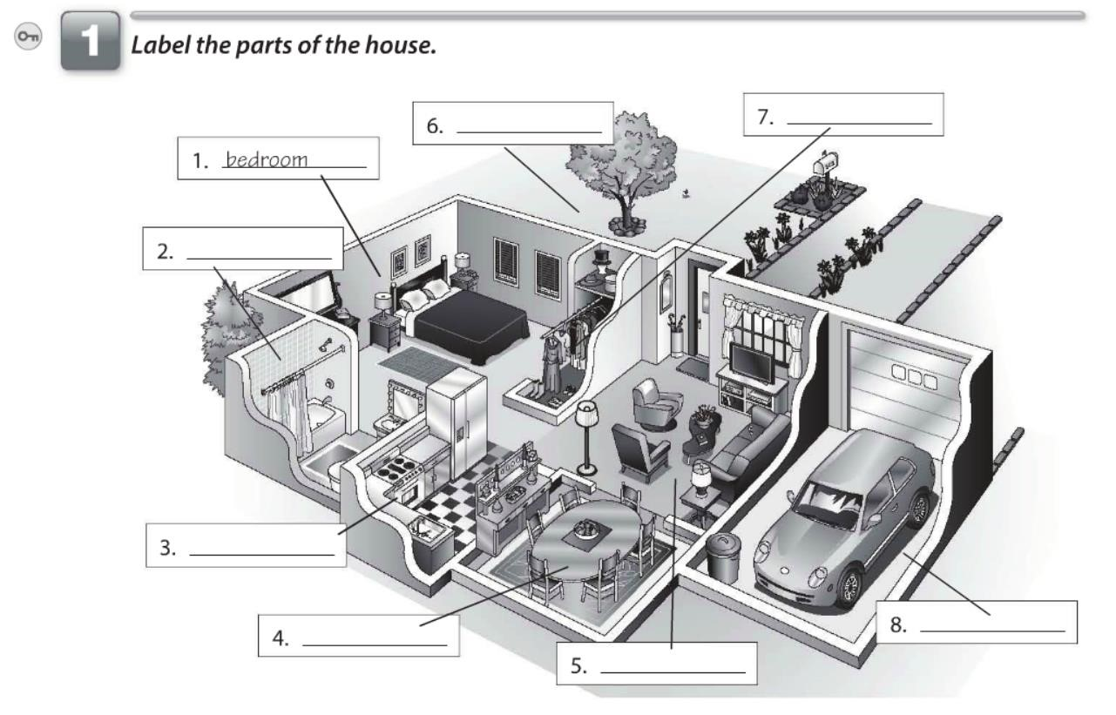

Back yard

Bathroom

kitchen

Garage

Living room

Dinner room

Closet

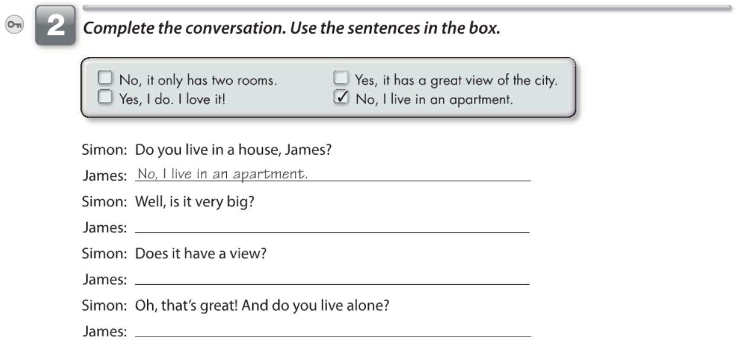

No, it only has two rooms

Yes, it has a great view of the city

Yes, I do. I love it!

10

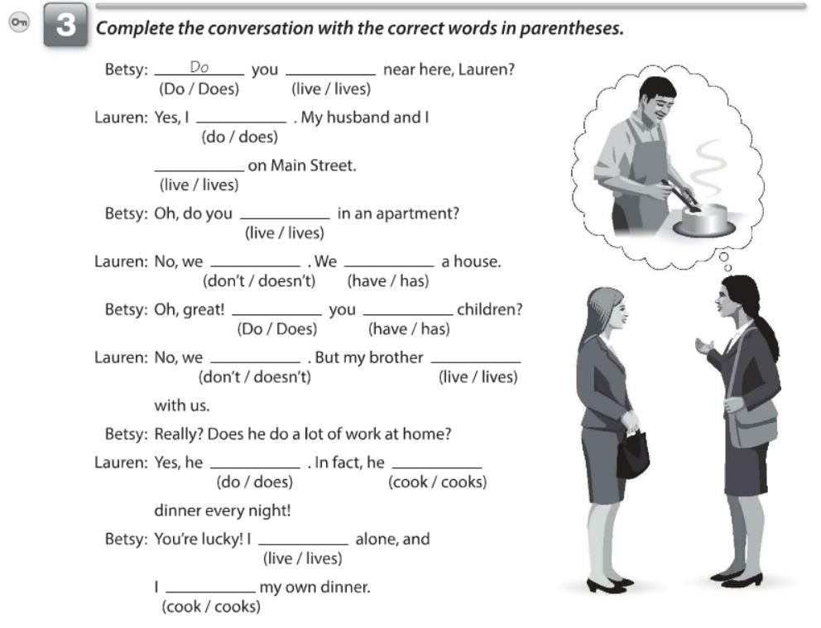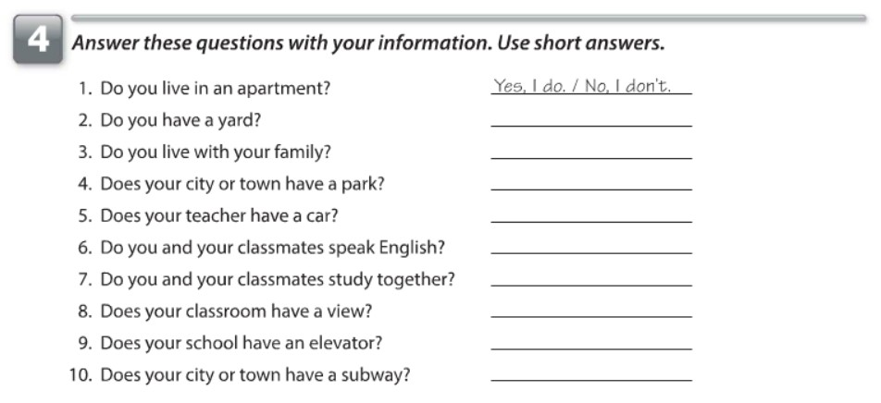

live

do

live

live

don't

have

Do

have

don't

lives

does

cooks

live

cook

No, I don't

Yes, I do

Yes, it does

Yes, He does/ No, He doesn't

Yes, we do

No, we don't

No, It doesn't

No, It doesn't

No, It doesn't

11

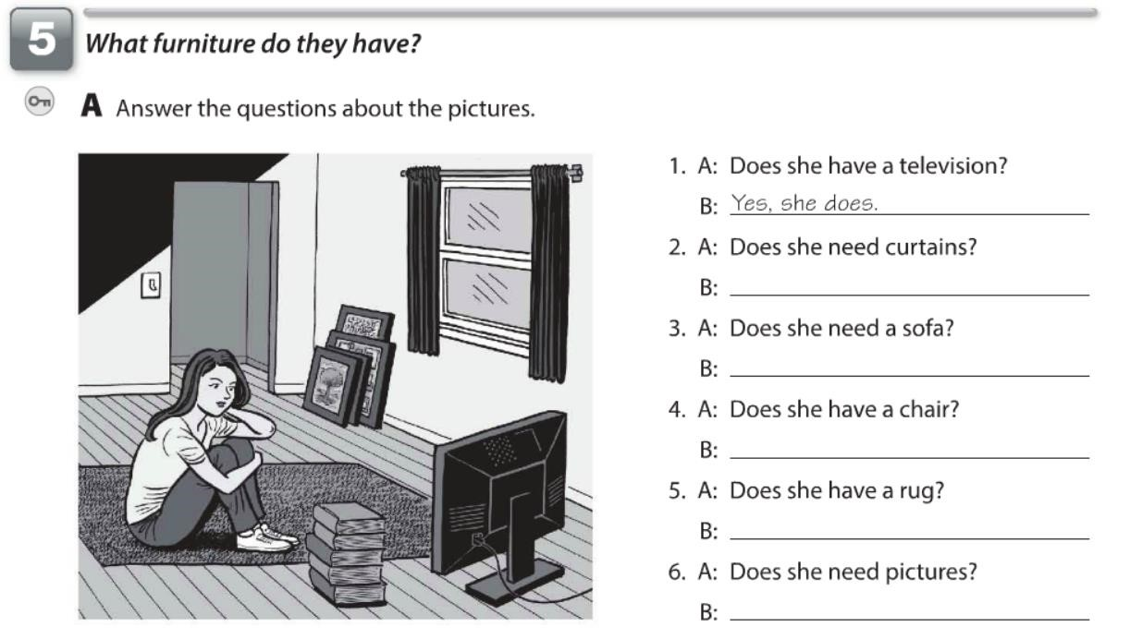

Yes, she does

No, she doesn't

No, she doesn't

Yes, she does

No, she doesn't

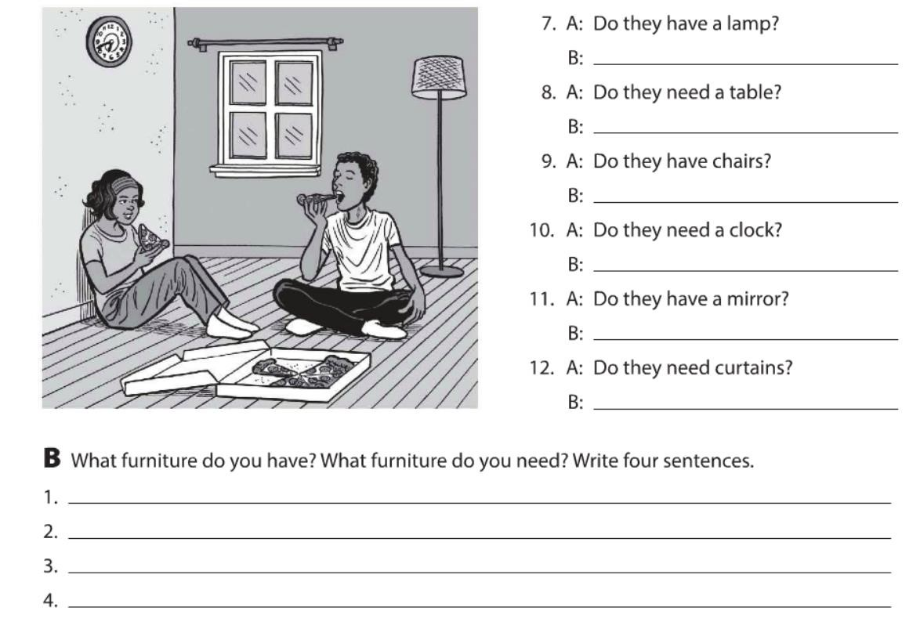

Yes, They do

Yes, They do

No, They don't

No, They don't

No, They don't

Yes, They do

I have a table

I need a desk

I need a lamp

I have a bookcase

12

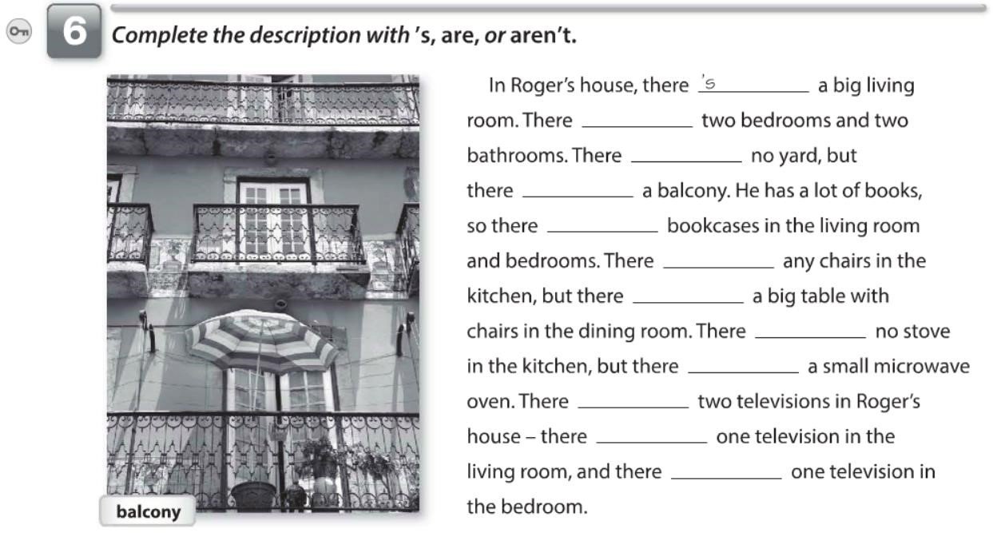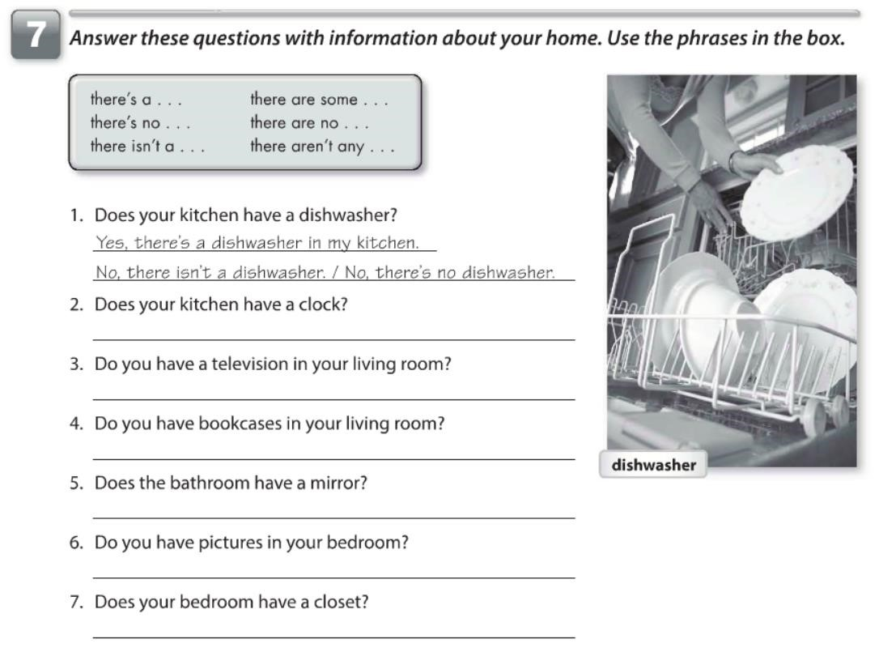

are

's

's

are

aren't

's

's

's

are

's

's

Yes, there's a clock in my kitchen

Yes, there's a television in my living room

Yes, there's a mirror in my bathroom

No, there aren't any bookcase in my living room

No, there aren't any pictures in my bedroom

Yes, there's a closet in my bedroom

13

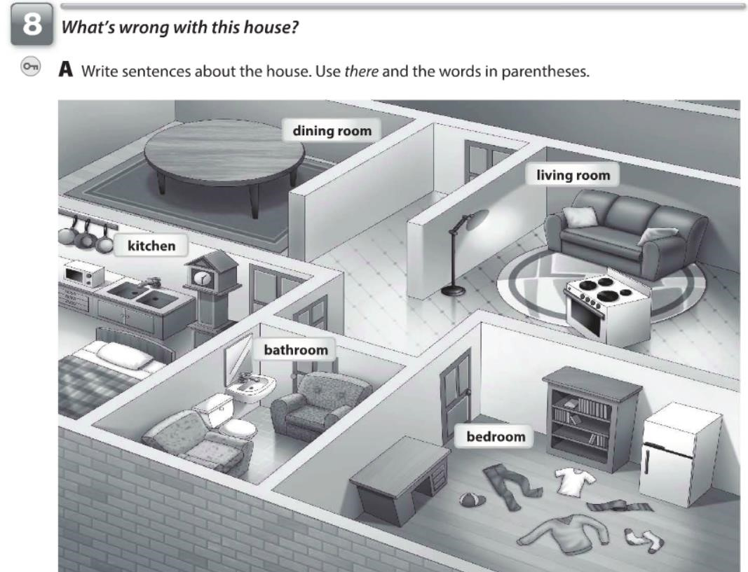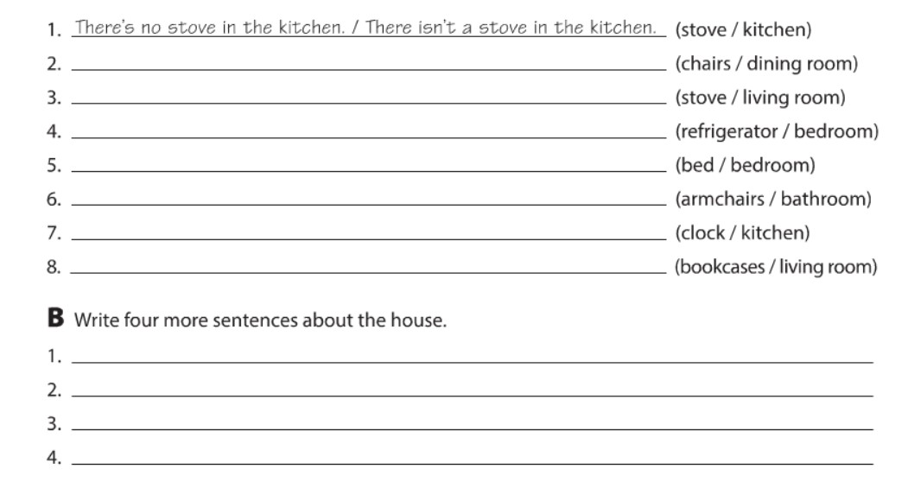

There aren't any chairs in the dining room

There's a stove in the living room

There's a refrigerator in the bedroom

There's no a bed in the bedroom

There are armcharis in the bathroom

There's a clock in the kitchen

There aren't any bookcases in the living room

There's a bed in the kitchen

There's a bookcase in the bedroom

There's a lamp in the living room

There's a desk in the bedroom

14

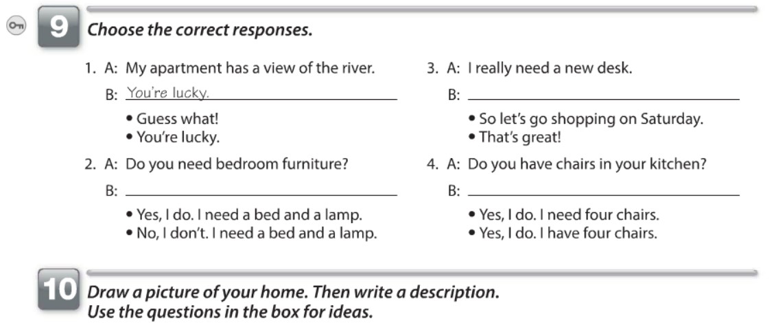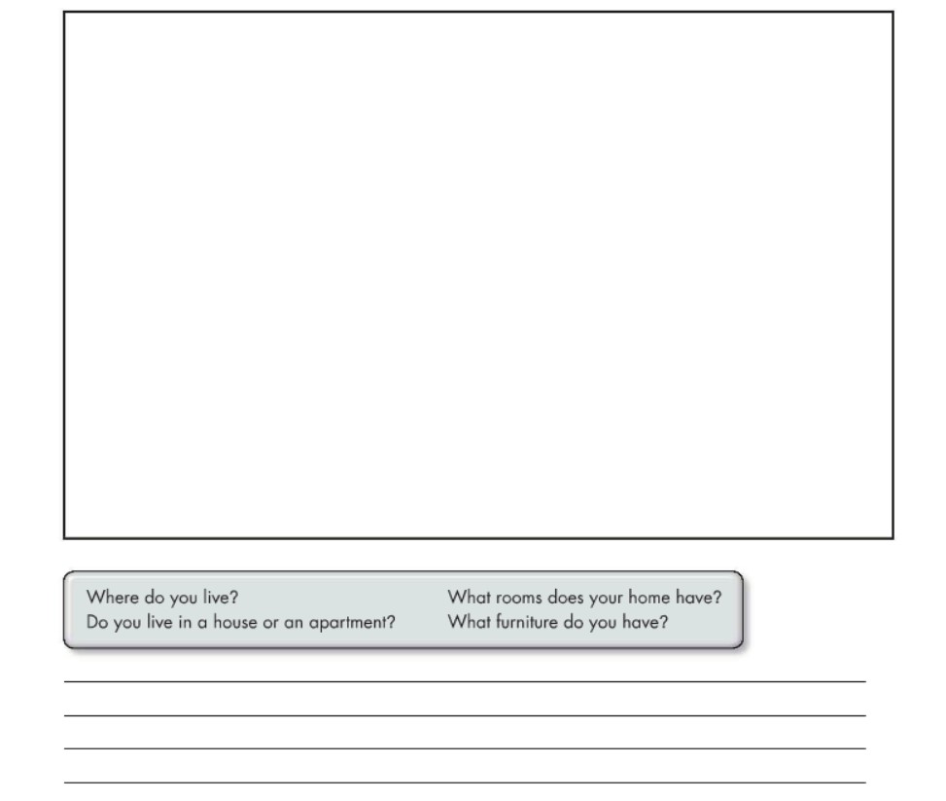

So let's go shopping on saturday

Yes, I do. I nedd a bed and a lamp

Yes, I do. I have four chairs

Living room

Dinner room

Kitchen

Bathroom

Bedroom

Bedroom

I live in Tapachula, I live in a house, my hause have two rooms and I have a bookcase, table, lamps

a tv to mention a few

15