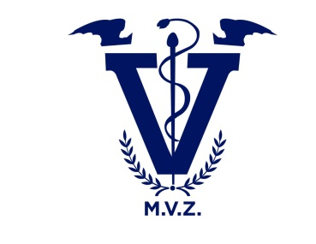

**UNIVERSIDAD DEL SURESTE**

**FACULTAD DE MEDICINA VETERINARIA**

**CONVERSATION AND ENTERVIEW**



**HECHO POR:**

**SOFIA HERRAN SILVA**

**TUTOR:**

**NAHIELI CAMERAS CAMAS**

**TUXTLA GUTIERREZ, CHIAPAS.**



**CONVERSATION**

-Hello Sofi, how are you?

-Hi Arturo, I`m fine, thank you, and you?

-I`m good, thank you, what will you do at night?

-I don`t know, maybe study

-Do you want to have dinner with me?

-Yes I would like it

-Perfect. I pass by you at 7:30

-Ok, see you later, bye.

