

Universidad del sureste

Enrique Eduardo Arreola

Inglés IV

Alexa Paola Villarreal Cerdio

4to cuatrimestre

Activity típico n°1 I come from a big amily, how often do you exercise?



wife

daughter

husband

son

Niece

sister

Mother

nephew

Uncle

father

staying

doing

taking

looking

working

studying

taking

starting

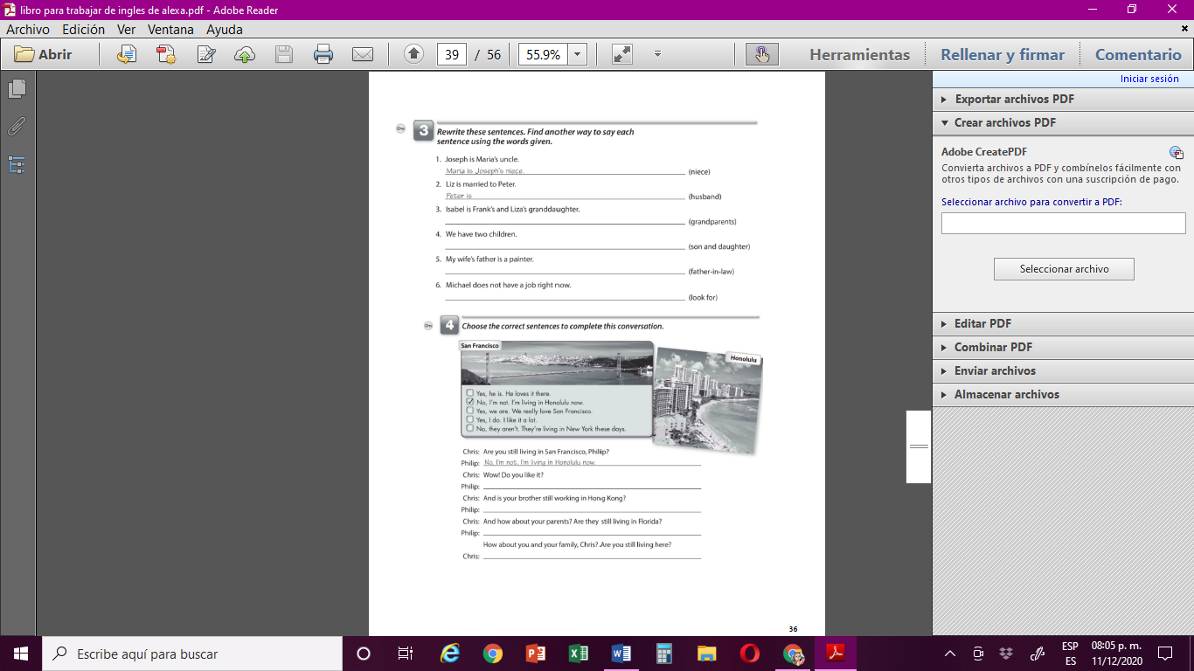

Liz’s husband

Frank and liza are isabel’s grandparents

We have a son and a daughter

My husband’s father in law is painter

Michael is not looking for a job

Yes, I do. I like it a lot.

Yes, he is. He loves it there

No, they aren’t. they’re living in new york these day’s

Yes, we are. We really love San Francisco

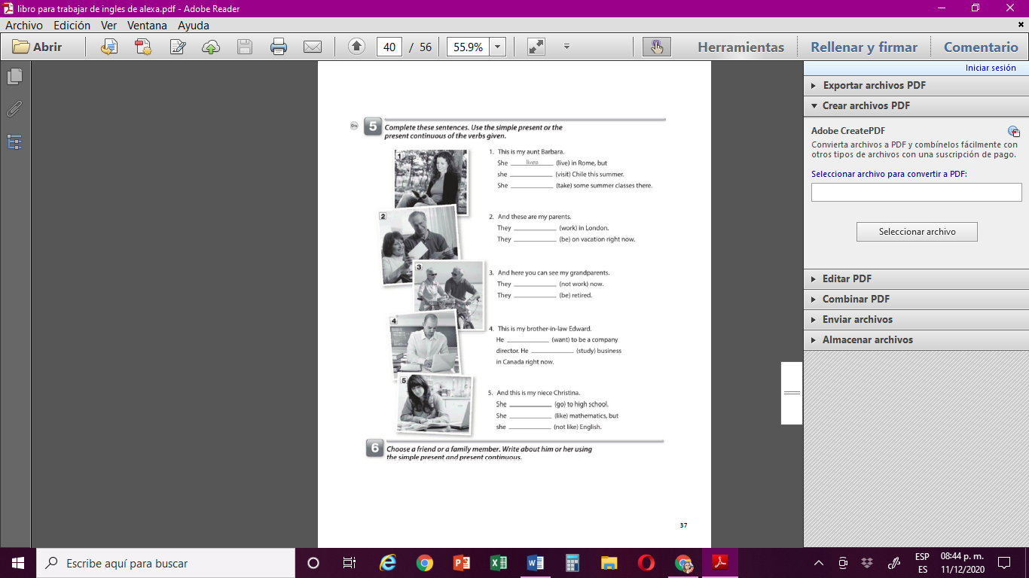

visits

takes

work

Being

Don’t work

being

wants

Are studying

Is going

likes

Does not like

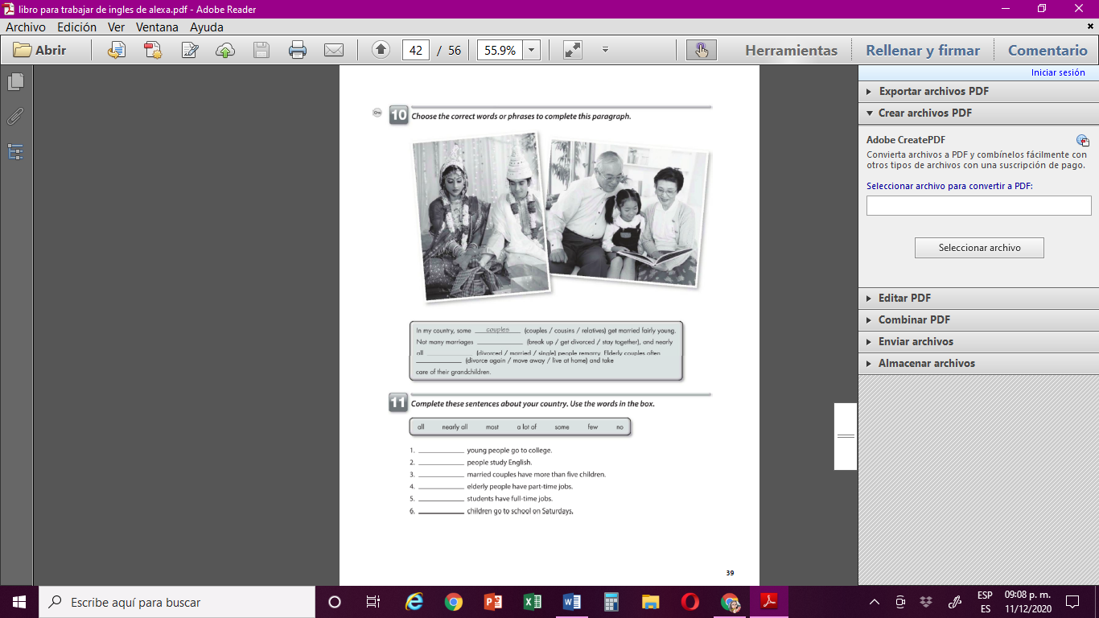

Get divorced

Live at home

divorced

All

A lot of

Some

Few

Most

Few

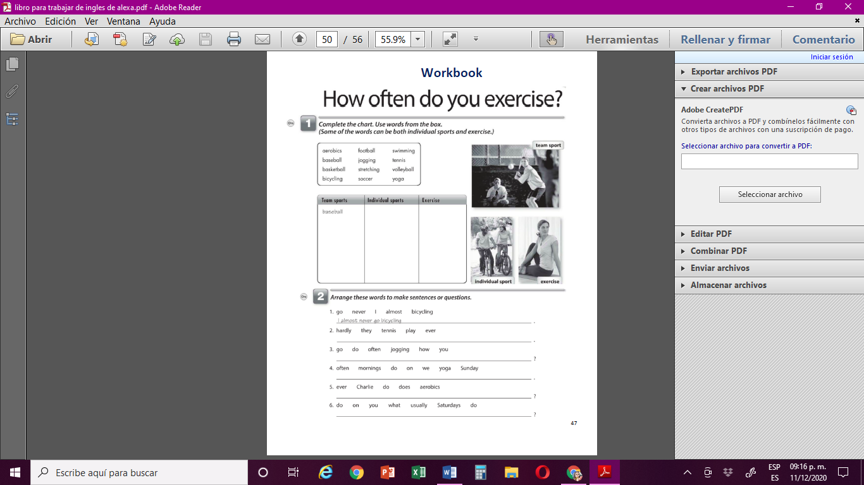

What do you do usually on saturda

Does Charlie ever do aerobics

We often mornings do yoga on Sunday

How do you often go jogging

They hardly ever play tennis

Yoga

Stretching

Aerobics

Jogging

Bicycling

Tennis

Swimming

Basketball

Football

Soccer

Volleyball

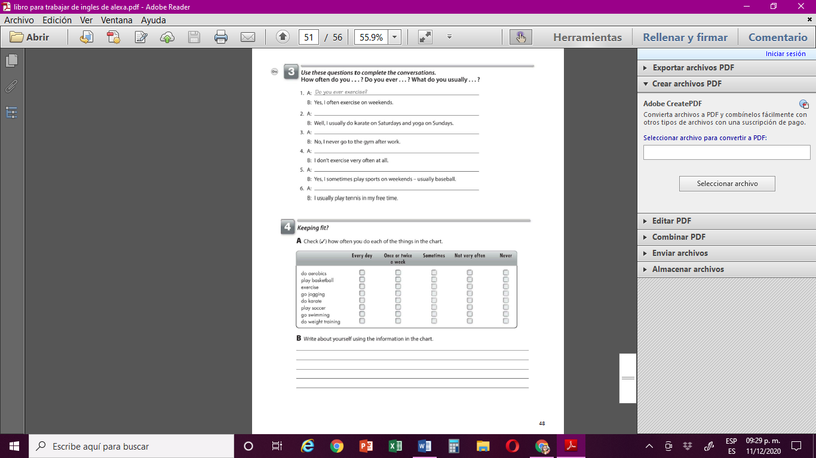

What do you do usually on Sundays

Do you ever go to the gym affter Work

How often do you do excercise

I sometimes do aerobics , but i never play basketball

I often do exercise, but i never do karate

I never play soccer,i sometimes go to the river to swimming

I never do weight training

What do you usually play in your free time

What do you usually sport play on weekends

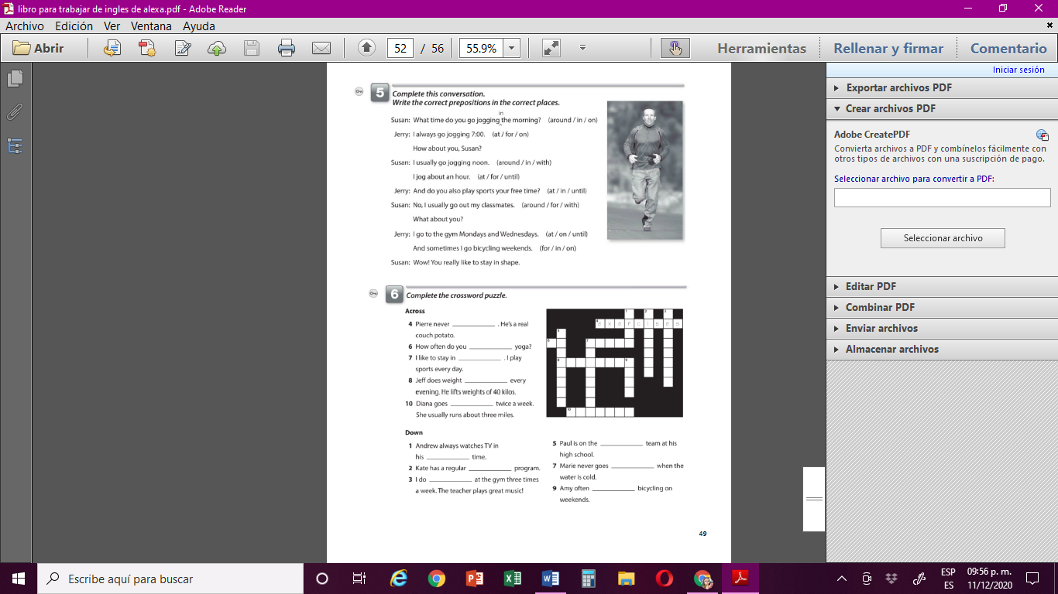

do

Training

Jogging

Free

Dieting

football

swimming

goes

exercise

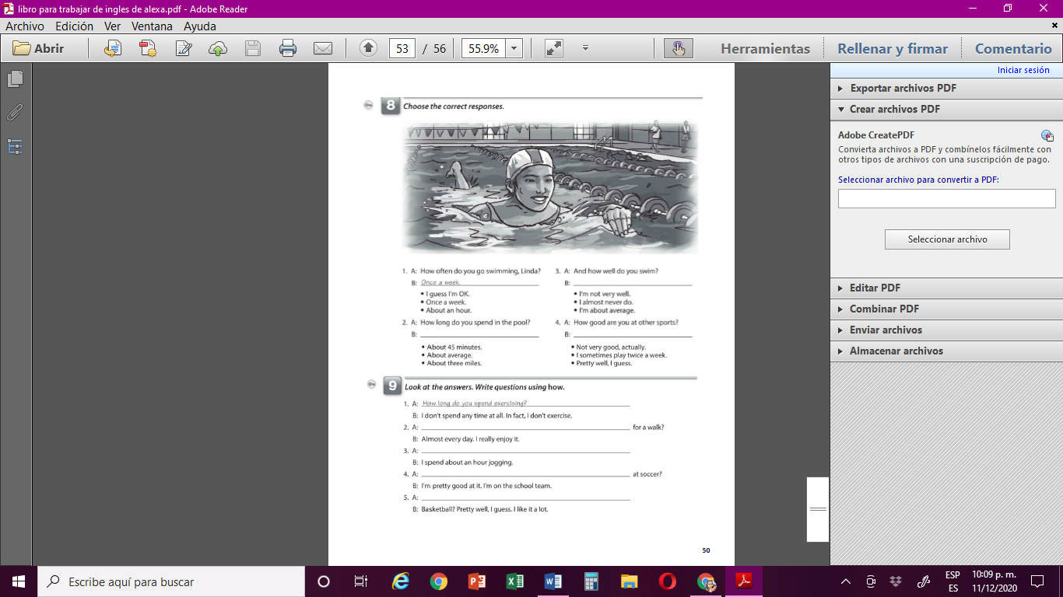

How good are you playing basketball?

How good are you

How long do you spend jogging

How often do you go

I’m not very well

Pretty well, i guess

I’m not very well