

**Nombre de alumno: ESTEBAN CONTRERAS HUERTA**

**Nombre del profesor: ANA LAURA CULEBRO**

**Nombre del trabajo: PARTIAL 3 ACTIVITY**

**Materia: INGLES**

**Grado: 1ER CUATRIMESTRE.**

**Grupo: B**

Comitán de Domínguez Chiapas Octubre 2020.

TEMA PRINCIPAL VOCABULARIO DE ROPA Y PRESENTE SIMPLE.

NOMBRE DE LA UNIDAD:

**Whose jeans are these?**

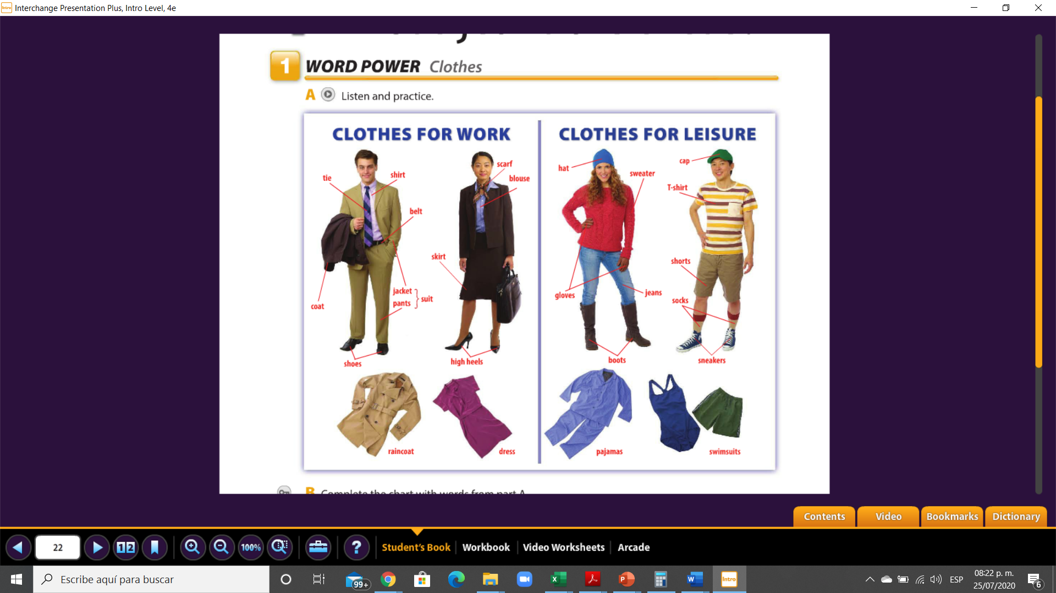

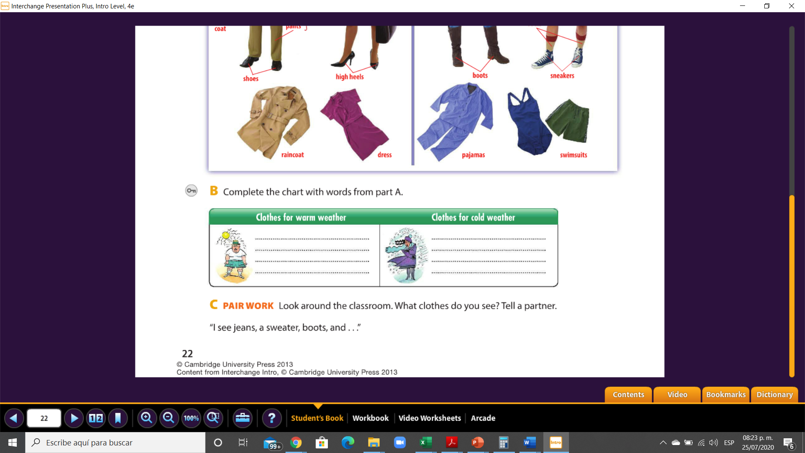

HAT

SWEATER

GIOVES

BOOTS

SHORTS

SWIMSUITS

T-SHIRT

CAP

35

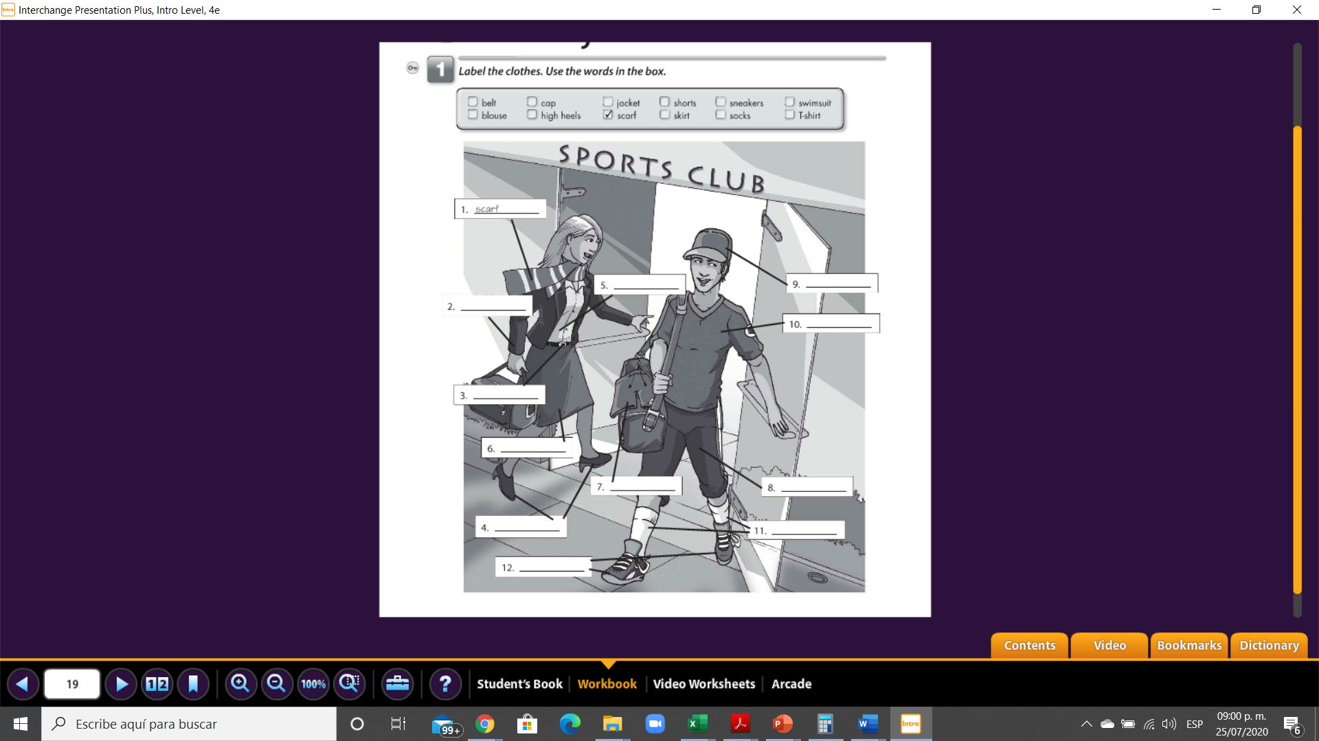

SOCKS

SNEAKERS

HIGH HEELS

SHORT

SWIMSUIT

SKIRT

BELT

T-SHIRT

CAP

BLOUSE

JACKET

45

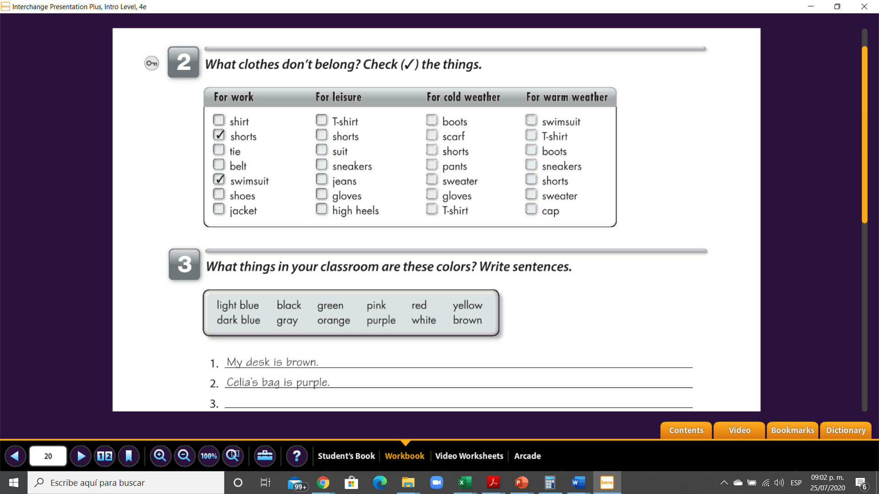

X

XX

X

X

x

X

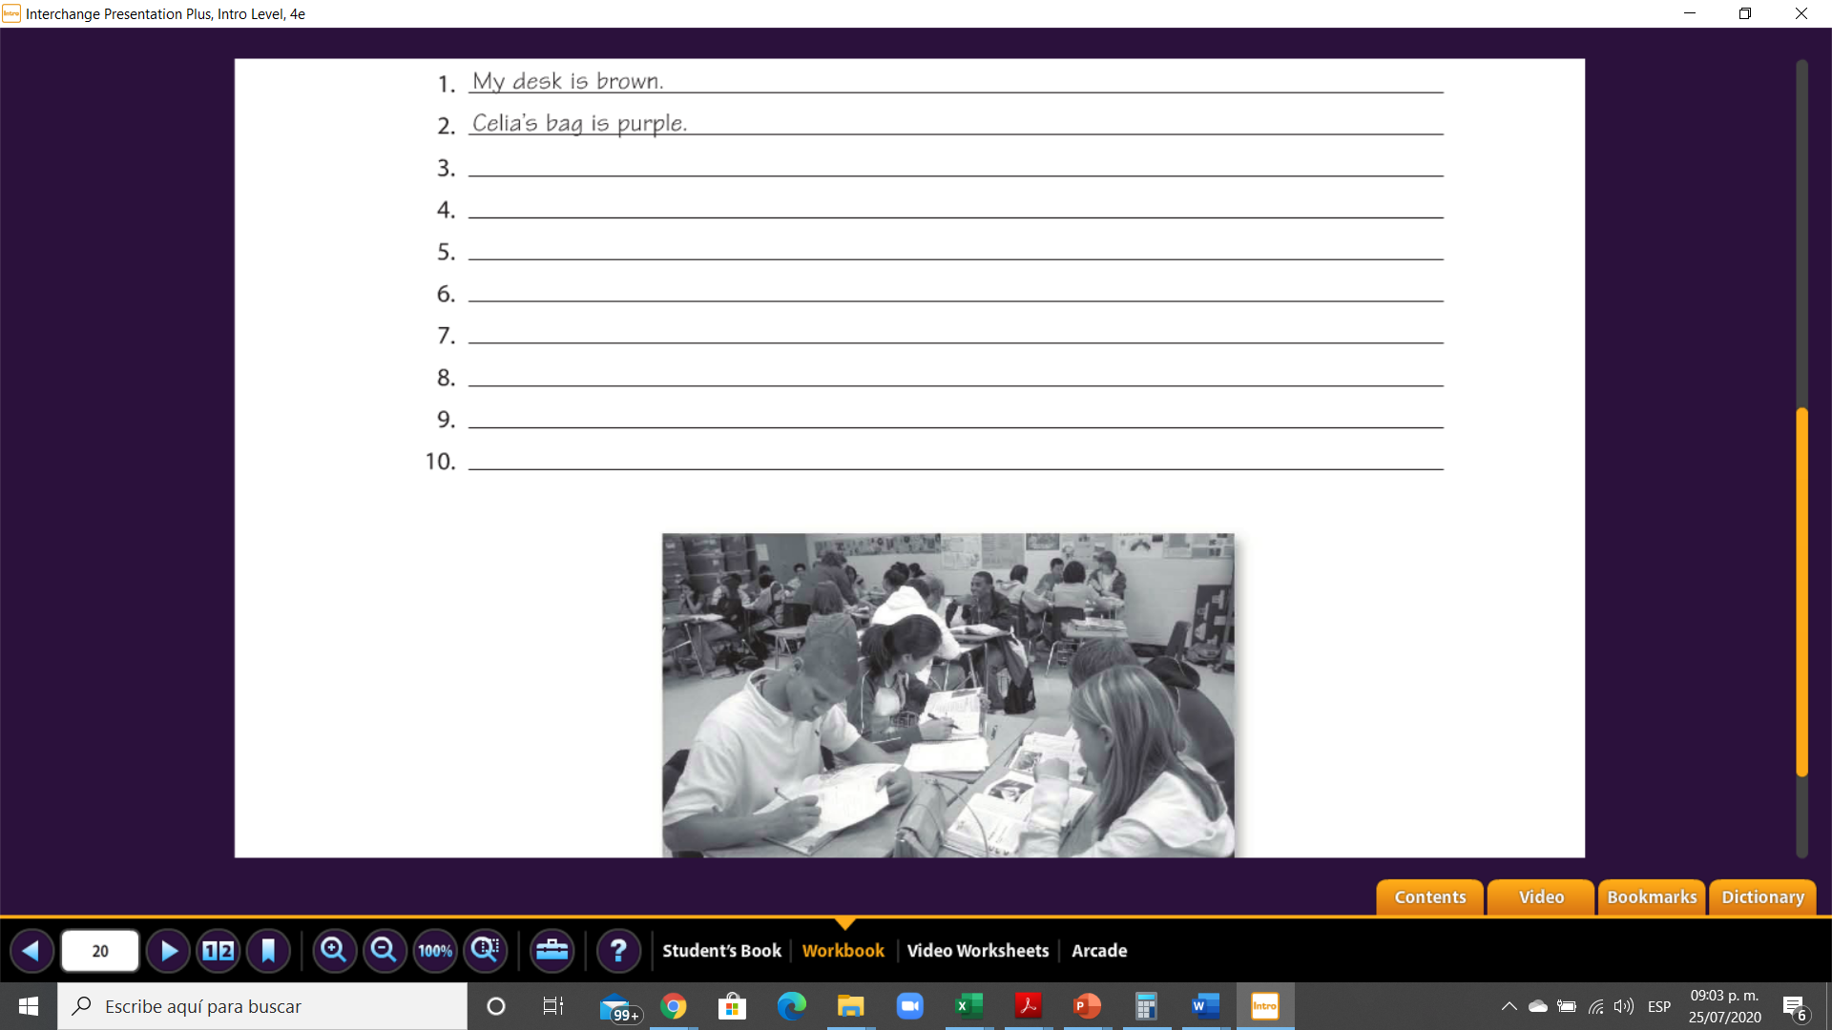

LUIS´S BACKPACK IS BLACK

THE DESK IS GRAY

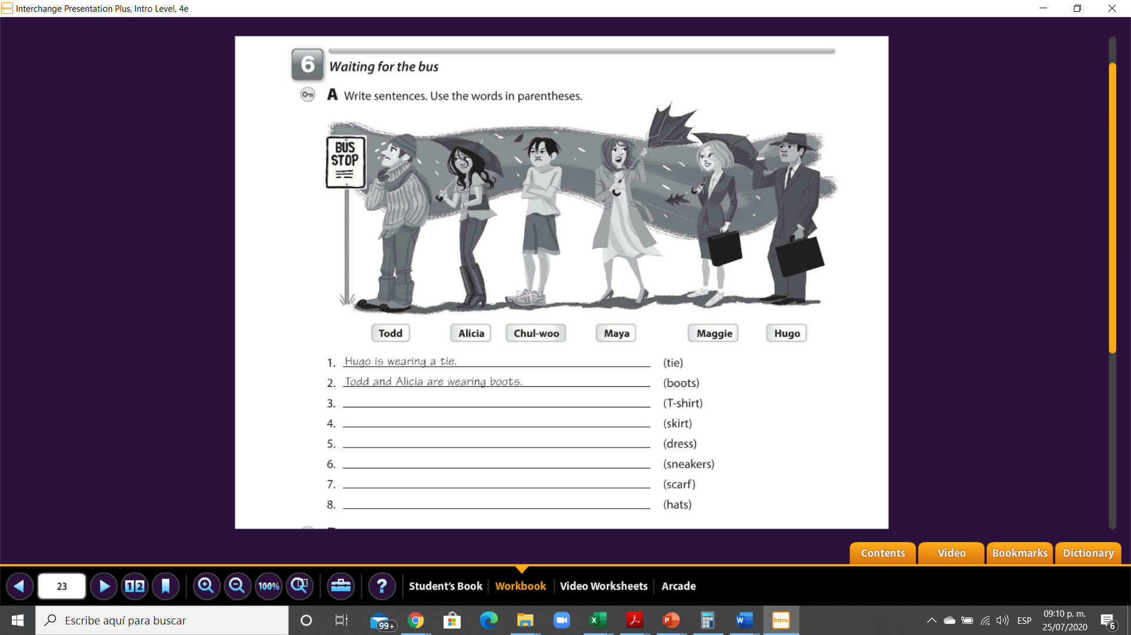

GREEN SCISSORS

ANA´S PENCIL IS PINK

THE CURTAINS ARE ORANGE

THE COMPUTER IS RED

A BLUE BOOK

THE CHAIRS ARE BLUE

46

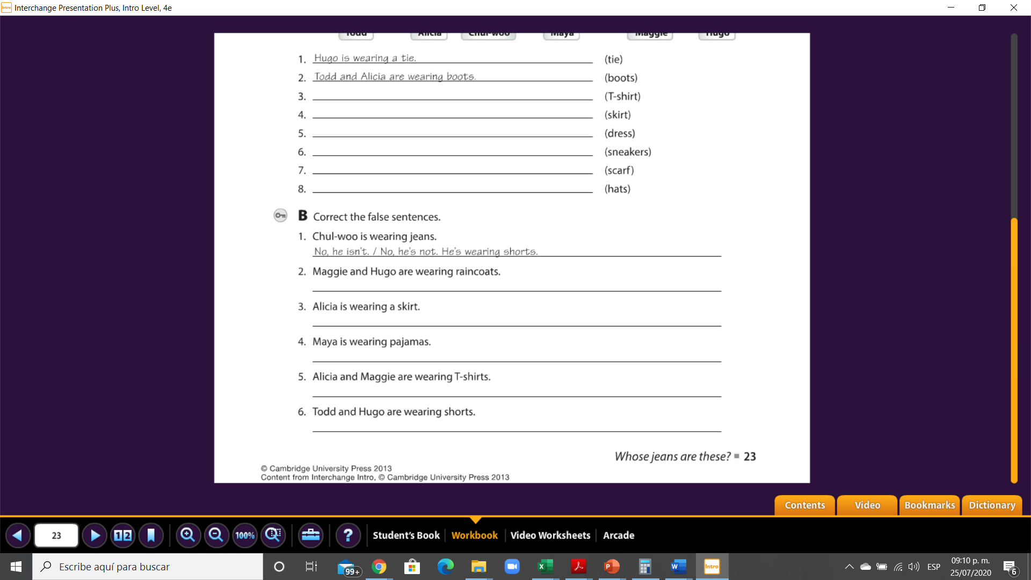

CHUL- WOO IS WEARING A T-SHIRT

MAGGIE IS WEARING A SKIRT

TODD AND HUGO ARE WEARING HATS

MAYA IS WEARING A DRESS

TODD IS WEAREING A SCARF

CHUL- WOO AND MAGGIE ARE WEARING SNEAKERS

No, they aren ´t. they are wearing jackets

No, she ins´t. she is wearing jeans

49

No, they aren´t they are wearing pants.

No, they aren´t. they are wearing blouse

No, she isn´t. she is wearing a dress