

**Nombre de alumno: JUAN PABLO MIJANGOS IBAÑEZ**

**Nombre del profesor: JUAN MANUEL JAIME**



**Nombre del trabajo: Weekly Activity #3 Unit 3**

**Materia: INGLES**

**Grado: 1**

**Grupo: A**

Comitán de Domínguez Chiapas a 09 de noviembre de 2020.

**Grammar – Weather and Seasons**

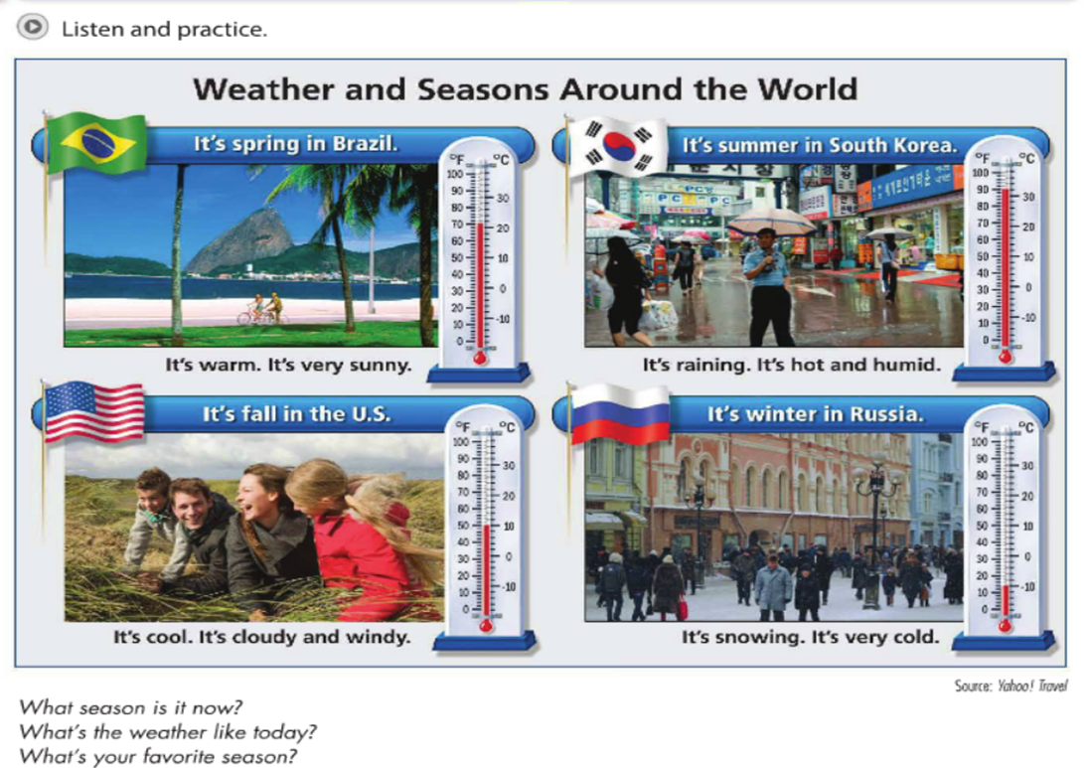

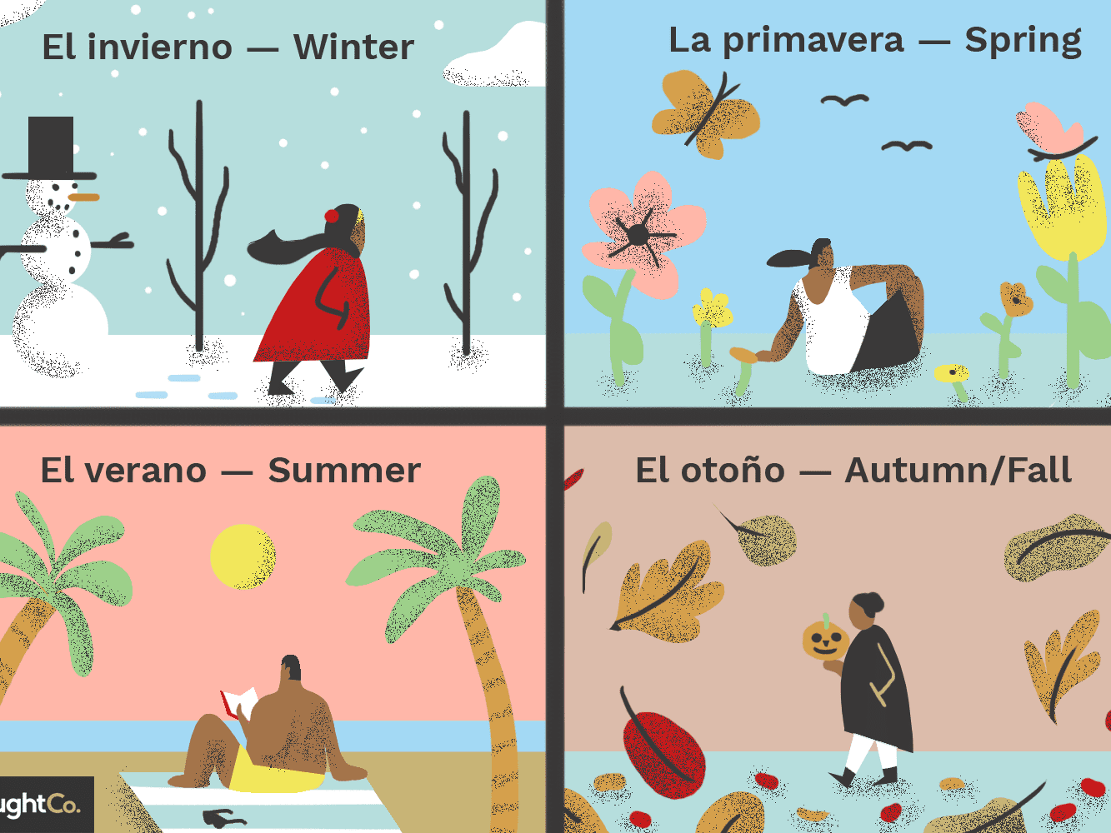

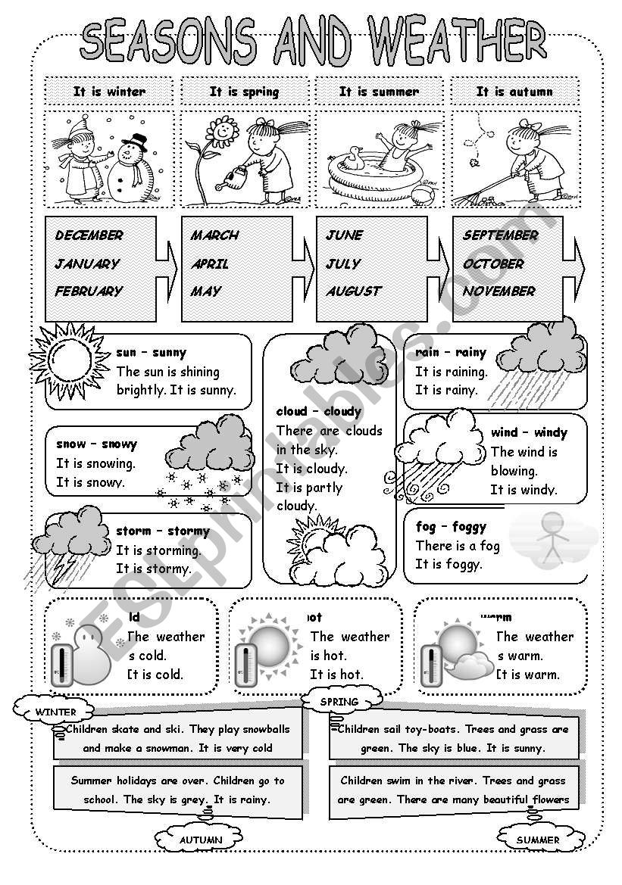

**Exercise 1**. What season is it? How is the weather? Write two sentences about each picture.

¿Qué estación es? ¿Como está el clima? Escribe dos oraciones acerca de cada figura.

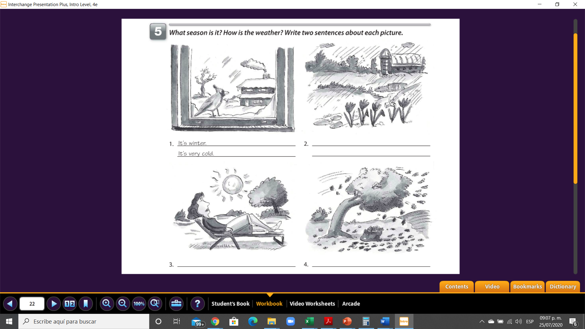

**It is autum**

**There is a lot of wind**

**It is spring**

**It is spring**

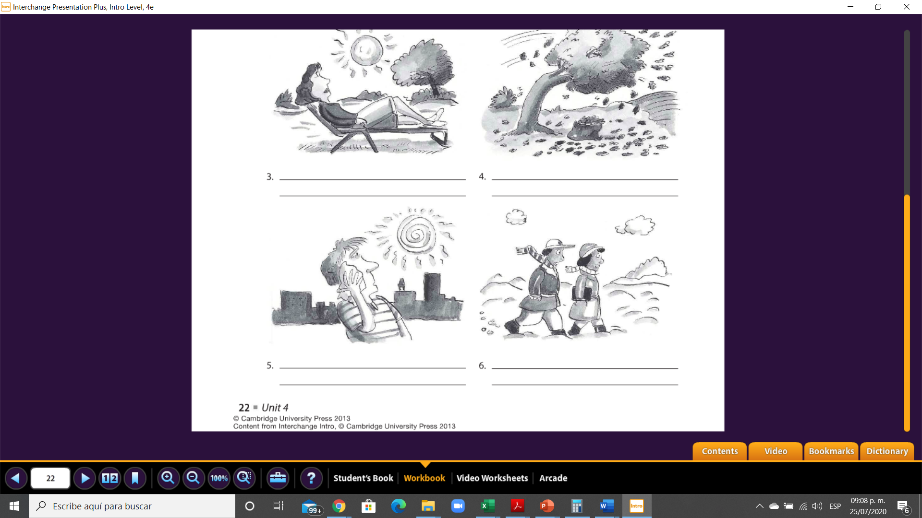

**There is much snow**

**There is a lot of heat**

**It is summer**

**The leaves of the trees fall**

**The sun shines a lot**

**It is winter**

**Gramar - Present continuos.**

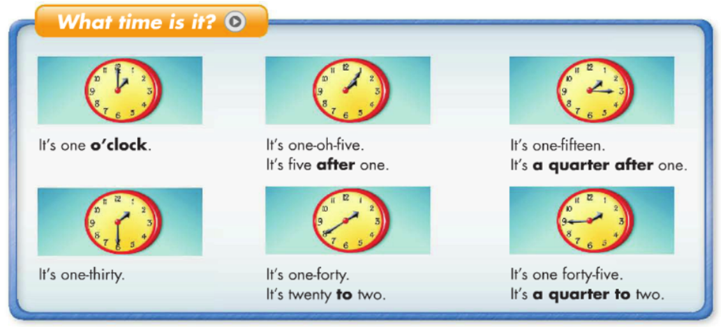

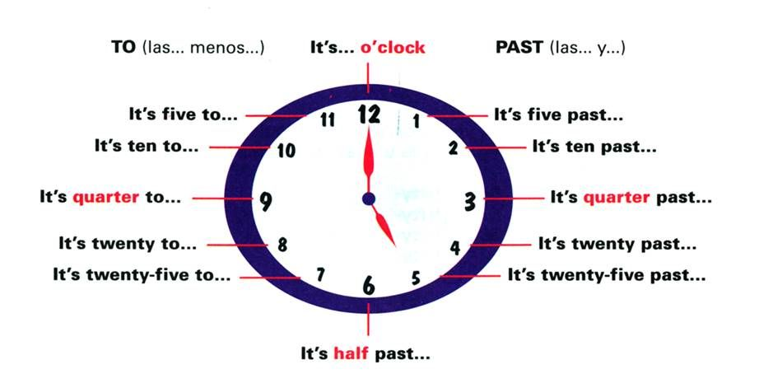

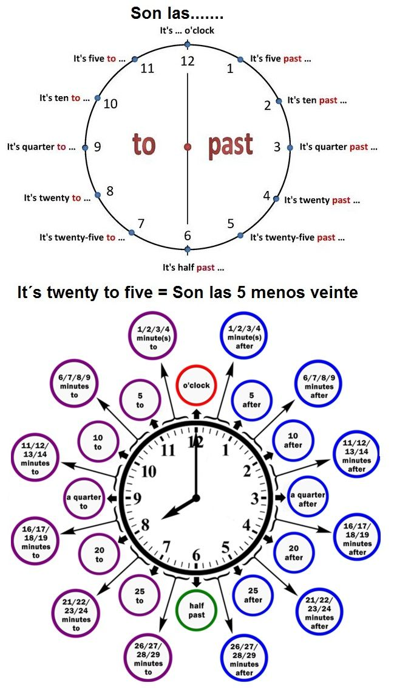

**Ver video en youtube para la explicación de las horas:**

[**https://www.youtube.com/watch?v=ItXtQGHnp1E&feature=emb_logo&ab_channel=DianaPerez**](https://www.youtube.com/watch?v=ItXtQGHnp1E&feature=emb_logo&ab_channel=DianaPerez)

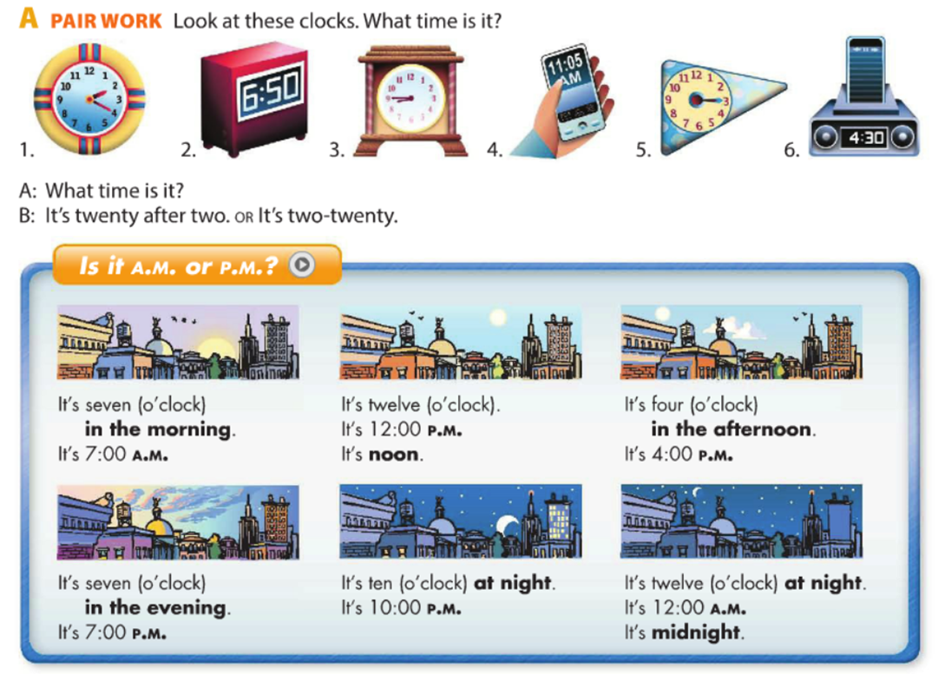

**Exercise 2**. What time is it?. Use the sentences in the box. ¿Que hora es?, usa las oraciones en la caja.

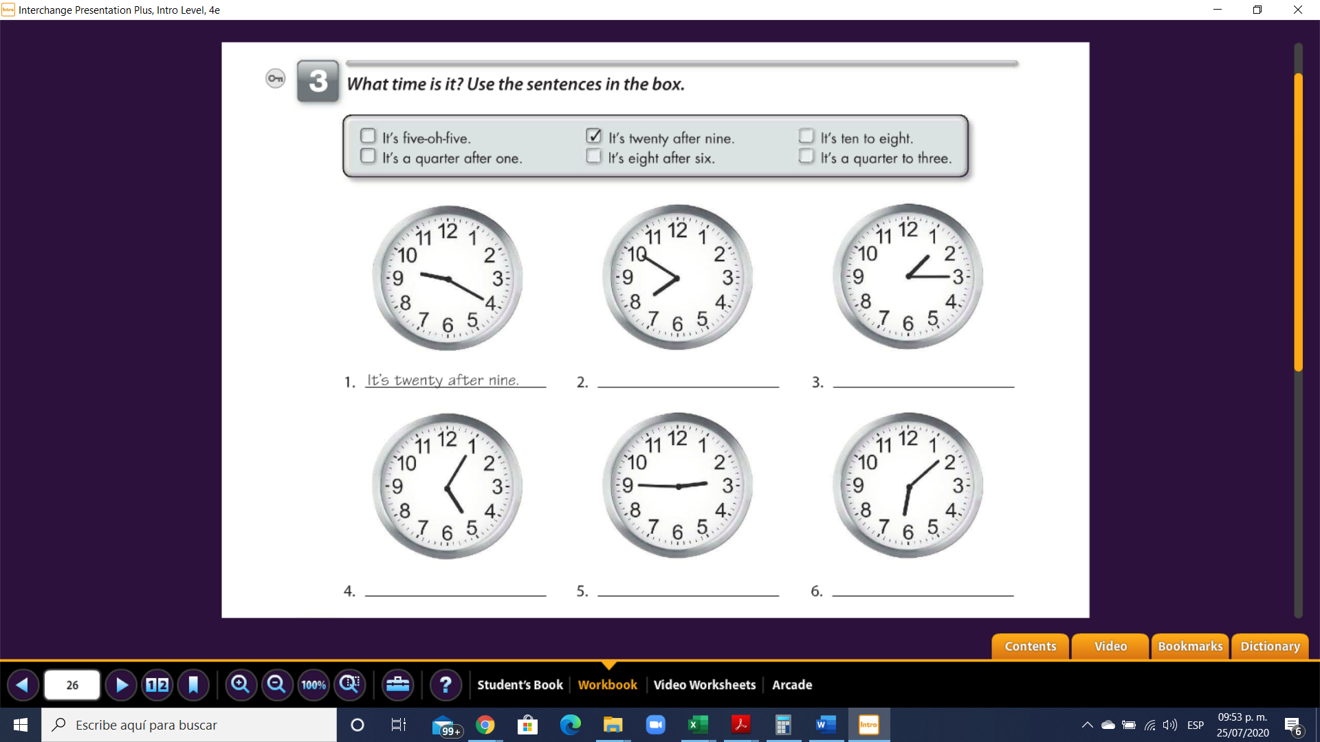

**Its six eight**

**Its two fourty five**

**Its five five**

**Its one fifteen**

**Its seven fifty**

**Exercise 3**. What time is it in each city? Write the time in two different ways. ¿Que hora es en cada ciudad? Escribe la hora en dos formas diferentes.

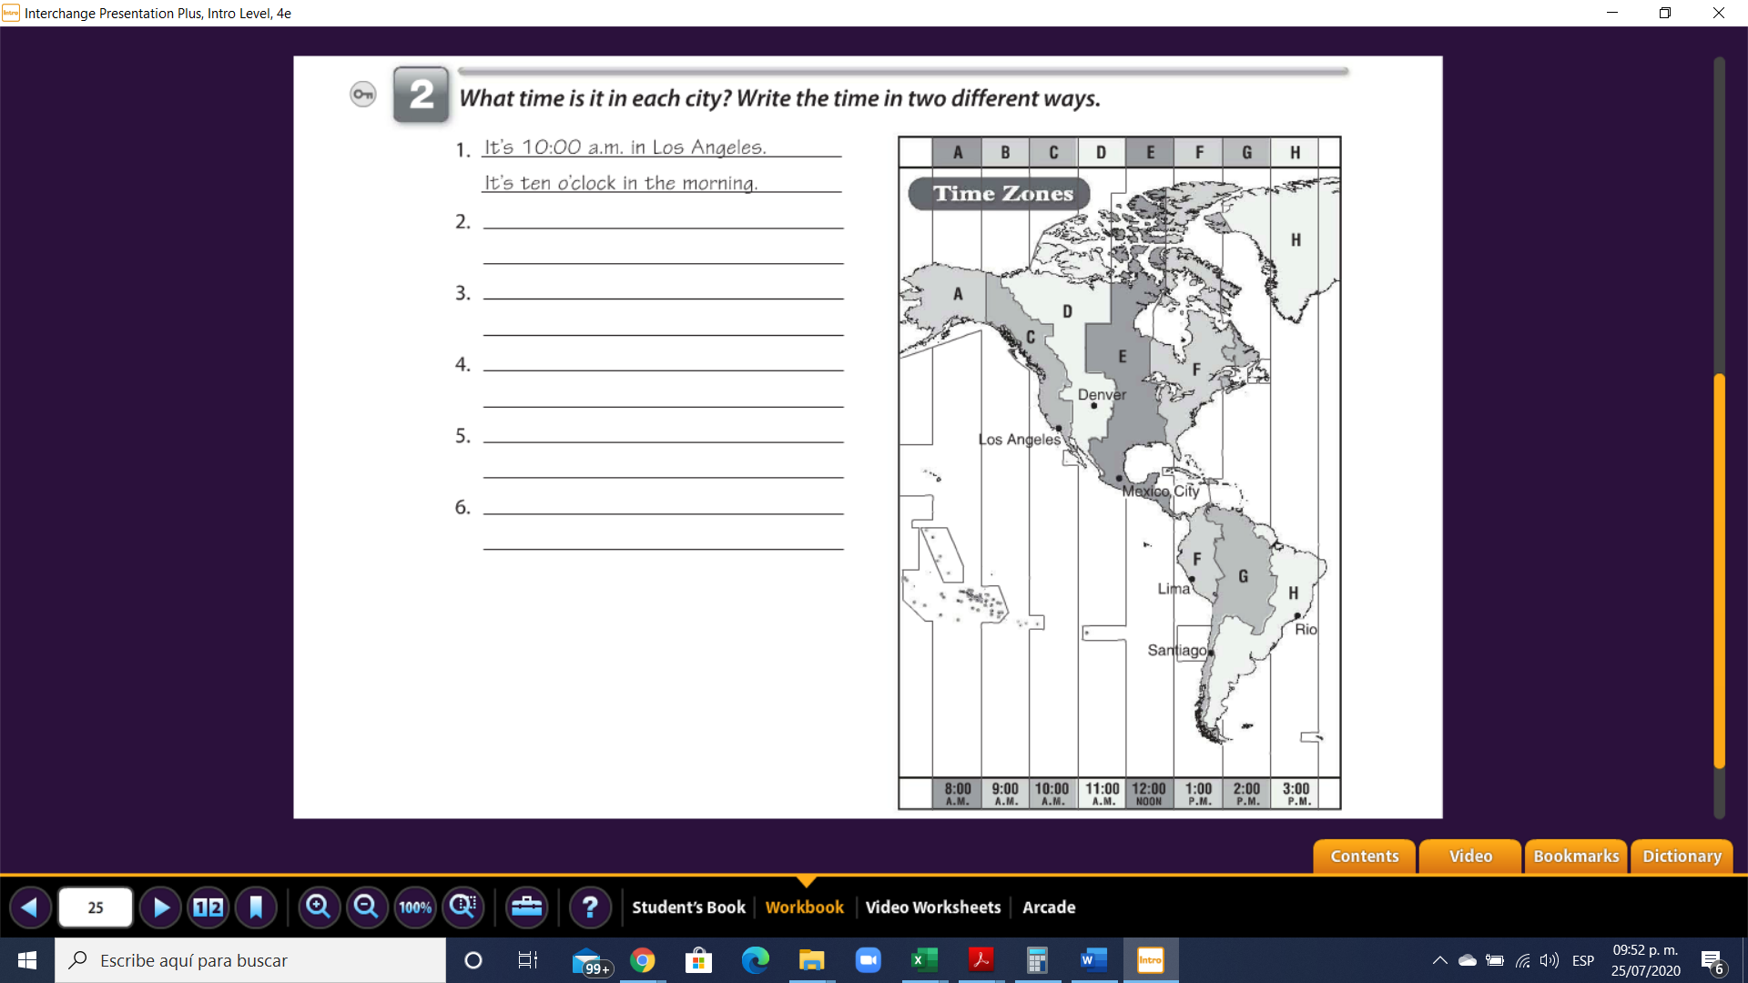

**Its three in the late**

**Its 3:00pm in rio**

**Its one o clock in the late**

**Its 1:00 pm in Santiago**

**Its one o clock in the late**

**Its 1:00 pm in lima**

**Its 11:00 am in the mornig**

**Its 11:00 .am in mexico city**

**Its eleven o`clok in the morning**

**Its 11:00 A.M in Denver**

**ans**

**ans**

**ans**

**ans**