Nombre del alumno: Esthela nahomy Álvarez Cruz

Nombre del profesor: LGT. Carlos Daniel Hernández Guillén

Nombre del trabajo: entregar los ejercicios correspondientes al topic 1 del Workbook

Materia: ingles I

Grado: 1

Fecha: 23/09/2020

Complete the questions with this or these

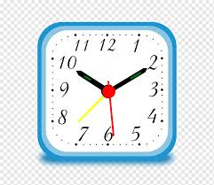



2.- whats this

1. - A: what’s this

3.- what are these

B: it’s a camera

B: earrings

B: it’s an alarm clock

alarm clock

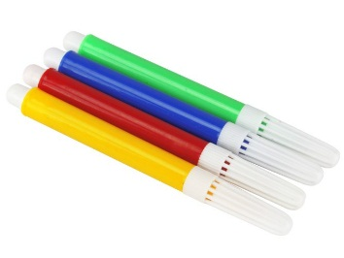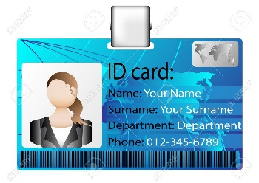

B: ID

ID

ID

6.- A: whats this



B: Sunglasses

5.- A: what ere these

B: markers

4.- A: what ere these

Amy: open this, too a umbrella thanks Amy

Dana: thanks Eva great

Eva: you´re earrings

Dana: ok thank you. Eva and what are these

Eva: it’s a scarf

Dana: ok what ´s this?

Eva: now open an box

Chris: a welcome

Dana: oh cool thank ´s

Chris: it’s a purse

Dana: wow what’s this

Complete the conversation. Use the words in the box

Thank you.

They are in your pockett

They are in your pocket

A: let me see yes they are

They are in your pockett

They are in your pocket

B: they an your pocket

They are in your pockett

They are in your pocket

A: hmm those are my pens

B: no, there is nothing not,  sorry

I left my

I left my

I left my

this newspaper

this newspaper

4. - A: I life my pens on your desk

I left my

I left my

I left my

this newspaper

this newspaper

A: hmm yes, that son are thanks 

your glassesey´ re

I don't know

I don't know

this newspaper

this newspaper

B: are not they on your desk 

your glassesey´ re

I don't know

I don't know

this newspaper

this newspaper

A: no they´ re your glasses 

your glassesey´ re

I don't know

I don't know

this newspaper

this newspaper

B: are I don't know in your purse

I don't know

I don't know

this newspaper

this newspaper

3. - A: where are your glasses

this newspaper

this newspaper

A: oh yes, it that's thanks

I have seen it

I have see

B: is the one under your chair

I have seen it

I have see

A: sorry has seen is my newspaper

I have seen it

I have see

B: no not, I have seen it

I have seen it

I have see

2. - A: sorry you haven't seen my newspaper

this newspaper

this newspaper

A: yes that’s its thank you

that is

B: wait a minute I'm going to look for it it on the desk?

A: no, it’s the dictionary

B: is it save in your bag

1. - A: where is my English dictionary

Complete the conversation

6. - the keys are in front of the umbrella

5. - the map is next to the briefcase

4 – The cell phone is under the table

3. - the glasses are under the chair

2.-The chair is in front of the desk

1. - The wallet in the purse

Complete the sentences. Use the prepositions in the box

B: They are behind the chair

A: where are the keys? (Keys)

B: They are behind the chair

A: where are the glasses?

B: s in front of television

A: where is the camera? (Camera)

B: they are under the table

A: where are the books? (Books)

B: It’s next to the television

A: where is the briefcase? (Briefcase)

A look at the picture. Write questions and answers about the things in parentheses 

Where are these things?