

**UNIVERSITY OF SOUTHEASTERN**

COMALAPA CHIAPAS BORDER

AS OF NOVEMBER 12, 2020

**RACE:**

DEGREE IN SOCIAL WORK

**MATTER:**

ENGLISH

**JOB:**

DESCRIPTIONS OF THE VERB "TO BE"

**TEACHER:**

ELISA PÉREZ

**STUDENT:**

DEYSI ALINA MARTINEZ ARGÜELLO

1 QUARTER. GROUP A"

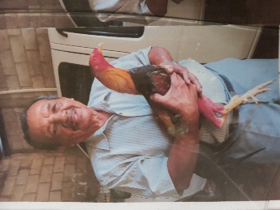

1.- He´s my dad

2.- Her name is Román

3.- He´s 80 years old

4.- He´s kind and loving

5.- He´s taking a nap right now

1.- She´s my mom

2.- her name is Deisi

3.- She´s 51 years old

4.- She´s loving and pretty

5.- She´s preparing food right now

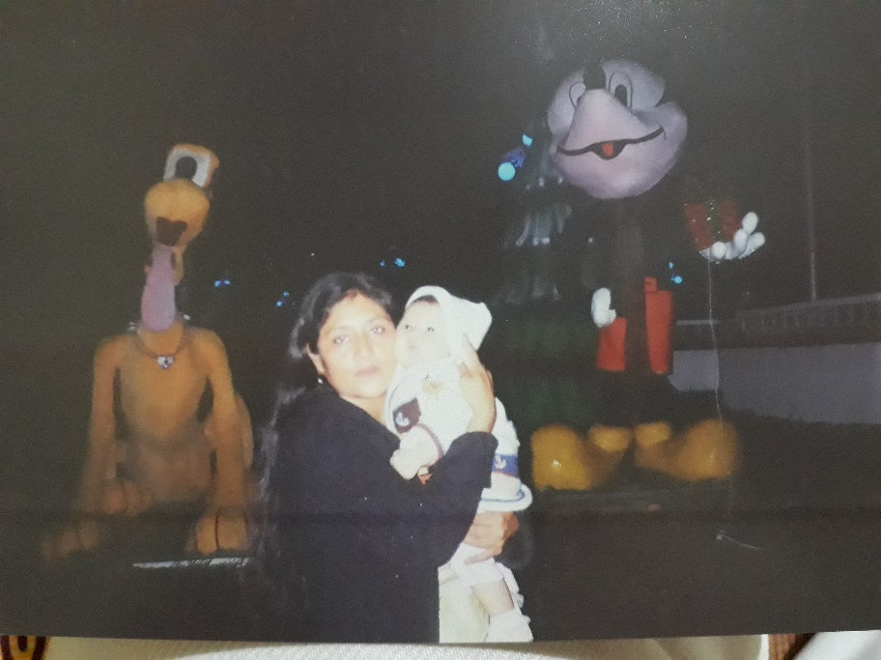

1.- My name is Deysi Alina

2.- I´m a student

3.- I´m from Cuauhtémoc city

4.- I´m 19 years old

5.- I´m kind and cheerful

6.- I´m doing task right now

1.- She´s my sister

2.- Her name is Yessenia

3.- She´s 28 years old

4.- She´s friendly and nice

5.- She´s in Baja California right now

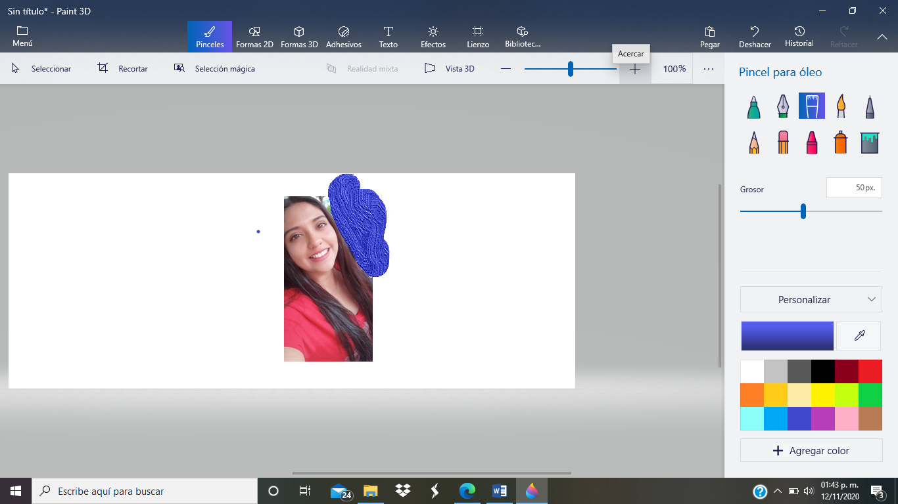

1.- She´s my aunt

2.- Her name is Natividad

3.- She´s 42 years old

4.- She´s pretty and cool

5.- She´s in San Cristobal right now

0

1.- He´s my uncle

2.- Her name is Julio

3.- He´s 48 years old

4.- He´s nice and flirtatious

5.- He´s working right now

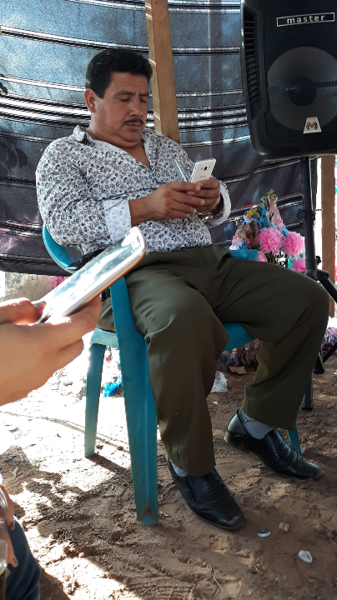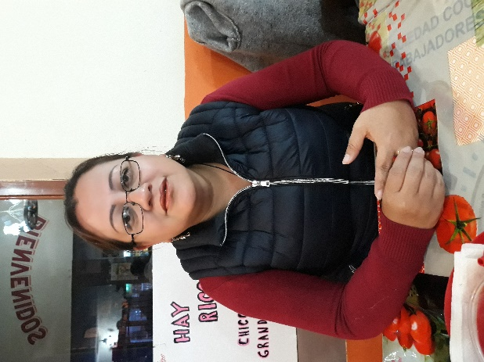

1.- She´s my niece

2.- Her name is Briana

3.- She´s 9 years old

4.- She´s beutiful and naughty

5.- She´s in Pacayal right now

1.- He´s my cousin

2.- Her name is Werner

3.- He´s 19 years old

4.- He´s crazy and funny

5.- He´s in his house right now



1.- She´s my best friend

2.- Her name is Nuria

3.- She´s 21 years old

4.- She´s funny and kind

5.- She´s in her work right now

1.- He´s my cousin

2.- Her name is Nelson

3.- He´s 28 years old

4.- He´s pretty and cool

5.- He´s traveling right now

