

**Nombre de alumno: NORMA GPE.**

**Nombre del profesor: ANA LAURA**

**CULEBRO**



**Nombre del trabajo: WORK # 1**

**Materia: INGLES III**

**Grado: 3er SEMESTRE**

**Grupo: BACHILLERATO EN ENFERMERIA**

Comitán de Domínguez Chiapas 2020.

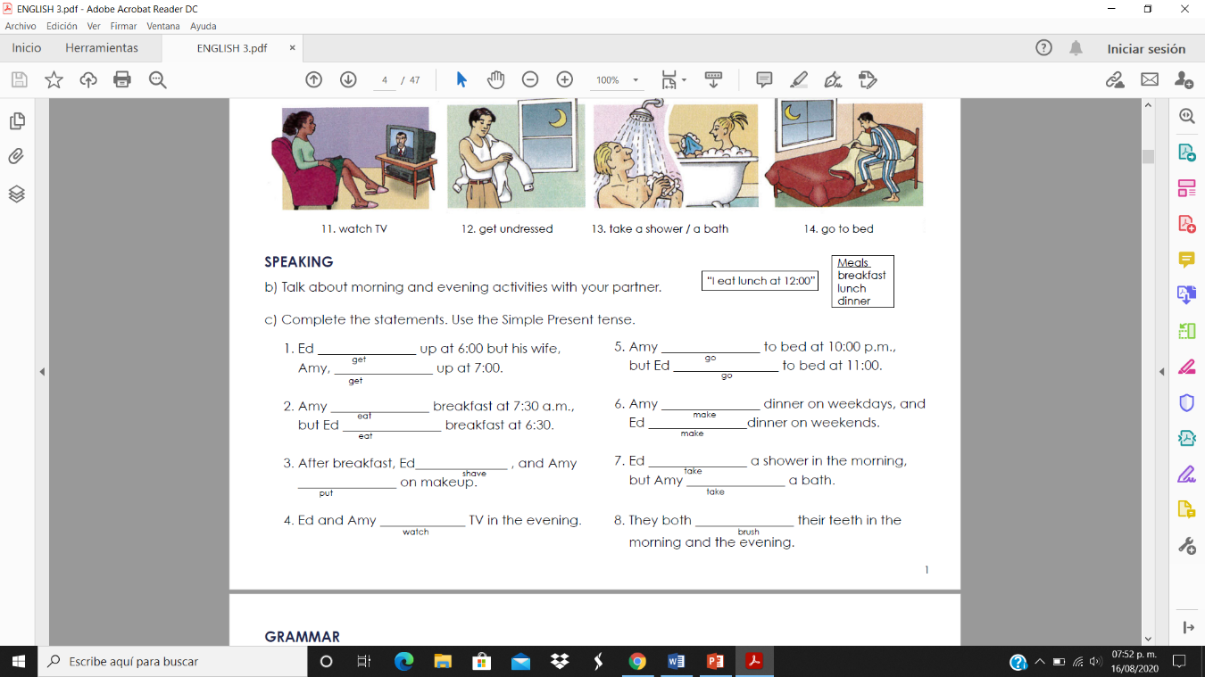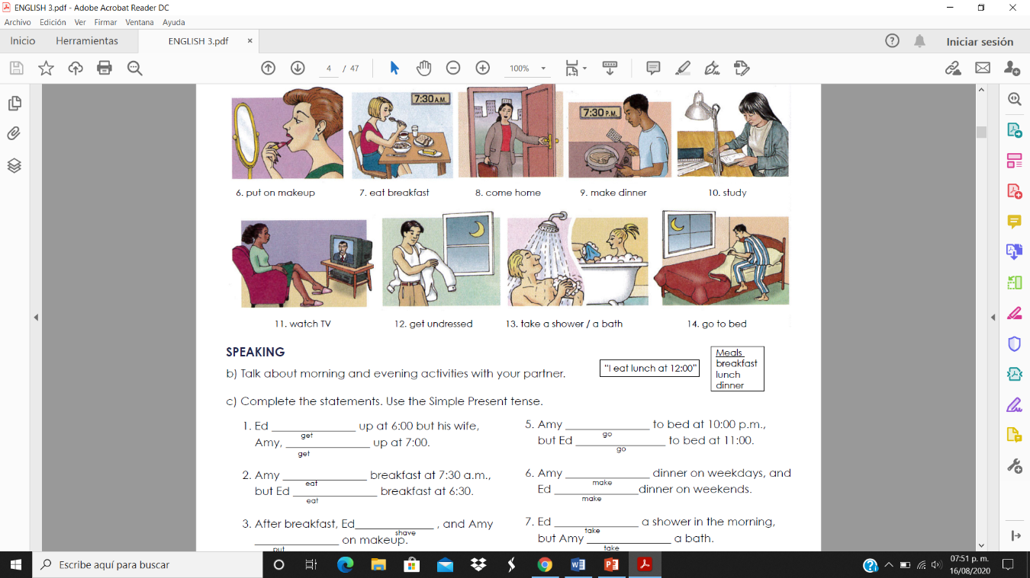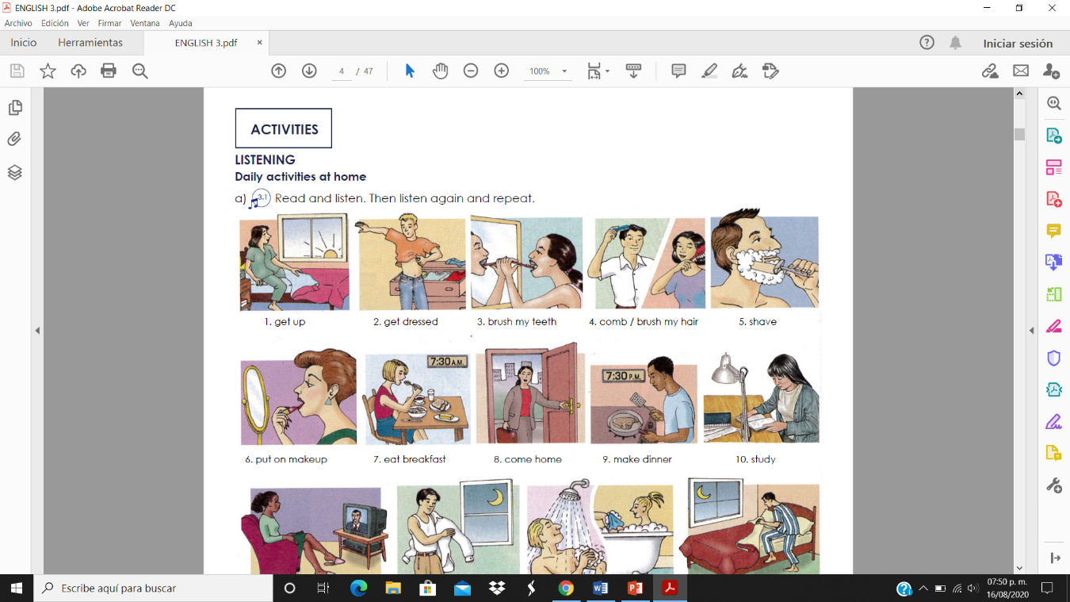

[**www.ejerciciosinglesonline.com**](http://www.ejerciciosinglesonline.com/)

**Grammar explanation:**[**English**](http://www.ejerciciosinglesonline.com/exercises-and-theory/grammar-exercises-and-theory/english-present-simple/)**,**[**Spanish**](http://www.ejerciciosinglesonline.com/exercises-and-theory/grammar-exercises-and-theory/present-simple/)

**Choose the correct answer using present simple tense:**

(Elige la respuesta correcta utilizando presente simple)

1. She  (think) Manuel is crazy.  
2. They  (not know) what to say.  
3.  (feel/she) ok?  
4. He  (not be) a relative of mine.  
5. I  (not know) who she  (be).  
6. She  (wash) her car every week.  
7. Paul   (sleep) seven hours a day.  
8. Mary and John  (be) my cousins.  
9. She always  (win).  
10. James  (cry) very easily.  
11. She  (pray) in church every Sunday.  
12. Sarah  (not like) pop music.  
13.  (John / play) football everyday?  
14.  (be) she a friend of yours?  
15.  (be) they in love?  
16.  (believe/ Mary) in God?  
17. Who  (be) your favourite football player?

<https://www.ejerciciosinglesonline.com/new-exercises/presente-simple-ex1/> **AQUÍ PUEDES REVISAR SI TUS RESPUESTAS SON CORRECTAS**