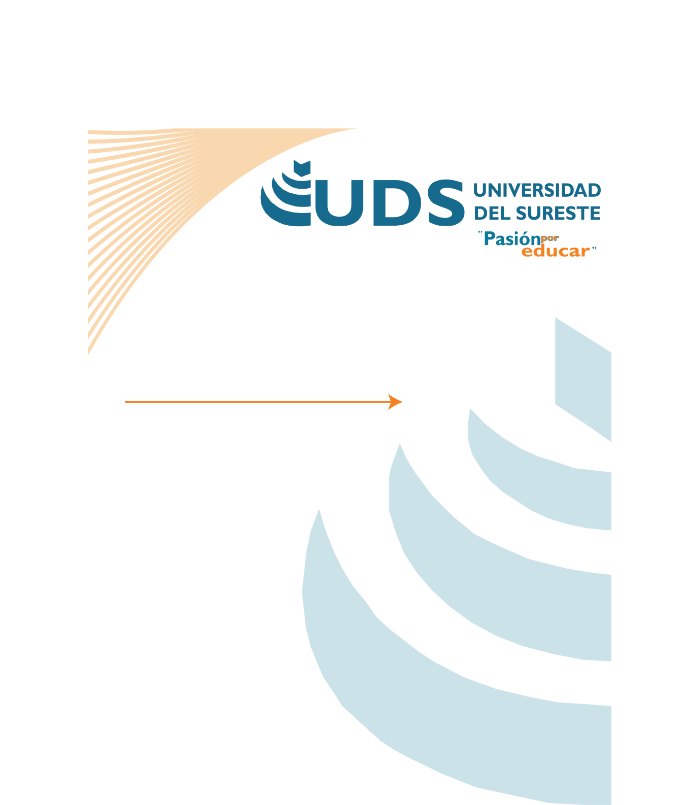

* Materia: Ingles ll
* Carrera: Enfermería general
* Semestre: 2° “A”
* Maestro: Carlos Rodrigo guillen
* Alumna: Karla Priscila ruano navas

**Monday:** Morning I woke up and went to the kitchen to have fruit breakfast with a little honey and a glass of juice

**Tuesday:** Morning i wake up i went to the kitchen and breakfast fruits with a glass of milk

**Wednesday:** morning I got up I went to the kitchen to have chayote with egg and a cup of coffee for breakfast

**Thursday:** morning I woke up went to the kitchen I ate breakfast with beans with egg and a cup of atoll

**Friday:** morning I will get up and have a banana smoothie with oatmeal and a chicken salad.

**Saturday:** morning i'm going to get up for breakfast french fries with a cucumber water

**Sunday:** morning I am going to get up to have breakfast of eggs with beans and a glass of mango