Nombre de

l alumno: duaner Alexis González gonzalez

Profesora

:

Dafne Abigail Almaraz Calvo

MATERIA: INGLES 1

ACTIVIDADES: CUADRO SINOPTICO (VERBO TO_BE)

MAPA MENTAL

(

SCHOOL SUPPLIES

)

MAPA MENTAL ARBOL GENEOLOGI

CO (FAMILY TREE)

FECHA: 30/SEPTIEMBRE/2021

**VERBO**

**TO BE**

# CONJUGACIONES

I am tired

You are nice

He is short

It is beautiful

We are good Friends

You are sad today

They are never happy

**Cuadro sinóptico (VERBO TO BE)**

# AFFIRMATIVE FULL / SHORT

I am = I’m

You are = you’re

He is = He’s

It is = It’s

We are = We’re

You are = You’re

# They are = They ’re INTEROGATIVE CONJUGACIONES

Am I? Am I a student?

Are you? Who are you?

Is he? Is he a teacher?

Is she? Where is she?

Is it? Is it not difficult?

Are we? Are we lost?

Are you? Why are you busy?

# NEGATIVE CONJUGACIONES FULL / SHORT

I am not = I’m not I am not very tall

You are not = You’re not you are not Irish

He is not = He’s not He is not my brother

She is not = She’s not She is not clever

It is not = It’s not It is not big

We are not = We’re not We are not ugly

You are not = You’re not You are not funny

They are not = They’re not They are not at school

**MAPA MENTAL: SCHOOL SUPPLIES THERES IS / ARE**



**SCHOOL SUPPLIES**

**THERE IS / ARE**

**THERE IS**

**A**



**THERE IS**

**A**

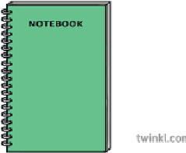

**THERE IS**

**A**



**THERE IS**

**A**



**THERE A**

**RE**



**THERE ARE**



**THERE IS**

**A**



**THERE IS**

**A**



**THERE ARE**

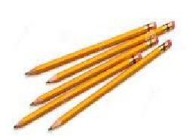

**THERE IS**

**A**



FAMILY TREE



**Grand father**

**His name is Elías**



**Grand mother**

**She name is Crisantina**



**Father**

**His name isFrancisco**



**Mother**

**She name isF Flora**



**Brother**

**His name isHabraham**

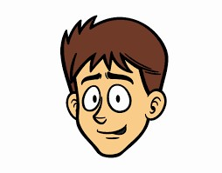

**Sisther**

**She name is Itzel**

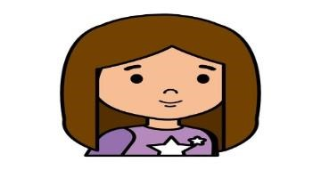

**Me**

**My**

**name is**

Alexis

Alexis



**Sisther**

**She name isCrisma**

