**Unit Activity #1 – U4**

*Nombre del Alumno:*

*Nombre del tema: Unit IV*

*Parcial: Fourth*

*Nombre de la Materia: English I*

*Nombre del profesor: Juan Manuel Jaime Díaz*

*Nombre de la carrera:*

*Cuatrimestre: 1st*

*Lugar y Fecha de elaboración*

Comitán de Domínguez Chiapas a 09 de diciembre de 2024.

**TOPIC 4**

**Exercise 1.** Write the name of the numbers.

1 - 11 - 30 -

2 - 12 - 40 -

3 - 13 - 50 -

4 - 14 - 60 -

5 – 15 - 70 -

6 – 16 - 80 -

7 – 17 - 90 -

8 – 18 - 100 -

9 – 19 - 135 -

10 – 20 - 192 -

**Exercise 2.**  Complete with “am”, “is”, or, “are”.

1. My surname _______ López.

2. We ______ from Madrid.

3. I _______ Anna.

4. Antonio and Juan ________ in room 7.

5. He _______ the English teacher.

6. You ______ in Class 3.

7. She ______ a student.

**Exercise 3.** Complete the questions with “who”, “what”, “where” or “how”.

1. _______`s your favorite sport?

2. _______`s Roberta from?

3. _______`s your favorite teacher?

4. _______are you?

5. _______time is it?

6. _______grade are you in?

7. _______`s your last name?

8. _______old is Mark?

**Exercise 4.** Translate to English:

1. Grandfather
2. Grandmother
3. Grandson
4. Granddaughter
5. Father
6. Mother
7. Wife
8. Husband
9. Son
10. Daughter
11. Sister
12. Brother
13. Aunt
14. Uncle
15. Niece
16. Nephew

**Exercise 5.** Complete the questions. Use “how old is” or “how old are”.

1._______________ your sisters?

2. _______________ Matt`s parents?

3. _______________ your grandfather?

4._______________ Helen`s husband?

5. _______________ her children?

6. _______________ his son?

**Exercise 6.** Circle the correct word or words to complete each sentence.

1. Mr. Thomas is ( my / I) boss.

2. Is Mrs. Cory (you / your) teacher.

3. Is (she / her) Dr. Kim?

4. Are (they / their) Connie and Sam?

5. Are (your / you) Barry`s friend?

6. He`s (my / I) colleague.

7. Mr. Benson is (Alec / Alec`s) neighbor.

8. Jake is (Ms. Rose / Ms. Rose`s) student.

9. (He`s / His) an architect.

10 (Kyle / Kyle`s) and Ray`s classmate is Gail.

**Exercise 7.** Read about some famous actors and their families and friends.

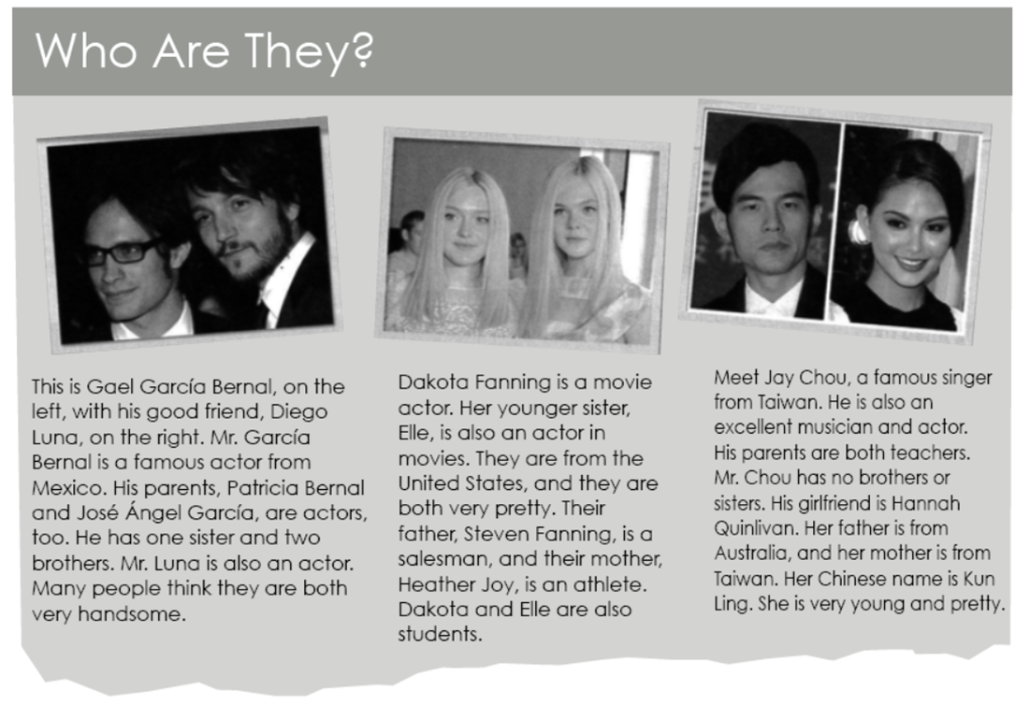

Now, complete the sentences.

1. Gael García Bernal is Diego Luna`s _________.

2. Patricia Bernal, José Ángel García, and Diego

Luna are all __________________.

3. Heather Joy is Steven Fanning`s ____________.

4. Elle Fanning is Heather Joy`s_________________.

5. Mr. Chou`s ________________ is good-looking.

6. Jay Chou`s parents have one _______________.

**Exercise 8.** Complete each sentence with “have” or “has”. Then choose the correct response. Circle the letter.

1. Matthew ____________ two sisters.

a. How old is she? b. How old are they?

2. Mark and Jamie __________ a daughter.

a. How old is her? b. How old is she?

3. I __________ a brother and sister.

a. How old is your brother? b. How old is my sister?

4. We________ a son.

a What`s your name? b. What`s his name?

**Exercise 9.** Unscramble the words. Write sentences.

1. brother / tall / is / My / very

2. handsome / He / too / very / is

3. your / Are / pretty / sisters / ?

4. Is / daughter / young / Her

5. cute / so / is / she