

**Nombre de alumno:**

**Nombre del profesor:**



**Nombre del trabajo: Weekly Activity #2 Unit 1**

**Materia:**

**Grado:**

**Grupo:**

Comitán de Domínguez Chiapas a 14 de septiembre de 2020.

**APPEARANCE AND HEALTH - Vocabulary**

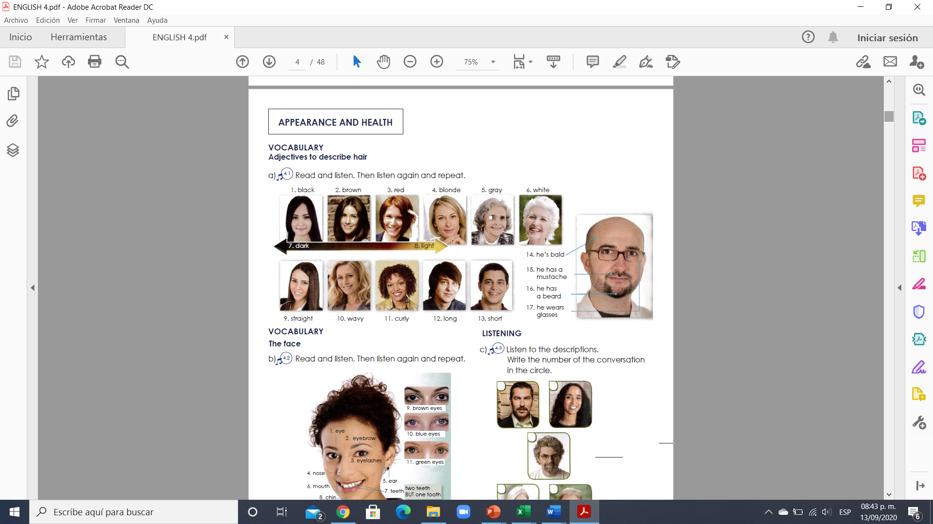

**Exercise 1.** Translate to spanish the vocabulary above. Traduce al español el vocabulario de arriba.

1. 10.

2. 11.

3. 12.

4. 13.

5. 14.

6. 15.

7. 16.

8. 17.

9.

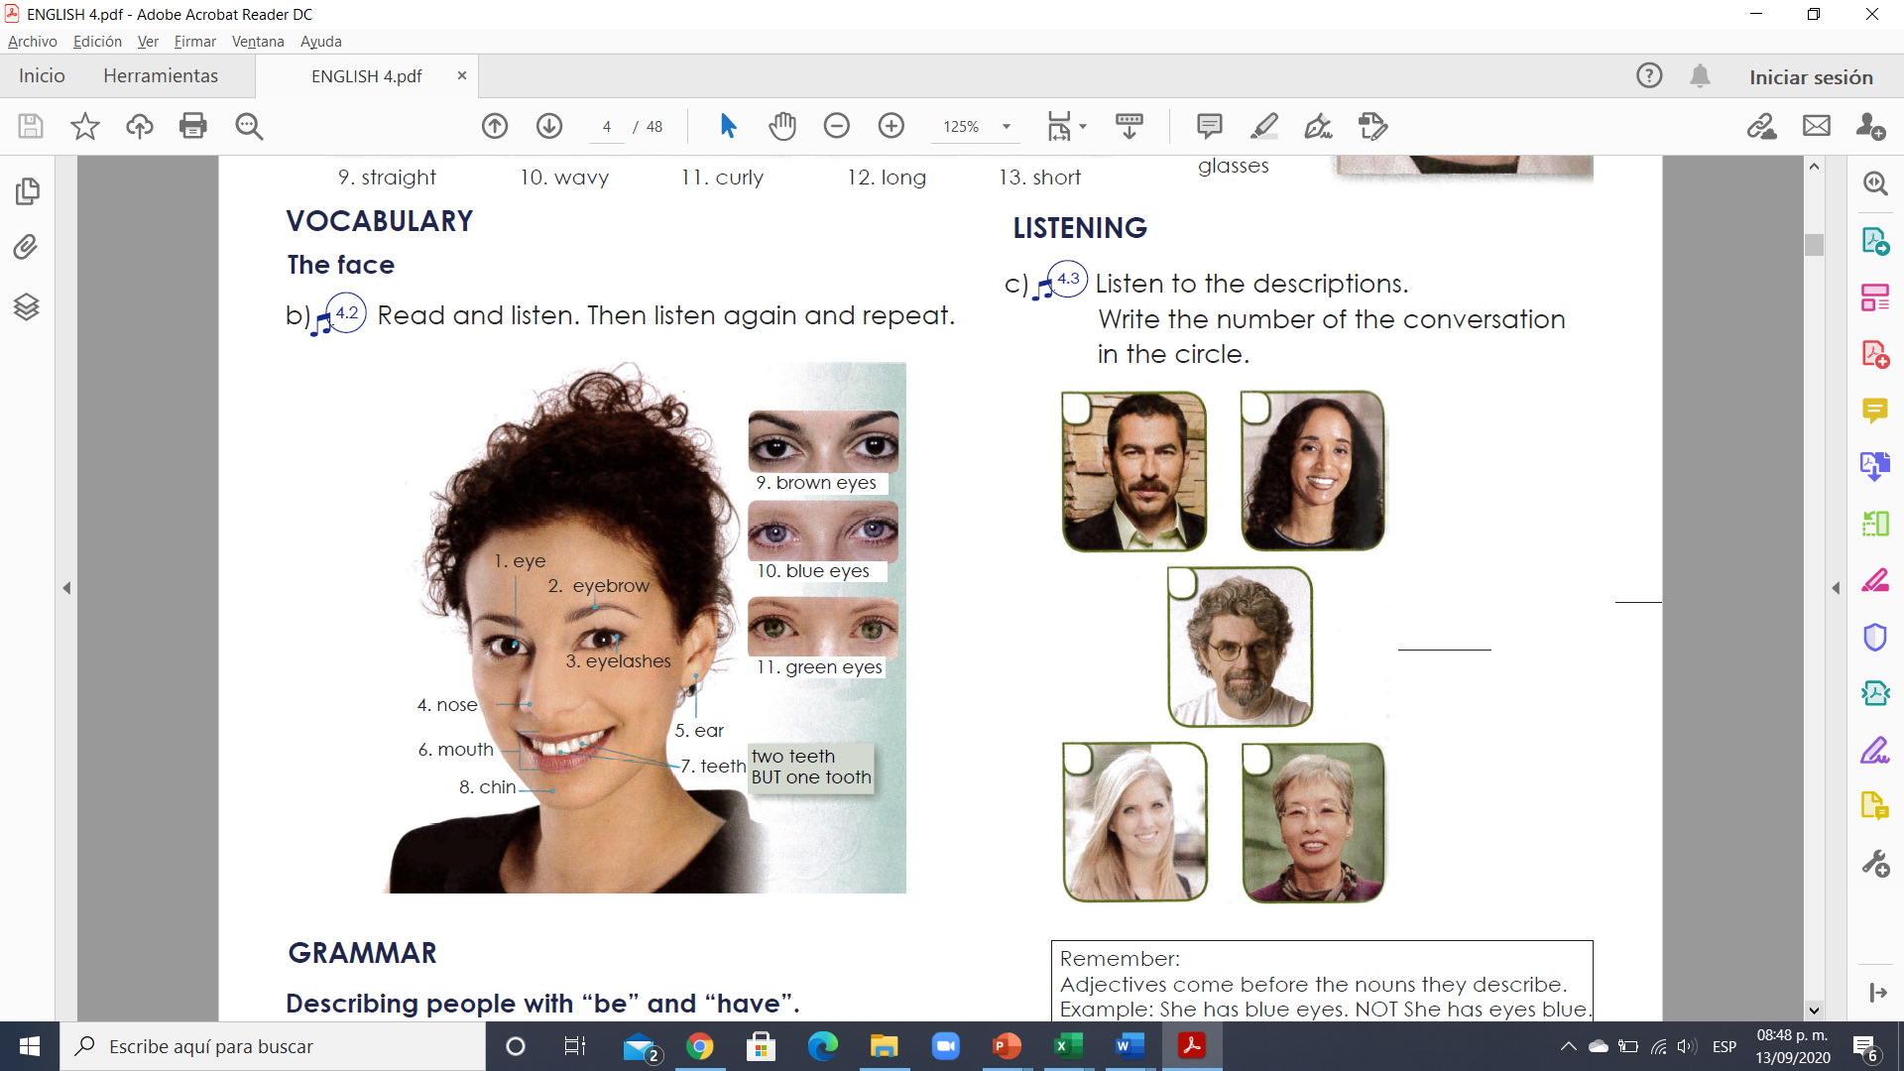

**Exercise 2.** Translate to spanish the vocabulary above. Traduce al español el vocabulario de arriba.

1. 7.

2. 8.

3. 9.

4. 10.

5. 11.

6.

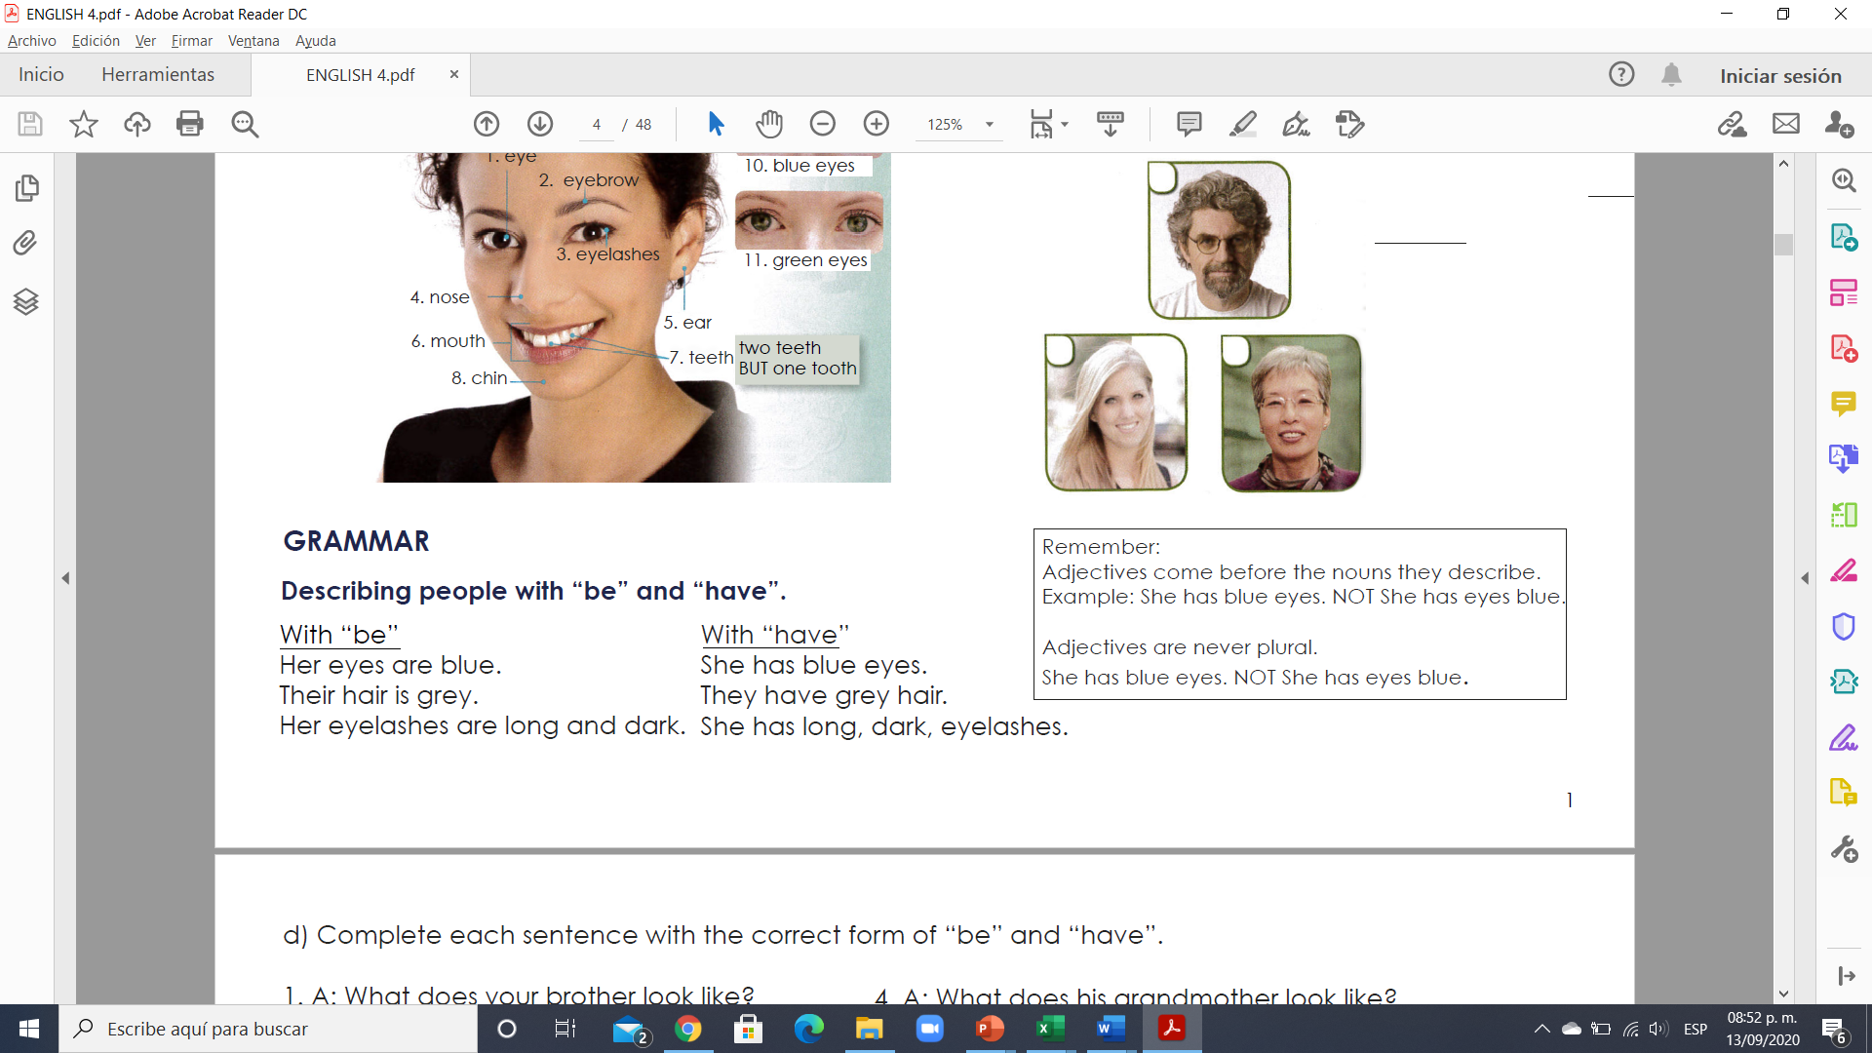

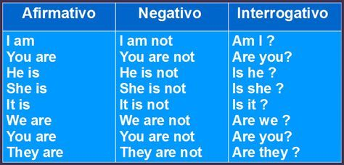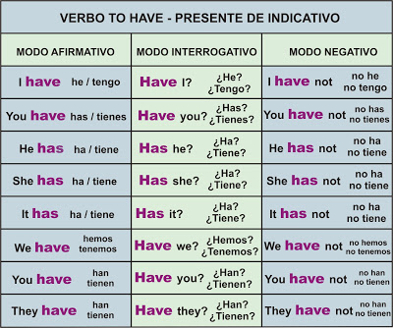

**VERBO TO BE**

**Exercise 3.** Complete each sentence with the correct form of “be” and “have”.

1. A: What does your brother look like?

B: Well, he ____________ a mustache and wavy hair.

And he wears glasses.

2. A: What does your mother look like?

B: Her hair ______________ curly and black.

3. A: What does her father look like?

B: He _________________ a short, gray beard.

4. A: What does his grandmother look like?

B: She ________________ curly, gray hair and beautiful eyes.

5. A: What does his sister look like?

B: His sister? Her hair _______________ long and pretty!

6. A: What do your brothers look like?

B: They ____________________ straight, black hair, and they wear glasses.

**Exercise 4.** Write a sentence with “be” and a sentence with “have”.

**Example:**

**1. Kate / hair/ long / straight**

(using “be”) a. Kate’s hair is long and straight

(using “have”) b. Kate has long straight hair

**2. George / short/ black hair**

(using “be”) a.

(using “have”) b.

**3. Harry/ long / curly/ hair**

(using “be”) a.

(using “have”) b.

**4. Mary/ eyes/ blue**

(using “be”) a.

(using “have”) b.

**5. Amy/ pretty/ eyes**

(using “be”) a.

(using “have”) b.