
Unit Activity #1 – U4
Nombre del Alumno:
Nombre del tema: Unit IV
Parcial: Fourth
Nombre de la Materia: English II
Nombre del profesor: Juan Manuel Jaime Díaz
Nombre de la Licenciatura:
Cuatrimestre: Second

Lugar y Fecha de elaboración

Comitán de Domínguez Chiapas a 23 de junio de 2024.

GRAMMAR
Possessive pronouns / Whose
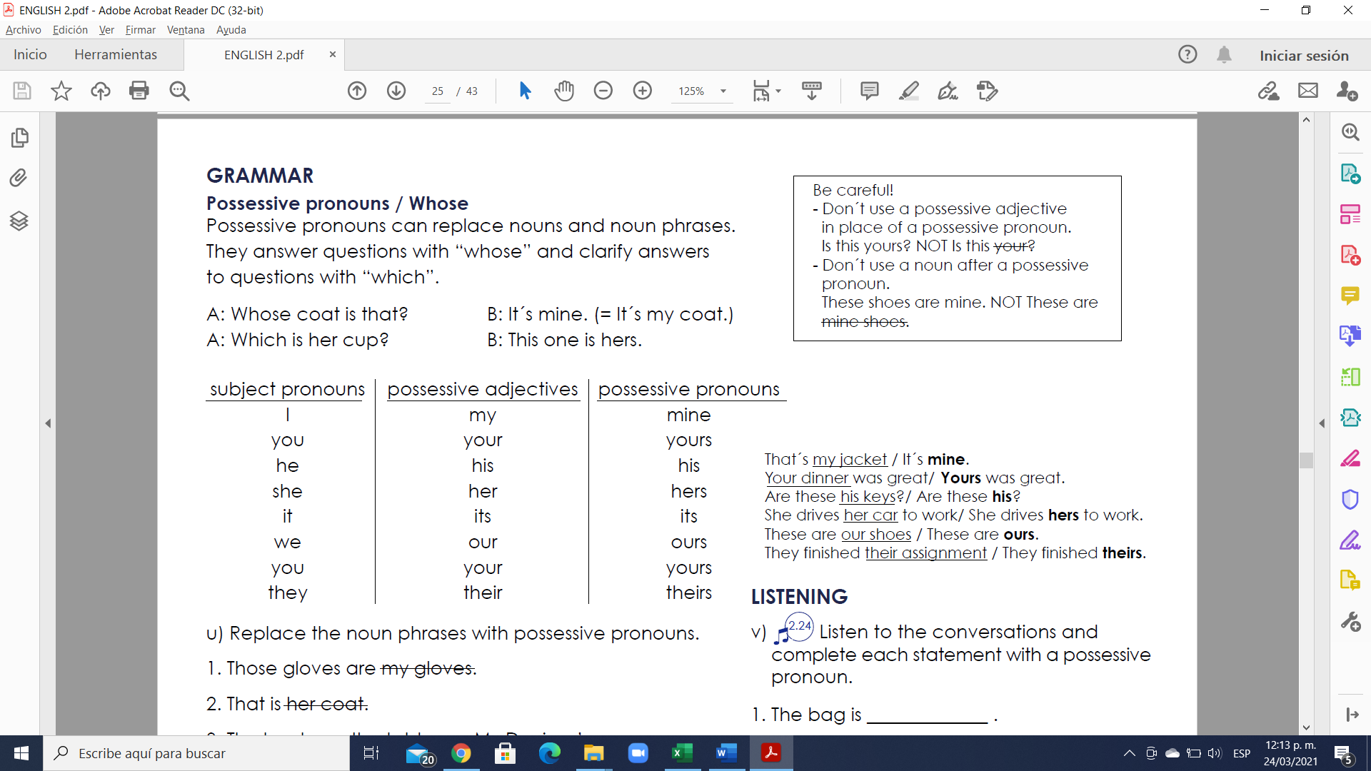
Possessive pronouns can replace nouns and noun phrases. They answer questions with “whose” and clarify answers to questions with “which”.
A: Whose coat is that? B: It´s mine. (= It´s my coat.)
A: Which is her cup? B: This one is hers.

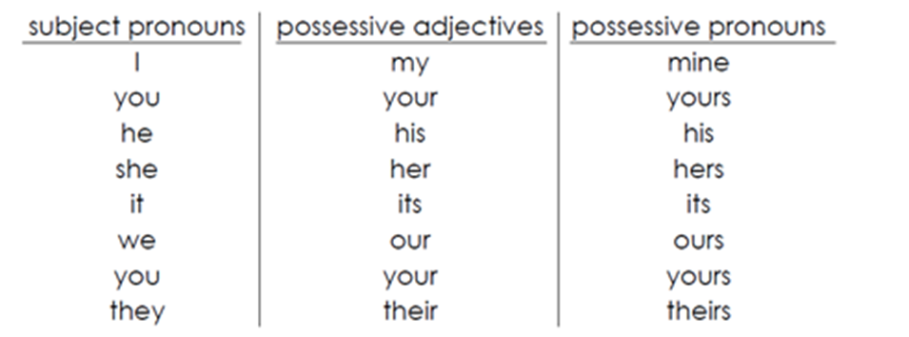

Examples:
That´s my jacket / It´s mine.
Your dinner was great/ Yours was great.
Are these his keys?/ Are these his?
She drives her car to work/ She drives hers to work.
These are our shoes / These are ours.
They finished their assignment / They finished theirs.

Exercise 1. Replace the noun phrases with possessive pronouns
- Those gloves are my gloves.
Answer:
2. That is her coat.
Answer:
3. The books on the table are Mr. Davison’s.
Answer:
4. Their car and our car are parked on the same street.
Answer:
5. Are those my tickets or her tickets?
Answer:
6. The white house is my mother’s house.
Answer:
7. Is this painting your painting or her brother’s painting?
Answer:
8. The newspaper under the chair is his daughter’s paper.
Answer:
9. Is this DVD your DVD or your friends’?
Answer:
10. Are these your son’s shoes?
Answer:

Exercise 2. Contesta correctamente
1. This car is ____ car. This car is his.
- he
- her
- his
- hers

2. This house is our house. This house is ____.
- our
- ours
- we
- its

3. This hat is my hat. This hat is ____.
- I
- me
- mine
- its

4. This is your bike. This bike is ____.
- you
- your
- yous
- yours

5. This is ____ dog. This dog is hers.
- her
- his
- hers
- she

6. These are ____ children. These children are theirs.
- theirs
- them
- they
- their

Vocabulary
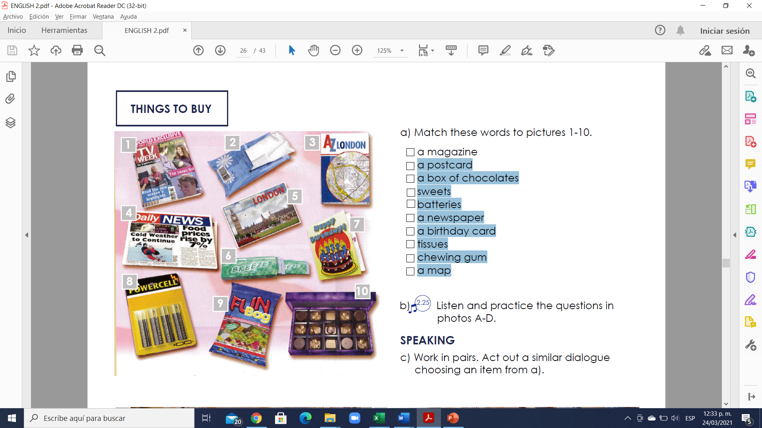
Exercise 3. Match the adjectives to pictures 1-10. (Escribe la letra de la figura que concuerda con la palabra)
( ) - a magazine
( ) - a postcard
( ) - a box of chocolates
( ) - sweets
( ) - batteries
( ) - a newspaper
( ) - a birthday card
( ) - tissues
( ) - chewing gum
( ) - a map

EVENTS AND TIMES
VOCABULARY
What time is it?
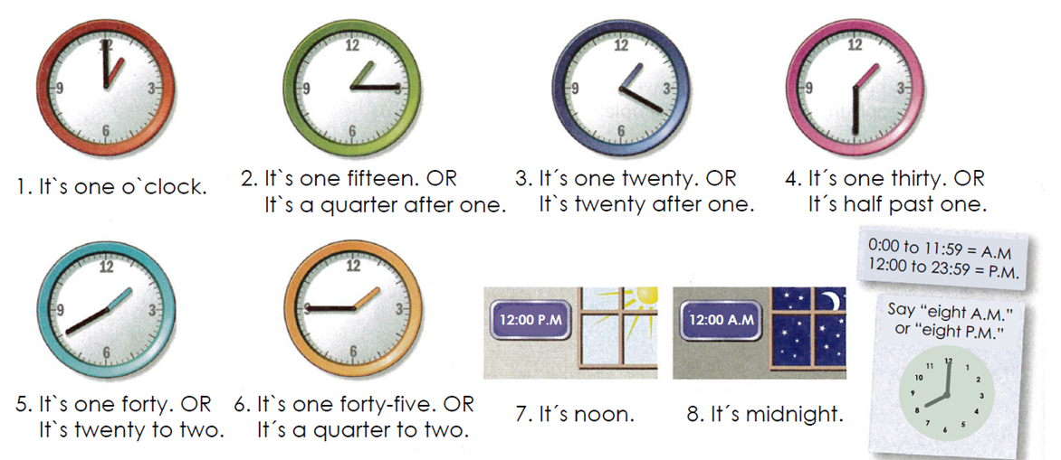

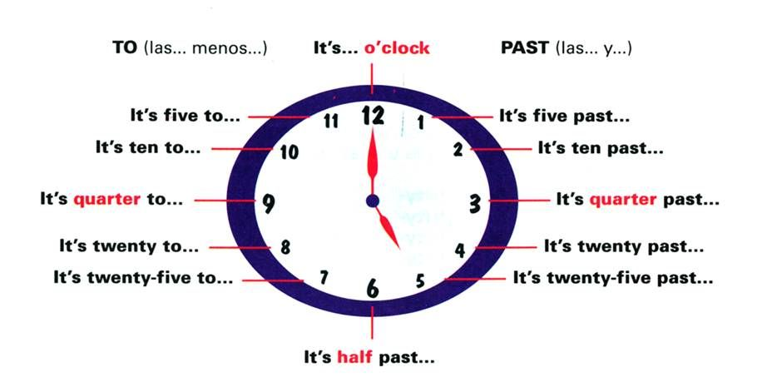
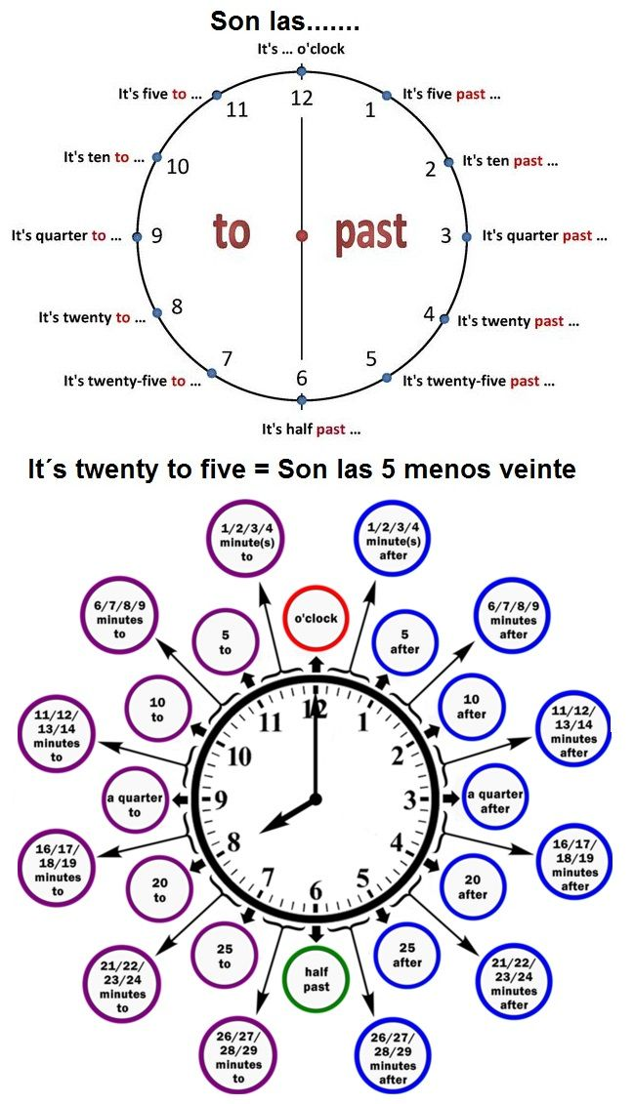
Ver video en youtube para la explicación de las horas:
https://www.youtube.com/watch?v=ItXtQGHnp1E&feature=emb_logo&ab_channel=DianaPerez
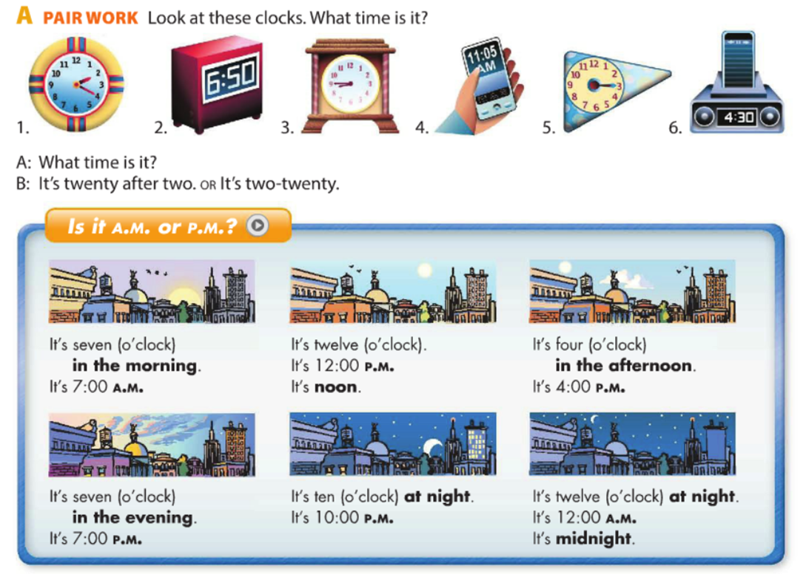

Exercise 4. What time is it?. Use the sentences in the box. ¿Qué hora es?, usa las oraciones en la caja.
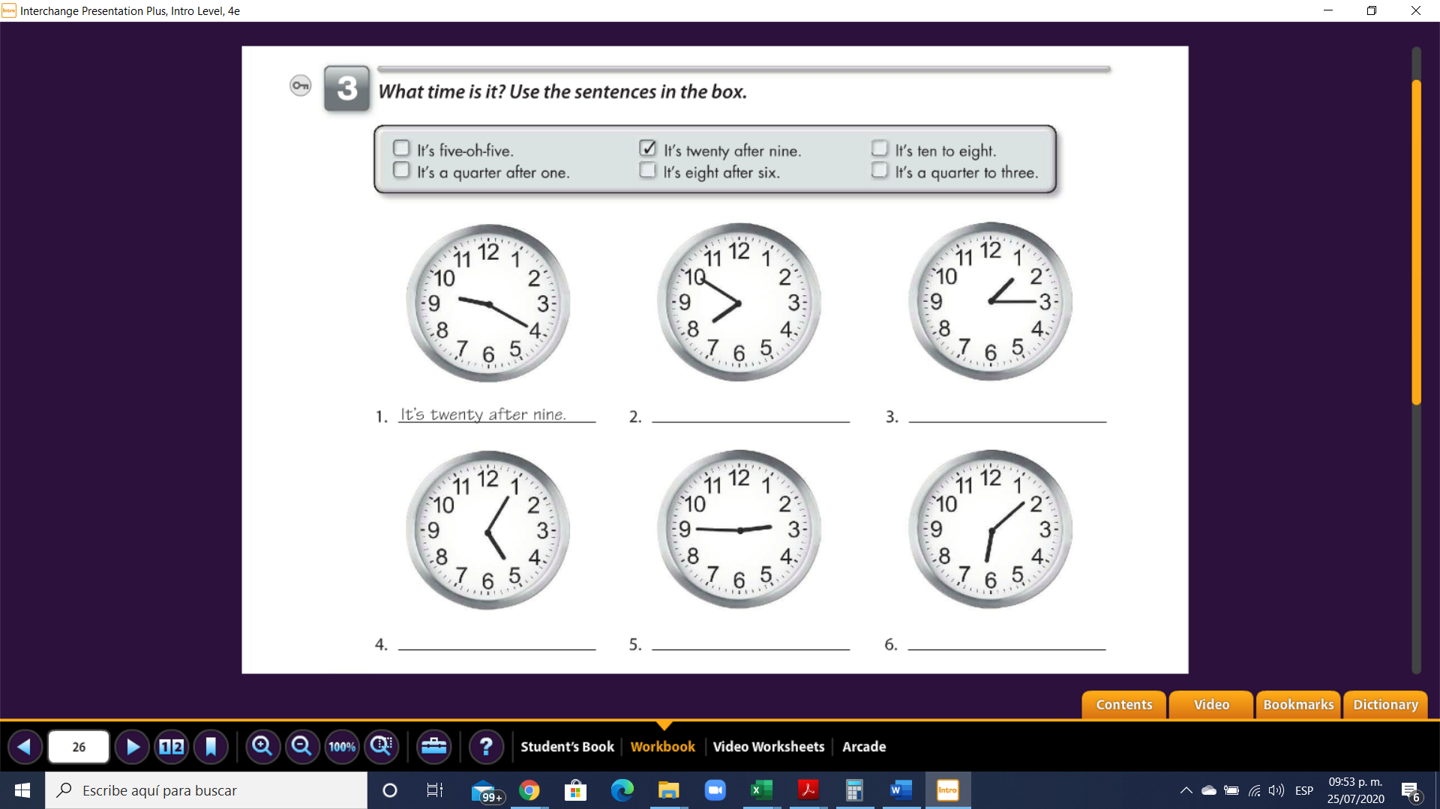
- It´s twenty after nine 2. ____________________ 3._____________________

- ______________________ 5. ____________________ 6._____________________

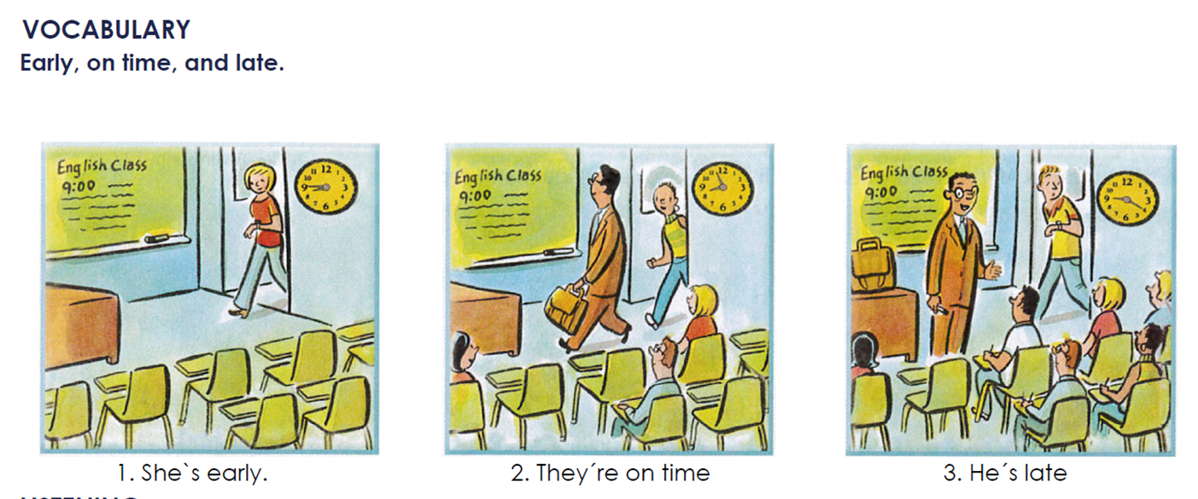

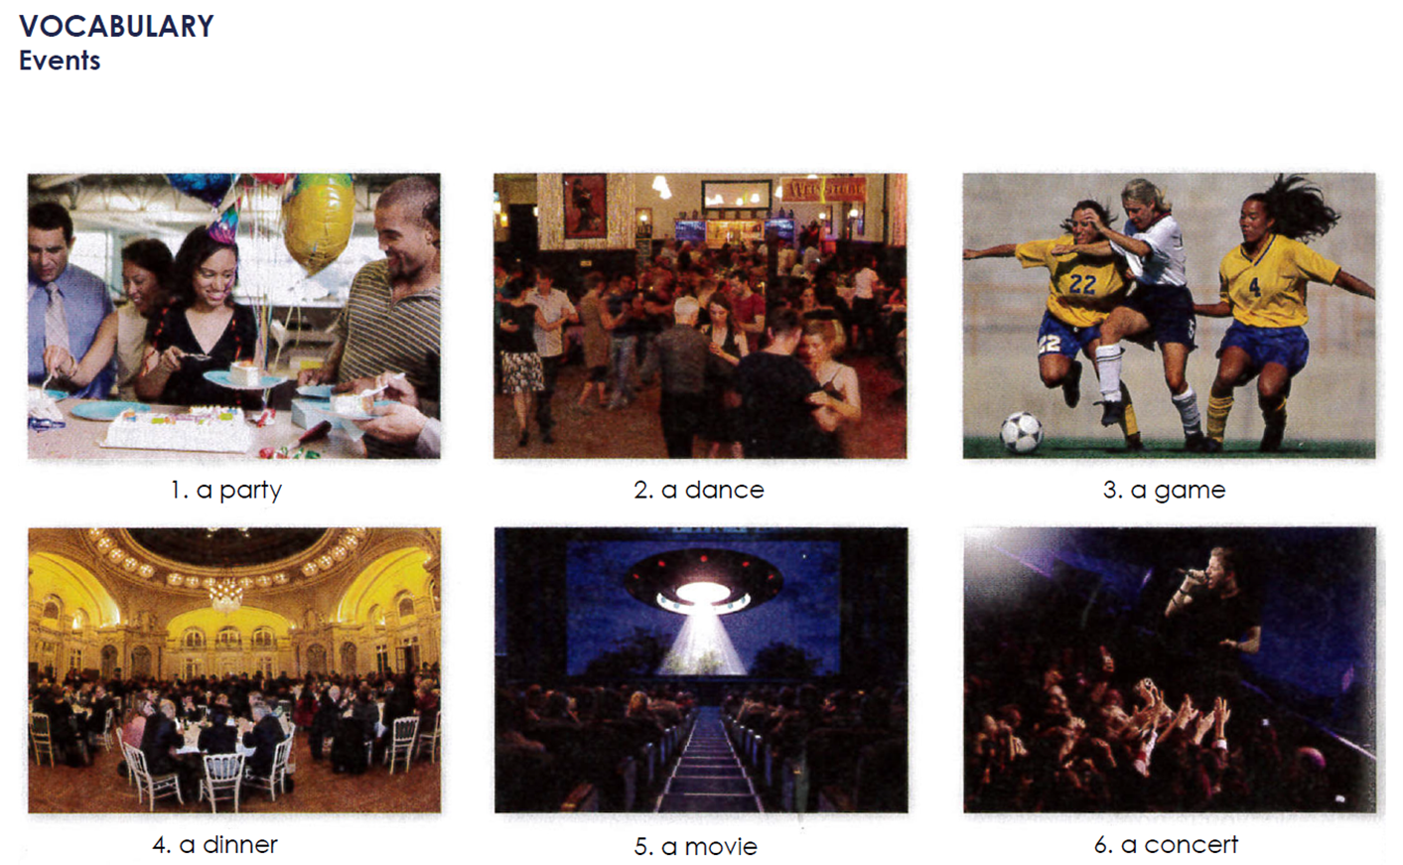

GRAMMAR
“Be”: questions about time / Prepositions “at” and “on”.

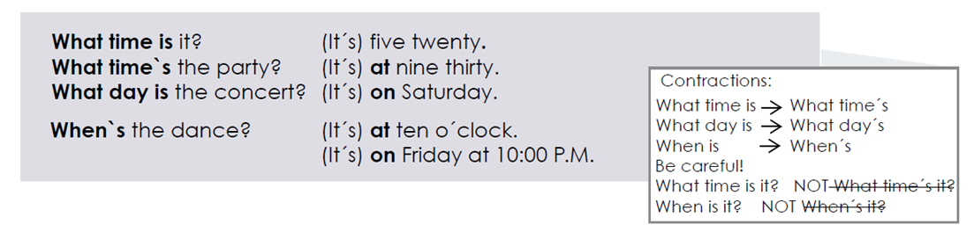

Exercise 5. Complete the questions and answers. Use contractions when possible.

1. A: When ________ the party? B: It’s ________ 11:00 p.m.

2: A: ________ days’s the game? B: It’s ________ Saturday.

3. A: What ________ the concert? B: It’s ________ 8:30.

4. A: What ________ the dinner? B: It’s ________ Tuesday.

5. A: ________ the dance? B: It’s ________ Friday at 9:00.

6. A: What ________ the class? B: It’s ________ noon.

GRAMMAR
Prepositions “in”, “on” and “at” for dates and times.
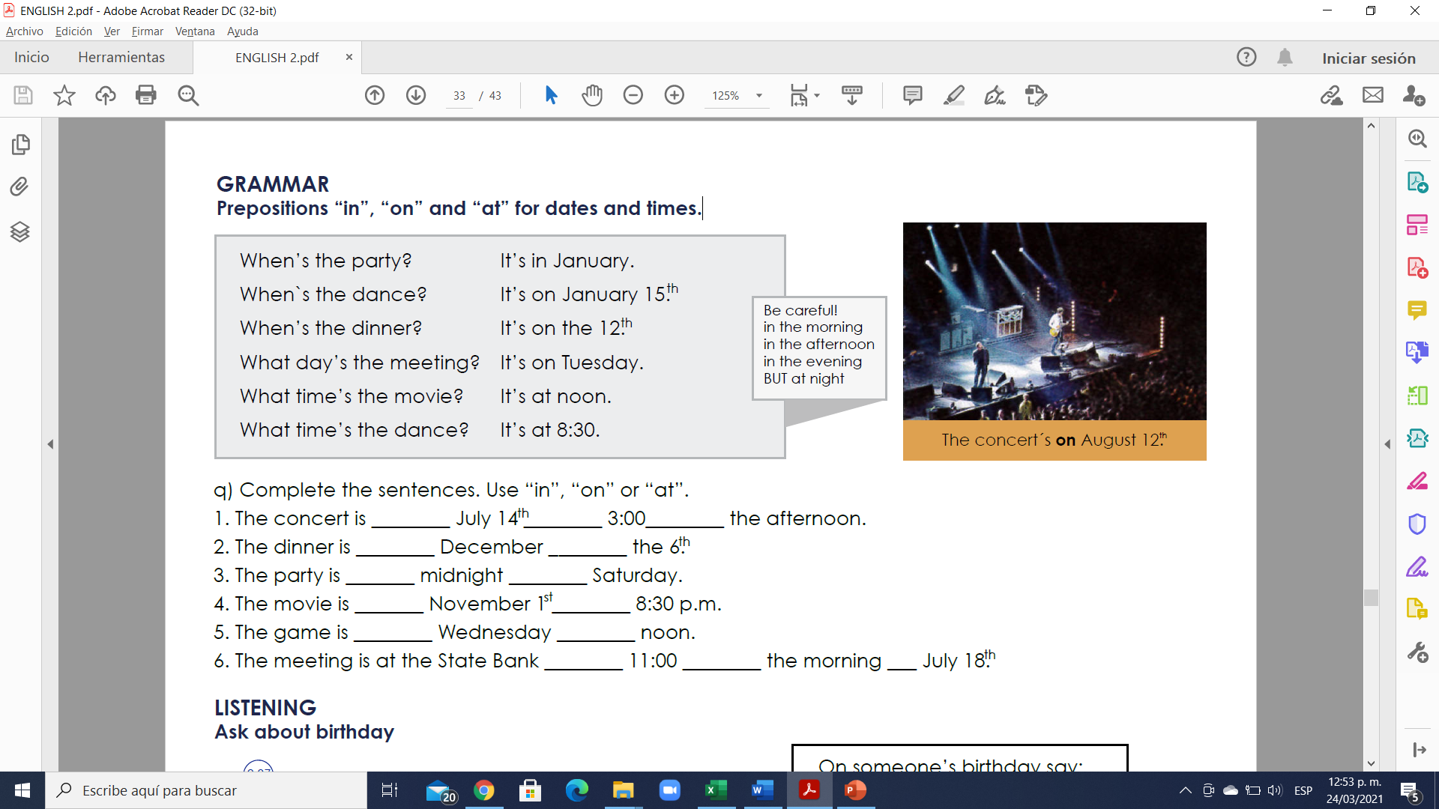

Exercise 6. Complete the sentences. Use “in”, “on” or “at”.

1. The concert is ________ July 14 ________ 3:00________ the afternoon.

2. The dinner is ________ December ________ the 6.

3. The party is _______ midnight ________ Saturday.

4. The movie is _______ November 1 ________ 8:30 p.m.

5. The game is ________ Wednesday ________ noon.

6. The meeting is at the State Bank ________ 11:00 ________ the morning ___ July 18.

