**Unit Activity #1 – U4**

*Nombre del Alumno:*

*Nombre del tema: Unit IV*

*Parcial: Fourth*

*Nombre de la Materia: English V*

*Nombre del profesor: Juan Manuel Jaime Díaz*

*Nombre de la carrera:*

*Cuatrimestre: 5*

*Lugar y Fecha de elaboración*

Comitán de Domínguez Chiapas a 04 de diciembre de 2023.

**GRAMMAR - The Present perfect**

- We use the Present Perfect to talk about something that happened in the past, but the exact time it happened is not important. It has relationship with the present.

Example: I have done my homework = I finished my homework in the past. It is not important at what exact time, only that it is now done (result in the present).

Example: I have forgotten my bag = It is not important when exactly I forgot it. The important thing is that I don’t have it right now.

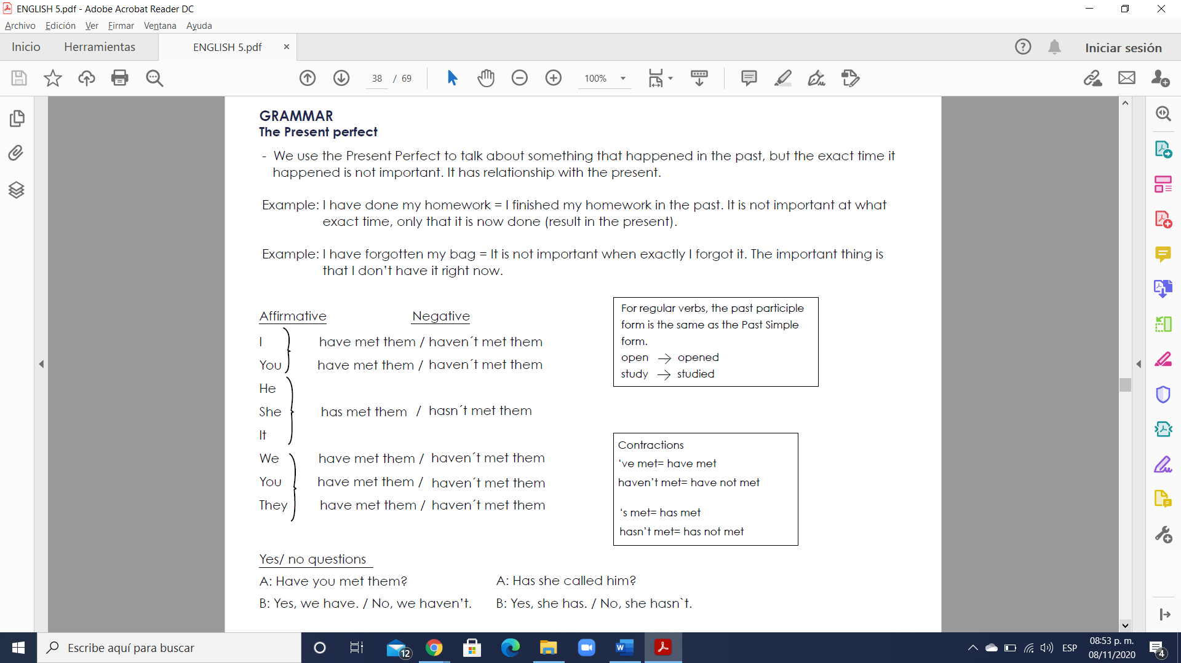

Yes/ no questions

A: Have you met them?

B: Yes, we have. / No, we haven’t.

- Remember: we use the Past Simple Tense to talk about a definite or specific time in the past.

Compare:

Present Perfect: indefinite time Past Simple tense: definite time

Example: I’ve met Bill twice Example: I met Bill in 1999 and again in 2004

**The Present perfect**

El presente perfecto equivale más o menos al pretérito perfecto del español. Veremos las diferencias en la sección sobre usos. En general, es una mezcla entre el presente y el pasado. Lo usamos para acciones en el pasado que tienen importancia en el presente.

**Grammatical Rules** (Reglas gramaticales)

**Form** (Forma)

Para formar el presente perfecto, se usa el verbo auxiliar “to have” en el presente y el participio pasado del verbo. Para verbos regulares, el participio pasado es la forma simple del pasado. Ver la lección sobre el pasado simple para más información sobre como formar el pasado.

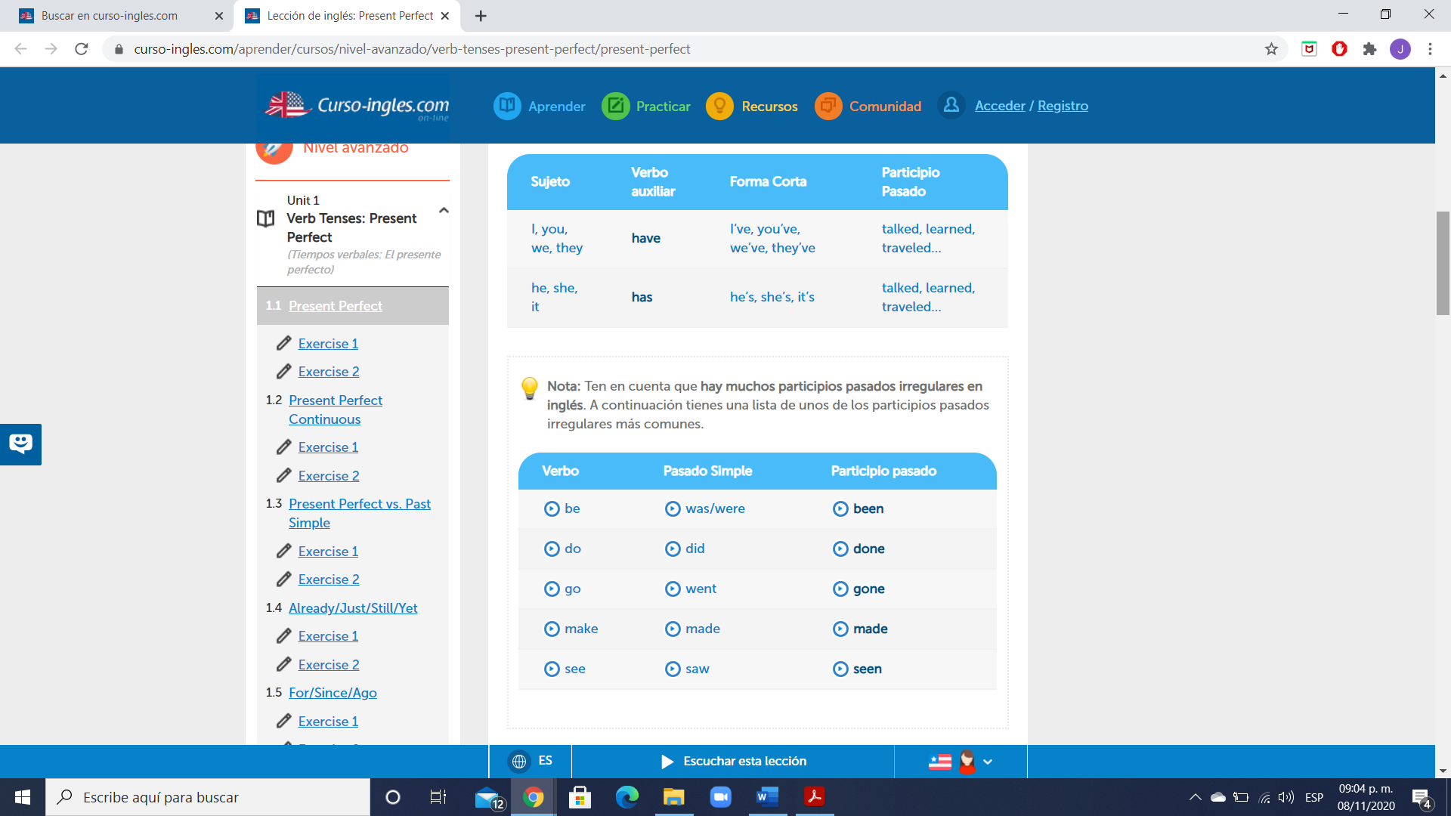

Nota: Ten en cuenta que hay muchos participios pasados irregulares en inglés. A continuación tienes una lista de unos de los participios pasados irregulares más comunes.



**Structure** (Estructura)

**1. Affirmative Sentences** (Frases afirmativas)

Sujeto + verbo auxiliar (to have) + participio pasado…

Ejemplos:

I have [I’ve] talked to Peter.(He hablado con Peter.)

She has [She’s] gone to work.(Ha ido a su trabajo.)

We have [We’ve] been to London.(Hemos ido a Londres.)

They have [They’ve] learned English.(Han aprendido inglés.)

**2. Negative Sentences** (Frases negativas)

Sujeto + verbo auxiliar (to have) + “not” + participio pasado…

Ejemplos:

I haven’t talked to Peter.(No he hablado con Peter.)

She hasn’t gone to work.(No ha ido a su trabajo.)

We haven’t been to London.(No hemos ido a Londres.)

They haven’t learned English.(No han aprendido inglés.)

**3. Interrogative Sentences** (Frases interrogativas)

Verbo auxiliar (to have) + sujeto + participio pasado…?

Ejemplos:

Have you talked to Peter?(¿Has hablado con Peter?)

Has she gone to work?(¿Ha ido a su trabajo?)

Have you been to London?(¿Has ido a Londres?)

Have they learned English?(¿Han aprendido inglés?)

Uses (Usos)

Se usa el presente perfecto para acciones que ocurrieron en un tiempo no concreto antes de ahora. El tiempo específico no es importante. Por lo tanto, no solemos usar expresiones de tiempo específicas (“this morning”, “yesterday”, “last year”…) con el presente perfecto. Se puede usar el presente perfecto con expresiones de tiempo no concretas (“never”, “ever”, “many times”, “for”, “since”, “already”, “yet”…). Este concepto de tiempo no específico es bastante difícil de comprender, por este motivo, a continuación tienes los usos particulares del presente perfecto.

1. Se usa el presente perfecto para describir una experiencia. No lo usamos para acciones específicas.

Ejemplos:

I have never flown in a plane.(Nunca he volado en un avión.)

He has worked in many different museums.(Ha trabajado en muchos museos

diferentes.)

We have been to Río de Janeiro.(Hemos ido a Río de Janeiro.)

2. Se utiliza el presente perfecto para un cambio en el tiempo.

Ejemplos:

I have become more timid in my old age.(Me he vuelto más tímido en mi vejez.)

Their English has improved a lot this year.(Su inglés ha mejorado mucho este año.)

He has learned to be more patient.(Ha aprendido a ser más paciente.)

3. Se usa para los éxitos o logros.

Ejemplos:

Our football team has won the championship three times.(Nuestro equipo de fútbol ha

ganado el campeonato tres veces.)

Dan has finished writing his first novel.(Dan ha terminado de escribir su primera novela.)

Scientists have succeeded in curing many illnesses.(Los científicos han tenido éxito en la

curación de muchas enfermedades.)

4. Usamos el presente perfecto para acciones que todavía no han sucedido. El uso del presente perfecto en estos casos indica que aún estamos esperando la acción, por eso, frecuentemente usamos los adverbios “yet” y “still”.

Ejemplos:

The plane hasn’t arrived yet.(El avión no ha llegado todavía.)

Our team still hasn’t won a championship.(Nuestro equipo aún no ha ganado un

campeonato.)

You haven’t finished your homework yet?(¿No has acabado todavía los deberes?)

5. Se utiliza el presente perfecto para hablar sobre acciones en diferentes momentos en el pasado. El uso del presente perfecto en estos casos indica que son posibles más acciones en el futuro.

Ejemplos:

We have spoken several times, but we still can’t reach an agreement.(Hemos hablado

varias veces, pero todavía no podemos llegar a un acuerdo.)

Our team has played 4 games so far this year.(Nuestro equipo ya ha jugado 4 partidos

este año.)

I love New York! I have been there 5 times already and I can’t wait to go back.(¡Me

encanta Nueva York! Ya he estado allí 5 veces y no puedo esperar para regresar.)

6. En general, usamos el presente perfecto continuo para situaciones que han empezado en el pasado pero siguen en el presente. Pero como hemos visto, hay algunos verbos que no podemos usar en los tiempos continuos. En estos casos, usamos el presente perfecto.

Ejemplos:

How long has Michael been in Barcelona?(¿Cuánto tiempo ha estado Michael en

Barcelona?)

I have loved you since the day I met you.(Te he querido desde el día que te conocí.)

**IRREGULAR VERBS**

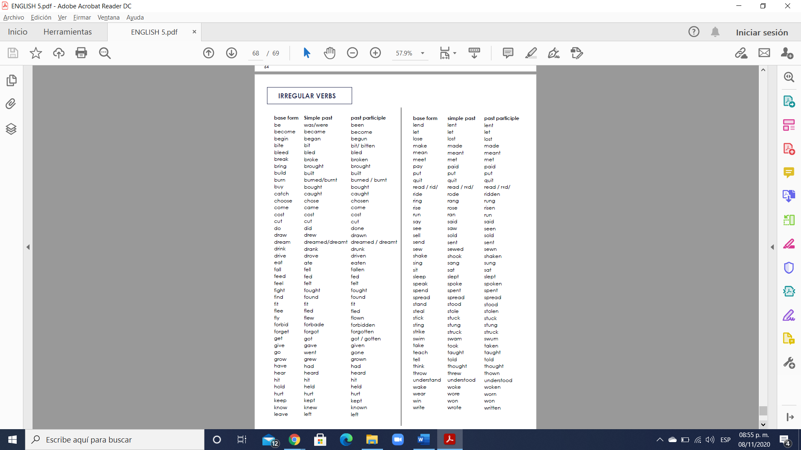

**Exercise 1.** Choose the correct form to complete each sentence.

1. We’ve _____ the 2:00 express train many times.

a. take b. took c. taken

2. I had breakfast at 9:00, but I haven’t _____ lunch.

a. have b. had c. having

3. Allison has _____ to the mall.

a. went b. gone c. go

4. My younger brother has _____ home from work.

a. come b. came c. comes

5. They posted some messages yesterday, but they haven’t _____ anything about their trip.

a. written b. write c. wrote

**Exercise 2.** Put the verbs into the correct form of the Present Perfect Simple.

1. I (not / work) ________________________________________ today.

2. We (buy) ______________________________________ a new lamp.

3. We (not / plan) _____________________________ our holiday yet.

4. Where (be / you) _________________________________________?

5. He (write) _______________________________________ five letters.

6. She (not / see) __________________________ him for a long time.

7. (be / you) _______________________________________ at school?

8. School (not / start) _____________________________________ yet.

9. (speak / he) ____________________________________ to his boss?

10. No, he (have / not) ___________________________ the time yet.

**Exercise 3.** Complete the sentences using present perfect simple:

1. _______ you _____ (see) Paul today?

2. She ____________ (go) outside.

3. _____ you ever ______ (visit) Paris?

4. I ________________ (already/eat).

5. She ___________________ (just / arrive)

**GRAMMAR - The Present Perfect with “already”, “yet”, “ever”, “before” and “never”.**

**Ever**

- The adverb “ever” expresses the idea of an unidentified time before now. It is always placed before the main verb (past participle).

- We use “ever” in questions.

Example: Have you ever been to England?

Example: Has she ever met the Prime Minister?

- We use “ever” in negative questions.

Example: Haven’t they ever been to Europe?

Example: Haven’t you ever eaten Chinese food?

- We use “ever” in negative statements using the pattern “nothing + ever” or ”nobody + ever”.

Example: Nobody has ever said that to me before.

Example: Nothing like this has ever happened to us.

- We use “ever” with “the first time”.

Example: It’s the first time that I’ve ever eaten snails.

Example: It’s the first time that I’ve ever been to England.

**Never**

- Like “ever”, the adverb “never” expresses the idea of an unidentified time before now. It is always placed before the main verb (past participle). “Never” means “at no time before now”.

Be careful! You can’t use “never” with a negative verb.

Example: I haven’t never been to Italy. I have never been to Italy.

Example: I have never eaten snails.

**Already**

- We use “already” to refer to an action that has happened at an unspecific time before now.

“Already” can be placed either before the main verb (past participle) or at the end of the sentence.

Example: I’ve already drunk three coffees this morning.

Example: Don’t write to John, I’ve already done it!

- We use “already” in questions.

Example: Have you already written to John?

Example: Has she finished her homework already?

**Yet**

- We use “yet” to say that something has not happened or been done up to the present time. It is usually placed at the end of the sentence.

- We use “yet” in negative statements.

Example: Kevin hasn’t registered for class yet.

Example: I haven’t finished my breakfast yet.

- We use “yet” in questions.

Example: Have the guests arrived yet?

Example: Have you toured Quito yet?

**Before**

- We use “before” to talk about a time from the past until now. We can use it with affirmative, negative and questions.

Example: I’ve seen that woman before but I can’t remember where (affirmative).

Example: I haven’t cooked this recipe before. I don’t know how to do it! (negative).

Example: Have you done this before? (question).

**Exercise 4.** Use the words to write statements and questions in the Present Perfect.

1. you/ go sightseeing / in London / before.

____________________________________________________

2. she / already / try / Guatemalan food.

____________________________________________________

3. they / ever / be / to Buenos Aires.

____________________________________________________

4. we / not take a tour of Prague.

____________________________________________________

**GRAMMAR - The Present Perfect with “for” and “since” and other uses.**

Use “for” and “since” to describe periods of time that began in the past.

**For**

We use “for” to describe a length of time.

Example: How long have you been there? I’ve been here for ten minutes.

Example: How long have you been there? I’ve been here for many years.

**Since**

We use “since” with a specific time or date in the past.

Example: How long have you been here? I’ve been here since eight o’clock.

Example: How long have you been here? I’ve been here since August.

Other uses

**- With “always”.**

Example: I’ve always wanted to see Car Planet.

**- With ordinals and superlatives.**

Example: This is the third time I’ve seen Ping Pong. It’s the best movie I’ve ever seen.

**- With “lately”, “recently” or “just”.**

Example: Have you seen a good movie recently/ lately? I’ve just seen The Beach- what a great movie!

**- With “still” or “so far”.**

Example: You still haven’t seen Tomato Babies? I’ve seen it three times so far!

**Exercise 1.** Choose the correct words to complete the paragraph.

I’ve been a big fan of Penélope Cruz (1 for/ since) more than twenty years. I’ve followed her career (2 since / so far) I was in high school. That means I’ve watched every movie she’s made (3 for / since) 1993, except for Vicky Cristina Barcelona. I (4 yet/ still) haven’t seen that one, but I plan to see it soon. I’ve (5 still / always) loved Penélope’s work. I’ve (6 since / always) been the first person in line at the theatre when her movies open. Of the movies Penélope has made (7 lately / always), the most interesting ones to me are To Rome with Love and I’m so excited. I think they’re the (8 best / just) movies she’s made (9 so far / still). I’ve (10 always / already) seen them twice.

**Exercise 2.** Complete with “for” or “since”.

1. I have been waiting __________ 4 o'clock.

2. Sue has only been waiting __________ 20 minutes.

3. Tim and Tina have been learning English __________ six years.

4. Fred and Frida have been learning French __________ 1998.

5. Joe and Josephine have been going out together __________ Valentine's Day.

6. I haven't been on holiday __________ last July.

7. Mary has been saving her money __________ many years.

8. I haven't eaten anything __________ breakfast.

9. You have been watching TV __________ hours.

10. We have been living here __________ 2 months.

**GRAMMAR - The Present Perfect Continuous.**

- The Present Perfect Continuous shows that an action started in the past and is continuing at the present time or has finished recently.

- It is formed using the construction has/have been + the present participle (base form + -ing).

Example: I have been reading War and Peace for a month now.

In this sentence, using the Present Perfect Continuous conveys that reading War and Peace is an activity that began sometime in the past and is not yet finished in the present.

- “Recently” and “lately” are words that we often find with verbs in the Present Perfect Continuous.

Example: Mia has been competing in flute competitions recently. (And she will continue to do so.)

Example: I haven’t been feeling well lately. (And I am still sick now.)

- The Present Perfect Continuous can be used with “for” and “since”.

Example: “I’ve lived here for five years” (emphasis is on the five year period. I still live here, so the action continues).

Example: “ I’ve been living here since 2001”.

“ I’ve lived here since 2001”( is also correct but the Present Perfect Continuous emphasizes

the continuing time.)

- Not all verbs are compatible with a continuous action. Some examples of such verbs are to “be”, to “arrive”, and to “own”.

Example: ~~I have been owning my Mazda since 2007~~.

I have owned my Mazda since 2007. (Present Perfect Simple)

Example: ~~Gus has been being late for work recently.~~

Gus has been late for work recently. (Present Perfect Simple)

**Exercise 3.** Complete each statement with the Present Perfect Continuous.

1. Rio __________________________ (play) at the Children’s Classic Cinema every Saturday since 2010.

2. Robert __________________________ (wait) in the ticket holders’ line for a pretty long time.

3. People __________________________ (worry about) violence in movies since the sixties.

4. I’ __________________________ (talk about) that movie for weeks.

5. We’ __________________________ (come) to this classic movie theatre for two years.

**VOCABULARY**

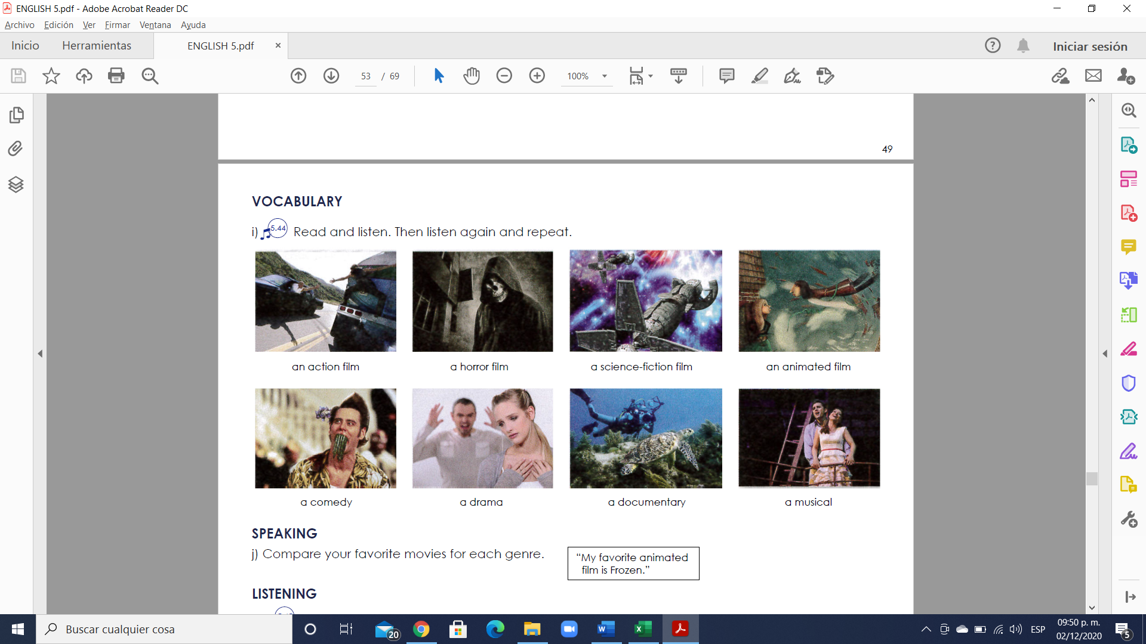

**Exercise 4.** Translate to Spanish the vocabulary above.

1.

2.

3.

4.

5.

6.

7.

8.