

**Nombre de alumno:**

**Nombre del profesor:**



**Nombre del trabajo: Weekly Activity #1 Unit 3**

**Materia:**

**Grado:**

**Grupo:**

Comitán de Domínguez Chiapas a 29 de junio de 2020.

**THE ARTS**

**Exercise #1:** Translate to Spanish the next adjectives to describe art:

1. Beautiful -
2. Exciting -
3. Fascinating -
4. Relaxing -
5. thought- provoking -
6. awful -
7. boring -
8. weird -
9. silly -
10. depressing -
11. feminine -
12. masculine -
13. unusual -
14. practical -
15. interesting -

**Exercise #2:** Write 6 sentences in Present Continuous using the vocabulary above.

**GRAMMAR**

**The Passive Voice**

- Most sentences are in the active voice: the subject of a sentence performs the action of the verb.

In the passive voice, the receiver of the action is the subject of the sentence.

Active voice: Architect Frank Gehry designed the Guggenheim Museum in Bilbao, Spain.

Passive voice: The Guggenheim Museum in Bilbao, Spain was designed by architect Frank Gehry.

- The Passive Voice is used to show interest in the person or object that experiences an action rather than

the person or object that performs the action. In other words, the most important thing or person

Example: The house was built in 1654.(= we are interested in the house, not in who built it.)

The road is being repaired. (= we are interested in the road, not in the people who are doing the repairs)

- Sometimes we use the passive voice because we don't know or do not want to express who performed

the action.

Example: I noticed that a window had been left open.

Every year thousands of people are killed on our roads.

- However, we can use a “by” phrase in a passive voice sentence when it is important to identify

the performer of an action.

Example: Pottery is made by people in many parts of the world. (not important).

Example: This bowl was found by someone in Costa Rica (not important).

Example: This dress was designed by Donatella Versace. (important).

- We form the Passive Voice with a form of “be” and the past participle of a verb. However, the form

changes for each tense. Study the following rules:

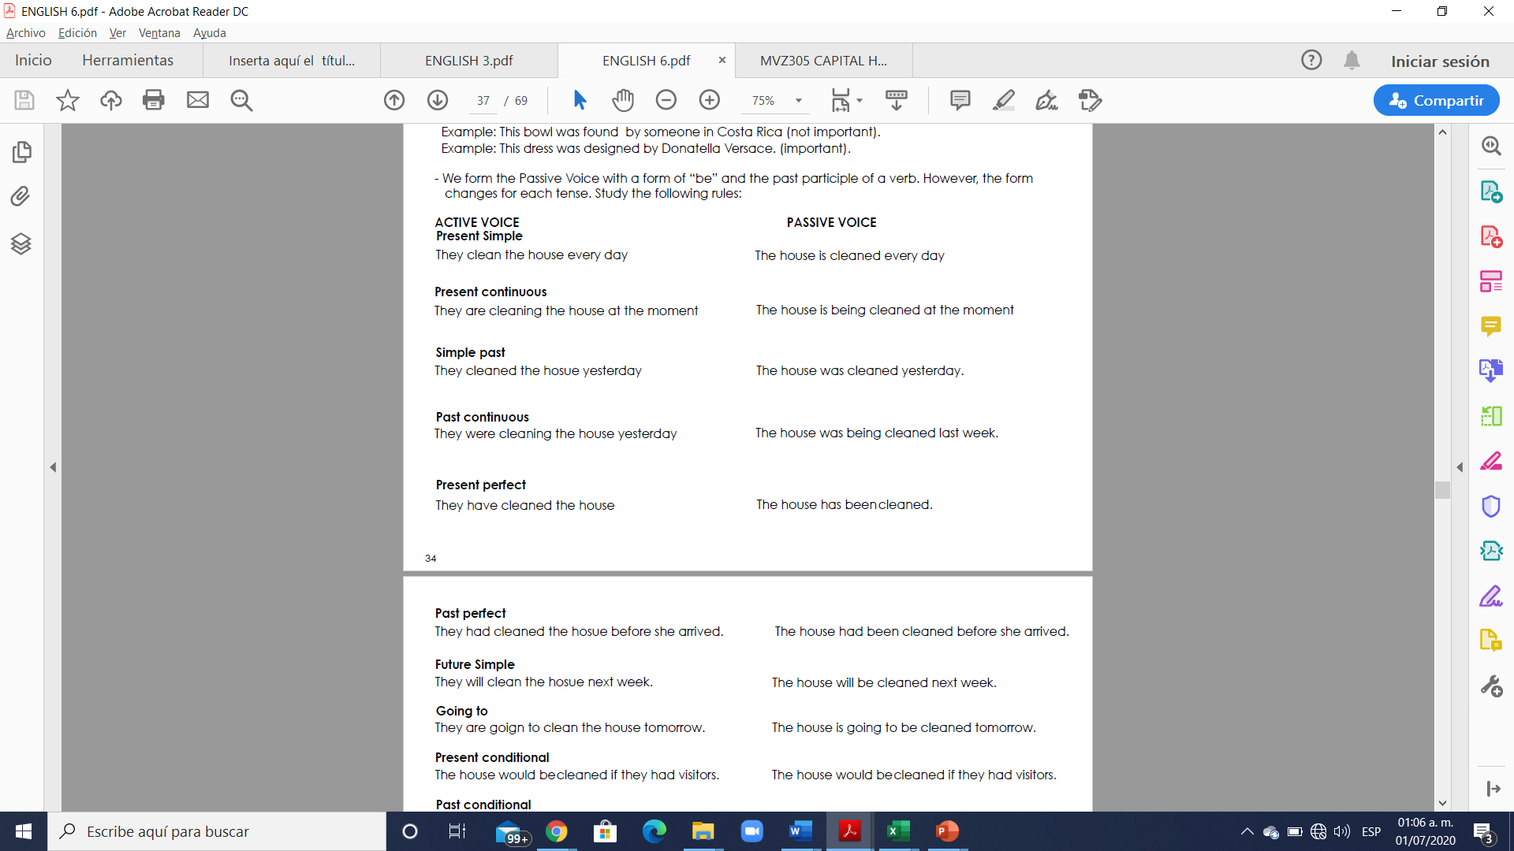

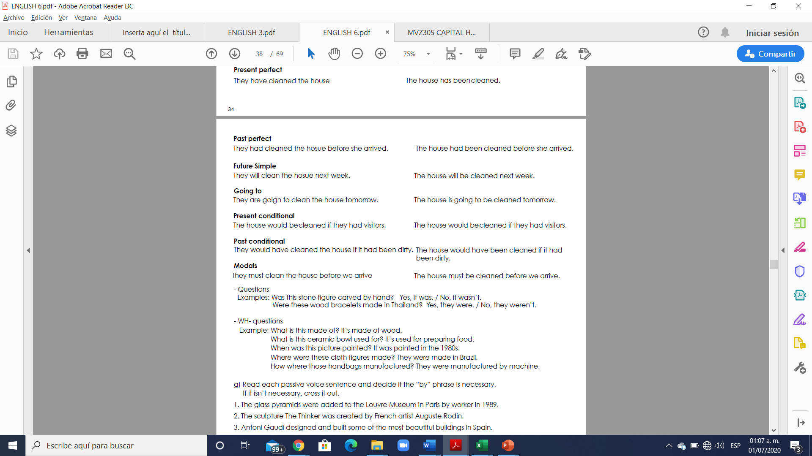

**Exercise#3.** Read each passive voice sentence and decide if the “by” phrase is necessary**. If it isn’t necessary, put in a red color.**

1. The glass pyramids were added to the Louvre Museum in Paris by worker in 1989.

2. The sculpture The Thinker was created by French artist Auguste Rodin.

3. Antoni Gaudí designed and built some of the most beautiful buildings in Spain.

His plans for the Casa Milà in Barcelona were completed by him in 1912.

4. The melody of “Ode to Joy” is known by people all over the world. It was written by German composer

Ludwig van Beethoven.

5. China’s famous Terracotta Army figures in Xi’an were discovered by farmers in 1974.

**Exercise#4.** Change each sentence from the active to the passive voice. Use a “by” phrase.

1. Leonardo Da Vinci painted the Mona Lisa in the sixteenth century.

A:

2. Brazilian photographer Sebastião Salgado took that photograph in 2007.

A:

3. Mexican filmmaker Alfonso Cuarón directed the 2013 3D film Gravity.

A:

4. Japanese master printmaker Katsushika Hokusai made that print over a century ago.

A:

5. Korean fashion designer Sang A Im-Propp created these beautiful handbags.

A:

6. Weavers have produced beautiful Persian rugs for several thousand years.

A:

**Exercise #5.** Complete the conversations. Write information questions, using the Passive Voice.

We interviewed Brian Tardiff at the Sandford Gallery about the exhibit of modern Hmong cloth quilts

Q: where are the quilts made?

A: These beautiful quilts are made in Vietnam by women from the Hmong tribe.

Q: __________ they __________ of?

A: They’re made of cloth. The pieces of cloth are cut by hand and sewn together.

Q: __________ the cloth _________?

A: It’s dyed in different colors, using plants and beeswax. It takes a lot of time.

Q: ___________ they ____________?

A: They are sewn by hand. Each is unique.

Q: ____________ they ____________for?

A: Many people just use them for decoration. However, Hmong culture

doesn’t have a written tradition, so some are used to tell stories about the women’s lives