

**Nombre de alumno:**

**Nombre del profesor:**



**Nombre del trabajo: Unit Activity #1– U3 1BEN**

**Materia:**

**Grado:**

**Grupo:**

Comitán de Domínguez Chiapas a 25 de octubre de 2021.

**TOPIC 3: WHERE ARE THEY?**

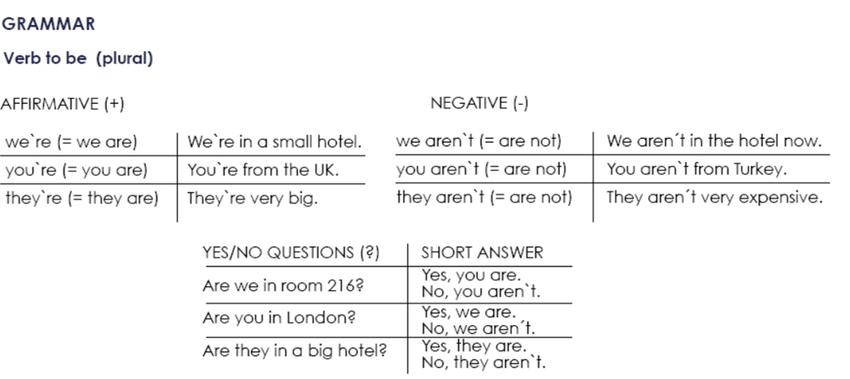

**Exercise 1.** Write the contractions: I`m, we`re, aren`t, etc.

1. We aren`t from Italy, ________ from Spain.

2. _______ a new hotel, but it______ very nice.

3. _______ a doctor and he _______ married.

4. You ______ Australian, _______ American.

5. ________ a manager and _______ a musician.

**Exercise 2.** Complete each statement with a singular or plural form of “be”.

1. I______ a writer.

2. She _____ not a pilot.

3. We _____ doctors.

4. They _____ not scientists.

5. We ______ managers.

6. He ______ a singer.

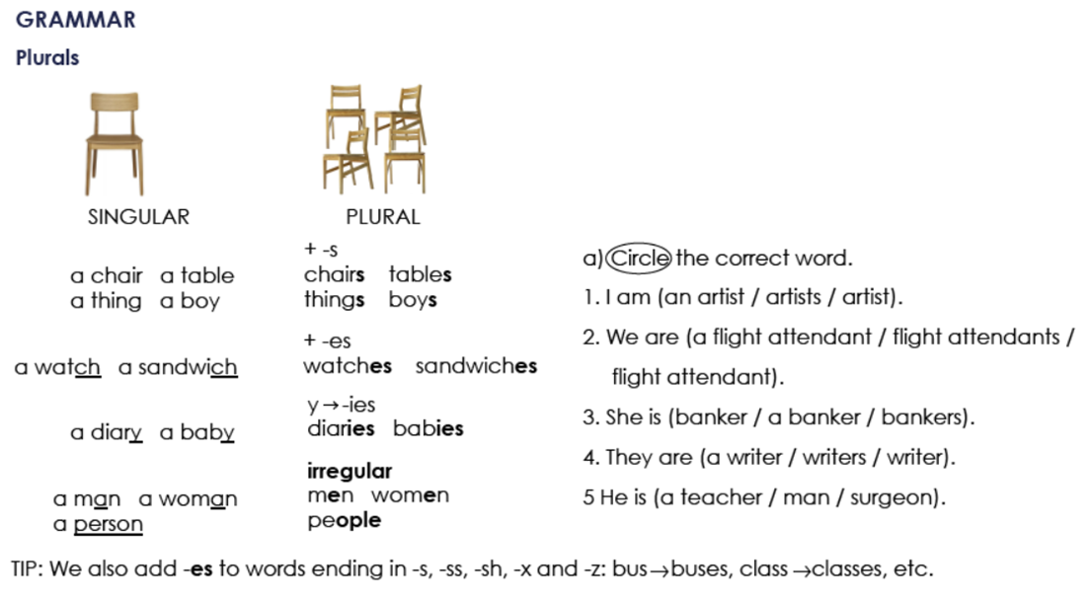

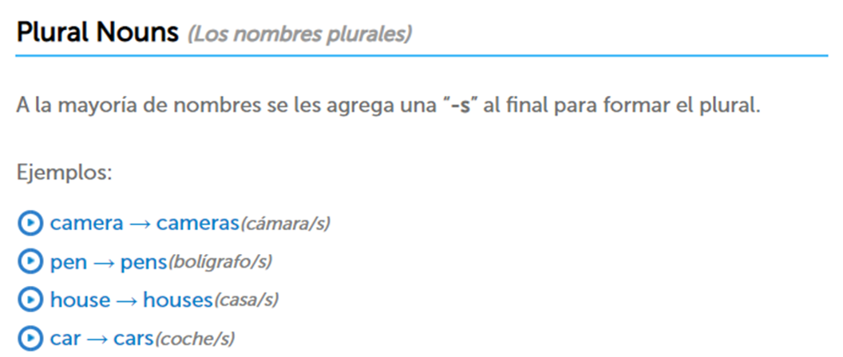

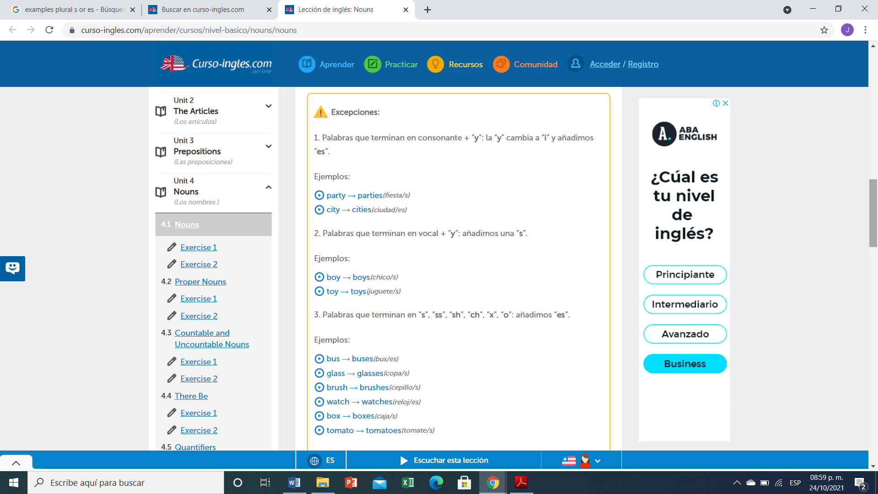

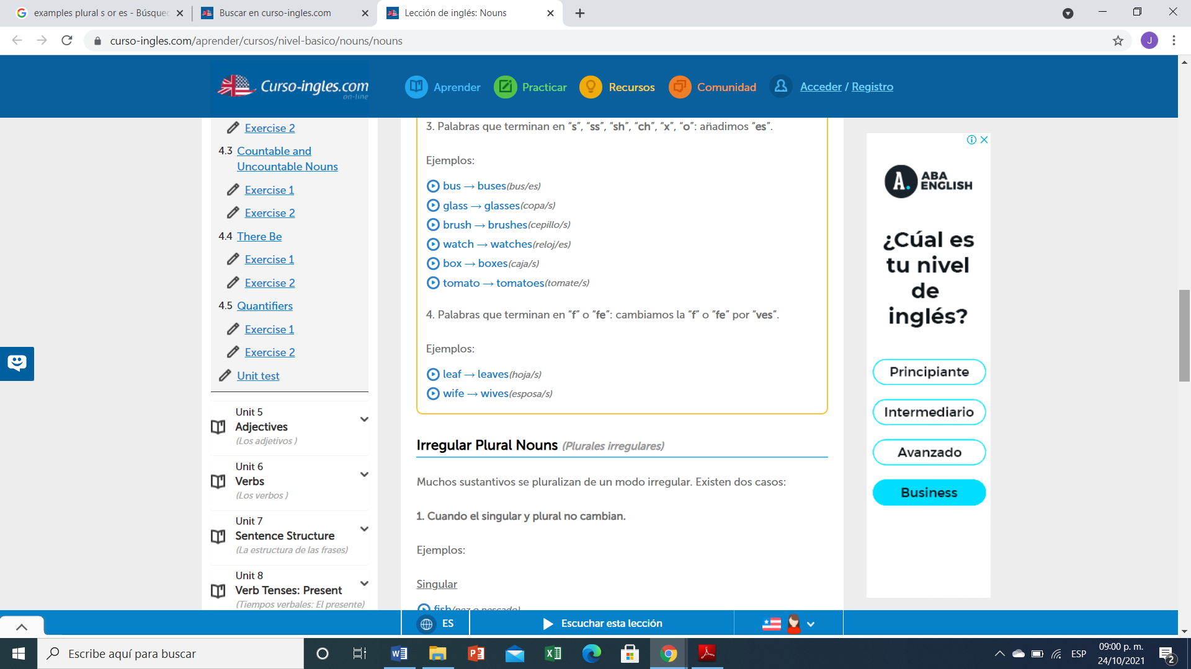

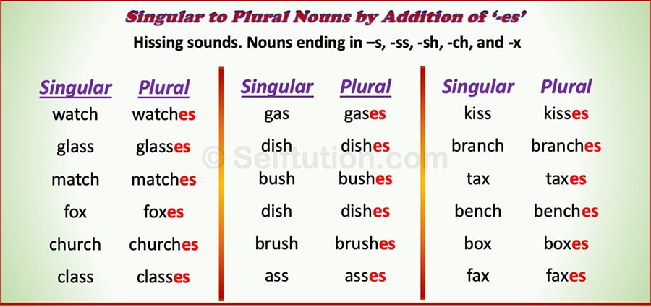

**Exercise 3.** Write the plural of:

1. Baby
2. Cake
3. Church
4. Glass
5. Wife
6. Fish
7. Month
8. Child
9. Wish
10. Woman
11. City
12. Man
13. Box
14. Foot
15. Mouse
16. Leaf
17. Sheep
18. Tomato

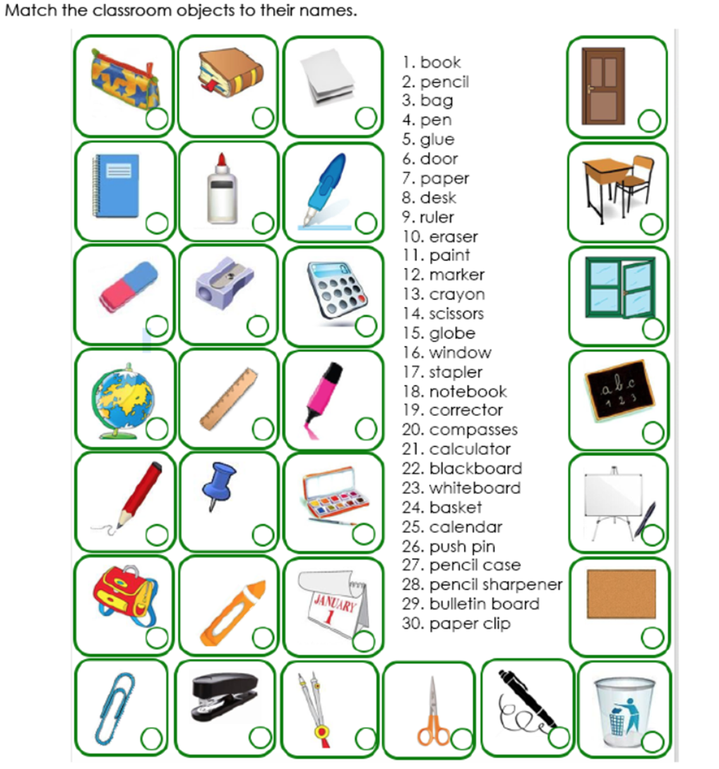

**1**

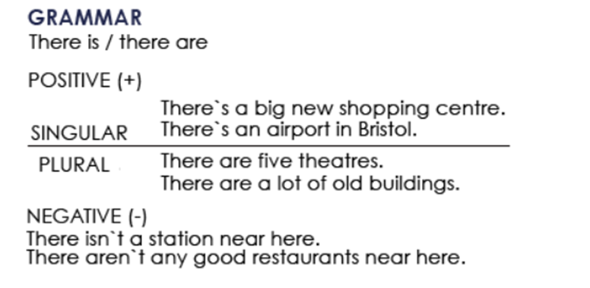

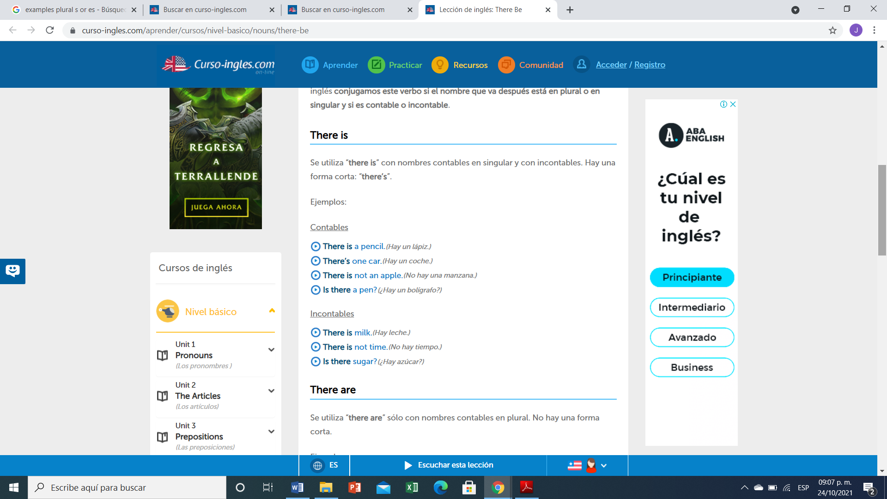

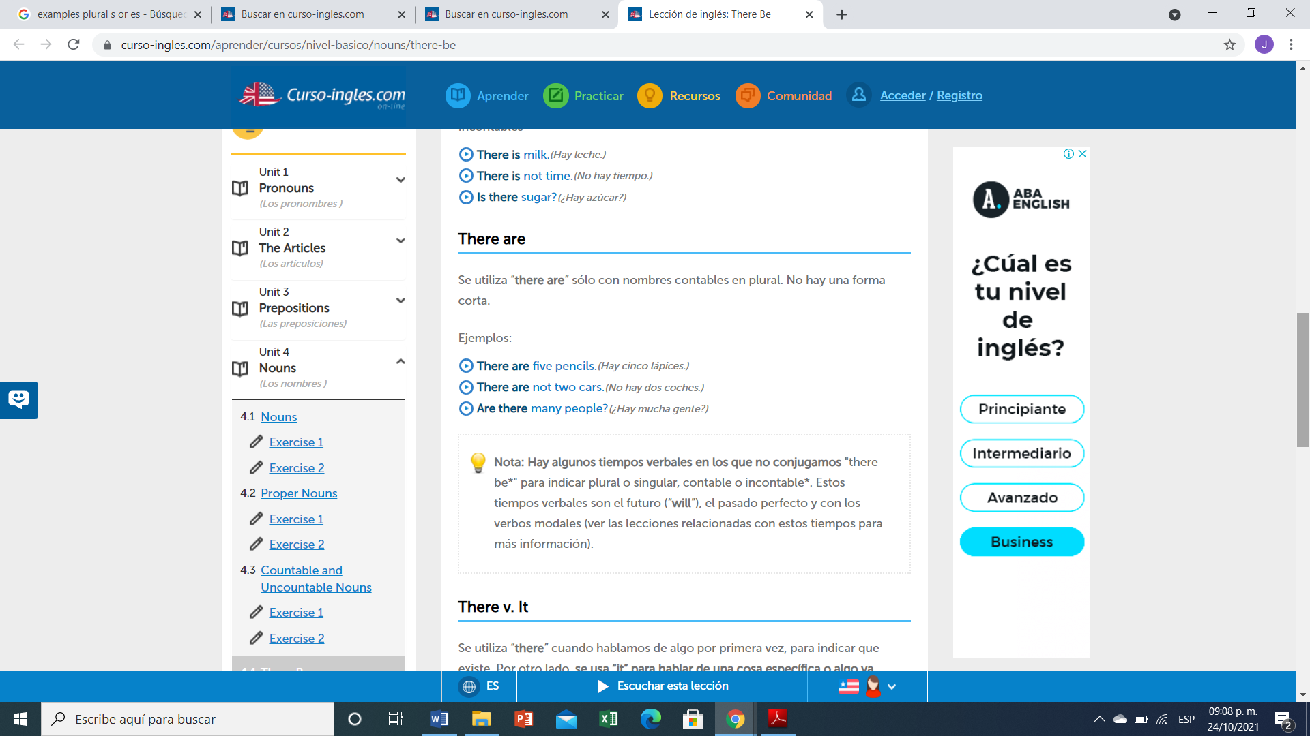

**Ejercicio #4 -** Completa las siguientes frases con la forma correcta de "there is or There are".

1. ___________ 5 apples in the bowl.
2. ___________ any water?
3. ___________ (not) any sugar in the coffee.
4. ___________ (not) any tomatoes in the salad.
5. ___________ some wine in the glass.
6. ___________ any money in your wallet?
7. ___________ a problem with this phone.
8. __________ any vegetables in this recipe?

**Ejercicio #5 -** Escribe las palabras en el orden correcto.

many / aren’t / this / pages / there / in

R:

any / eggs / there / the / in / are / fridge / ?

R:

is / nearby / restaurant / nice / there / a

R:

dining / are / chairs / in / room / there / three / the

R:

hospital / there / this / isn't / a / in / town

R:

here / is / bank / there / a / near / ?

R: